PRSF NEW MUSIC BIENNIAL
HULL
29th JUNE to 2nd JULY 2017
ARTIST PACK
ARTIST: Philip Veneables and David Hoyle
ARTIST CONTACT (Mobile number): TBC – PROMOTER TO CONFIRM
VENUE: Funktion
Address: Funktion, 54 Analby Road, Hull, HU3 2SB
Phone: 07578 935253
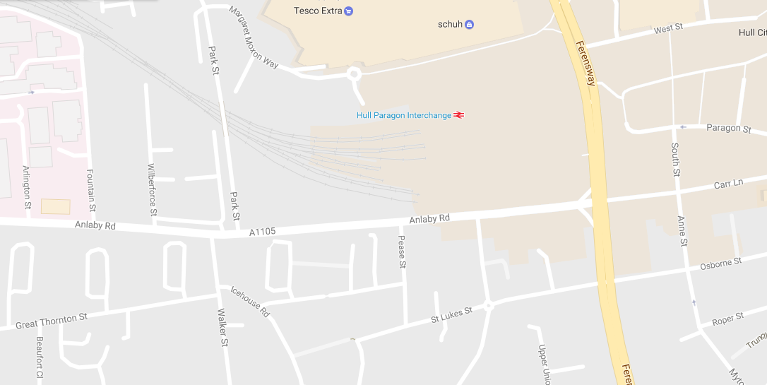
LOADING IN FROM:

PARKING REQUIREMENT and LOCATION:
TBC – PROMOTER TO CONFIRM
PERSONNEL
STAGE MANAGER (Primary contact show weekend only): Olivia Haw - 07926 654734
PRODUCTION MANAGER: Gareth Hughes – 07733112272
PRODUCTION ASSISTANT: Joanna Morley – 07725 942808
VENUE CONTACT: Adam Smith – 07581 392886

DATE AND TIME OF PERFORMANCE: Sunday 2nd July 17:30 (45mins)
PRODUCTION SCHEDULE:
SUNDAY 2 JULY
09:00 - 22:00 (ACCESS) | AM | Piano in
 | AM | Piano tuned
 | 09:00 - 14:00 | LX and Sound in
 | 14:00 - 17:00 | Artists arrive and rehearsal
 | 17:00 | Doors
 | 17:30 | PERFORMANCE - Philip Venables and David Hoyles
 | 18:00 | Cleared
 | 18:00 - 22:00 | Tech out
MONDAY 3 JULY
08:00 - 12:00 (ACCESS) | 08:00 - 12:00 | Staging out
 | AM | Piano out

TECHNICAL
Sound
FOH Control
1 Allen & Heath Qu-Pac Ultra Compact Digital Mixer
1 iPAD & Router
Speaker System
2 L Acoustic 115XT
2 Powerdrive 44BE Speaker Stand
2 L Acoustics - SB18
2 L Acoustics LA8
Balcony Fills
2 L Acoustic 108P
2 Powerdrive 44BE Speaker Stand
Monitor System
Microphones
1 Shure ULXP Beta58 Handheld Radio System - CH38
Other Equipment
1 63A 3-Phase Mains Distro #3
Staff
1 Engineer – FOH
AV
Material
1 Laptop
1 Christie LHD 700 HD Projector
1 Christie LNS-W33 Lens for LHD 700 1.3-1.8:1
1 10' x 5.9' Fastfold Screen (Widescreen)
Staff
1 Engineer – AV
Lighting
Material
1 Avolites Tiger Touch Pro Console
1 Paradim Patch Rack Dimmer
8 Equinox Maxi Par Tri RGB LED
8 650W Fresnel
4 3.5m Wind Up Manfrotto Stand
4 Aluminium Leg - 4ft / 1257mm
4 13A To 16A Adapter
1 Socapex To 6x 16A Adapter
Staff
1 Engineer - Lighting
RIDER:
TBC
BACKLINE:?
BACKLINE | Upright Piano | Teagues Pianos

ACCREDITATION
David & Alice Porter (Directors)
Steve & Sam Shaw (Directors)
Peter & Lorraine Boardman (Directors)
Wes Zepherin (Director)
Kirsty & Gary Halliday (Marketing)
Ben Pugh (Production)

