Venue Event Manager Handbook

Future Forum – 7th December 2017

Section 1 – Overview
1.0 Event Overview
1.1 Contacts and Festival Team
1.2 Communication
1.3 Risk Assessments
1.4 Timetable of Events
1.5 Accident and Near-Miss Reporting and Investigation (PRINT)
Section 2 – Venues
2.0 Venue Details
Panellist Overview and Contacts
Section 3 – Public and Volunteers
3.0 Volunteers
3.1 Fire Safety
Section 4 – Schedules
4.0 Production Schedules

Section 1 – Overview
Substance is a festival of place. A bespoke celebration and exploration of the The North - the people and stories, music, arts and culture, urbanism and architecture. Substance aims to own the conversation about where, what and how the cultural Northern Powerhouse exists. How we might define it; should we try and define it. How it has changed our cities and landscape. How it has regenerated our cities and changed national and international perceptions of them. The impact it has on everything from the economy to civic pride. How it has changed, how we might change it.
Substance Future Forum invites creative industries, businesses, organisations, artists, digital pioneers, social commentators, policy makers and change makers of the future to a day of active debate and discussion on the culture, creativity and future of the north.
Through panel discussions, keynote speeches, installations and debate; Substance aims to deliver a day that sets out how the rich creativity and culture of the north can lay the foundations for future generations, using the regenerated areas of Hull UK City of Culture as a backdrop.

The Venue Event Managers are the Hull 2017 representative as the primary point of contact for the Core Festival Team and Venue staff, working closely with artists and co-ordinating with any suppliers.

Venue Event Manager Responsibilities:

- Artist, production and venue coordination and liaison to ensure that each conference is successfully delivered
- Being aware of and carrying out preventative measures as detailed in the event risk assessment. Report Incidents following the Hull 2017 accident reporting procedure. Liaise with and report to festival core team in the event of any serious incidents or issues arising
- Liaise with venue staff to ensure the festival is successfully delivered according to the venue’s standard working procedures and policies
- In emergencies, follow the venue emergency procedures and co-ordinate safe evacuation with venue staff
- Any other reasonable duties required in order to meet the purpose of this role

1.1 Contacts and Festival Team
Carys Tavener Production Manager
Mobile no.: 07851077582
Office: 01482 318860
Email: carys.tavener@hull2017.co.uk
The festival team is made up of core members from Hull 2017 working in partnership with venues in and around Humber Street:
Hull UK City of Culture Festival Team Core Members:
Sam Hunt Executive Producer
Martin Atkinson Producer 07721754934
Carys Tavener Junior Production Manager 07851077582
Andrew Carruthers Operations Manager 07962112218
Sarah Moor Marketing
Ben McKnight Media & PR
Venue Staff:
Joe Hubbard Fruit 07875971439
Tom Watson Wykeland (1 @ The Dock) 01482 320968
Dileepa Ranawake C4Di Theatre 07446698735
Jane Owen Hull Minster 01482 224460
Louis Jones Humber Street Gallery 07585443895
Other Staff:
2x First Aiders North East Medical Services Roaming, on-call
Claire Drury Artist Liaison 07740408504
Siana-Mae Heppell-Secker Artist Liaison 07552458936
Venue Event Managers
Venue | Event Manager | Time | Contact
Fruit | Danielle Harris | All Day | 07594212377
1 @ The Dock | Oliver Cooper | All Day | 07450941066
C4Di | Joanna Morley | All Day | 07725942808
Hull Minster | Danielle Harris | 12:30 – 1:30 (Lunch) | -
Hull Minster | Danielle Harris | 1:30 – 2:20 (Guardian) | -

Festival Team Roles and Accreditation:
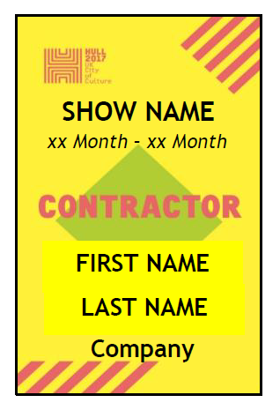 Technical Crew
Set-up the production and event space
Ensure the smooth running of the production, including operating
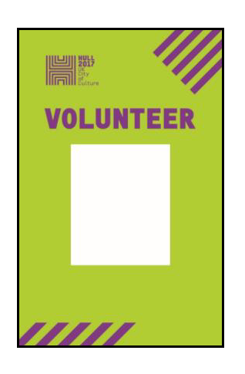 Volunteers
Greet and welcome members of the public
Assist with public way-finding
Assist with ticketing, ushering, and Front of House
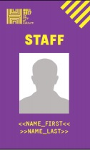Core Team
Keep an overview of entire festival operation
Answer questions and respond to incidents
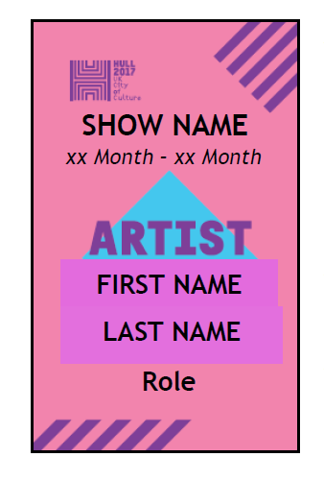 Panellist
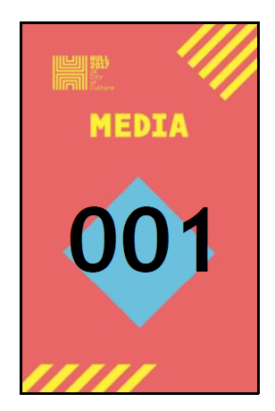 Media
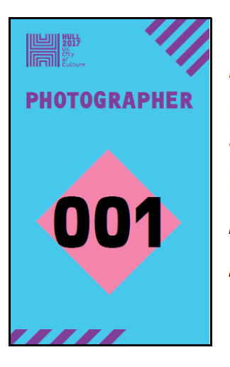 Photographer

1.2 Communication
The following staff will collect a radio from Pacific Exchange and communicate on channel 1 throughout the day:
Carys Tavener
Andrew Carruthers
Joanna Morley
Danielle Harris
Olly Cooper
First Aid x2
Martin Atkinson
A What’sApp group will be created for the duration of the day’s events for all staff to communicate.
Festival core team will always be contactable by direct mobile.

1.3 Risk Assessment
See Attached

1.4 Timetable of Events
Welcome, register and breakfast | 09:00 – 10:00 | Humber Street Gallery
Welcome and Introduction | 10:00 – 10:20 | Fruit
Title | Time | Venue
How Arts Can Save the NHS | 10:30 – 11:15 | 1 @ The Dock
Tell The World | 10:45 -11:30 | C4Di Theatre
You’re Only Here For The Culture | 11:00 – 11:45 | Fruit
How To Avoid An Identity Crisis | 11:30 – 12:15 | 1 @ The Dock
Lunch | 12:30 – 1:30 | Hull Minster: Nave
Guardian Live in Conversation | 1:30 – 2:20 | Hull Minster: Nave
Show Me The Money! | 2:45 – 3:30 | C4Di Theatre
From Stage To Screen | 3:00 – 3:45 | Fruit
HullOS v2042gm – your City evolved. Connected, Accelerated and Accepted | 3:15 – 4:00 | 1 @ The Dock
What Is The Role of A Capital City? | 3:45 – 4:30 | C4Di Theatre
It’s A Little Bit Leave It | 4:00 – 4:45 | Fruit
Art Can Change The World | 4:14 – 5:00 | 1 @ The Dock
We Made Ourselves Over | 4:45 – 5:30 | C4Di Theatre
Northern Souls | 5:00 – 5:45 | Fruit
A Journey Through the Land of Green Ginger | 6:00 – 6:30 | Fruit
Social Event | 8:00 | Fruit

1.5 Accident and Near-Miss Reporting and Investigation
Venue Event Managers are to ensure any completed report forms are given to Carys Tavener
An Accident and Near-miss Reporting Form, a Safeguarding Incident Reporting Form and Volunteer Concern Reporting Form will be available at all times in the venue.
Show Reporting
The Venue Event Manager is to confirm capacity of each conference and email it to Carys Tavener.
Accident or Near-Miss Reporting: (an event that results in injury or ill health OR an event not causing harm but with the potential to cause injury or ill health)
Any person involved in or witness of an accident or near-miss is to complete an Accident/Near Miss Reporting Form, and give it to the Venue Event Manager.

Safeguarding Incident Reporting (disclosures or suspicions of abuse)
Any person involved in or witness of a safeguarding incident is to complete a Safeguarding Incident Reporting Form and give it to the Venue Event Manger.

Volunteer Concern Reporting
Any person involved in or witness to a volunteer incident is to raise their concern with either the Team Leader Volunteer (a volunteer) or the Venue Event Mangaer, who are to give the person the option to complete a Volunteer Concern Reporting Form. If so, the Venue Event Manager passes it directly to Carys Tavener.

Section 2 Venues
2.0 Venue Details
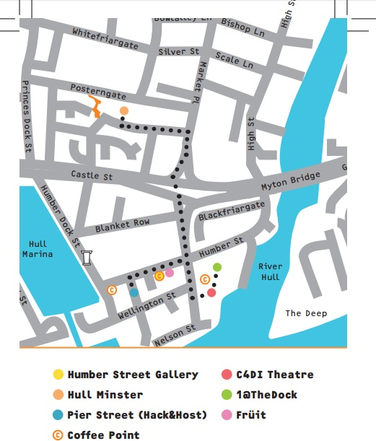
FRUIT

62-63 Humber St, Hull HU1 1TU
Capacity | 150 Seated
Layout | Audience seating in rows  6 Panelist chairs on stage with 2x black cube coffee tables (1 per 3 chairs)  TV Screen either side of stage behind panelists  Please Ensure all panelists have water provision  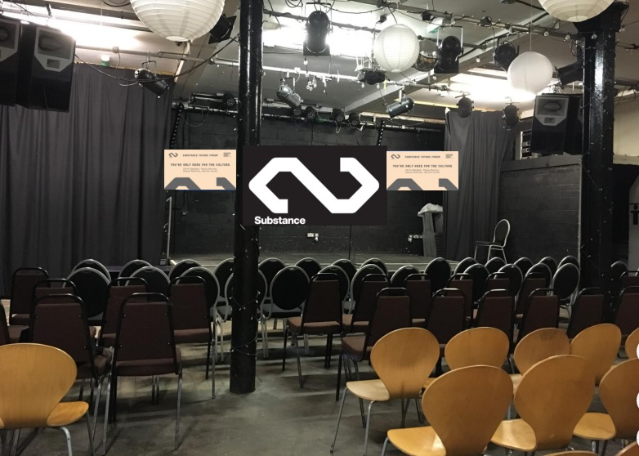
Wi-Fi (for staff use only) | Username: ZyXel86031E  Password: 58AF815F55C3
Tech | 12x Mic headsets  6x Beltpacks  2x Handheld Mics  For 15 minute change-overs between panelists, prepare headsets on waiting panelists and then swap beltpacks.

Overview and Contacts

You’re Only Here For The Culture
Chair | John Harris | Organisation
Panellist | Martin Green | Organisation | Hull 2017
Panellist | Paula Murray | Organisation | Croydon Council (bidding for Borough of Culture)
O7436039215
Panellist | Shona McArthy | Organisation | Edinburgh Festival Fringe
Panellist | Chris Baldwin | Organisation | Galway 2020 European Capital of Culture
Panellist | Pete Massey | Organisation | Arts Council

From Stage To Screen
Chair | Nikki Bedi | Organisation | BBC
Panellist | Rocio Cano | Organisation | Sky Arts Producer
Panellist | Jeremy Routledge | Organisation | Calling the Shots: Channel 4 Random Acts
Panellist | Lamia Dabboussy | Organisation | BBC Arts Editor
Panellist | Peter Groom | Organisation | Director of Herd and Commissioned Random Acts Artist
O7702157163

It’s A Little Bit Leave It
Chair | Joe Hakim | Organisation | Warren: Spoken Word Artist
07949055681
Panellist | Andrew Gooch |  | Writer, actor and poet from East Hull
Please contact Joe Hakim
Panellist | Jodie Langford |  | Spoken Word Artist based in Hull
Please contact Joe Hakim
Panellist | Frank Mathers |  | Supporting Hull’s Music Scene
Please contact Joe Hakim
Panellist | Jack Foster |  | From North Hull Estate
Please contact Joe Hakim
Panellist | Emily Morrison | Organisation | British Council
Panellist | Emma Hardy |  | MP
07963 195277

Northern Souls
Chair | Ra Page | Organisation | Comma Press
Panellist | Saba Ahmad | Organisation | And Other Stories
Panellist | Jacob Ross | Organisation | Peepal Tree
Panellist | Jamie McGarry | Organisation | Valley Press

A Journey through the Land of Green Ginger
Chair | Katy Fuller | Organisation | Hull 2017
07771764656

1 @ THE DOCK

Building 1, @ The Dock, Fruit Market, HU1 1UU
Alarm Code | 160517 (almost certainly won’t need to use)
Capacity | 130 Seated
Layout | Audience seating in rows  6 Panelist chairs raised on a temporary stage with 2x black cube coffee tables (1 per 3 chairs)  TV screen off stage either side pointing to opposite banks of seating  Bins provided by Hull 2017.  Please Ensure all panelists have water provision  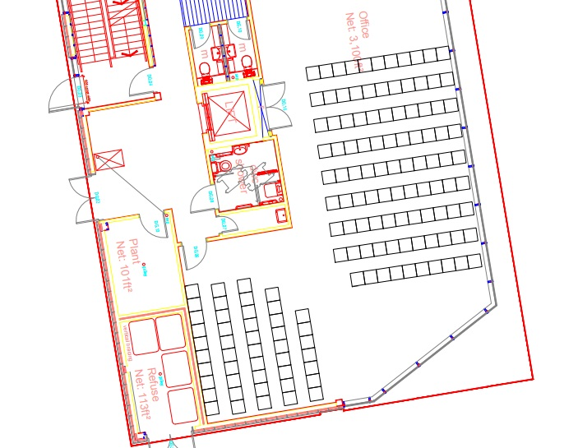
Wi-Fi (for staff use only) | Name: TNCAPE08931 (-5G)  Password: 39F6ECAE03
Tech | 12x Mic headsets  6x Beltpacks  2x Handheld Mics  For 15 minute change-overs between panelists, prepare headsets on waiting panelists and swap beltpacks.

Overview and Contacts

How Art Can Save the NHS
Chair | Nikki Bedi | Organisation | BBC
Panellist | Bob Fulcher | Organisation | West Yorkshire Playhouse
Panellist | Nicky Taylor | Organisation | Theatre and Dementia Research Associate at West Yorkshire Playhouse
07888723429
Panellist | Victoria Amedume | Organisation | Upswing
07939027444
Panellist | Alex Mitchell | Organisation | Silent Uproar
07855801234
Panellist | Dr Dan Roper: CCG | Organisation | Hull Clinical Commissioning Group
07760270467
Panellist | Sarah Emmott | Organisation | Art With Heart
07763643281

How To Avoid An Identity Crisis
Chair | Amy Garcia | Organisation
Panellist | Dr Jo Byrne | Organisation | Culture, Place and Policy Institute, University of Hull
07540232309
Panellist | Anthony Yates | Organisation | Visit Hull and East Yorkshire
O7855507018
Panellist | Professor David Atkinson | Organisation | University of Hull, Professor of Cultural and Historical Geography
07775 650595
Panellist | Lottie Gross | Organisation | Editor of Love Exploring
O7542116737
Panellist | Emma Elizabeth Davidson | Organisation | Writer
Panellist | Julie Corbett | Organisation | Hull 2017 Volunteer

HullOS v2042gm – your City evolved. Connected, Accelerated and Accepted
Chair | David Keel & Sarah Louise | Organisation
Panellist |  | Organisation | C4Di
Panellist |  | Organisation | C4Di
Panellist |  | Organisation | C4Di
Panellist |  | Organisation | C4Di

Art Can Change The World
Chair | Nikki Bedi | Organisation | BBC
07708510727
Panellist | Aisha Zia | Organisation | Theatre 503 & Common Wealth Theatre
O7877316600
Panellist | Leone Higgins | Organisation | Eggs Collective
079791 246053
Panellist | Gillian Nicole | Organisation | Director of Digital and Online Content at The Artists Information Company
07936 599323
Panellist |  | Organisation | Hack & Host

C4Di Theatre

31-38 Queen St, Hull HU1 1UU
Capacity | 40 Seated 10 Standing
Layout | Audience seating in rows  6 Panelist chairs with 2x black cube coffee tables (1 per 3 chairs)  Please Ensure all panelists have water provision  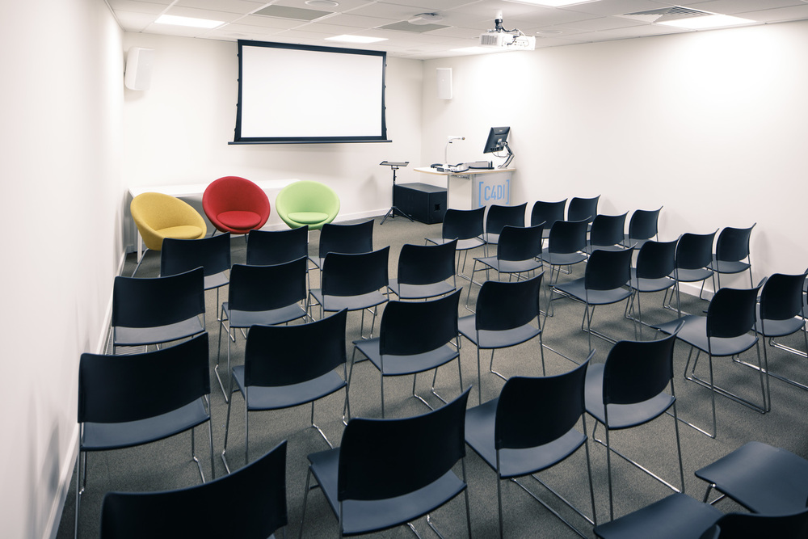
Wi-Fi | Please see venue staff
Tech | Projection screen lowered  No Microphones. Please see venue staff for any assistance

Overview and Contacts

Tell The World
Chair | Susannah Simons | Organisation | Director of Arts and Outreach for Canvas
07736481163
Panellist | David Collins | Organisation | Opera North
07970 463173
Panellist | Daniel Elms | Organisation | New Sound Collective
07731587989
Panellist | Katherine Jewkes | Organisation | MIF and The Space
Panellist | Nina Rogers | Organisation | Yorkshire Sculpture Park

Show Me The Money!
Chair | Susannah Simons | Organisation | Director of Arts and Outreach for Canvas
07736481163
Panellist | Dominic Gibbons | Organisation | Wykeland Group
07730 488153
Panellist | Francesca Heygi | Organisation | Hull 2017
Panellist | Pat Connor | Organisation | Head of BBC Development & Events
07710 304053
Panellist | Kevin Moore | Organisation | Humber Bridge
078500 99467

What is The Role of a Capital City?
Chair | Anna Wood | Organisation | The Quietus
Panellist | Vanessa Reed | Organisation | PRS Foundation
Panellist | Chiedu Oraka | Organisation | Hull based Grime artist
O7729409125
Panellist | Mal Campbell | Organisation | The Trades Club in Hebden
07716 532019
Panellist | Katherine Cantwell | Organisation | Heavenly Recordings
07583 434259

We Made Ourselves Over
Panellist | Nick Tandavanitj | Organisation | Blast Theory
Panellist | Rich Wilson | Organisation | One Hull of a City
O7539032304

Hull Minster

Market Place, HU1 1RR
Capacity | Nave: 210
Layout | Nave:  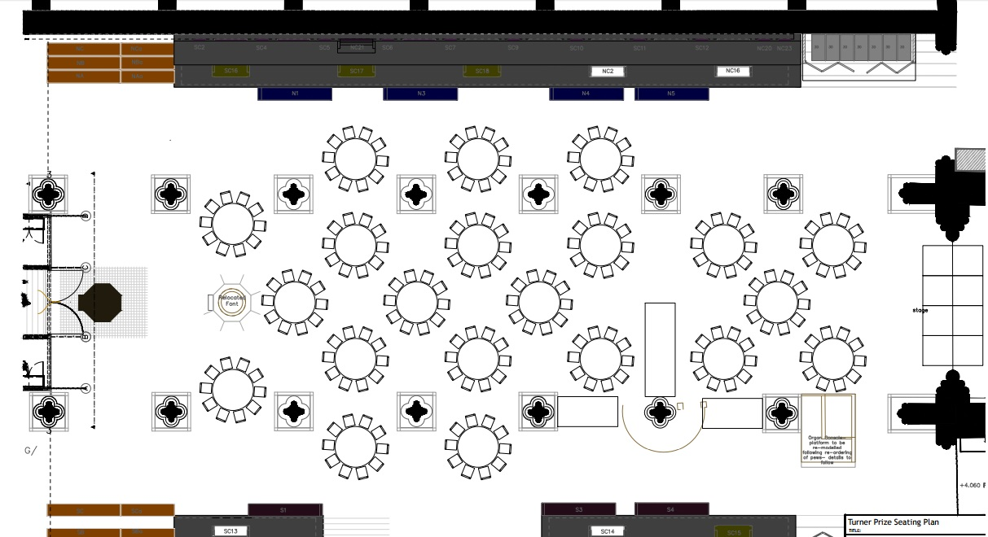  Please Ensure panelists have water provision
Wi-Fi
Tech | 6x Mic headsets  6x Beltpacks  2x Handheld Mics

Overview and Contacts

Guardian Live in Conversation
Panellist | John Harris | Organisation
Panellist | Stuart Arnold | Organisation | The Yorkshire Party

Section 4 – Public and Volunteers

4.0 Volunteers

Hull 2017 Volunteers will be briefed and deployed throughout the day at Humber Street Gallery by Andrew Carruthers, who will respond to varying requirements throughout the day.
Please radio to Andrew if you need more volunteer assistance in your venue.

Time | Total No. of volunteers | Positions: Venues | Positions: Wayfinding
09:00 – 13:00 | 20 | 2x Fruit  2x C4Di  2x 1 @ The Dock | 2x Wayfinding between C4Di and 1 @ The Dock entrances  2x Corner of Humber Street  2x Outside Fruit on Humber Street  6x Roaming
11:30 – 15:30 | 10 | 4x Hull Minster | All wayfinding to and from Hull Minster:  2x A63 Crossing  2x Corner of Market Place  2x North Church Side
14:00 – 18:00 | 20 | 2x Fruit  2x C4Di  2x 1 @ The Dock | 2x Wayfinding between C4Di and 1 @ The Dock entrances  2x Corner of Humber Street  2x Outside Fruit on Humber Street  6x Roaming
18:00 – 22:00 | 10 | Fruit | Assisting get-outs, tidying, closing venues.

4.1 Fire Safety

Show-stop procedure for Venue Event Manager in the event of an emergency evacuation

Show-stop is required if the alarm sounds or venue staff order.

Ensure houselights are turned on and stop any discussion. Stand as fully visible to the audience as possible and make a clear and audible announcement instructing the audience to evacuate the building quickly and calmly.
“Ladies and Gentlemen, due to circumstances beyond our control we are unable to continue. Please leave at once by the nearest available exit and assemble:
Fruit – Humber Street
1 @ The Dock – Queen Street Car Park
C4Di Theatre – Car Park Adjacent to Nibble
Hull Minster -
Do not stop to collect any personal belongings. Thank you.”
Leave the venue through the nearest available exit. Contact venue staff and inform them of the emergency. The venue staff will ensure that the suitable emergency services are summoned.
Once in the Assembly Area:
Make yourself known to emergency services.
When it is safe to do so, contact Carys Tavener to inform of the evacuation.
You will be informed by the emergency services when (or if) clear to return and address the public to inform them.

EVACUATION PLAN FOR FRUIT

If you discover a fire, raise the alarm immediately. Manually operated call points (break glass boxes) are located on behind the bar, box-office and stage left, adjacent to the firedoors.

** When the alarm has been raised, leave the venue by the fire doors to the right of the box-office and await the duty manager at the exterior of the building.**

It is imperative that the building is evacuated calmly and quickly. DO NOT PANIC MEMBERS OF THE PUBLIC, this could cause people to be crushed and fire exits to be blocked.

Management, security and all other staff must repeatedly tell members of the public, artists and any other people unfamiliar with the building that it is not a false alarm and to leave through the nearest fire escape. Remember, people in the venue could be intoxicated and may not treat the alarm seriously.

It is the responsibility of the duty manager to call the emergency services.

DO NOT re-enter the building under any circumstances unless authorised to do so by the emergency services.

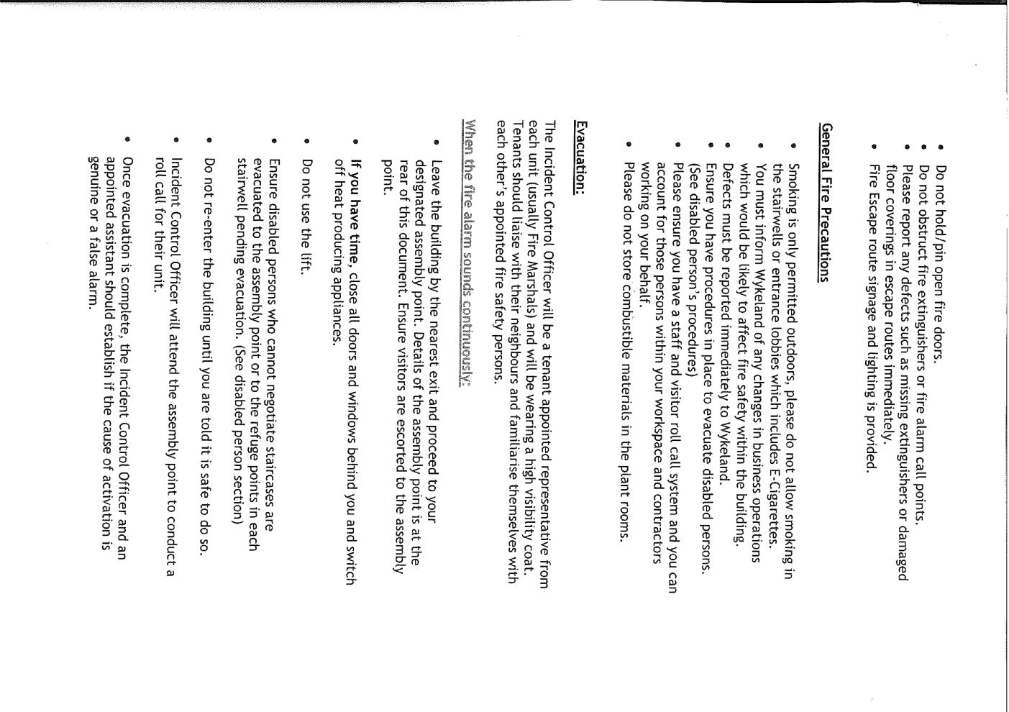
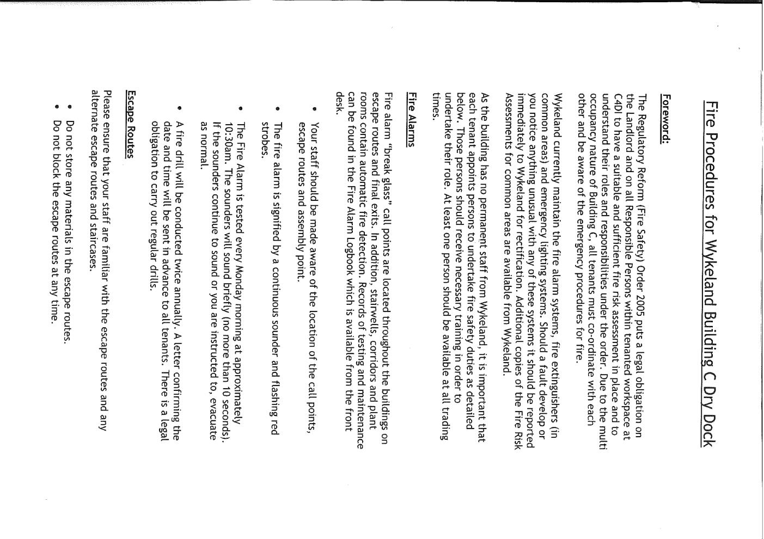
Evacuation Plan for 1 @ The Dock

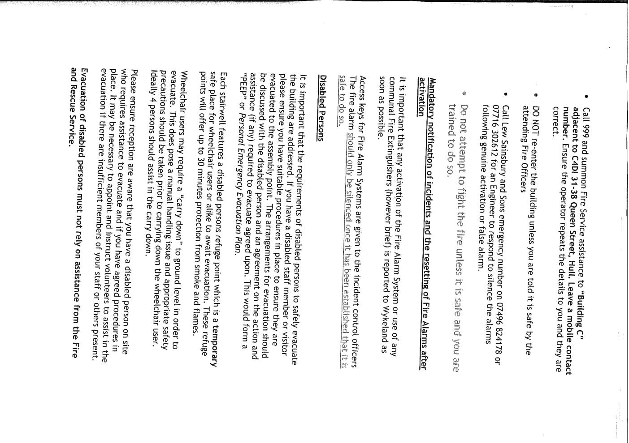
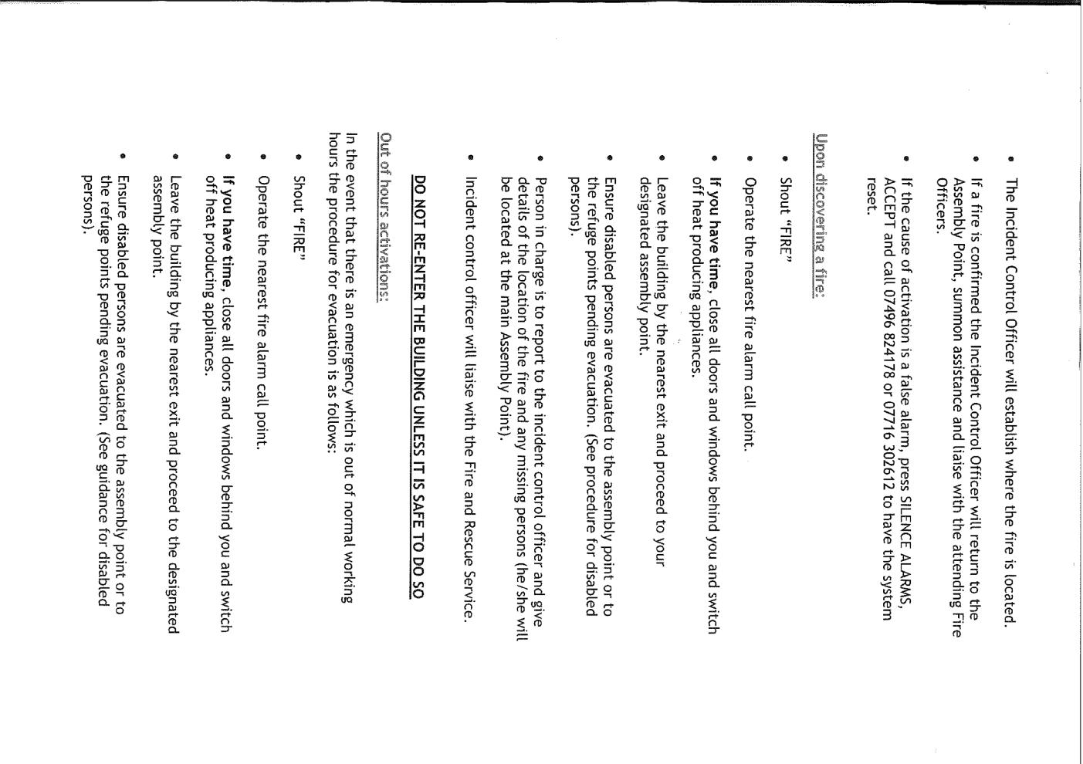
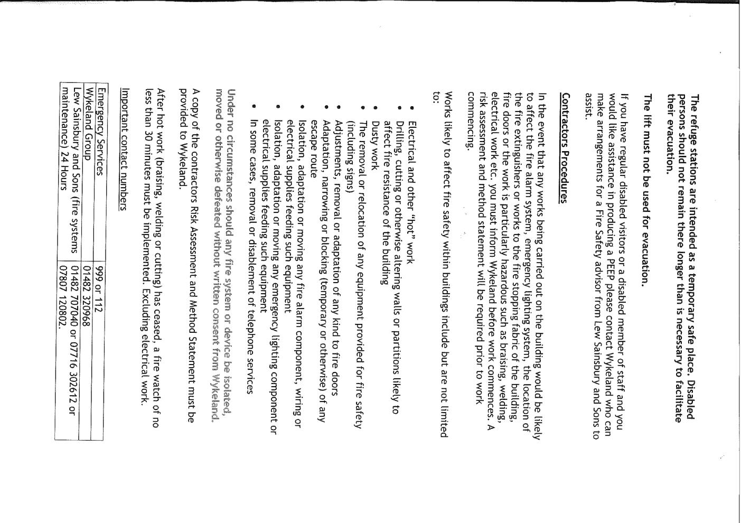
Section 5 – Schedules
5.0 Fruit Production Schedule

5.0 1 @ The Dock Production Schedule

5.0 C4Di Theatre Production Schedule

5.0 Hull Minster Production Schedule
 | Hull Minster
07:00
08:00
08:30
09:00 | Get-in and set-up
09:15 | Get-in and set-up
09:30 | Get-in and set-up
10:00 | Joanna deliver panellist chairs
10:20 | Set-up
10:30 | Set-up
10:45 | Set-up
11:00 | Set-up
11:15 | Set-up
11:30 | Set-up
11:45 | Set-up
12:00 | Set-up
12:15
12:30 | LUNCH
13:00 | LUNCH
13:30 | Guardian Live in Conversation
14:00 | Guardian Live in Conversation
14:20 | Guardian Live in Conversation
14:30 – 16:00 | Get-Out: PANELLIST CHAIRS COLLECTED BY?

