Invitation to artists/creative industries
<Image amended to say Substance: Future Forum
Fruit, Hull Minster & Humber Street Area
Thursday 7 December

“Celebrating the culture, creativity and future of the north”

Substance Future Forum invites creative industries, businesses, organisations, artists, digital pioneers, social commentators, policy makers and change makers of the future to a day of active debate and discussion on the culture, creativity and future of the north.
Through panel discussions, keynote speeches, installations and debate; Substance aims to deliver a day that sets out how the rich creativity and culture of the north can lay the foundations for future generations, using the regenerated areas of Hull UK City of Culture as a backdrop.
The day will be bringing together an impressive array of partners to inform and contribute to the discussions:

 | 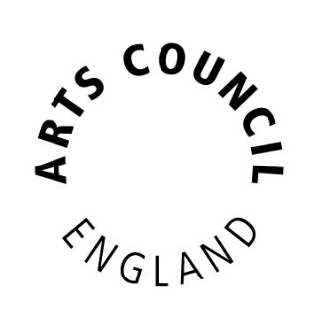 | 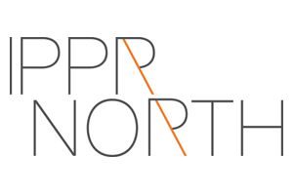
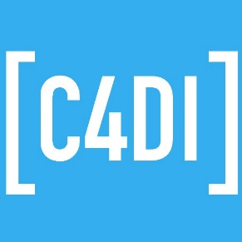 |  | 
 | 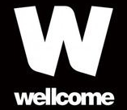 | 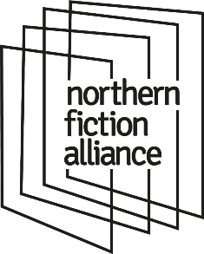
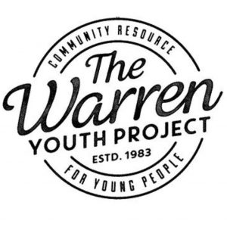 |  | 

Sessions will include:
- How the creative sector is a vehicle for political, social and economical change?
- What makes a successful city of culture?
- How does a city or town's cultural product hit a global audience, and what benefit does that bring to a place?
- Arts and Business: a working relationship with benefits beyond the obvious.
- Showcasing place and displaying cultural ambition with a bang: The impact of site specific performances and outdoor arts.
- The Next Gen: Young people – The Future of the North. Policies and their implications.

With more to be announced soon, as well as keynote speakers and installations.

We are looking for an excellent group of participants to enjoy and take part in discussions and talks throughout the day. In order to make sure we have the right people in the room we believe there should be no barriers to access for those who struggle to afford the ticket price.
If you might struggle to pay the ticket price and feel this day will really benefit you, we do have a small amount of bursary places available. Please contact substance@hull2017.co.uk with a short paragraph about yourself and what particular elements of the Future Forum are of interest to you.

Invitation to Businesses Organisations

