Hull UK City of Culture 2017
Project Zephyr
Feasibility Study
Draft 1 | 22 July 2016

This report takes into account the particular
instructions and requirements of our client.
It is not intended for and should not be relied
upon by any third party and no responsibility
is undertaken to any third party.

Job number 249697
Ove Arup & Partners Ltd
Admiral House Rose Wharf
78 East Street
Leeds LS9 8EE
United Kingdom
www.arup.com

Contents

Page
1 Introduction 1
2 The Proposal 2
2.1 General 2
2.2 Parties Involved 2
2.3 Location Chosen for the Installation 3
2.4 Key Dates 4
2.5 Confidentiality 4
3 Ownership & Liabilities 5
3.1 Ownership & Loan Agreement 5
3.2 Insurance 5
4 Permissions and Licences 7
4.1 Summary of licence requirements 7
4.2 Planning Consent 7
4.3 Transport Licences 8
5 Transport (including Removal) 9
5.1 Access Route Options 9
5.2 Preferred Route 9
5.3 Transportation 9
5.4 Affected Street Apparatus 10
6 Installation 11
6.1 Supports 11
6.2 Mock Up 12
6.3 Headroom Clearances 12
7 Operation 13
7.1 Security Presence 13
7.2 Secure Design 13
7.3 Maintenance 13
8 Programme 14
8.1 Overall Programme 14
8.2 Detailed Installation Programme 14
9 Cost Estimate 16
9.1 Approach 16
9.2 Summary of Cost Estimate 17
10 Risk Register 18
10.1 Approach 18
10.2 Summary of Risk Register 19
11 Next Steps 21
11.1 Actions 21
11.2 Roles and Responsibilities 21

Appendices
Appendix A
Preferred and Alternative Installation Arrangements
Appendix B
Preferred Access Route
Appendix C
Programme
Appendix D
Cost Estimate
Appendix E
Risk Register

- Introduction
Arup has been commissioned by Hull UK City of Culture 2017 Ltd (“Hull 2017”) to undertake this feasibility study into the feasibility of realising the “Zephyr” installation – the artistic installation of a Siemens 75m long wind turbine blade within the city centre of Hull.
This report describes the concept for the installation and identifies the key governance, technical, programme and economic issues associated with the realisation of the art installation. A high level risk assessment has also been undertaken to identify some of the key risks associated with this project.
The purpose of this report is to enable Hull 2017 and other stakeholders to decide whether they wish to proceed with the project.
This is a confidential report – all parties given access to this document are deemed to have signed Hull 2017’s Non-Disclosure Agreement and are bound by its terms.

- The Proposal
  - General
In 2017, Hull will be celebrated as the UK’s City of Culture. The first three months of 2017 is themed “Made in Hull”.
As part of wider initiatives to develop the UK’s offshore wind industry, Siemens are investing £450m in a new wind turbine blade manufacturing facility in Alexandra Dock, Hull. The facility is nearing completion and will shortly move into production. Siemens have appointed a significant part of their workforce and are implementing a programme in Hull and Denmark to train these new workers to make the turbine blades. The largest wind turbine blade Siemens produce is the B75 – this is 75.4m long and 4.6m diameter at the “root” end of the blade. This blade will be made in their Hull facility.
To celebrate both the UK City of Culture and the opening of the Siemens blade manufacturing facility, it is proposed that a B75 turbine blade is installed within the city centre as part of the “Made in Hull” season. In addition to the dramatic physicality of the blade, the installation will celebrate Hull’s shipbuilding past, its craftsmanship and the city’s potential future as a centre of the UK offshore wind industry.
Hull 2017 have appointed artist Nayan Kulkarni to help exhibit the blade within the city centre. Nayan has called this art installation “Zephyr” which has been taken as the working title for the project.

  - Parties Involved
The parties involved in the project to date are as follows:
- Hull 2017 – Project Sponsor, responsible for coordinating funding and overall delivery of the project.
- Siemens – Loan of the blade
- ALE (as subcontractor to Siemens) – specialist transport and installation.
- Arup – technical project definition, costing and risk management.
- Nayan Kulkarni – Artist

  - Location Chosen for the Installation
It is proposed that the blade be installed within Queen Victoria Square. This location has been selected based on consideration of the following criteria:
Table 2.1: Selection criteria for locating the installation
Criteria | How applied
Visibility | To help promote Hull to a UK audience and to communicate the wider issues related to the blade, a highly visible location is preferred. Locations within the retail core of the city are therefore preferred. Images of the blade will be seen worldwide – the background to these images should show a positive image of the city and its heritage.
Impact on highways | It is preferred that the blade is located in a pedestrianized area so that impact to traffic (including buses and taxis etc.) is minimised. Where the blade overhangs a service route, an appropriate clearance envelope will be maintained.
Minimum impact on retail premises | The selected location should not block access to retail units. It should also have minimum impact on sightlines between retail units many shoppers like to “zig-zag” between retail units along a street.
Minimum impact on residential premises | On some of the streets, residential premises are located above shops and impact on these residential units should also be minimised.
Access for servicing vehicles | Some of the pedestrian areas are used for servicing retail units and civic buildings (e.g. City Hall) which do not have rear access. Large articulated lorries can access across the pedestrian areas from time to time.
Access for emergency vehicles | Emergency vehicle access is required to all areas. Safe routes for emergency vehicles must be provided around the installation.
Coordination with Public Realm construction works | Construction works to repave many of the pedestrianised streets are currently underway. The majority of these works are due to be complete on 23rd December 2016, however some areas including King Edward St North & Jameson St East (outside BHS), Beverleygate and areas north and south of the City Hall do not complete until 24th March 2017.
Available transport routes | The blade must be able to be transported to/from the proposed location without undue disruption.
Impact on buses on Carr Lane | The position of the blade at Queen Victoria Square will cause the tip of the blade to extend over Carr Lane. The blade will be orientated at a gradient and an appropriate clearance envelope will be maintained over the carriageway to allow vehicles (including buses) to pass under.
After considering a number of options, the preferred location for the blade in Queen Victoria Square has a number of significant benefits - this location does not obstruct the highway and minimises impact on retailers, residents and servicing. The square contains many of Hull’s emblematic buildings (including the Ferens Art Gallery) and will be one of the focal points for the Hull 2017 celebrations.
It is recognised that a key risk (see also Section 10) for this location is a potential delay to the completion of the public realm construction works in Queen Victoria Square. For this reason, two potential options within the Square have been defined as follows:
- Option A (preferred) – located from the end of King Edward Street and passing between the Queen Victoria Statue and City Hall. This arrangement is shown on drawing 249697-SK-001 contained in Appendix A.
- Option B (alternative) – located from the end of King Edward Street and passing to the west of the Queen Victoria Statue – this option will only be used if the Public Realm works around City Hall are not completed by the end of the year. This arrangement is shown on drawing 249697-SK-002 contained in Appendix A.
  - Key Dates
The following key dates are identified for the art installation:
Table 2.2: Key dates
Operation | Key Date
Installation of the blade in Queen Victoria Square | Sunday 1st January 2017
Removal of the blade from Queen Victoria Square | Sunday 2nd April 2017
The selection of 1st January as the date for installation is driven by a desire to firmly mark the opening of the 2017 City of Culture celebrations. The blade will make a dramatic statement which should capture national and international media attention and make a very positive statement about Hull.
Whilst it is recognised that installation on the 1st January may bring some additional labour costs, it is noted that this day is a public holiday and there will be less traffic and pedestrian activity in the city centre which will help make the installation process more straightforward.
The removal of the installation will take place towards the end of the “Made in Hull” season and prior to the new art events planned over the Easter period (Easter is Sunday 16th April 2017).
  - Confidentiality
It is desired that the installation is kept as a surprise as this will increase its impact and accentuate the positive benefit for Hull. All parties and stakeholders involved in the project will therefore be required to abide by the conditions of Hull 2017’s Non-Disclosure Agreement.
However it is noted that there is a risk that the licence and permit applications will need to give some description of the event and this will need to be carefully managed. In particular, a planning application will need to be consulted on publically which would result in disclosure of information – this process therefore must be carefully managed.
- Ownership & Liabilities
  - Ownership & Loan Agreement
It is proposed that the blade will remain the property of Siemens. Hull 2017 will enter into a “Loan Agreement” with Siemens to use the blade in the “Zephyr” art installation.
The form of this loan agreement will require further discussion, however two principle options exist which differ by defining who is responsible for the transportation, installation and removal operations. The two options can be defined by the “Period of the Loan” as follows:
Table 3.1: Options for Loan Agreement
Loan Option |  | Description
1 | Start of agreement | Date and time at which the blade is removed from Siemens’ land in Alexandra Dock
1 | End of agreement | Date and time at which blade is returned to Siemens at Alexandra Dock
2 | Start of agreement | Date and time when blade in installed onto its supports within Queen Victoria Square
2 | End of agreement | Date and time when blade is removed from the supports within Queen Victoria Square
Option 1 above is probably the more straightforward arrangement in that all activities relating to the installation and removal of Zephyr will be the responsibility of Hull 2017. It is noted that the transport operation will be undertaken by ALE as a subcontractor to Siemens and therefore there would be no contractual linkage between Hull 2017 and ALE. To overcome this issue, it is proposed that, in parallel to signing the Loan Agreement, ALE enter into a collateral warranty with Hull 2017 to enable Hull 2017 to manage their liabilities.
During the period of the loan, Hull 2017 shall be liable for the following:
- Damage caused to the blade – it is recommended that a condition survey is undertaken before handover and after return of the blade. The value of the blade is approximately £350,000.
- Damage caused to third party property
- Injuries to persons employed during the execution of the project
- Injuries to members of the public during the execution of the project.
  - Insurance
It is recommended that Hull take out an “All risks” insurance to cover for these risks, or specifically extends their current insurance to include Project Zephyr. The Insurance Company may wish to review and input into the risk management process for the project (see section 11).
Subcontractors and sub-consultants appointed by Hull 2017 should be required to carry Third Party [Public] Liability Insurance, and Employers Liability Insurance and Contractor’s All Risks or Professional Indemnity insurance as appropriate in order for Hull 2017 to manage their liabilities.
As identified above, ALE are likely to be employed as a subcontractor to Siemens for the transport of the blade. ALE will be expected to carry insurances to cover their works. It is recommended that a collateral warranty is put in place between Hull 2017 and ALE to cover the transport operation.

- Permissions and Licences
  - Summary of licence requirements
This project will require Hull 2017 to obtain a number of permissions and licenses as set out in the table below. This list should be reviewed with the relevant authorities.
Table 4.1: Likely Permission, Permit and License Requirements
Authority | Required Prior to Installation | Required Prior to Removal
Hull City Council Planning | - Planning consent
Hull City Council Events | - Event license and/or similar to occupy Queen Victoria Square.
Hull City Council Highways | - Abnormal Loads license;  - Traffic management and Temporary Traffic Regulation Orders;  - Suspension of parking bays, loading bays, etc.  - Removal/reinstatement of safety barrier and street furniture.  - Oversail license. | - Abnormal Loads license;  - Traffic management and Temporary Traffic Regulation Orders;  - Suspension of parking bays, loading bays, etc.  - Removal/reinstatement of safety barrier and street furniture.  - Oversail license.
Highways England | - Abnormal Loads license (HESO);  - Traffic management and Temporary Traffic Regulation Orders;  - Removal/reinstatement of safety barrier and street furniture. | - Abnormal Loads license (HESO);  - Traffic management and Temporary Traffic Regulation Orders;  - Removal/reinstatement of safety barrier and street furniture.
Police | - Police escort;  - Removal of vehicles causing obstruction or illegally parked cars. | - Police escort;  - Removal of vehicles causing obstruction or illegally parked cars.
Private landowners (if required) | - Oversail license. | - Oversail license.

  - Planning Consent
As the structure is >4m in height and is likely to be in the Square for >28 days, planning consent is likely to be required. It is noted however, that all planning application processes are subject to public consultation and this may conflict with Hull 2017’s desire to create a “surprise”.
Two potential scenarios for Planning have been proposed as summarised in the following table.
Table 4.2: Potential Scenarios for Planning
Scenario |  | Advantages | Disadvantages
1 | Submit a full Planning Application. Undertake Public Consultation. Allow 8 weeks for approval | Compliant with Planning Law | Secrecy of proposal unlikely to be maintained.  Planning Permission may be refused
2A | Install the Blade under a “Temporary Planning” consent | Temporary Planning does not require public consultation.  28 day limit for installation. | Hull 2017 may be required to remove the blade after 28 days
2B | Install the Blade under a “Temporary Planning” consent  Submit a full Planning Application say mid January (prior to end of 28 day period)  Allow 8 weeks for approval | Temporary Planning does not require public consultation  Full Planning Application submitted to retain blade in position for >28 days | Not strictly compliant with Planning Law – if it can be demonstrated that Hull 2017’s desire was always to leave the blade in place for >28 days.  Full Planning Application unlikely to be determined before the blade is removed.  Hull 2017 objectors may claim due process is not being complied with
As identified above, no one route offers the requirement for creating a “surprise” and be fully compliant with the Planning System. It is recommended that discussions are held with the Head of Planning and Chair of the Planning Committee to agree an acceptable approach.
  - Transport Licences
The dimensions of the blade and the potential axle loads will require the transport of the blade to comply with ‘abnormal load’ regulations. This will require the relevant authorities to be notified including Highways England, Hull City Council (as local highway authority) and Police.
It should be noted that the application process for obtaining an Abnormal Loads license, traffic management, temporary suspension of on-street parking and securing Police escort is likely to take around 12 weeks.

- Transport (including Removal)
  - Access Route Options
Abnormal Load Engineering Limited (“ALE”) have been instructed by Siemens to consider the route options available for transporting the B75 blade by road between Alexandra Docks/Siemens factory yard to Queen Victoria Square.
The following have been considered in the high level route review:
- The overall dimensions of the B75 Turbine Blade are taken from Siemens drawing D3179302 rev. 003 as 75.422m (length), 6.378m (width) and approx. 4.6m (height).
- The transport weight of the B75 Turbine Blade is approx. 30 tonnes.
A number of route options have been considered by the project team and a high level review has been undertaken by ALE to identify the most feasible route from the options discussed.
  - Preferred Route
A high level review of routing options found “Route D” to be the most feasible to transport the blade from King George Docks to Queen Victoria Square in Hull city centre.
Route D is shown on ALE’s Overview Map 1 and 2 contained in Appendix B. The route comprises of Hedon Road, A63 Garrison Road, Myton Bridge, Market Place, Lowgate, Alfred Gelder Street and Carr Lane.
A further detailed study is being undertaken by ALE to identify all pinch points, conduct swept path analysis and identify every item of street furniture that will be affected during transportation.
The preferred route will also need agreement from Highways England (Authority for the A63) and Hull City Council (as the Authority for the local highway network) to obtain the transport permits, arrange traffic management and street furniture alterations.
  - Transportation
The current proposal is to transfer the blade using self-propelled modular trailers (SPMT). SPMTs allow tight manoeuvres (smaller turning circles) to be achieved and travel at approximately 3mph which allows time to identify potential obstacles during turning movements.
An SPMT will be positioned at two location of the blade – at the root end and at a strengthened section of the blade towards the tip end. Bespoke fixtures have been specially designed to aid transporting of the blade – this comprises of a casing for the root end of the blade and a clamp towards the tip end of the blade. The blade has been designed to be transported in this manner.
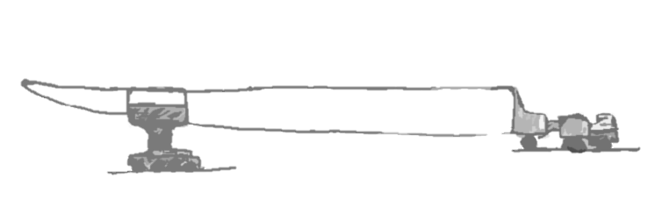
Tip end of blade Clamp on SPMT Casing (root end) on Tractor/SPMT

Illustration of blade support positions during transport
Considering the end position of the blade at Queen Victoria Square, it maybe that the blade will be transported “root” first until the Lowgate/Alfred Gelder Street junction at which point the blade will travel in reverse (“tip” first) along
Alfred Gelder Street and Carr Lane until Queen Victoria Square. This will be determined by the detailed route survey and crane arrangements.
  - Affected Street Apparatus
A further detailed survey, including swept path analysis, will be undertaken to identify all affected street apparatus between Alexandra Docks and Queen Victoria Square.
All affected street furniture will be visited at least 4 weeks prior to the installation date and a schedule of advanced highway works (pre-installation activities) prepared. This will include identifying ‘cast in concrete’ columns/poles that can be re-installed into NAL type sockets (“socketed”) for easier removal and replacement.
It is proposed that a Contractor is appointed to undertake the “pre-installation activities” and that these works are undertaken at least two weeks prior to the installation date. This is reflected in the project programme.
On the day of the installation, street apparatus will be temporarily removed immediately before the blade passes and reinstalled immediately after the blade passing. This operation will be prioritised for traffic and regulatory information (including signs and traffic signals).
Ideally, the same labour gangs should be used for the pre-installation activities and for the removal/re-installation of street apparatus on the day the blade is transported.
In the absence of a detailed route survey, an allowance has been made in the cost estimate for the removal and reinstatement of street apparatus (see Section 9). The budgeted amount will require review following the detailed route survey.

- Installation
  - Supports
A visit has been made to Siemens’ production facility in Alborg and further technical information has been made available by Siemens to identify how the blade is to be supported.
The current proposal is to pre-fabricate steelwork structures to hold the blade at its “root” end and also part-way along the length of the blade. These structures can be fabricated off site and then brought so site and bolted together on the date of the installation.
It is proposed that the supports simply sit on the surface of the public realm. The supports will have sufficient mass to resist the wind loads applied to them. These loads will be spread over the surface of the public realm so that the loading is less than a HGV wheel-load (the criteria that has been used for the design of the pavement).
It is intended that the standard fixings used by Siemens to hold down the blade will be used to connect the blade to the supports. In addition a strap will be placed over the tip end of the blade to provide an additional level of security should the clamp start to loosen.
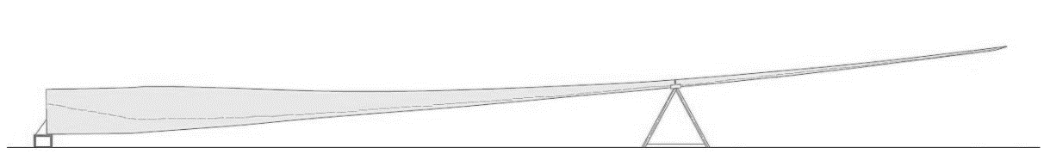
Root support Tip Support

Illustration of Proposed Installation at Queen Victoria Square

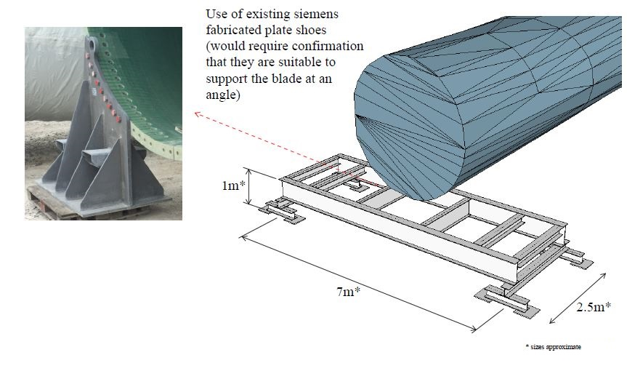Illustration of Root Support
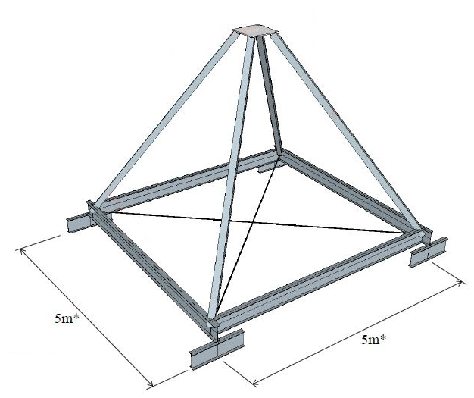
Illustration of Tip Support (Blade Clamp Omitted)
  - Mock Up
It is proposed that the supports are delivered to Siemens’ yard in Alexandra Dock to enable a “mock up” of the installation to be undertaken. This “mock up” process will involve locating the supports in position, craning the blade into position and bolting it down. The blade can then be removed and supported to ground level.
This mock up process will provide a valuable opportunity to check that the blade is supported correctly and to make any modifications to the supports if these are required. It will also give the installation teams a chance to practice the operation and get a better idea of time requirements etc.
  - Headroom Clearances
Arup’s drawing 249697-SK-001 shows the plan position of the blade in Queen Victoria Square and highlights the areas below the blade that have less than 2.3m clearance from ground level (for pedestrians and cyclists) and also areas with less than 5.5m clearance (for vehicles).
Benches will be positioned below the blade where a 2.3m headroom clearance cannot be achieved. The position of the benches should be such that it prevents people from bumping into the blade and directs blind/partially sighted people around.
- Operation
Safety and security during the operational phase of the project will be of paramount importance. The operational phase of the project is considered to be the duration of the blade in Queen Victoria Square.
  - Security Presence
The propensity for human interaction with the blade and the accessibility of the blade to the public has raised a number of risk items (see Risk Register/Section 10). This includes people climbing onto the blade, graffiti and vandalism.
It is anticipated that initially a 24 hour, 7 days a week security presence will be required. Security personnel on site will interface with Hull City Council wardens and emergency services (as required).
Queen Victoria Square is monitored by Hull City Council via CCTV cameras and this operation will also help to detect problems.
Security requirements should be reviewed on a weekly basis by Hull 2017, Hull City Council, Security personnel and representatives from the emergency services. Safety and security risks, i.e. vandalism, may reduce over time and there may be scope to reduce security presence on site whilst still being supported by wardens and CCTV coverage.
  - Secure Design
To help prevent vandalism and personal injury (through attempts to climb onto the blade), the following will be considered as part of the detailed design and implemented during the operational phase:
- Restricted access to blade supports – a “clam shell” arrangement around the blade support is being considered to prevent members of the public climbing onto the structure.
- Benches will be positioned below the blade where a 2.3m headroom clearance cannot be achieved.
- Anti-climb paint will be applied to supports (where appropriate).
- Display of information boards (with relevant contact telephone numbers), signs informing the public of surveillance and orders not to climb will be positioned around the blade.
  - Maintenance
A maintenance regime for cleaning, repairing and repainting the blade and supports will be established for the entire duration of the operational phase. The maintenance strategy will be developed during detailed design stage.

- Programme
  - Overall Programme
A programme for the project is included in Appendix C. This identifies the overall duration of the scheme including design, approval and procurement activities.
The activities relating to design of the supports, procurement and fabrication of the supports, and mock up sit on the critical path. A delay to these activities potentially impacts on the opportunity to undertake a mock up and identify potential problems prior to installation at Queen Victoria Square.
In order to achieve the programme, a decision to proceed should be made by 26th August 2016 followed immediately by signing of agreements/contracts and commissioning of the detailed design for the supports.
The programme allows a day for a mock installation in Siemens’ factory yard at the beginning of December 2016 followed by a lessons learnt meeting. This allows two weeks for any adjustments to be made to the supporting structures prior to installation in Queen Victoria Square.
The programme also allows 8 working days for pre-installation activities in December 2016. Pre-installation activities includes transferring anchored/‘cast in concrete’ street apparatus into NAL type sockets or bolted arrangements to help expedite removal/reinstallation of street apparatus during the transport of the blade.
  - Detailed Installation Programme
A detailed programme will need to be developed for the day of installation (and also removal) so that all activities are coordinated efficiently and safely. For the purposes of this feasibility study, the following timeline is proposed.

Table 8.1: Initial detailed programme for installation
Date / Time | Activity
Friday 30th December 2016
11.00 | Meeting with key project members to review following:  - Completion of preparation works  - Detailed Installation programme  - Risk Register
13.00 | - Team building meeting with all persons involved. Remind them of roles & responsibilities
Sunday 1st January 2017
6.00 | - Meet at Siemens Yard.  - Health and Safety Induction
6.30 | - Load steel supports onto lorries – transport to site  - Cranes into position in Queen Victoria Square  - Gangs start to remove street-furniture
7.30 | - Blade leaves Siemens Yard under police escort  - Steel supports lifted into position and bolted together
8.30 (approx.) | - Blade leaves A63 (Highways England property)  - Gangs start to replace street furniture
10.00 | - Blade arrives in Queen Victoria Square
11.00 | - Blade lifted into position
12.00 | - Blade securing in position  - Safety checks
13.00 | - Cranes demobilised & removed from site  - Clean Up
14.00 | - Hand-over

- Cost Estimate
  - Approach
This is a unique project and therefore reference rates and costs are not available. A “bottom up” approach has therefore been used to establish the cost estimate for this Feasibility Study.
It is recommended that this cost estimate is revisited as the project progresses and more accurate costing information becomes available as the design of the supports is developed and discussions with streetworks contractors and others advance.
The cost estimate is split into six sub-headings as follows:
- Transportation – estimated costs to remove and reinstall street furniture in order to transport the blade between Queen Alexandra Docks to Hull city centre. The proposed transport route has been walked and an initial assessment made of the requirements to remove and relocate street furniture. To reduce risk an “enabling” contract is envisaged to place street furniture into sockets to facilitate removal and reinstallation on the day of the move. Costs have been estimated on the basis of providing 4 gangs of labour plus support plant to undertake the installation operation. Additional sums have been allowed for security, Police attendance and temporary traffic management.
- Installation – costs for manufacture of the supporting structure including provisional sum allowances for security and pedestrian control and adjustment to lighting apparatus.
- Event Costs – Provisional sum allowed for a launch event.
- Maintenance – allowances for cleaning, repainting, security and reactive maintenance.
- Removal – The removal costs are very similar to the initial transportation costs as the operation to remove and replace street furniture to transport the blade between Hull city centre and Queen Alexandra Docks is very similar.
- Management and Consultancy – A provision sum is included to allow for project and commercial management, structure design, Health and Safety, and Planning. The sum excludes for local authority fees (including planning fees).
It is noted that the capital cost of the blade is excluded from the cost estimate. ALE’s technical input and transportation costs, storage and trial erection, and craneage (via subcontractor) form part of the Siemens offer and has also been also excluded from this estimate.
The cost estimate is contained in Appendix D along with the scope and assumptions applied.
  - Summary of Cost Estimate
A summary of the cost estimate, broken down by the sub-headings referred to in Section 9.1, is provided in Table 9.1. Please note that the values shown are exclusive of VAT.
Table 9.1: Summary of Cost Estimate
Description | Estimated Cost
Transportation | £188,900.00
Installation | £115,500.00
Event Costs | £10,000.00
Maintenance | £75,790.00
Removal | £69,100.00
Management and Consultancy | £70,000.00
Contingency | £26,464.50
Total | £555,754.50

- Risk Register
  - Approach
A Risk Register has been prepared to identify the key risks, impact, risk rating, mitigation measure(s) and current risk owner and a copy of the Risk Register is contained in Appendix E. The project team has input to the Risk Register at a workshop held on 23rd June 2016.
The Risk Register will require reviewing by the project team/board throughout the subsequent stages of the project. As part of the review, the project board will be responsible for setting/reviewing contingency allowances against the risk items and ensure that an appropriate overall contingency amount is allowed for.
The following project stages are suggested for a review of the Risk Register:
- Prior to submission of Planning application/permit.
- Award of Planning Consent
- Completion of detailed design.
- Tender document review (prior to commencing tender process).
- Construction contract signing.
- Following trial assembly (at Siemens site).
- Prior to transport/installation of blade in Hull city centre.
- Following installation.
- Prior to removal of blade from Hull city centre.
The number of project stakeholders is expected to increase as the project progresses and therefore it is imperative to undertake further reviews to capture the potential risks as seen by all stakeholders.
Currently, the risks identified have been allocated to a current member of the project team. It may be that some of these risks can be re-allocated to another party (i.e. to a Contractor) but this can only be considered once the risks are well defined and the other party is in the best position to manage the potential consequences of the risk occurring.
Formal risk management procedures should be implemented during the next stage of the project and continued through to the end of the project. A Risk Manager should be identified who will apply the following procedures to mitigate/control the risks:
- Risk Management Workshops
- Costing of the Risk Register
- Reviews with Risk Owners
  - Summary of Risk Register
In the following table, key project risks (red and orange category risks scoring over 9 – see Appendix E) have been identified together with the proposed strategy to manage the risks. A more detailed risk register is included in Appendix E.
Table 10.1: Summary of Key Project Risks
Risk | Mitigation Action | Risk Allocation (Owner)
Delay to Queen Victoria Square Public Realm Works | Engage with Public Realm works Contractor and monitor programme to ensure completion of works. Propose "Plan B" location for the Blade with reduced risk of conflict. | Hull 2017
Public interfere with blade during installation/removal | Recruit wardens (or similar) to help manage public. Use fencing / barriers to clearly cordon on working area & remove public. Do not advertise installation/removal process. Installation / removal to occur during quiet periods (e.g. early Sunday morning) | Hull 2017
Damage to Public Realm | Ensure that loading on surface is less that design loading (i.e. spread loads from cranes, supports etc.). Place protection materials (geotextiles, timbers etc.) between foundation pads & new surface. Undertake photographic survey before and after installation, Repair damage following removal of blade and supports. | Hull 2017
Budget exceeded | Develop a cost plan and update it at regular intervals. Include a contingency allowance to cover uncertainty in pricing | Hull 2017
Political objectors | Set out an Engagement Plan to inform political leaders of project and gather support. Implement in good time so that there are few surprises | Hull 2017
Planning consent is not granted | Engage with planners at early stage to understand and address potential issues. Engage with Chair of Planning Committee. | Hull 2017
Fire | Provide security presence to deter vandals & use CCTV to monitor. Engage with Fire Service to assess risk. Consider use of specialist intumescent paints in areas accessible by people. | Hull 2017
People collision with blade | Install physical barrier (e.g. a bench) to prevent people walking under lowest part of blade (i.e. where headroom is <2.3m | Hull 2017
High winds during installation & removal | In Method Statement identify safe wind speeds for transport and lifting operations. Monitor weather forecasts. Check wind speeds on day. Be prepared to delay transport movements if too windy | ALE
Planning consent delayed | Engage with all statutory consultees as part of the pre-application process. Undertake pre-application consultation to solicit views and, in application, demonstrate how these views have been taken into account. | Hull 2017
Legal Enforcement Action | Engage with Planners to agree strategy. Engage with Chair of Committee & gain political support. Submit planning application towards end of 28 day period | Hull 2017
Temporary Planning Consent | Engage with Planners. Plan to submit full planning application. Be prepared to manage PR around potential enforcement action | Hull 2017
Surprise element | Engage with planners to see if temporary planning route would be acceptable. Carefully control information (particularly visual information) about the sculpture and who it’s sent to. | Hull 2017
New Year's Eve | Address issue with workforce in team briefing before installation. Use breathalyser to check for alcohol. Ensure sufficient resources are employed to cover for risk that an employee may not turn up and to help manage public | Hull 2017
Climbing | Install "No climbing" sign. Provide physical security presence as deterrent. Use CCTV cameras to monitor activity around blade. Install anti-climb paint on supports. Use "clam shell" concept to close up supports and create physical barrier during "closed periods" (e.g. night-time) | Hull 2017
Straps securing blade | Implement checking regime to check that blade is held firmly - e.g. taughtness of straps and tension in bolts. Tighten if necessary | Hull 2017

- Next Steps
  - Actions
Subject to a decision to proceed, the following actions will need to be undertaken within the first month (August):
- Hull 2017 to confirm whether to proceed with the project
- Siemens to confirm if blade will be made in Hull.
- Presentation to Council Leader.
- Sign Loan and sponsorship agreement(s) – Hull 2017 & Siemens.
- Arrange insurances and warranties.
- Hull 2017 to appoint Consultants (PM, Structural Engineer, CDM).
- Progress detailed design of supports.
- Prepare to commence procurement process for supports.
- Siemens to appoint specialist transporters (ALE).
- Discussions with the Events team.
- Informal meeting with Planner(s).
- Establish Communications Plan.
  - Roles and Responsibilities
The following table (Table 11.1) sets out the anticipated project team needed to deliver the project.
Table 11.1: Anticipated Project Team Roles
Role | Potential Scope | Organisation
Project Sponsor | Responsible for the overall delivery and funding of the project. Ensuring that the work is governed effectively and delivers the objectives that meet identified needs. | Hull 2017 & Siemens
Client Project team | Appoint the project delivery team, arrange insurances/indemnity, prepare the Communication Plan, key stakeholder engagement. | Hull 2017
Blade supplier | Temporary loan of a blade (and storage supports) for the art installation. | Siemens
Transport (including craneage) | Specialist transporter and logistics planning. Obtain all relevant licenses/permits for transport of blade. | ALE
Artist |  | Nayan Kulkarni
Curator |  | Andrew Knight
Public Relations | Input into the Communication Plan. Pre and post-installation public and stakeholder engagement in accordance with the Communication Plan. | To be arranged
Video Maker |  | To be arranged
Project Manager | Manage and monitor the project against programme, cost and risk management. | To be arranged
Cost Control | Prepare a project Cost Plan and monitor costs against plan. | To be arranged
Structural Engineer | Detailed design of blade supports. | To be arranged
Planning Agent | Planning advice. Pre-application discussions with Planning Authority. Preparation and submission of planning application, and post-application discussions in order to secure Planning consent. | To be arranged
Principal Designer (CDM) | Plan, manage, monitor and coordinate Health and Safety in the pre-construction phase. Liaison with the Principal Contractor, keeping them informed of any risks that need to be controlled during the construction phase. | To be arranged
Security (during operation) | Work jointly with the Client Project Team to prepare a Surveillance and Security Plan. Security presence at Queen Victoria Square for the entire duration of the operation phase. | To be arranged
Maintenance (during operation) | Input into a maintenance plan. Cleaning, repairing and repainting of the blade and supports. | To be arranged
Highway works team (Street Furniture Contractor) | Street apparatus alterations – including pre-installation activities and works required during blade alterations. | To be arranged
Crowd Control | Crowd control on route during delivery/removal of the blade and at Queen Victoria Square during installation. | To be arranged
Police Escort | Police escort during delivery and removal of the blade. | Humberside Police
Supports Fabricator | Fabrication and supply of supporting structures. | To be arranged

Preferred and Alternative Installation Arrangements

Preferred Access Route

Programme

Cost Estimate

Risk Register

