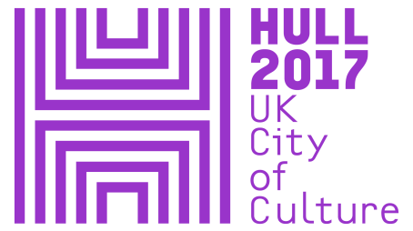
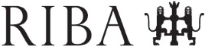

ROYAL INSTITUTE OF BRITISH ARCHITECTS PRESS RELEASE

For immediate release: 1 August 2017

RIBA and Hull 2017 put architecture centre stage in City of Culture year

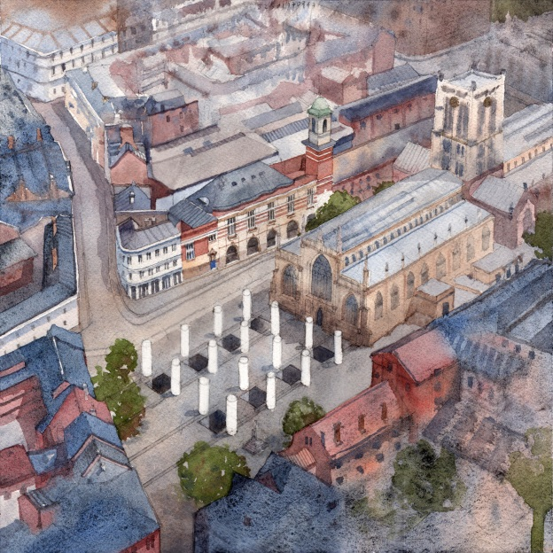
Pezo von Ellrichshausen, Hull pavilion, Hull, UK, 2017

The Royal Institute of British Architects (RIBA) and Hull UK City of Culture 2017 have jointly commissioned Chile-based architects Pezo von Ellrichshausen and Swiss artist Felice Varini to design an ambitious temporary outdoor structure in response to the historic heart of Hull.

A Hall for Hull is part of the Hull 2017 'Look Up' programme of public art installations and will transform Trinity Square with sixteen galvanized steel columns arranged in a grid formation in front of Hull Minister to highlight the symmetry of its facade. Visitors to the installation will be able to inhabit each of the six-metre-high columns and experience varying light conditions created by perforations in the steel skin. The rigid geometry of the columns will be carefully distorted and redefined by the artwork of Varini, challenging perceptions of perspective and scale in this particular public setting.

The project, supported by the British Council, has been developed through an invited competition for an architectural and artistic collaboration, with a brief to create a temporary intervention designed specifically for the square. Hull 2017 and RIBA have been working closely with Hull Minster to develop the project. The built structure will launch on 1 October 2017, as part of the fourth season of Hull's City of Culture year, entitled 'Tell the World'.

Marie Bak Mortensen, RIBA Head of Exhibitions, said: “Pezo von Ellrichshausen and Felice Varini have developed an exceptional proposal; one where Varini’s abstracted art applied to architectural space aligns with Pezo von Ellrichshausen’s practice of monumental architecture - carefully considered to the scale of Hull Minster and its surrounding square. Visual and physical contradictions merge as visitors to Trinity Square will be met by imposing, static steel columns that are open to the sky and whose perforations create as feeling of lightness. Adding Varini’s illusionist artwork that beguiles the viewer, A Hall for Hull effortlessly fulfils the commission’s aim to push the boundaries of how we observe art, architecture and public spaces and to facilitate unique experiences for residents and newcomers to the city. I look forward to seeing this installation unfold in-situ as RIBA takes its programme outside its dedicated gallery spaces in London and Liverpool.”

Pezo von Ellrichshausen and Felice Varini were chosen from a pool of eighteen outstanding, emerging and established architects practising in the UK and internationally. Trinity Square has benefited from Hull City Council's £25 million public realm improvements programme. This latest transformation will build on the drive to bring new life to this historic part of the city.

Sam Hunt, Executive Producer, Hull 2017, said: "The Hull 2017 Look Up programme is about making people see and experience this amazing city in new and exciting ways. A Hall for Hull will certainly do that, creating a new way of looking at and crossing Trinity Square and observing Hull Minster. It is helping kick off our fourth season and we hope that it will encourage even more people, both residents and visitors, to head to this key destination in the heart of the city."

The selected co-commission, sponsored by Wedge Galvanising, is intended to offer new and memorable experiences that capture the excitement in Hull during 2017. ‘A Hall for Hull’ is part of ‘Look Up’, a Hull 2017 curated programme of temporary installations in public places and spaces around the city.

The final design was selected by a panel of experts which included:
- Marie Bak Mortensen, Head of Exhibitions, RIBA
- Paul Holloway, Arts and Events Manager, Hull City Council
- Sam Jacob, Architect and Owner, Sam Jacob Studio
- Sarah Mann, Director, Architecture Design Fashion, British Council
- Jane Owen, Operations Manager, Holy Trinity Church
- Sarah Weir, Executive Director, Design Council
- Sam Wilkinson, 'Look Up' Hull 2017
ENDS

Notes to editors:

For further information & images, please contact Nicola Osmond-Evans in the RIBA press office: nicola.osmond-evans@riba.org; 020 7307 3813 or visit www.architecture.com
For information about Hull 2017, please contact Ben McKnight: ben.mcknight@hull2017.co.uk / 007718 100 793.

- The Royal Institute of British Architects (RIBA) is a global professional membership body that serves its members and society in order to deliver better buildings and places, stronger communities and a sustainable environment. www.architecture.com
Follow @RIBA on Twitter for regular updates www.twitter.com/RIBA
- Hull UK City of Culture 2017 is a 365 day programme of cultural events and creativity inspired by the city and told to the world. Hull secured the title of UK City of Culture 2017 in November 2013. It is only the second city to hold the title and the first in England. Divided into four seasons, this nationally significant event draws on the distinctive spirit of the city and the artists, writers, directors, musicians, revolutionaries and thinkers that have made such a significant contribution to the development of art and ideas. The Culture Company was set up to deliver the Hull 2017 programme and is an independent organisation with charitable status. It has raised £32 million, with over 70 partners supporting the project, including public bodies, trusts and foundations and local and national businesses. Key contributions are coming from: Host City – Hull City Council; Principal Partners - Arts Council England, BBC, Big Lottery Fund, East Riding of Yorkshire Council, Heritage Lottery Fund, KCOM, KWL, Spirit of 2012, Yorkshire Water and the University of Hull; Major Partners –Associated British Ports, Arco, BP, the British Council, British Film Institute, Green Port Hull, Hull Clinical Commissioning Group, MKM Building Supplies, P&O Ferries, Paul Hamlyn Foundation, Sewell Group, Siemens, Smith & Nephew and Wykeland Group. The National Lottery has contributed more than £10m of this funding, making it the largest single funding body for Hull 2017. For information go to www.hull2017.co.uk Follow us on Twitter @2017Hull Instagram @2017hull Facebook HullCityofCulture
- Wedge Group Galvanizing - With nearly 150 years of history Wedge Group Galvanizing is the UK's largest hot dip galvanizing organisation. They have 14 plants around the UK which are designed and equipped to set industry leading standards for sustainability and low environmental impact. Wedge has demonstrable experience in working with architects and artists including Antony Gormley and Chris Brammall.
- The British Council is the UK’s international organisation for cultural relations and educational opportunities. We create friendly knowledge and understanding between the people of the UK and other countries. Using the UK’s cultural resources we make a positive contribution to the countries we work with – changing lives by creating opportunities, building connections and engendering trust. We work with over 100 countries across the world in the fields of arts and culture, English language, education and civil society. Each year we reach over 20 million people face-to-face and more than 500 million people online, via broadcasts and publications. Founded in 1934, we are a UK charity governed by Royal Charter and a UK public body. The majority of our income is raised delivering a range of projects and contracts in English teaching and examinations, education and development contracts and from partnerships with public and private organisations. Eighteen per cent of our funding is received from the UK government. The British Council’s Architecture Design Fashion (ADF) department creates links between designers and cultural institutions around the world, through a diverse range of projects across the three disciplines. For further information about ADF at the British Council, please visit www.britishcouncil.org/design.
- Additional in-kind support has been granted by setWorks, a production and manufacturing company specialising in the realisation of bespoke objects and environments, and Constant Structural Engineering.
- Look Up is a year-long programme of major public art commissioned by Hull UK City of Culture 2017 and made for the Hull’s public spaces and places, co-curated by Andrew Knight and Hazel Colquhoun. Each installation will reflect Hull’s history, present or future, each will catch passers-by by surprise interrupting the public realm with ideas that amuse, confront or challenge residents and visitors alike. Other Look Up commissions include Nayan Kulkarni’s Blade, a 75 metre long Rotor blade Queen Victoria Square in January this year. The second which runs until the end of the year is Michael Pinsky's The City Speaks which functions as a 21st century Speakers Corner. During seasons two and three, Look Up has seen commissioned works popping up in shopping centres, train stations, car parks, streets and public squares, by artists including Bob & Roberta Smith, Tania Kovats, Chris Dobrowolski and Claire Barber. Look Up has been developed in partnership with a number of organisations and companies including The Deep, GF Smith, Hull School of Art & Design and Royal Institute of British Architects (RIBA).

