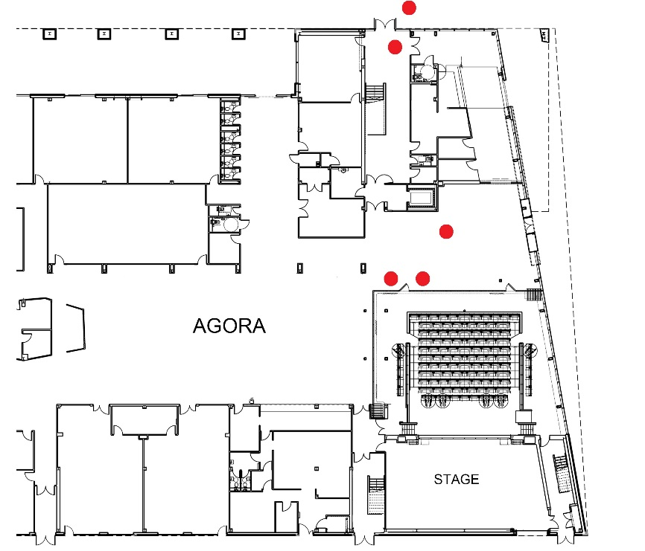Archbishop Sentamu: James Campbell & Yvette

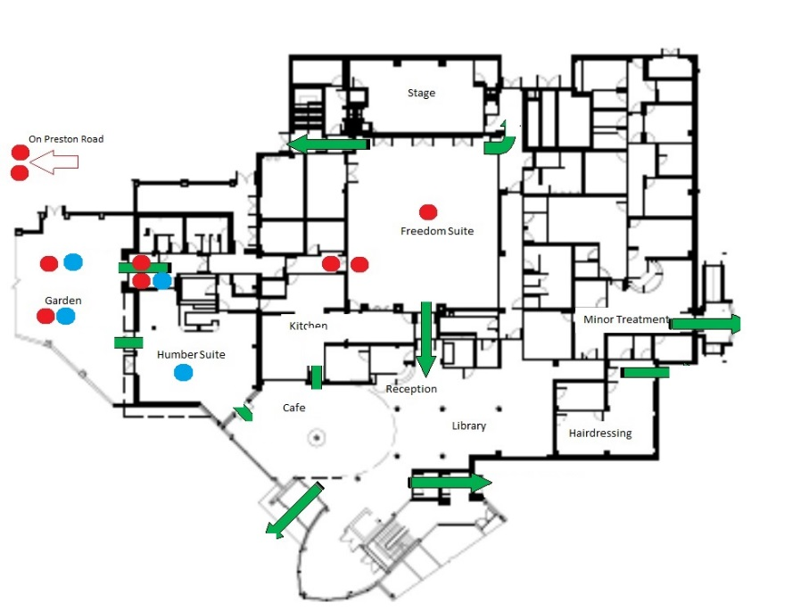Freedom Centre: Word on the Street, Band, Picture House & Picasso

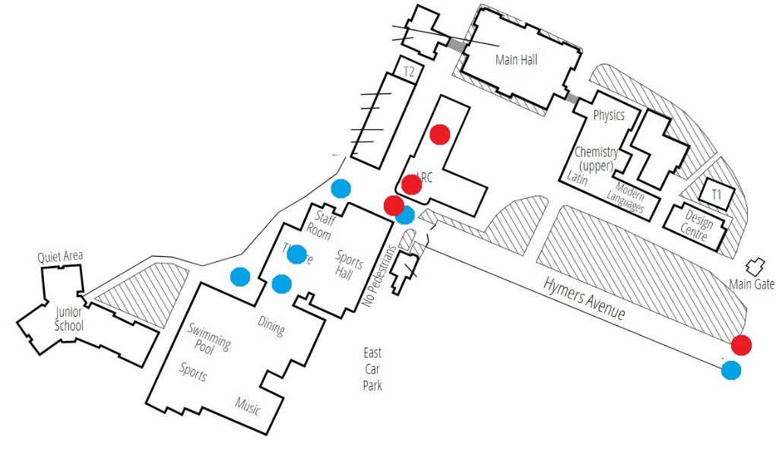Hymers College: Picture House, Yvette & Picasso

KINGSWOOD
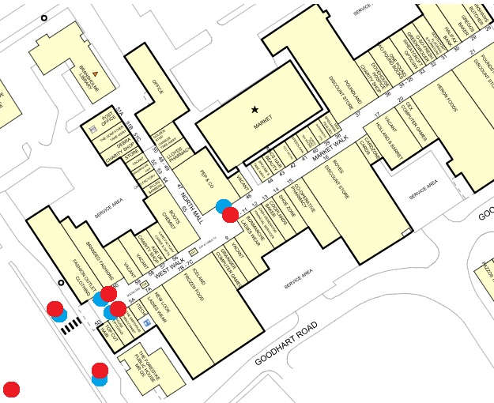North Point: Word on the Street & Band

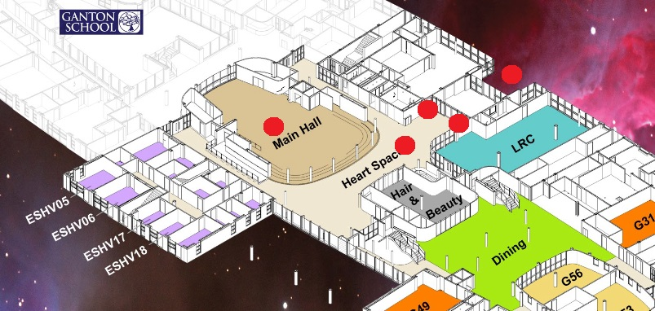Sirius Academy: James Campbell, Band, Tipping Point
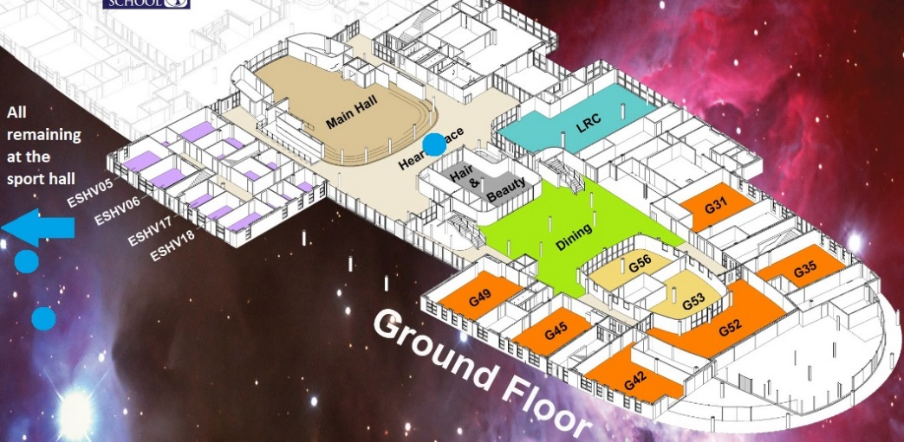

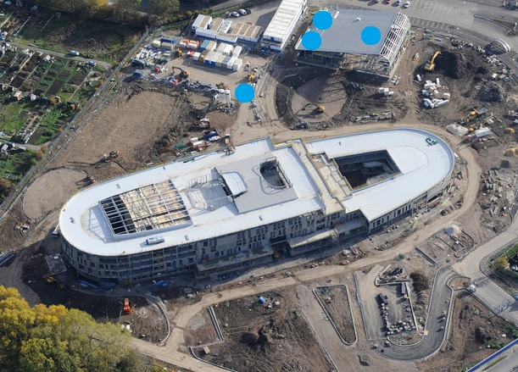
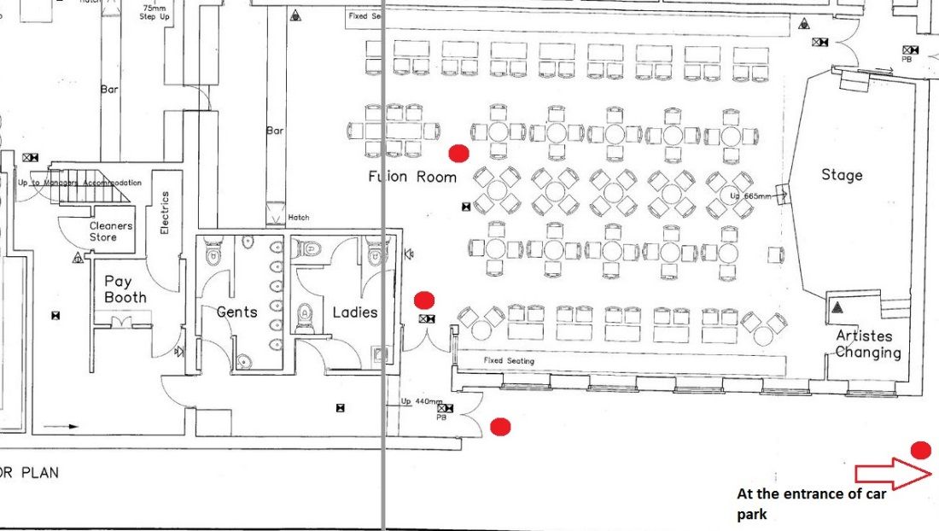The William Gemmell: Word on the Street

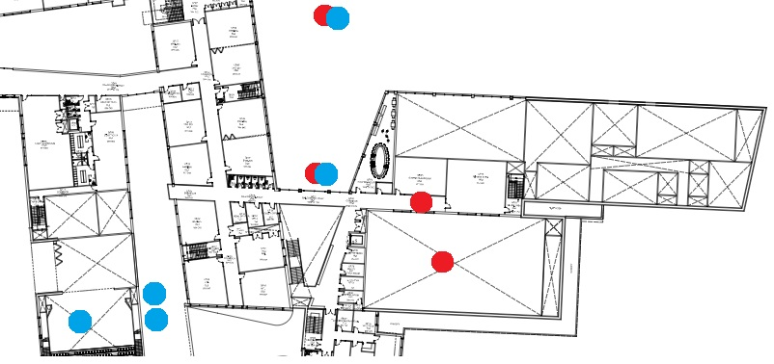Winifred Holtby Academy: Tipping Point, James Campbell & Picture House

