TATE LOGO
HULL 2017 LOGO
HULL CITY COUNCILLOGO
TURNER // RETURN

Copy about the event
RETURN // ART
Schedule of talks

Schedule of film screenings
With thanks to…
List of artists
List of artists
List of artists
List of artists
List of artists

TURNER
//
RETURN
BACK COVER
(A6)
4
INSIDE COVERS
(Double A6)
2 3
FRONT COVER
(A6)
1
4 on the back
1 on the back

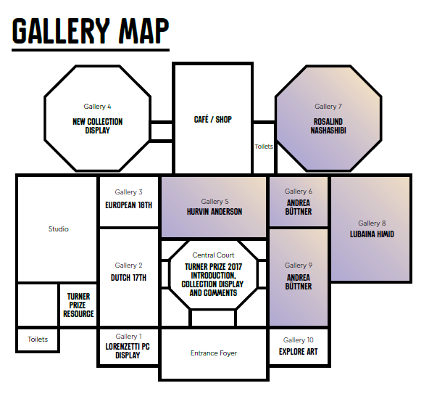
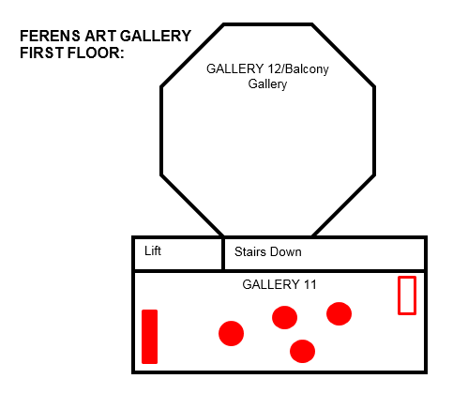
FULLY FOLDED OUT
(A4)
7) RETURN // EXCHANGE
8) RETURN // DECADENCE
Music listings:
Your guide to Turner // Return

1) RETURN // PRINT
2) RETURN // ART
3) RETURN // FEESTING
4) RETURN // FINE CUT
5) RETURN // DEBATE
6) RETURN // PERFORMANCE
6
8
7
5
1/4 on the back
2/3 on the back

