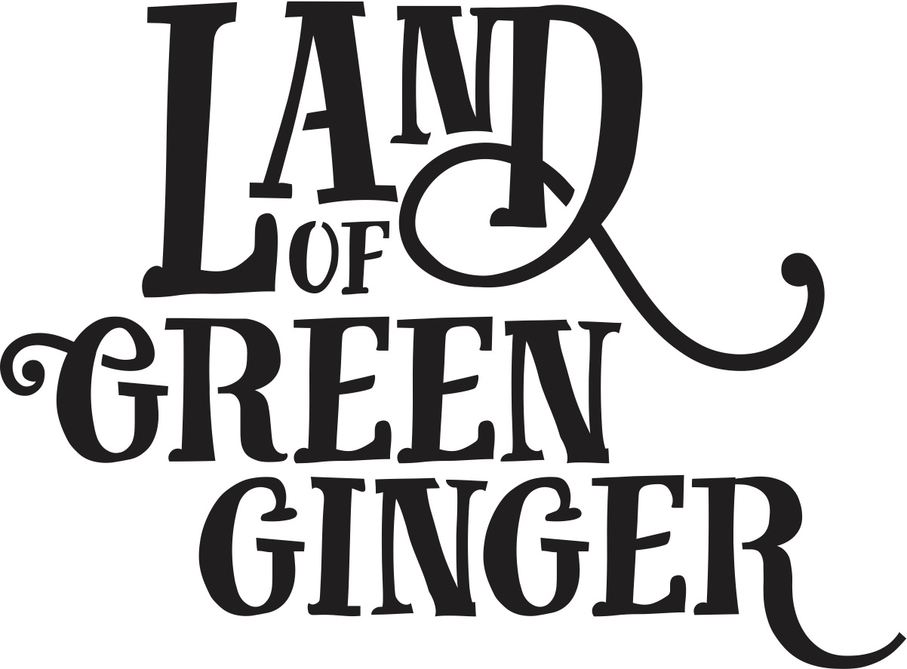

Call for Illustrator

Brief
Job Title: Illustrator
Reporting to: Producer
Fee: £6000-8000 to be negotiated
Contract type: Freelance
Contract length: We envisage the contract will be around 5 weeks in length.

Throughout the year Hull 2017’s ground-breaking community engagement project, Land of Green Ginger, invited Hull’s residents to immerse themselves in a magical citywide story, inspired by and celebrating the spirit of Hull.
Land of Green Ginger was presented as a series of Acts of Wanton Wonder delivered by artists in neighbourhoods outside of the city centre. The Acts were united under one story line, which was presented online for the public to delve into. A brief summary of the project can be found here.
In 2018, the Land of Green Ginger story will culminate in a seventh and final Act of Wanton Wonder – a beautiful book that will be gifted to Hull’s residents.
The Land of Green Ginger book will tell the stories of the project, the narrative as it took place, and the stories of the local people it touched. It will be the record of City of Culture as lived by the residents of the city and as informed by their imagination and creativity.
We are seeking a talented freelance illustrator to help us to interpret and tell the Land of Green Ginger story.
The book will be up to 60 pages long, and we would be interested in working with the illustrator to develop the presentation of illustrations included throughout. These could be a range of double page and single page spreads as well as half page and smaller complimentary illustrations.

Style
There once was a land that nobody believed existed.
And every day people passed by it or around it or over it or through it, but never once saw it or felt it or heard it or knew any person or thing in it.
Until, one day, the land revealed itself…
The above words will more than likely be included in the book and were the first words that were published before the project began.
Style Guide
Please find below examples of some of the marketing materials used throughout the project. This gives an indication of the style in which Land of Green Ginger was presented through the live projects. We are interested in a continuation of this style to a degree, but we are also keen that the book has its own distinctive style.
Season One Brochure
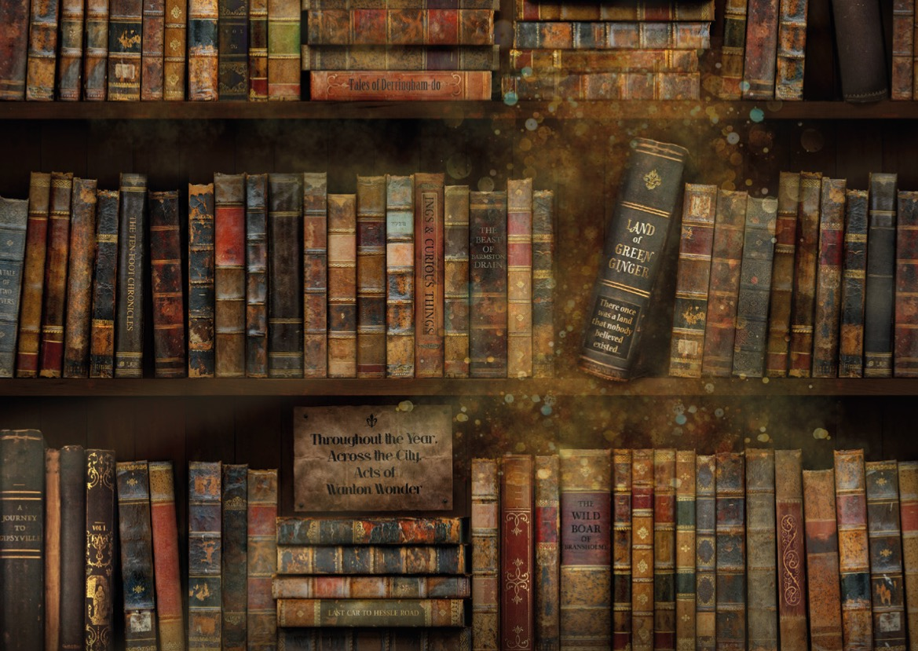

Season Two Brochure
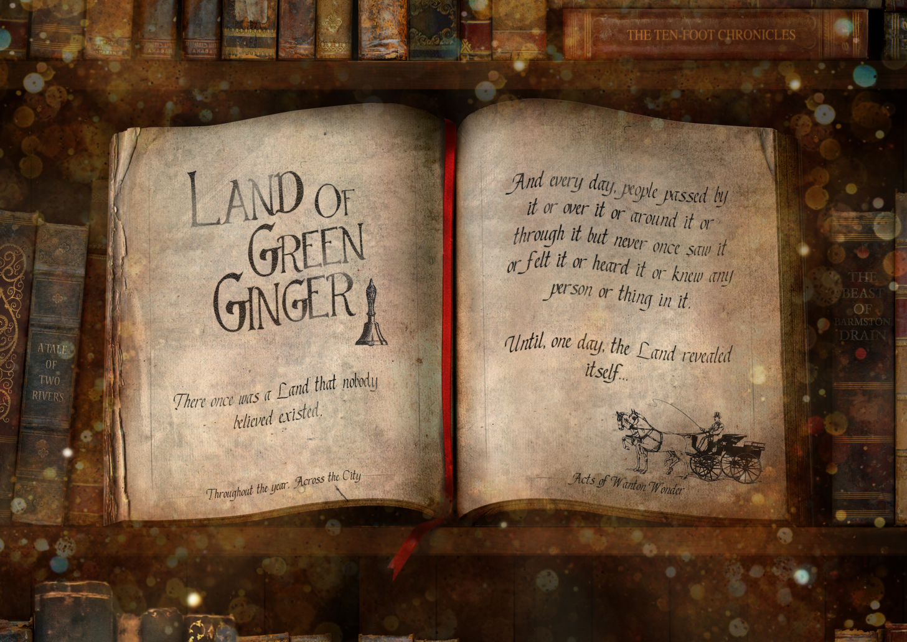
Season Four Brochure
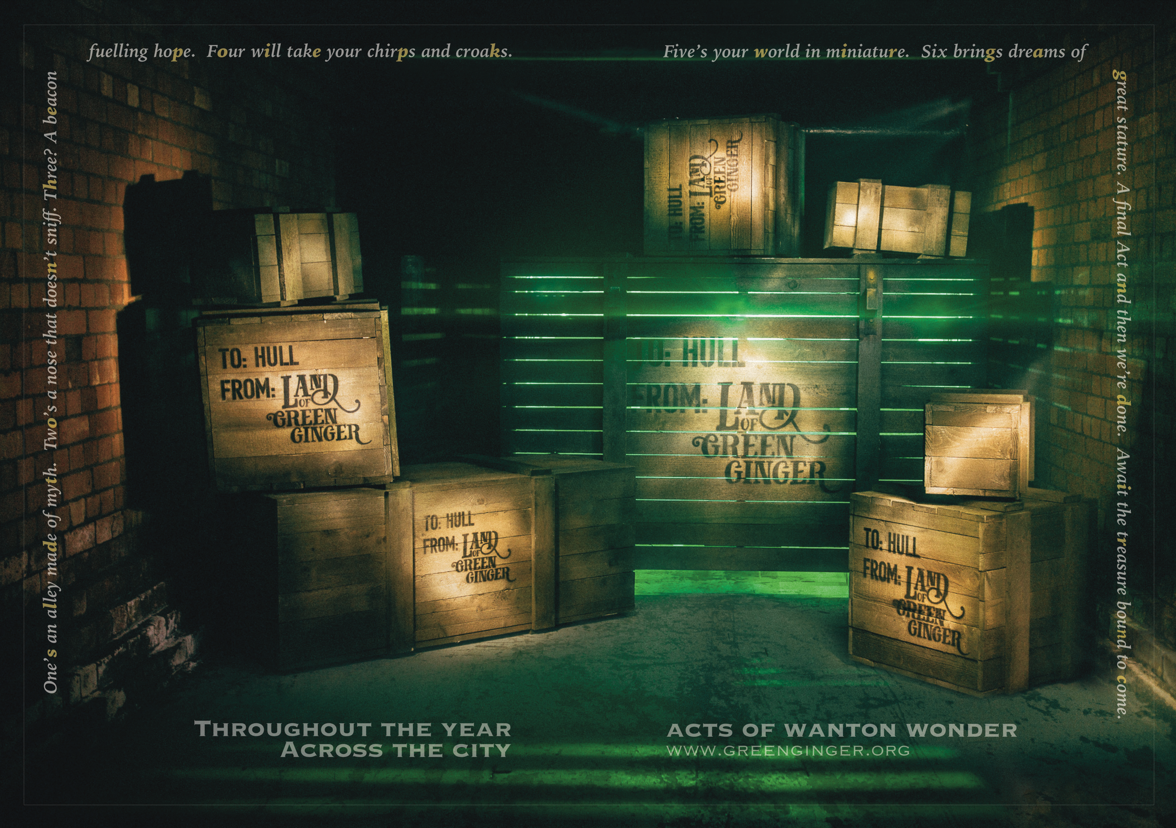

7 Alleys

Land of Green Ginger Unleashed
