PRSF NEW MUSIC BIENNIAL
HULL
29th JUNE to 2nd JULY 2017
ARTIST PACK
ARTIST: Emily Hall
ARTIST CONTACT (Mobile number): TBC – PROMOTER TO CONFIRM
VENUE: Mortimer Suite (Sharp)
Address: Hull City Hall, Queen Victoria Square, Carr Lane, Hull, Hu1 3RQ
Phone: DIRECT NO.???
LOADING IN FROM: Paragon Street (Green dot)
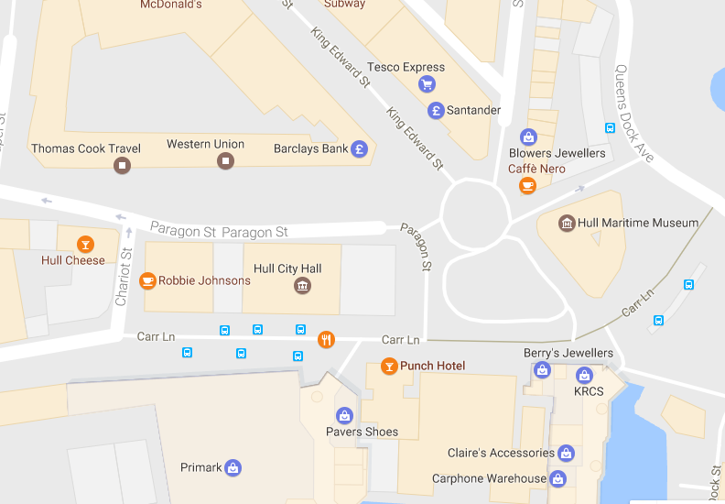

PARKING REQUIREMENT and LOCATION:
TBC – PROMOTER TO CONFIRM
PERSONNEL
STAGE MANAGER (Primary contact show weekend only): Danielle Harris - 07594 212377
PRODUCTION MANAGER: Gareth Hughes – 07733112272
PRODUCTION ASSISTANT: Joanna Morley – 07725 942808
VENUE CONTACT: Tony Evans (Technical)/Lorna (FOH)

DATE AND TIME OF PERFORMANCE: Saturday 1st July 15:00 (45mins)
PRODUCTION SCHEDULE:
FRIDAY 30 JUNE
06:00 - 00:00 (ACCESS) | 06:00 - 11:00 | Tech in - ALL
 | 09:00 | Piano delivery - Mortimer Suite - Sharpe
 |  | BOTH MORTIMERS AS DRESS ROOMS FOR BBC PHIL
 | 10:00 | Piano tuning - Mortimer
SATURDAY 1 JULY
08:00 - 00:00 (ACCESS) | 09:00 | Piano tuning - Mortimer
 | 09:00 - 11:00 | Branding and dressing - Mortimer Suite (Sharp)
 | 11:00 - 14:00 | Emily Hall - Artists arrive and rehearsal - Mortimer Suite (sharp)
 | 15:00 | DOORS - Mortimer Suite (sharp)
 | 15:15 - 16:00 | Emily Hall - PERFORMANCE
 | 16:30 - 21:00 | Reset tech for Mortimer Suite (sharp) - Gould Piano Trio
SUNDAY 2 JULY
08:00 - 20:00 (ACCESS) | 08:00 | Piano tuning - Mortimer Suite
 | 09:00 - 10:45 | Piano Trio rehearsal - Mortimer Suite (sharp)
 | 09:30 | Box office on site
 | 10:45 | DOORS - Mortimer Suite (sharp) - Mark Simpson
 | 11:00 - 11:45 | Mark Simpson PERFORMANCE
 | 14:00 - 20:00 | Derig and clear
MONDAY 3 JULY
 | AM | Materials back to storage
 | AM | Piano off site

TECHNICAL
Speech System
Basic PA System
1 Combined System Rack 1
2 L Acoustic MTD108A
1 Camco Vortex 6
2 Powerdrive 44BE Speaker Stand
2 13A To 16A Adapter
8 XLR Splitter
Microphones
2 Pulse Headset Microphone - Beige
2 Sennheiser EW512 G3 - Belt Pack System - Range GB
Staff
1 Engineer - Systems
RIDER:
TBC
BACKLINE:
ACCREDITATION
David & Alice Porter (Directors)
Steve & Sam Shaw (Directors)
Peter & Lorraine Boardman (Directors)
Wes Zepherin (Director)
Kirsty & Gary Halliday (Marketing)
Ben Pugh (Production)

