PRSF NEW MUSIC BIENNIAL
HULL
29th JUNE to 2nd JULY 2017
ARTIST PACK
ARTIST: Jason Singh and Anne Martin
ARTIST CONTACT (Mobile number): TBC – PROMOTER TO CONFIRM
VENUE: Mortimer Suite (Soft)
Address: Hull City Hall, Queen Victoria Square, Carr Lane, Hull, Hu1 3RQ
Phone: direct no??
LOADING IN FROM: Paragon Street (Pink Dot)
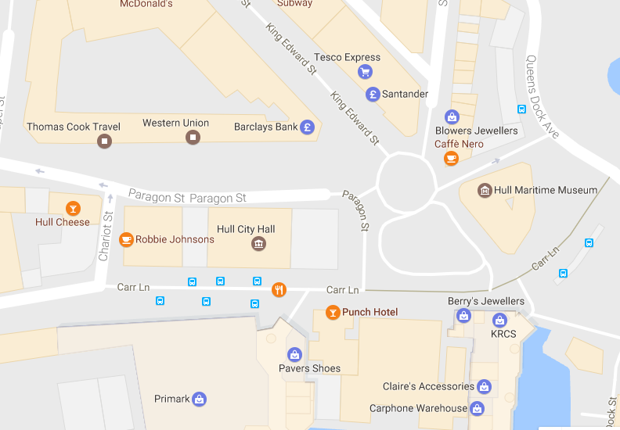

PARKING REQUIREMENT and LOCATION:
TBC – PROMOTER TO CONFIRM
PERSONNEL
STAGE MANAGER (Primary contact show weekend only): Danielle Harris - 07594 212377
PRODUCTION MANAGER: Gareth Hughes – 07733112272
PRODUCTION ASSISTANT: Joanna Morley – 07725 942808
VENUE CONTACT: Tony Evans (Technical)/Lorna (FOH)

DATE AND TIME OF PERFORMANCE: Sunday 2nd July 12:15 (45mins)
PRODUCTION SCHEDULE:
THURSDAY 29 JUNE
NO ACCESS TO MAIN HALL | AFTER PERFORMANCE 23:00 - 02:00 | Stage extension
STAGE EXT (23:00 - 02:00) | DAY | Set up dressing rooms
 | DAY | Dressing and branding
 | PM | OB truck into Paragon Street -
 | DAY | Volunteer briefing with Stage Manager
FRIDAY 30 JUNE
06:00 - 00:00 (ACCESS) | 06:00 - 11:00 | Tech in - ALL
 | 09:00 | Piano delivery - Mortimer Suite - Sharpe
 | 10:00 | Piano tuning - Mortimer
 |  | BOTH SUITES TO BE USED AS DRESSING ROOMS FOR BBC PHIL
 | AM | Materials from storage to Mortimer Suite
SATURDAY 1 JULY
08:00 - 00:00 (ACCESS) | 09:00 | Piano tuning - Mortimer and Main Hall
 | 16:00 - 19:00 | Tech set - Jason Singh
 | 19:00 - 21:00 | Jason Singh rehearsal - Mortimer Suite (soft)
 | 21:00 - 23:00 | Branding and dressing - Mortimer (soft)
SUNDAY 2 JULY
08:00 - 20:00 (ACCESS)
 | 12:00 | DOORS - Mortimer Suite (soft) - Jason Singh
 | 12:15 | Jason Singh - PERFORMANCE
 | 13:00 | FINISH
 | 14:00 - 20:00 | Derig and clear
MONDAY 3 JULY
 | AM | Materials back to storage
 | AM | Piano off site

TECHNICAL
Sound
FOH Control
1 Yamaha LS9-32
Speaker System
4 d&b C4-SUB Loudspeaker
2 d&b C4-TOP Loudspeaker
2 d&b P1200 Amplifier
1 EP5 Cabling
Monitor System
6 L Acoustic 108P
1 XLR & Powercon Package for 108P
Microphones
8 Behringer Ultra DI 100
1 AKG C451
4 Shure SM57
4 Shure SM58
1 Shure ULXP Beta58 Handheld Radio System - CH38
4 Microphone Stand - Short
4 Microphone Stand - Tall
Misc
1 Multicore System 3 - 24-way 75m
1 24-Way Veam Stagebox
1 16-Way Veam Returns Stagebox
Staff
1 Engineer - FOH
1 Local Crew
Lighting
Material
1 Avolites Titan One
1 Paradim Patch Rack Dimmer
6 Alu LED Par RGBW 18x 8W - 40deg
6 ETC Source Four Junior Zoom 25 - 50 Degree
4 Doughty Tank Trap
Staff
1 Engineer - FOH
RIDER:
TBC
BACKLINE:
ACCREDITATION
David & Alice Porter (Directors)
Steve & Sam Shaw (Directors)
Peter & Lorraine Boardman (Directors)
Wes Zepherin (Director)
Kirsty & Gary Halliday (Marketing)
Ben Pugh (Production)

