Sean McAllister – Creative Director

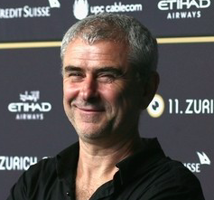
BAFTA nominated director Sean McAllister is known for his candid, frank films, depicting with extraordinary intimacy the lives of ordinary people who are struggling to survive but are survivors, caught up in political and personal conflict, struggling to make sense of the world we live in. From his early films Working For The Enemy (1997) and The Minders (1998), both nominated for a Royal Television Society Awards, to his more recent successes, Sundance Jury Prize-winning The Liberace Of Baghdad (2004), Japan: A Story Of Love And Hate (2008) and ‘The Reluctant Revolutionary‘, Sean’s work continues to inspire, to surprise and to fascinate audiences. His most recent film, Sheffield Jury Prize winning A Syrian Love Story (2015) was named The Guardian's #3 film of 2015, nominated for a BIFA, EFA, UK Critics Circle garnering McAllister a BAFTA nomination and the Cinema For Peace Justice Award.

Rupert Creed – Writer.
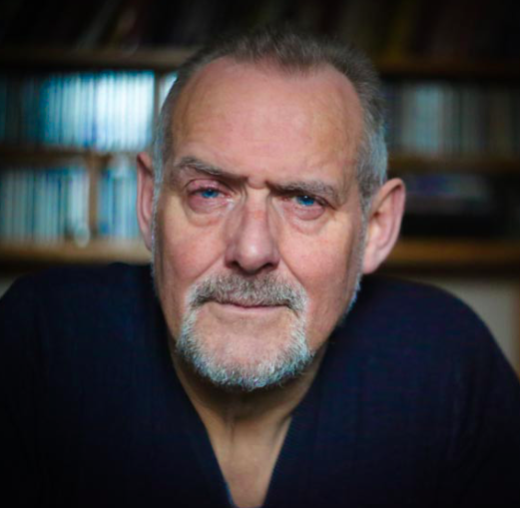
I traded Brighton for Hull when I moved here to do Drama and German at Hull University in 1974, and I’m one of those people who never left. Hull has been my adopted city now for over 40 years. I got a job with Hull Truck in the 70s joining the creative mayhem under founder director Mike Bradwell. Hull was a depressed city in those years but it was and is a great place to do your own thing- so I started Remould Theatre here in the 80s which ran for 16 years, producing documentary plays like ‘The Northern Trawl’ and the first large cast community plays in the city and region. I worked as Producer for the BBC in Hull on the community storytelling project ‘Telling Lives’, have written plays for Hull Truck, and direct their Act !!! theatre group. Hull is an amazing place for stories. There’s something special about the richness of its history and the openness of its people to share their experiences. ‘We Are Hull’ puts the city’s people centre stage in ways that we hope will surprise and inspire you, and make you feel proud to be part of and spend time in this gem of a city.

Durham Marenghi – Lighting Designer
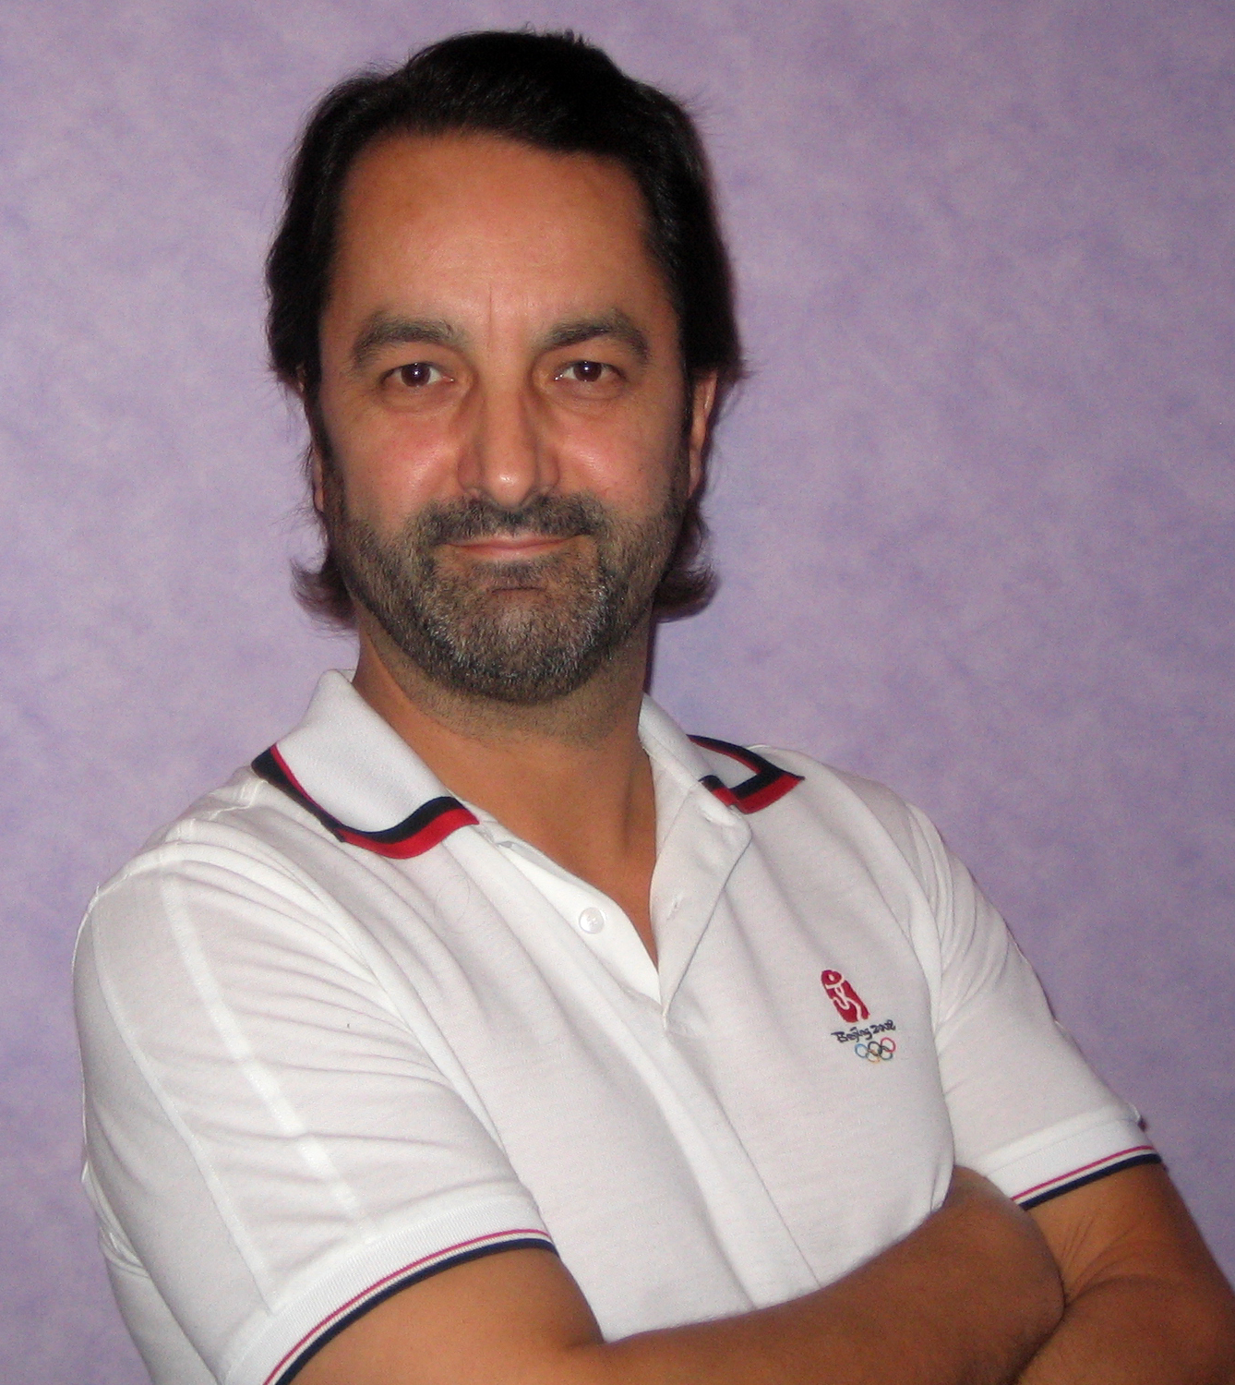

Durham Marenghi has designed the lighting for a wide variety of Theatre, Opera, Dance, Trade, Concert and Television Productions and is the first British lighting designer to have lit the Opening and Closing Ceremonies of an Olympic Games.
TELEVISION broadcasts include the critically acclaimed DIAMOND JUBILEE CONCERT in June 2012 and the QUEEN'S GOLDEN JUBILEE LIGHT AND FIREWORKS EXTRAVAGANZA in June 2002; the NEW YEAR'S EVE Light and Fireworks show from the LONDON EYE from 2004; the event lighting of THE WALL for Roger Waters in Berlin 1990, arguably the biggest rock show of that decade and The HONG KONG HANDOVER CEREMONY on June 30th,1997
Durham also lit the WINTER OLYMPICS OPENING and CLOSING CEREMONIES in Turin 2006; the LONDON 2012 OLYMPIC HANDOVER in Beijing 2008; the WINTER PARALYMPICS OPENING and CLOSING CEREMONIES in Sochi 2014 and most recently the SUMMER OLYMPIC OPENING and CLOSING CEREMONIES in Rio 2016.
To discover more about Durham’s work visit his website at www.durhamld.com

Dan Jones: Sound Designer.

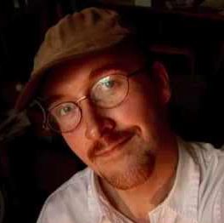

Dan Jones is a BAFTA and multi Ivor Novello winning film composer and theatre sound designer who as well as scoring film and television works regularly for the National Theatre and Royal Shakespeare Company. Recent work includes his score for the BBC’s critically-acclaimed Shakespearean epic The Hollow Crown starring Benedict Cumberbatch and working with Massive Attack on songs for their forthcoming album. His work as a film composer includes includes the Oscar-nominated Shadow of the Vampire, Max, The Tonto Woman (Oscar nomination for Best Short) and the BAFTA winning dramas Appropriate Adult, Any Human Heart and The Lost Honour of Christopher Jeffries as well as David Attenborough’s Life of Mammals. He composed and conducted the score for The Great North Run’s Millionth Opening ceremony and has written the music for the last two Paralympic Heritage Flame Events for Sochi and Rio. He regularly produces large outdoor artworks and audio installations including Music for Seven Ice Cream Vans and Sky Orchestra which creates a giant surround sound audio work from hot Air Balloons flying over cities. The piece opened the Sydney Festival in 2007 and launched the London Mayor’s count down to the 2012 Olympics. Last year he was commissioned to write an outdoor musical work to commemorate the 300th anniversary of Birmingham Cathedral. He is joint artistic director of Sound and Fury Theatre Company and co-directed their productions of War Music, Going Dark, Charlie Ward and Kursk, his sound design for which was awarded the first ever Special Jury Prize for Sound Design at the Prague Quadrennial.

Ala Lloyd – Production Designer

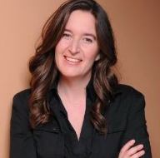
Ala is a Production Designer, and RIBA Chartered Architect. She has worked on a huge range of international creative productions and construction projects throughout her career. As founding Director of Lloyd Live Design she brings these experiences together to deliver a variety of complex and bespoke projects for live events. These include permanent entertainment structures, environments and artistic installations for indoor and outdoor theatre, TV, music tours and physical theatre.
She worked with Mark Fisher OBE, Will Alsop, Rem Koolhaas, and was Head of Design for London 2012 Ceremonies Ltd. She was honoured to be Creative Director of HRH 90: The Patron’s Lunch on the Mall, in London, June 2016. She is a member of the Society of British Theatre Designers, and has mentored and taught students and young professionals throughout her career, most recently at Backstage Academy, LS Live UK. She was nominated as Set Designer of the Year by Total Production in 2014 and 2015.

