PRSF NEW MUSIC BIENNIAL
HULL
29th JUNE to 2nd JULY 2017
ARTIST PACK
ARTIST: Ray Lee
ARTIST CONTACT (Mobile number): TBC – PROMOTER TO CONFIRM
James Ball - +44(0)7508 112 753
VENUE: Zebedee’s Yard
Address: Zebedee’s Yard, 23 Posterngate, Hull HU12JT
Phone:
LOADING IN FROM: Posterngate (orange dot)
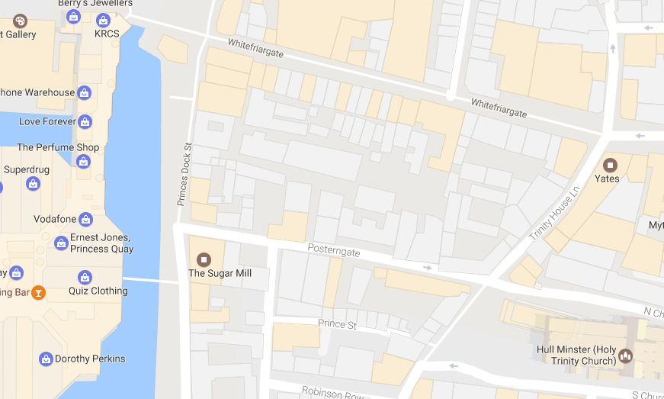

PARKING REQUIREMENT and LOCATION:
TBC – PROMOTER TO CONFIRM
PERSONNEL
STAGE MANAGER (Primary contact show weekend only):
PRODUCTION MANAGER: Gareth Hughes – 07733112272
PRODUCTION ASSISTANT: Joanna Morley – 07725 942808
VENUE CONTACT:
DATE AND TIME OF PERFORMANCE: Friday 30th June 11:00,16:00 and 22:00, Saturday 1st July 11:00. 16:00 and 22:00 and Sunday 2nd July 10:00 and 12:00 (all performances 45mins)
PRODUCTION SCHEDULE:
WEDNESDAY 28 JUNE
AM | Pick up keys from Mike (gates and green room) | GDH
07:00 | CAR PARK CLOSED | Trinity House
08:00:00 - 22:00 | Set up | Invisible Forces
22:30 | Isolate ambient lighting | GDH
THURSDAY 29 JUNE
12:00 | 12 rung Zarges dropped off | HPSS
DAY | 2x TV and media player set up - Greenroom | HPSS
12:00 - 16:00 | Crew call x6 | Music Consortium
16:00 - 20:00 | Crew call x2 | Music Consortium
20:00 - 23:00 | Lighting and sound test | Invisible Forces
23:00 - 00:00 | Lighting test only | Invisible Forces
23:00 - 10:30 | 2x SIA - over night security | Prestige
FRIDAY 30 JUNE
07:00 | CAR PARK CLOSED | Trinity House
10:30:00 - 23:00 | 2x sia 2x stewards - event security | Prestige
11:00 - 11:45 | PERFORMANCE - Ray Lee - Ring Out | Invisible Forces
16:00 - 16:45 | PERFORMANCE - Ray Lee - Ring Out | Invisible Forces
22:00 - 22:45 | PERFORMANCE - Ray Lee - Ring Out | Invisible Forces
23:00 - 08:00 | 2x sia - over night security | Prestige
SATURDAY 1 JULY
07:00 | CAR PARK CLOSED | Trinity House
10:30:00 - 23:00 | 2x sia 2x stewards - event security | Prestige
11:00 - 11:45 | PERFORMANCE - Ray Lee - Ring Out | Invisible Forces
16:00 - 16:45 | PERFORMANCE - Ray Lee - Ring Out | Invisible Forces
22:00 - 22:45 | PERFORMANCE - Ray Lee - Ring Out | Invisible Forces
23:00 - 08:00 | 2x sia - over night security | Prestige
SUNDAY 2 JULY
07:00 | CAR PARK CLOSED | Trinity House
10:00 - 10:45 | PERFORMANCE - Ray Lee - Ring Out | Invisible Forces
12:00 - 12:45 | PERFORMANCE - Ray Lee - Ring Out | Invisible Forces
14:00 - 20:00 | OUT | Invisible Forces
14:00 - 20:00 | Crew call x6 | Music Consortium
20:00 | CAR PARK OPEN | Trinity House

TECHNICAL
Material
1 Laptop
1 Samsung 55inch LCD Screen
1 Unicol K Stand Complete
RIDER:
TBC
BACKLINE:
N/A
ACCREDITATION
David & Alice Porter (Directors)
Steve & Sam Shaw (Directors)
Peter & Lorraine Boardman (Directors)
Wes Zepherin (Director)
Kirsty & Gary Halliday (Marketing)
Ben Pugh (Production)

