PRSF NEW MUSIC BIENNIAL
HULL
29th JUNE to 2nd JULY 2017
ARTIST PACK
ARTIST: Peter Edwards
ARTIST CONTACT (Mobile number): TBC – PROMOTER TO CONFIRM
Tour Manager – Dylan Bate - 07740844941
VENUE: Hull Minster
Address: Market Pl, Hull HU1 1RR, UK
Phone: +44 1482 224460

LOADING IN FROM: North Church side, (Purple P)
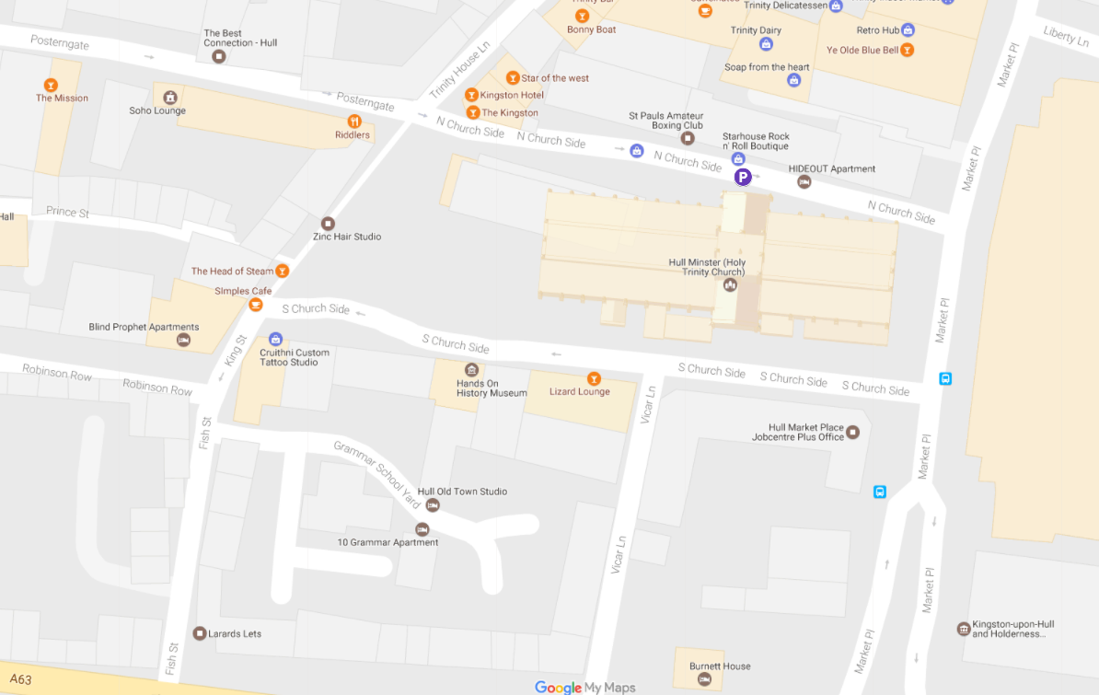
PARKING REQUIREMENT and LOCATION:
TBC – PROMOTER TO CONFIRM
PERSONNEL
STAGE MANAGER (Primary contact show weekend only): Ben Pugh - 07970 950552
PRODUCTION MANAGER: Gareth Hughes – 07733112272
PRODUCTION ASSISTANT: Joanna Morley – 07725 942808
VENUE CONTACT: Jane Owen

DATE AND TIME OF PERFORMANCE: Sunday 2nd July 16:15 (45min)
PRODUCTION SCHEDULE:
FRIDAY 30 JUNE
08:00 - 00:00 (ACCESS) | 09:00 - 16:00 | Sound in | HPSS
 | 13:00 - 20:00 | Daniel Elms - rehearsal | Dan Elms
 | 21:00 | Box office on site | David Watson
 | 21:45 | Doors | SM
 | 22:15 | Daniel Elms - PERFORMANCE | Dan Elms
 | 23:00 | Finish | SM
 | 00:00 | Cleared - SL/SR screens derigged | HPSS
SATURDAY 1 JULY
20:30 | Piano delivered | From Fruit
SUNDAY 2 JULY
08:00 - 00:00 (ACCESS) | 09:00 - 12:00 | Risers configured for Peter Edwards brass | HPSS
 | AM | Piano tuned | ???
 | 12:15 - 13:00 | Artists arrive - Peter Edwards | Peter Edwards
 | 13:00 - 15:45 | Rehearsal - Peter Edwards | Peter Edwards
 | 15:45 | Doors | FOH
 | 16:15 | PERFORMANCE - Peter Edwards | Peter Edwards
 | ??? Sam Lee
 | ??? Sam Lee
 | 19:30 | Doors | FOH
 | 20:00 | PERFORMANCE - Sam Lee | Sam Lee
 | 21:30 | Cleared | FOH
 | 21:30 - 00:00 | LX and sound out | HPSS
MONDAY 3 JULY
08:00 - 12:00 (ACCESS) | 08:00 - 12:00 | Staging out | HPSS
 | AM | Piano out | ???

TECHNICAL
Sound
FOH Control
1 Yamaha LS9-32
Speaker System
6 L Acoustics - KARA
4 L Acoustics - KARA-ANGARMEX
2 L Acoustics - KARA M-Bump
2 L Acoustics - SB18
2 L Acoustics LA8
Monitor System
2 L Acoustic 108P
2 Rane 4 Channel Headphone Amplifier
8 Sennheiser HD201 Headphones
10 6.35mm Headphone Extension Cable
Microphones
4 Shure SM58
4 Microphone Stand - Tall
3 d:vote DPA 4099
2 DPA Clip for Piano (PC4099)
1 DPA Clip for Sax and Trumpet (STC4099)
3 DPA DAD 6001 XLR 48 volt adapter
1 Sennheiser e906
1 Microphone Stand - Short
Other Equipment
1 63A 3-Phase Mains Distro #3
1 63A 1-Phase Cable 10m
Staff
1 Engineer - FOH
1 Local Crew
1 Local Crew
AV
Projection
1 Truss Hammer
1 Christie Lens ILS 0.73SX+/0.67HD
1 Christie Roadster HD20K- J Series Projector
1 8m x 4.5m Contrast Grey Projection Surface (Widescreen)
4 Litec QX30 - Corner Dado Section
2 Litec QX30S - 0.5m Truss Section
2 Litec QX30S - 1m Truss Section
4 Litec QX30S - 2m Truss Section
6 Litec QX30S - 3m Truss section
32 Litec QX30S - Spigot
128 Litec QX30S - Split Pin
128 Litec QX30S - Truss Pin
2 Geni Super Lift
1 Custom Screen Surround
Sources
1 Apple iMac 21.5"
Processing
1 Black Magic ATEM 1 M/E Production Studio 4K
2 Black Magic Mini Converter - HDMI to SDI 4k
2 Black Magic - Switching PSU for Mini Convertor
Staff
1 Engineer – AV
Lighting
Control
1 Avolites Tiger Touch Pro Console
1 Avolites PowerCube
1 100m Lighting Multicore
Fixtures
4 Alu LED Par RGBW 18x 8W - 40deg
6 Robe Pointe
6 Robe Robin 600 LED Wash
6 ETC Source Four Junior Zoom 25 - 50 Degree
12 Prolights SmartBat+
Rigging
2 Litec QX30S - 3m Truss section
Misc
1 63A 3-Phase Cable 23m
Transportation
1 7.5T Box Van
1 Engineer - Lighting
1 Lighting Tech
RIDER:
THE PROMOTER shall provide at no cost to Artist catering for up to TWENTY (20)
persons as follows:

A choice of vegetarian and non-vegetarian meals must be made available (fish is
acceptable for the vegetarians).

Pork is NOT acceptable for the Hot Meal for the non-vegetarians.
Please also ensure that a choice is available for any person with wheat, dairy or nut
allergies.

All Coffee should be Fair Trade Ground Coffee – not instant and DEFINITELY not
Nescafe. All other products (tea, fruit etc) should be Fair Trade where available. A
few extra pence here means a decent livelihood for producers across the world.

BEFORE ARRIVAL / SOUNDCHECK
Please provide the following rooms:
Peter Edwards (Principal/Conductor’s room/Star room)
Orchestra Gents
Orchestra Ladies
Production Office
Green Room
Room with practice piano (if available)
Please clearly sign all Dressing Rooms and ensure there is sufficient signage from
Dressing Rooms to Stage and Back.

IN GREEN ROOM
(Or distributed equally among Band Dressing Rooms if there is no Green Room):
Sandwiches, fruits, nuts, crisps, etc
(Sandwiches should be separate platters of vegetarian and non-vegetarian. Please
remember that Ham is Pork and Pork is not acceptable)
Fresh Coffee, Milk & Sugar
Tea (English and Herbal Selection)
1 Filter Coffee Machine
1 Kettle
10 ltrs fresh fruit juice - orange, apple, pineapple, etc
30 x 500ml bottles mineral water (still)
1 Ice bucket full of Ice
1 Iron & Ironing Board
1 Corkscrew & Bottle Opener
20 Mugs
20 Hi Ball Tumblers
Nu Civilisation Orchestra - The Jazz Ticket Page 3 of 10
TJT riders 2017-05-01.pages This version 1 May 2017
IN PRODUCTION OFFICE
Free use of:
1 Photocopier
Wifi Internet connection
13A Power sockets
Tea and Coffee, Milk, Sugar, Kettle & 5 Mugs
6 x 500ml bottles mineral water (Still)

MEALS:
At a time to be agreed with the Tour Manager, but generally after soundcheck.
Hot Meals for all members of the travelling party (or money to buy such meal at the
rate of GBP 15.00/person unless a greater amount is specified in the contract)
Meals should be at a nearby quality restaurant, or cooked on site by professional
music tour caterers. There should be Meat, Fish and Vegetarian options, and include
at least two courses. If the meal is in the venue, drinks from the dressing room rider
may be used. If the meal is not in the venue then drinks should also be included.

AFTER SOUNDCHECK:
I
N GREEN ROOM OR BAND DRESSING ROOMS:
10 ltrs fresh fruit juices - orange, apple, pineapple, etc
5 ltrs Coca Cola
20 x 500ml bottles mineral water (Still)
12 bottles good quality lager
2 bottles good quality red wine
2 bottles good quality dry white wine
Tea and Coffee replenished as required
All cold drinks to be iced
ON STAGE BEFORE HOUSE OPENS:
16 x 500ml bottles mineral water (Still)
16 Clean Hand towels

BACKLINE:
BACKLINE | Gretsch kit or similar: | ALBEMARLE KIT 3
 | 18/10/12/14 | ALBEMARLE KIT 3
 | 14x5.5 wooden snare | ALBEMARLE KIT 3
 | Cymbal set | ALBEMARLE KIT 3
 | All hardware | ALBEMARLE KIT 3
 | 2m x 2m drum carpet | ALBEMARLE KIT 3
 | Percussion 1 Set of Conga / Quinto / Tumba | STS
 | LP Galaxy Giovanni or similar quality | STS

ACCREDITATION
David & Alice Porter (Directors)
Steve & Sam Shaw (Directors)
Peter & Lorraine Boardman (Directors)
Wes Zepherin (Director)
Kirsty & Gary Halliday (Marketing)
Ben Pugh (Production)

