PRSF NEW MUSIC BIENNIAL
HULL
29th JUNE to 2nd JULY 2017
ARTIST PACK
ARTIST: Eliza Carthy and The Moulettes
ARTIST CONTACT (Mobile number): TBC – PROMOTER TO CONFIRM

VENUE: Stage@theDock
Address: Stage@TheDock, 47 Queen Street, Hull, HU1 1UU.
Phone: 01482 304080
LOADING IN FROM: Queen Street (yellow dot)
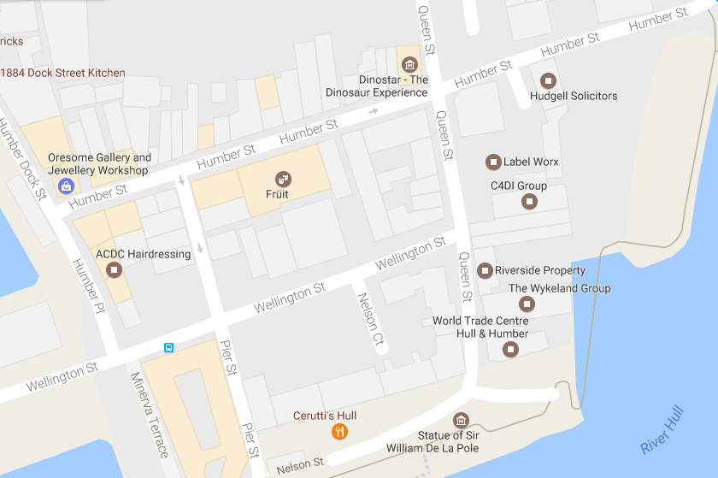

PARKING REQUIREMENT and LOCATION:
TBC – PROMOTER TO CONFIRM
PERSONNEL
STAGE MANAGER (Primary contact show weekend only): Hannah Lutkin - 07709 351209
PRODUCTION MANAGER: Gareth Hughes – 07733112272
PRODUCTION ASSISTANT: Joanna Morley – 07725 942808
VENUE CONTACT:

DATE AND TIME OF PERFORMANCE: Saturday 1st July 20:30 (45mins)
PRODUCTION SCHEDULE:
SATURDAY 1 JULY
20:30 | PERFORMANCE - Eliza Carthy - Rivers and Railways
TECHNICAL

RIDER:
TB Food Rider:
Snacks/ crudités/ sandwiches/ fruit on arrival
Hot Meal for Band & Crew (6 People)
(3 vegetarians & 3 meat eaters- but happy to eat Vegetarian food if thats easier)

Drinks:
2 x Large bottles of Sparkling Water
Cucumber
Herbal Tea/ Tea/ Coffee & Kettle
Selection of quality beers / ales
1 bottle of Red Wine
1 small bottle of quality Gin
Tonic Water
2 Lemons
2 Limes
Honey

BACKLINE:
BACKLINE | Kick Drum | ALBEMARLE KIT 2
 | Snare Drum x2 | ALBEMARLE KIT 2
 | Rack drum x2 | ALBEMARLE KIT 2
 | Rack Tom | ALBEMARLE KIT 2
 | Floor Tom | ALBEMARLE KIT 2
 | All hardware and cymblas | ALBEMARLE KIT 2
 | 2 kick brum pedals | ALBEMARLE KIT 2
 | Drum mat | ALBEMARLE KIT 2
 | 2 single keyboard stands | STS
 | 2 guitar stands | STS
 | Bass amp (2 channel) | STS
 | Fender Guitar amp | STS
 | Keyboard Amp | STS

ACCREDITATION
David & Alice Porter (Directors)
Steve & Sam Shaw (Directors)
Peter & Lorraine Boardman (Directors)
Wes Zepherin (Director)
Kirsty & Gary Halliday (Marketing)
Ben Pugh (Production)

