“Depart”
by
Circa

Draft Event Manual: Version 1

The final version of this Event Manual will be implemented for the duration of the Event.

HULL

CONFIDENTIAL

CONTENTS

- Distribution List 2

- Producer’s Statement 2/3

- Performance description/Key elements 3

- Health and safety statement 4

- Environmental/key onsite staff 5

- Infrastructure 6-7

- Box Office procedures/cash handling 8-9

- Noise Management Plan/Sound equipment 9-11

                - Lighting 12

                - General Health and Safety/Show procedures 13-15

                - Risk assessments 16-25

- Stewarding – Numbers & Location 26

DISTRIBUTION LIST

London International Festival of Theatre (LIFT)

Spitalfields Music

National Centre for Circus Arts (NCCA)

Hull UK City of Culture 2017

Hull Council and SAG Meeting attendees

Circa

Northern School of Contemporary Dance

Producers’ Statement

Synopsis

SUMMARY
A spell-binding performance from internationally acclaimed circus artists, Circa, in a unique and atmospheric location.

Led by Yaron Lifschitz with a creative team including the electronic musician Lapalux, this ethereal collaboration brings together acrobats, aerialists, choral singers and video artists for a heart-stopping performance.
Described as a meditation, Depart is a playground for the soulful, an art gallery without walls, a circus in search of transcendence filled with moments of joyous beauty.

DEPART will take place at General Cemetery, adjacent to Spring Bank West from 18-21 May at 9.15pm each evening, and also at 7.15pm on 19th, 20th and 21st May.
- The performance is approx. 1 hour in duration and should be complete by 10.15pm.

Building on Lifschitz’s innovative use of live classical and contemporary music with circus, “Depart” will also have a richly textured sound design that will include recorded music as well as massed community voices singing work specially arranged for them by composer SAM GLAZER; all within an over-arching soundscape designed by the renowned artist, LAPALUX. Community choir members will take part in the performances which will also feature lighting design from the award-winning LEE CURRAN and video and installation design from SDNA. “Depart” is a ground-breaking collaboration that combines innovative professional work from renowned artists of the highest calibre and across disciplines alongside a uniquely wide-ranging programme of community engagement, capacity-building and skills exchange. This project celebrates international artists who are at the top of their game working with their peers in Britain and sharing their work and skills with the wider community.

"You get the astonishment of great circus with the sense of transcendence more familiar in “higher” forms. I could go on, but you should probably just get on and book". Matt Trueman, Telegraph

Performance

The performance of “Depart” will commence with audience gathering at Thoresby Primary School site entrance, on the corner of Thoresby Street and Hardwick Street. The audience (250 in total) will be split into 8 groups of 25 each and will be invited to enter the cemetery through the gate at the school edge. The audience groups will be led onsite to the various performance areas (x9) that are dotted around the cemetery by x2 guides per group, and there will also be "embedded" choir members that move with each group. For the performances’ finale, the groups will come together around an 8 metre diameter circular stage at the Finale Site, as marked on the plan. At least x1 guide per group will be in radio contact with the Stage Manager throughout the performances.

Audience Movement/Performance Locations and Elements for the show:

- 7 Circa performers
- Community choir - TBC members (throughout the cemetery).
- 26 National Centre for Circus Arts students.
- 4 Northern School of Contemporary Dance students
- 3m x 3m FOH gazebo with lighting and sound control areas at Finale Site.
- 8 metre diameter stage x 1200m high stage for Finale Site.
- 4m x 4m @ 1600 mm high stage for Chinese Pole.
- Shipping container/Production base for equipment overnight
- Backstage dressing room facilities/toliets for all performers above.
- Warm-up/Green Room areas for performers above.

Audience Maximum Capacity: A maximum of 250, ticketed.

Key Elements of this document:
1. Producers’ Statement
2. Outline of event and infrastructure
3. In addition, manuals held in LIFT office and on site will contain:
Event Insurance Certificates
Information on subcontractors, their insurance details (if appropriate), Health and
Safety statements, Risk Assessments, Method Statements, Letters of permission and licenses.

Should any persons named in the Distribution List require information from this manual please contact Simon MacColl, Production Manager on 07730 404809

This Event Manual has been drawn up by Simon MacColl (Depart Production Manager), in conjunction with Linda Peterkopa (Depart Producer). This Event Manual is a method statement devised by myself and my team and proven over years of use. I have been appointed by the event organisers to oversee technical and health & safety aspects of this event and this document acts as a reference and support manual for the principal event staff and concerned authorities.

Production Manager, Simon MacColl reports to Linda Peterkopa/Mark Ball at LIFT.

Health & Safety Method Statement

The methodology and operational outline contained in this document has been developed over many years using the experience of similar outdoor events in Tower Hamlets Cemetery, London, Victoria Square Birmingham, Greenwich and Deptford as well as at numerous other outdoor events worldwide. The developing methodology has taken experience and advice from producers, health and safety experts and licensing and emergency services professionals at all of the above events.

This Event Manual describes the methods and plans for the event planned for the period commencing Saturday, 13th May until Monday, 22nd May, 2017. The Event Manual is an operational guide and should be regarded as the event method statement. The manual also contains the overall risk assessment for the event.

The final content of the manual is arrived at as a result of discussion between the Safety Advisory Group and the Producers’ representatives. The membership of this group is included within the manual (distribution list). The Manual is presented to this group for their approval. If any members of the group wish to see changes in the planning, we ask that their recommendations are made in writing to Simon MacColl.

Health & Safety Coordinator Statement
The Health & Safety arrangements for this event will be based on the information given in current Health & Safety legislation with a multi-agency approach based on best practice and previous experience being applied. The preparations and organisation for the event are geared towards ensuring that safety of both public at the event and workers and contractors at the event the event is paramount at all times.

In order to protect health, safety and welfare of the people attending these events as well as the employees, contractors and sub-contractors working at the event, health and safety has to be managed. It is of fundamental importance that the planning for effective health and safety management should begin at the same time as the planning for all other aspects of the proposed event

Planning for the event requires preparing strategies for crowd management, transport management, fire, first aid, major incident and contingency planning. Successful planning for the event requires a team approach. It cannot be achieved by one individual operating alone but requires seeking information, advice and support from Council staff, the emergency services (such as Police, Fire Brigade, etc), the health authority, local authority, production staff and security & stewarding contractors.

Environmental Impact
Production

We are committed to minimising the environmental impacts associated with our productions and events through the use of material, lighting and sound. We will measure, and seek to lower, the impacts of our performances wherever possible. In this particular production, we are looking at the following with regards to the production elements:

- Use energy-efficient technologies such as LED lighting and low energy sound consoles when resources permit.
- Ask suppliers for the environmental credentials of their products.
- Switch off lights and equipment not in use.
- Educate our production crew and stage management employees.
- Avoid the use of tropical hardwood.
- Use FSC and/or recycled wood where possible.
- Consider the weight/cubic capacity/packaging of materials and equipment to minimise transport impacts.
- Use companies like Set Exchange and Scenery Salvage in the UK to recycle sets.
- Opt for sustainable and recycled materials for props and staging.
- Reuse and recycle sets and props as much as possible.
- Store sets and props post-production where possible.

Principal Personnel on Site

Simon MacColl - Touring Production Manager
Linda Peterkopa - Touring Producer
TBC s - Touring Assistant Production Manager
TBC - Touring Stage Manager
TBC - Touring Production Electrician
TBC - Touring Sound Chief
Alistair Laurens - Touring Technical Manager
Tom Ratcliffe - Touring Rigging Chief
TBC - Front of House Manager/Box Office Manager
X2 - Show Lighting Crew
X2 - Show Sound crew
X2 - Show General Crew
TBC - Site Security

INTRODUCTION TO THE EVENT



Get in: Commence of a phased build from Saturday, May 13th until Wednesday, May 17th, 2017.
Dress Rehearsals for invited Audience: Wednesday, May 17th @ 9.15pm.
Performance Dates: 18-21st May at 9.15pm each evening, and also at 7.15pm on 19th, 20th and 21st May.

Get-out: Some rigging and company equipment immediately after last show
on Sunday, May 21st.
All other infrastructure, sound and lighting etc on Monday, May 22nd.

Show Timings: 8.45pm
Audience arrives at entrance and is directed into groups and given differentiated wristbands
(There will be a small staffed bar in at the Audience entrance serving beer, wine and soft drinks to audience with wrist bands)
9.15 pm Performance/walks start throughout site
10.00pm Transitions to Finale Site
10.15pm END

Capacity per show: 250 ticketed audience

Audience movement through the installation/performance

Signage and stewards will direct arriving audience members towards the Thoresby Primary School entrance to the cemetery, where there will be Box office and toilet provision. Within this area the audience will be allocated wristbands. Way Finders will muster their respective audience groups with the aid of both pre-recorded and spoken word announcements as part of the start of the performance. Toilets will be provided at this site, in the form of a 3+1 wheeled unit.
The audience will be led around the site in groups to the various performance areas, which will be lit at given cues in order to guide public towards them. Once all performance stations have been viewed, the audience will be guided towards the finale stage – a fifteen minute staged performance. The audience is constantly guided throughout the site at all times.
Stewards will be on hand at the finale site to direct people towards the exit. This exit route from the finale site to the Thoresby Primary School exit will be lit to enable the audience to easily orientate themselves and move swiftly towards the exit.

Infrastructure

Dressing rooms and production base

The show requires a base as a meeting point pre and post-show for the choir and warm-up space for performers in the event of unsuitable weather for warming-up outdoors. We will also use ??? as a production base. This will be used for crew toilets, and overnight security base, as well as overnight charging for any equipment that requires it, and also to provide tea and coffee-making facilities for site staff, and to provide a dedicated area as the First Aid point for site medical providers.
Further to this, a shipping container will be brought to site to house any equipment needing to be locked away overnight.

.

Audience Entry to site / box office

Audience entry is via the Bow Common Lane entrance adjacent to Lockhart Field. Signage and stewarding at the Southern Grove entrance will direct audience to the Bow Common Lane entrance. A temporary box office will be housed under a 2m x 2m gazebo with trestle table. There will be a member of security at all times at the box office whilst it is in use; it will be set up and struck daily. Please see LIFT cash handling policy, below:

LIFT 2016 Off-Site Cash Handling and Transit Policy

General Cash Handling

• Encourage credit or debit card payments to help keep cash to a minimum, including for Box Office transactions
• Store cash in a strong, secure cash tin. If possible have two staff when manually collecting cash.
• Transfer excess cash to the cash tin regularly.
• Use signs to clearly state that there is minimal cash on premises/limited cash in tills. For example: 'time delay safes are used' or 'no money is left on the premises' or 'employees cannot open the safes'.
• At the end of the working day, before cashing up check for any suspicious behaviour and call/radio security or production supervisor.
• Try to locate the main box office cash handling area as far as possible from customer areas.
• Count cash away from, and out of view of, customer areas and as far away from entrances/exits or public areas as possible.
• When counting money in the box office, carefully identify callers before letting them in.
• It is good practice not to keep large sums of cash in one location, and not to allow money to build up, especially during the evening and late at night.
• Empty tills at frequent intervals, irregular times, and not in front of customers.
• Regularly remove high-value notes from tills and store in a secure cash box.

Cash In Transit

If you transport cash:
• Think about your personal safety, if attacked, surrender cash!
• Vary the route and time of day when you go to the bank so your movements cannot be predicted.
• Wear your own clothing rather than any provided uniform so that you are less conspicuous.
• Bank your money regularly to keep cash to a minimum.
• Check the area outside your premises and any transport before leaving the premises or bank.
• Ensure staff are trained and made aware of what precautions they should take when they are transporting large sums of money.
• If possible, travel by vehicle rather than on foot or public transport. Take care with taxis - always use a reputable firm.
• Ensure your drivers are insured for business purposes and have a valid licence.
• Forewarn the bank of expected arrival time and inform another staff member staff of expected return time.
• Use secure security bags or unmarked bags/containers to carry cash and do not draw attention to them. You could also use cash-carrying waistcoats, as well as security bags, to divide the risk.
• Avoid using quiet streets and alleyways. If possible, you should use a busy route and walk in the centre of the pavement facing oncoming traffic.

Box Office Protocol

Payment for pre-booked or on the day tickets will be accepted at the box office.
The following are acceptable forms of payment:
• Credit cards
• Cheques with valid cheque card
• Cash
• debit cards
• Keys to the till, cashbox, or safe, will be held by either the Box Office manager or the Venue manager, who should keep the keys secure and ensure that they are not left unsecured in the office overnight. Sensible precautions should be taken to ensure that the box office in which cash is regularly stored is locked when unoccupied.
• All cash collected / cash and petty cash floats should be held securely, either in a till, or in a locked cash box at all times. In the latter case, the cashbox should be kept out of sight at all times in a locked cabinet or drawer. When cash has to be held in an office for any length of time, it should be stored securely.
• Where cash is being counted by staff, this should be done out of sight.
• Floats should be made up in the box office and distributed to outlets 15 minutes before opening and then tills kept locked until trading commences. All floats should be doubled checked before trading.
• All cash income should be held intact. Under no circumstances should deductions be made, or personal or other cheques cashed, from any cash collected on behalf of LIFT.
• All staff members responsible for collecting cash should issue a receipt and a copy should be retained as a record supporting daily cash collected.
• Members of staff involved in the cashing up process should countersign the reconciliation.
• The original reconciliation document, e.g., detailing the breakdown of the sales, should be copied and the copy should be retained as the box office record.
• The Box Office should reconcile cash received to supporting records on a daily basis. Either on a weekly or a daily basis, (influenced by the sums involved), the department should prepare the cash to be deposited with the bank. Ideally, someone other than the person responsible for cash collection should complete this task. Failing that however, in order to ensure separation of duties, another member of staff should check that the cash collected agrees with supporting records, e.g. duplicate receipts / till control totals, and to the pay in documentation submitted with the cash collected to the Finance Office.
• Care should be taken at all times with large value notes, i.e. £20/£50.

First Aid provision

First aid cover will be provided by HULL provision to go in here
A room within The Production Base will be the base for the medical provision, who will be in radio contact with stage management throughout each performance. Event cover will be for show days only. Outside of those dates, first aid provision will be by means of a first aid kit, and an accident book held onsite.

Overnight security

Overnight security will be at ________ TBC. All easily portable lighting and sound equipment will be removed each evening, and locked in the shipping container. Any other infrastructure will be made safe/fenced off as necessary. A 40-foot shipping container will be sited ___ TBC providing a secure lock up for equipment overnight.

Generators

There will one super-silent generator at the finale site/control area. This is to service the lighting, sound and video needs for the show at that area. There will be various battery sources (TBC) throughout the site to service the small video projectors. There may be need for x1 more generator onsite - TBC...

Amplified sound

- Pre-recorded sounds (Ambient track throughout the site)
- Speakers dotted around the Finale Stage, surrounding the audience.

Localised sound will be used throughout the Cemetery by means of battery-powered speakers, hidden from public view/contact. These units will be set and struck on a daily basis. Sound playback will be by means of battery-operated media players for these small stand-alone installations. The Finale site will utilise a ground-stacked PA system, provided by Richard Nowells Sound Services. The speaker design is such that the sound dispersion is narrow and focusable, guaranteeing very little sound bleed outside of the cemetery. The sound engineers will work with HULL to ensure that the correct volume level is set, and maintained. Per show, music will be amplified for no longer than 15 minutes. There will be a microphone at the control point, should there be a need for any public announcements.

Assessment
Given the nature of this immersive theatrical event, and the desires of the creative team to create a site-responsive/sympathetic experience, it is not felt that excessive noise levels will be a problem.

There are a number of sources of amplified sound throughout the event site. Any use of PA during the performances will occur between the hours of 1915 and 2215. In each instance the PA is for amplifying sound within a localised area, and not larger sections of the Event Site overall.

Amplified Sound Sources

Thoresby Primary Entrance

Description: Small tannoy speakers facing audience entrance point, and away from residences, used for playback at the start of the performance. Equipment comprises:

x4 Adastra 100v Horn speakers
x1 Adastra 100V Line -120W Slave Amp
x1 Lab Gruppen 1600
x1 Shure SH 55 Microphone (Prop only)

Chinese Pole Site

Description: x2 small battery powered speakers for L/R orientation for audience at stage. The speakers will face away from residential area, and will face into the park. Equipment comprises:

x2 XP40i Powered Speakers
MP3 player

Tree Aerial sites

Description: There will be several aerial performances in trees throughout the site. Some of these will have sound accompaniment, through the following equipment:

x2 JBL Horn speakers
x1 Caliber CA 120W 12V Car Amp

Main Finale Site
Description: Small speakers for playback on stands to surround audience, in order to envelop in surround-sound. Exact spec TBC for Hull

x8 D and B C6 on stands surrounding audience
x2 D and B B2 subs at stage
x4 D&B A1 Amplifier
x6 D&B EPAC S2 Amplifiers

Non-amplified elements

A choir of 100 participants will be used throughout the performances. The choir are un-amplified at all times. As the walks for the audience are mainly kept away from the periphery of the park, it is not envisaged that loud levels of sound from the choir will be experienced by residents.

Schedule / Location / Description
Date | Description | Times
Mon, 15th May | Fit-up all site. Sound equipment in to all spaces | 0900 - 2000
Tue, 16th May | Fit-up all site. Sound equipment in to all spaces. Artists onsite in evening - no sound | 0900 - 2000
Wed, 17th May | Technical rehearsals - soundcheck during day | 0900 - 2200
Thu, 18th May | Technical work on site as necessary - no loud music during day  Dress rehearsal with audience in evening | 0900 - 2300
Fri, 19th - Sun, 22nd May | Technical work on site as necessary - no loud music.  Shows in evenings - audio at Show levels. | 0900 - 1800 Set-up/checks  1900 - 2300 Full runs with sound

Noise Mitigation Measures
Given the nature of the performances, and the localised performance elements, it is a fair assumption that there will be little disturbance caused for local residents and businesses. Considering the very nature of the event itself, the nature of the site where it takes place and the overall positive reaction by the local residents and general public to this type of event, it is not anticipated that this will be of cause for concern or nuisance to people in the vicinity of the show site. However the following noise management measures will be in place:
General
- The event will adhere to the Noise Council’s Code of Practice on Environmental Noise Control at Concerts (1995) and any other relevant legislation, HSE or other guidance as issued by Hull.
- In accordance with Noise Council guidelines we intend to operate within the satisfactory levels that follow. We anticipate an amplified music noise limit of 65dB(LAeq 15min) for octaves centred around 65 &125Hz, measured 1m from facade of nearest noise sensitive premises. We anticipate the predominant noise source to be the finale stage at the end of the evening, which will last for 20 minutes maximum.
- Sound levels to be regularly monitored by the show sound throughout the event and to advise PA operators accordingly that the noise limits are not exceeded – sound levels will be set well below limits. The results of the noise monitoring shall be available to the Licensing Authority at any time
- In the unlikely event of possible concern / public complaint Event Management will take appropriate measures to reduce sound levels. The following structure is in place should there be any complaints:

Local complaints can report to Front of House, where there will be a member of the Production Department available on radio. This point will be identified by an event banner/Information sign. The Production member will call through on radio to the Production Manager, Simon MacColl, who is onsite throughout all rehearsals and shows. Similarly, all Stage Management and Security will be on radio comms, and can report to Simon MacColl in the event of a complaint/problem.

Simon MacColl | LIFT Production Manager | 07730 404809
TBC | Sound Supervisor onsite
Linda Peterkopa | Depart Producer | 07783 541853
 | Hull Producer

Lighting elements

The groups will be led/encouraged by Guides. Each Lead Guide will be equipped with a powerful torch, should there be a need for added lighting en route. Within each walk, there will be localised areas of battery-powered LED lighting to highlight the various performance and installation elements. These will be set and struck from their positions on a daily basis by the show crew.
The finale site will utilise more conventional theatre lighting, focussed on the stage. These will be set on the stage, and also rigged from the control stage, at the Front of House position. Extra provisions in this area will include general flood lighting for the whole area, for end of show and any evacuation. There will also be a stand-alone mast lighting tower with its own generator that will be switched on should there be any problems with power onsite. This mast will be locked within the Herras fencing surrounding the stage each evening for security.
Handheld flaming torches will also be used to lead the front of each group. These are hired-in from SFX Rentals, and further RAMS are on file for the use of these. The Guides will also carry a small hand-held CO2 extinguisher as part of their stage management equipment for each performance.

Staging elements:

There are various stages throughout the site, as details below, and in the following plan:

- x1 8 metre diameter stage x 1200m high stage for Finale Site.
- x1 4m x 4m @ 1600 mm high stage for Chinese Pole.

The staging is being provided by TBC. They will install all stages, and sign-off the structure. The staging units are rated @ 5kN/square metre.

A structural report from Steeldeck will be on file and can be forwarded on request.

Rigging elements:

Tom Ratcliffe (Head Rigger) will lead a team of two show riggers in installing and managing tree rigging for aerial performances.

All rigging will be pulled up and tied off out of public reach at the end of each working day and re-set on a daily basis for shows.

The trees selected for rigging from are as per the map below (Blue X with numbers). A full tree survey is available, with report on each trees use, and will be completed by Tom Ratcliffe.

Health & Safety

All aspects of this event will be subject to proper risk assessment with Method Statements provided to demonstrate the risk management strategies in place to control any risks identified. These risk assessments will cover all structures, P.A Systems, Lighting Equipment, Vehicle Movements and security

The festival team will liaise with all bodies to ensure a safe, well planned and well-run event is delivered.

Show Stop Procedure - incident

In the event of a major incident the following personal are authorised to call a show Stop.

Simon MacColl
Tom Ratcliffe (Head Rigger)
TBC (Touring Stage Manager)

The radio call to be used for a show stop is: “This is (identify yourself), I am calling a show stop – I repeat I am calling a show stop. Please stand by for further information.

The production Manager will then instigate the following procedure

- ASMs and stewards halt their groups (ASM’s communicate via a loud hailer )
- Emergency services contacted when appropriate
- Any amplified sound will be cut to ensure communication, as directed by the Production Manager.
- Exit lighting is bought up
- If the show stop incident can be made good then the call is made to resume show
- If the emergency services are bought on site , the chain of command is passed onto that service
- If an evacuation is called it will be called over the radio and each stage manager assume control of their audience assistance from their two allocated stewards
- ASM call “ due to unforeseen circumstances we need to evacuate the site – if you would please follow me in an orderly fashion “
- Stewards top and tail each group
- Groups move to their closest exit – Southern Grove is the preferred path. There will be no re-entry in the event of a show stop evacuation
- All show personnel will evacuate to Production Base where the Stage Manager will check all to be present
- Security secure the site to avoid re-entry
- Site will re-open once the relevant authority deems it safe.
- Once re-opened production staff re-enter to strike as per end of night procedure
- Stewards sweep site for any members of public

Show Stop Procedure - planned

The production team is in constant contact throughout the build, rehearsals and performances by two- way radio.

Any occurrence that requires proceedings to stall in order to be rectified can be communicated to the Production Manager and Stage Manager by radio holders
- Call is made stating nature of incident
- A decision is made in consultation with heads of depts. (sound / lighting/ SM /rigger )
- Guides communicate to the groups via loud hailer “due to a technical issue we need to pause the show for a moment – we appreciate your patience and will get things back under way as soon as possible”
- Any amplified sound will be cut to ensure communication, as directed by the Production Manager.
- If the situation/risk can be resolved – call will be made to resume show.
- If not the production manager will call an evacuation over.
- If an evacuation is called it will be called over the radio and each stage manager assume control of their audience assistance from their two allocated stewards
- ASM call “Due to unforeseen circumstances we need to evacuate the site – if you would please follow me in an orderly fashion “
- Groups move to their closest exit. There will be no re-entry in the event of a show stop evacuation
- All show personnel will evacuate to Thoresby Primary School where the Stage Manager will check all to be present
- Security secure the site to avoid re-entry
- Site will re-open once the relevant authority or production manager deems it safe.
- Once re-opened production staff re-enter to strike as per end of night procedure

There will be two designated production personnel who can call a planned show stop. In addition they are responsible to account for the following show personnel following an evacuation

Tom Ratcliffe: Responsible for all riggers/aerialists
Stage Manager: Responsible for collecting all performers
Simon MacColl: Responsible for all technical and production crew and public.

Once satisfied that the performance areas are clear the Production Manager will join the staff and performers at the evacuation Assembly Point. Registers will have already been taken by the above named people who will liaise with the Production Manager to confirm that everyone is present.

Security& Public Safety

Security is to be undertaken by TBC, and all persons will have acceptable standard of training. There will be proper supervision of security staff. For the shows we will increase the security persons and have additional stewards. Please see security provision detail below for numbers and positions. Security personnel are in radio contact and can be mobilised to deal with any problems, the two roaming Stewards will be re-deployed to cover any area affected. Radios will be given to all technical crew, TBC Medical Services and all key contractors. A full stewarding plan developed with HULL SECURITY PROVISION and seen by SAG members will be included in the final event management plan four weeks before the event, and available to all parties. All build and installation activities will be phased so as to allow safe public and staff access to as much of the area as possible and no pinch points or unnecessary blocking will be allowed. Any works in spaces of common use will be designated with barrier tape whilst work is taking place on the install.

Stewarding.

TBC stewards will be bought in to manage audience movement and safety and assist the public in their time on site. Each audience group will be assigned two guides who will top and tail the group in their progress through the site

Meeting/Lost Children Point

The Production Base will act as the Lost Children point for the site, and staff there will be in radio contact with all key show personnel. Signage will be displayed showing the Meeting/Lost Children point.

Litter

Litter will be cleared by the stage management and stewarding team, who will litter-pick as required throughout the event. All litter to be cleared from site after the event. No industrial rubbish will be generated or left on site. All contractors are instructed to remove any debris or rubbish and to keep all work areas clean and tidy. No large build-up of litter is envisaged, as audience is mobile, other than the finale section, which will be looked at each evening.
A site sweep will be done at 9 am throughout the production and performance period.

Health & Safety

All contractors will have been issued with a copy of this document and are aware of the risks and the methods employed to control these risks. All contractors will risk assess their own areas and a copy of these assessments will be available on site or from the dance exchange office. Conditions on site will be monitored and reviewed at all times throughout the event for compliance and adherence to the below risk assessment and to the risk assessments provided by contractors.

Toilet provision

There will be a mobile toilet block with male and female facilities for users onsite at the Cantrell Field site ( see plan). These will be pumped out/cleaned on a weekly basis.

Traffic management/information etc

At point of purchase of tickets online, members of public will be sent an e-mail with the following information:
-How to get to and from the site
-Recommendations on appropriate clothing and footwear
-That no food is available on site
-
-That there is no dedicated parking onsite for cars. They will be advised to use public transport.

Further information:

-There will be a steward on Thoresby Primary School entrance in high visibility vest to direct public to the site and to assist any road crossings, if needed.
-A steward will do a visual check of the to ensure that the road is clear of any traffic blocks etc for the emergency services. Police will be notified if there are any obstructions to the site.
-All vehicles onsite during fit-up and get-out will be accompanied by a member of production staff in high visibility vest, after precise instruction on 5MPH speed limit onsite, with hazard lights flashing.
-All vehicles will report to the Production Base before entering site. All contractors will have contact details for onsite Production Manager.
-Vehicle movement on site is, and this is reflected in the schedule and will be managed by the production manager.

RISK ASSESSMENT - General Site

Show Date: 18 - 21 May, 2017
Build Date: 13- 17 May, 2017

Status: 1st Draft
DEPART - Build, De-rig and Show
Activity | Hazards | People at risk | Severity | Likelihood | Rating | Precautions | Residual rating
Transport to and from site | Traffic accidents, collision, site damage | general public, event staff, contractors and crew | 3 | 1 | 1 | - All work to be carried out in a safe working area, clearly defined and protected from public access  - All transport contractors to carry out independent risk assessments and normal safety checks.  - All transport contractors to be fully briefed and all vehicle movements on and off site to be monitored at all times  - Minimal vehicle access will be required for deliveries.  - Vehicles only permitted on site for load and unload period  - Security staff and those working around moving vehicles to be dressed in high visibility clothing and hard hats/PPE as required | Low
Loading and unloading | Personal injuries | Contra-ctors, crew and event staff | 3 | 1 | 1 | - No very heavy equipment is anticipated as being needed on site, and crew are not expected to lift heavy weights  - All crew to be aware of best practice for lifting and carrying | Low
Installing Scenic elements  Working at height  Working at night | Personal injuries | Public, Contractors and crew | 3 | 1 | 1 | - All working areas are protected from access by public during build  - All cables to be properly run to avoid slips or trips  - All work to be carried out in well-lit areas.  - Any work at height will be carried out with appropriate use of PPE, and a qualified rigger will be onsite. | Low
Installing lighting and PA | Manual handling/lifting injuries  Working at height  Falling objects  Working at night | general public, event staff, contractors and crew | 2 | 2 | 1 | - Crew are all suitably trained and aware of their responsibilities.  - All working areas are protected from access by public  - PPE to be worn at all times, where necessary, by all crew and contractors  - All equipment to be properly rigged and secondary suspensions fitted where necessary  - Any free-standing structures to be suitable weighted/tied-off  - Working areas to be lit adequately with floodlights where necessary.  - All lights to be suitable and properly cabled and earthed | Low  Low
General Fire Risk | Volatile materials, sources of heat. | general public, event staff, contrac-tors and crew | 3 | 1 | 1 | - All main performance areas covered by fire extinguishers and monitored at all times  - No catering on site  - Litter pickers to be deployed on site to prevent build up of litter  - All scenic elements will be flame-proofed, as per normal theatre licencing requirements  - All power to be suitably protected with RCDs on generators | Low
Electricity | Electric shock/slips or trips, use of generators | general public, event staff, contrac-tors and crew | 3 | 1 | 1 | - All power to be suitably protected with RCDs on generators  - All equipment and structures to be earth bonded, as necessary  - All hire equipment PAT tested, and supplied by reputable theatrical hire companies  - All cables to be of suitable type, properly run and out of the reach of the general public. All cables suitably protected from causing slips or trips  - Competent persons on standby at all times of use  - Qualified electrician to sign-off all electrical installations  - Use of generators will be as per supplier instructions, subject to full risk assessment. | Low
Public Order | Disturbance or disruption  General Security  Alcohol | General public, event staff, contrac-tors and crew | 1 | 1 | 1 | - Trained security persons on site at all times  - Members of production team wearing high visibility and briefed to assist members of the public  - Nature of event is such that no unruly behaviour is anticipated.  - Site to be monitored for any build up of persons who are drunk or likely to get drunk and measures taken to control this  - Alcohol will be served only to audience wearing wristbands  - Bar is only open 30 minutes. | Low
Aerial Work | Fall,slip from height | general public, event staff, contrac-tors and crew | 3 | 1 | 1 | - All rigging points in trees – surveyed by an arborist  - All rigging points checked daily  - All rigging equipment certified to above standard of task  - All rigging equipment pulled up out of public reach and or struck over-night.  - All rigging installs will happen in cordoned-off areas, stewarded from the public. | Low
Storage and use of flaming torches and flame paste | Fire, burns | general public, event staff, contrac-tors and crew | 3 | 1 | 1 | - Flame paste for torches will be held within a locked flameproof container within the safe in The Lodge, and will only be accessible by Stage Manager and Production Manager  - All loading of paste etc will be done indoors at a pre-determined time before each performance, in a well lit room in The Lodge.  - Assistant Stage Managers will be equipped with a small CO2 extinguisher throughout the performance time that the torches are used.  - The torches have a dead-mans switch that turns the flame off should the torch fall to the ground. | Low

Severity Index |  |  | Likelihood Index |  |  | Risk Rating Matrix |  |  |  |  | Residual Risk
Catastrophic | Fatality, major injury, fire or loss of property | 3 | Certain | Harm is certain or near certain | 3 |  | Catastrophic | Serious | Minor | Insignificant | Low | Risks adequately controlled - no further actions required
Serious | Over 3 day injury, damage to health, serious property damage | 2 | Likely | Harm will occur frequently | 2 | Certain | 9 | 6 | 3 | 0 | Medium | Major accident possible - further control measures required
Minor | Slight injury, minor property damage | 1 | Unlikely | Harm will seldom occur | 1 | Likely | 6 | 4 | 2 | 0 | High | Control measures ineffective, possibility of major accident high, immediate further action required, possibly suspend work
Insignificant | No injury or damage | 0 |  |  |  | Unlikely | 3 | 2 | 1 | 0 | High

Risk Assessment - specific acts. This will be updated constantly, in order to provide full coverage, up to the event.

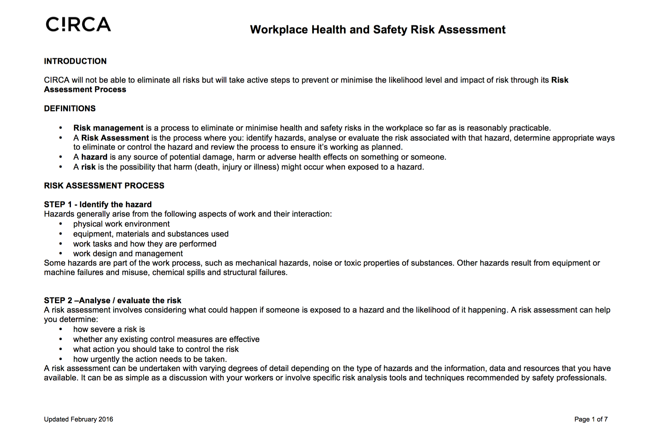

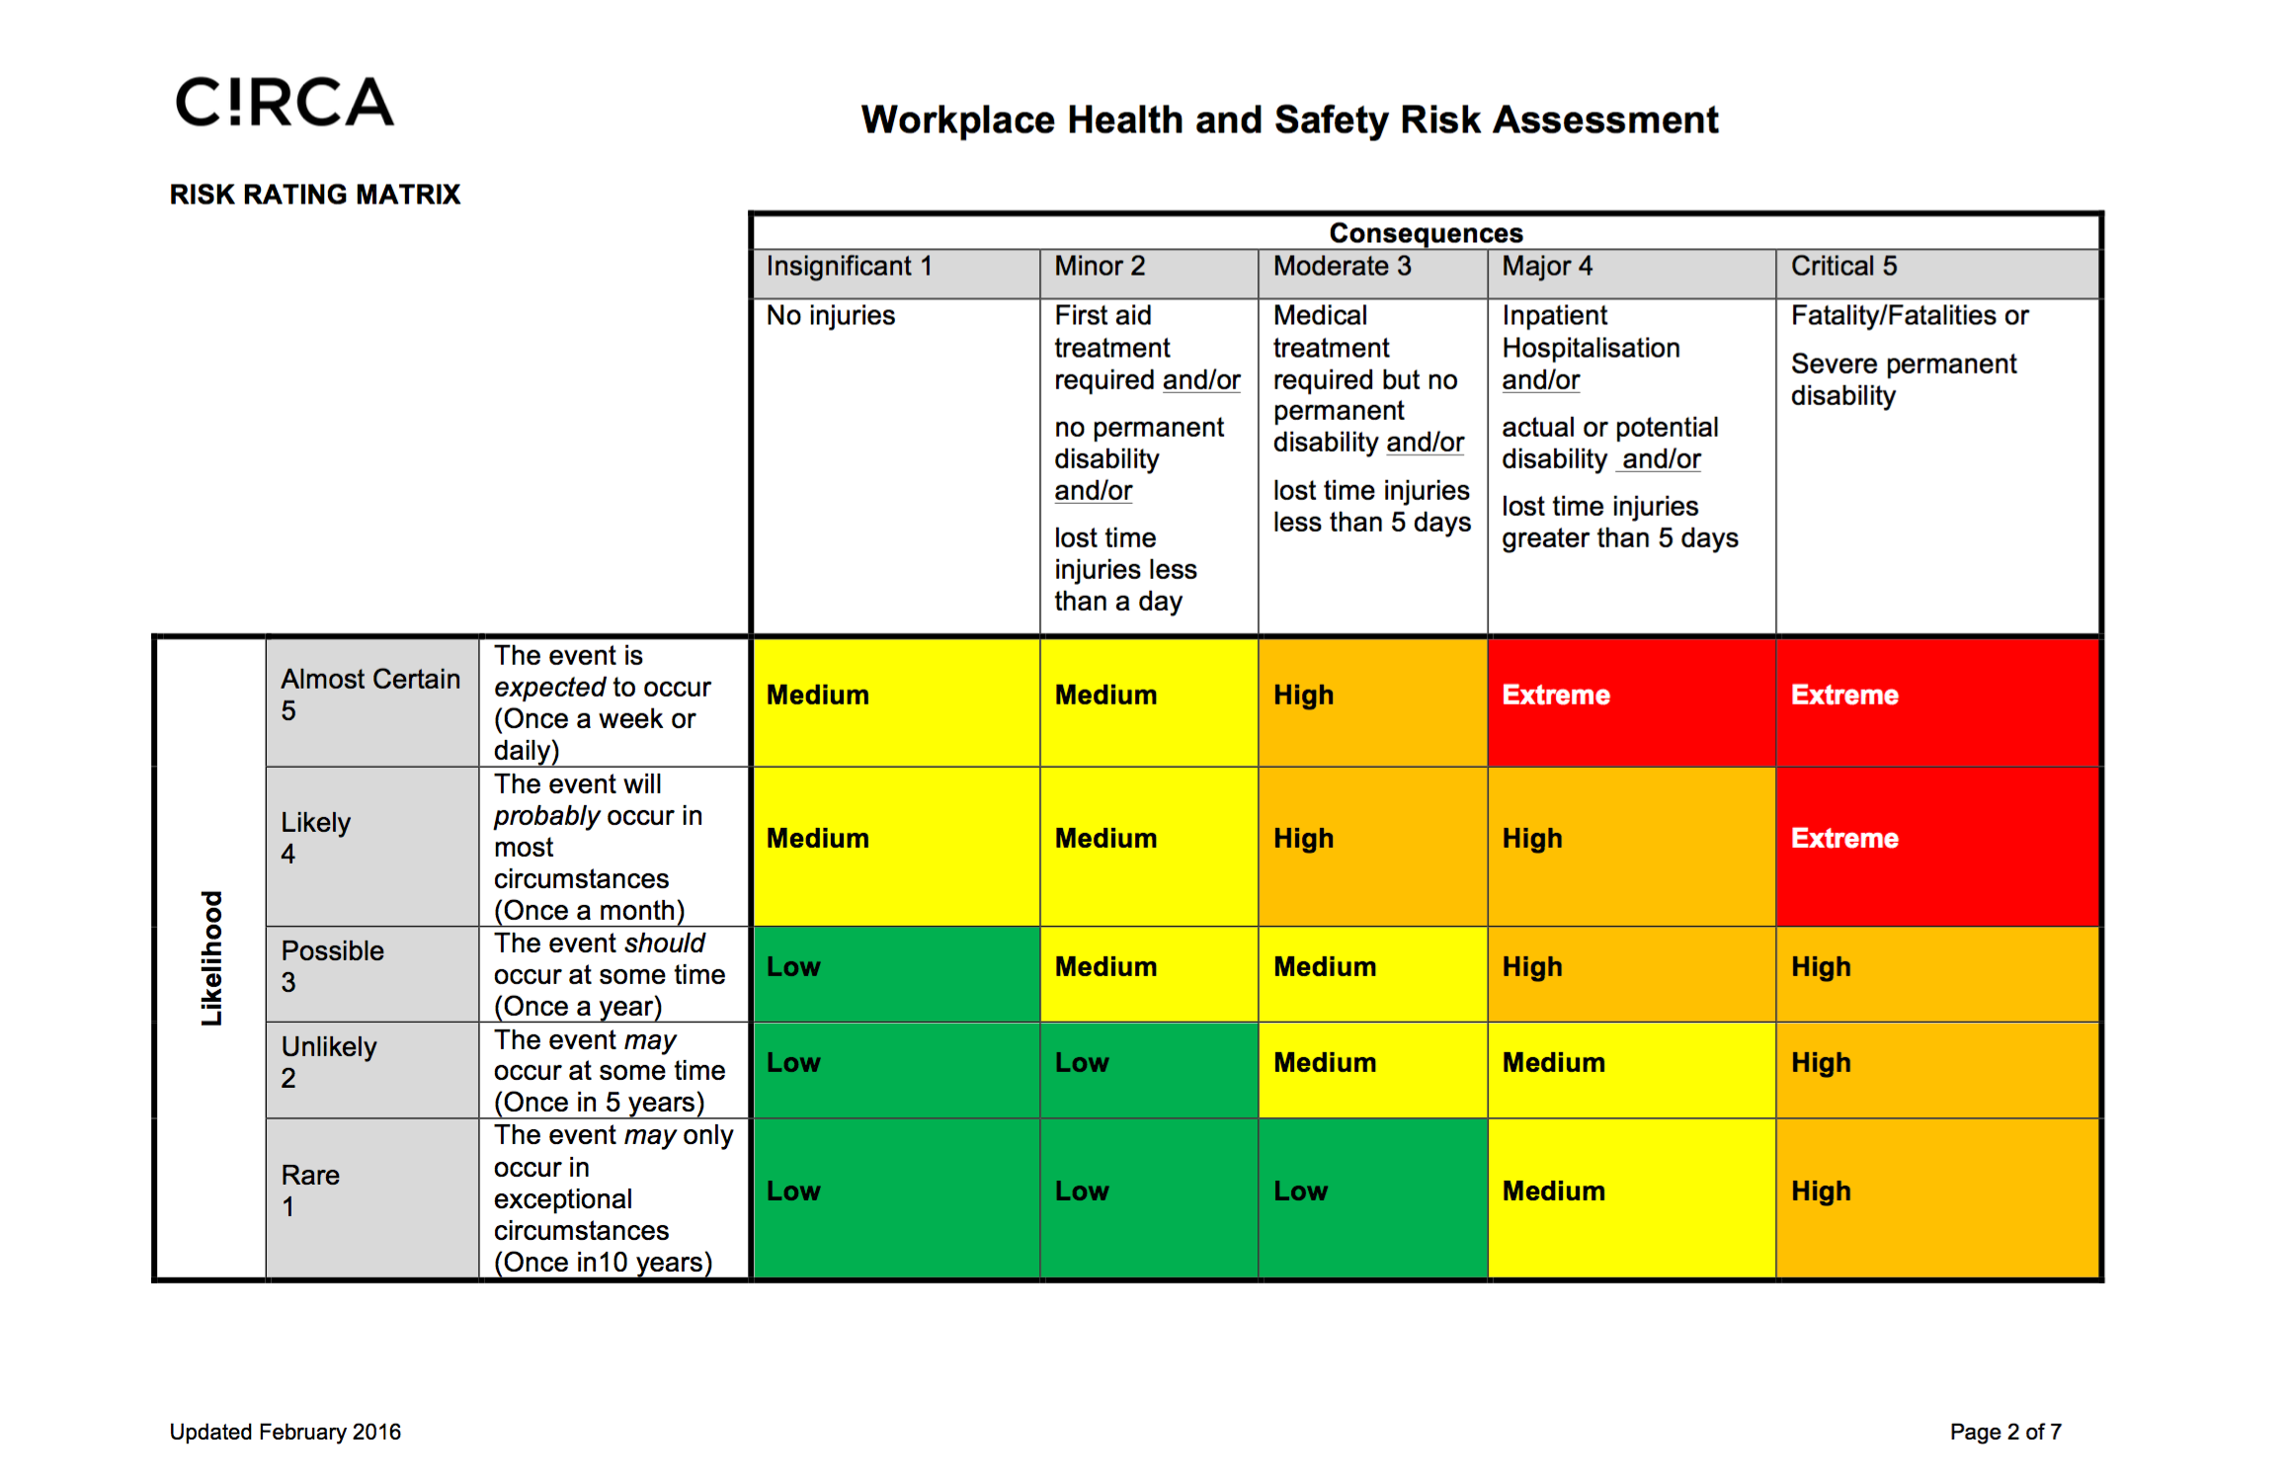

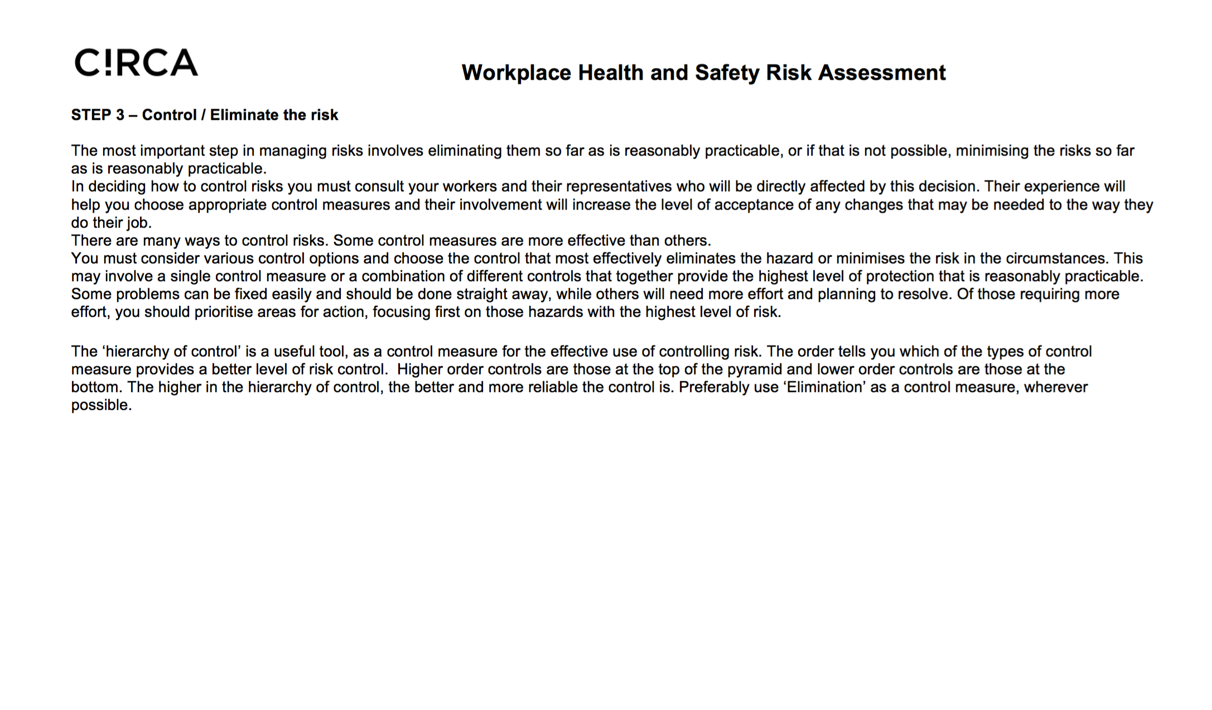

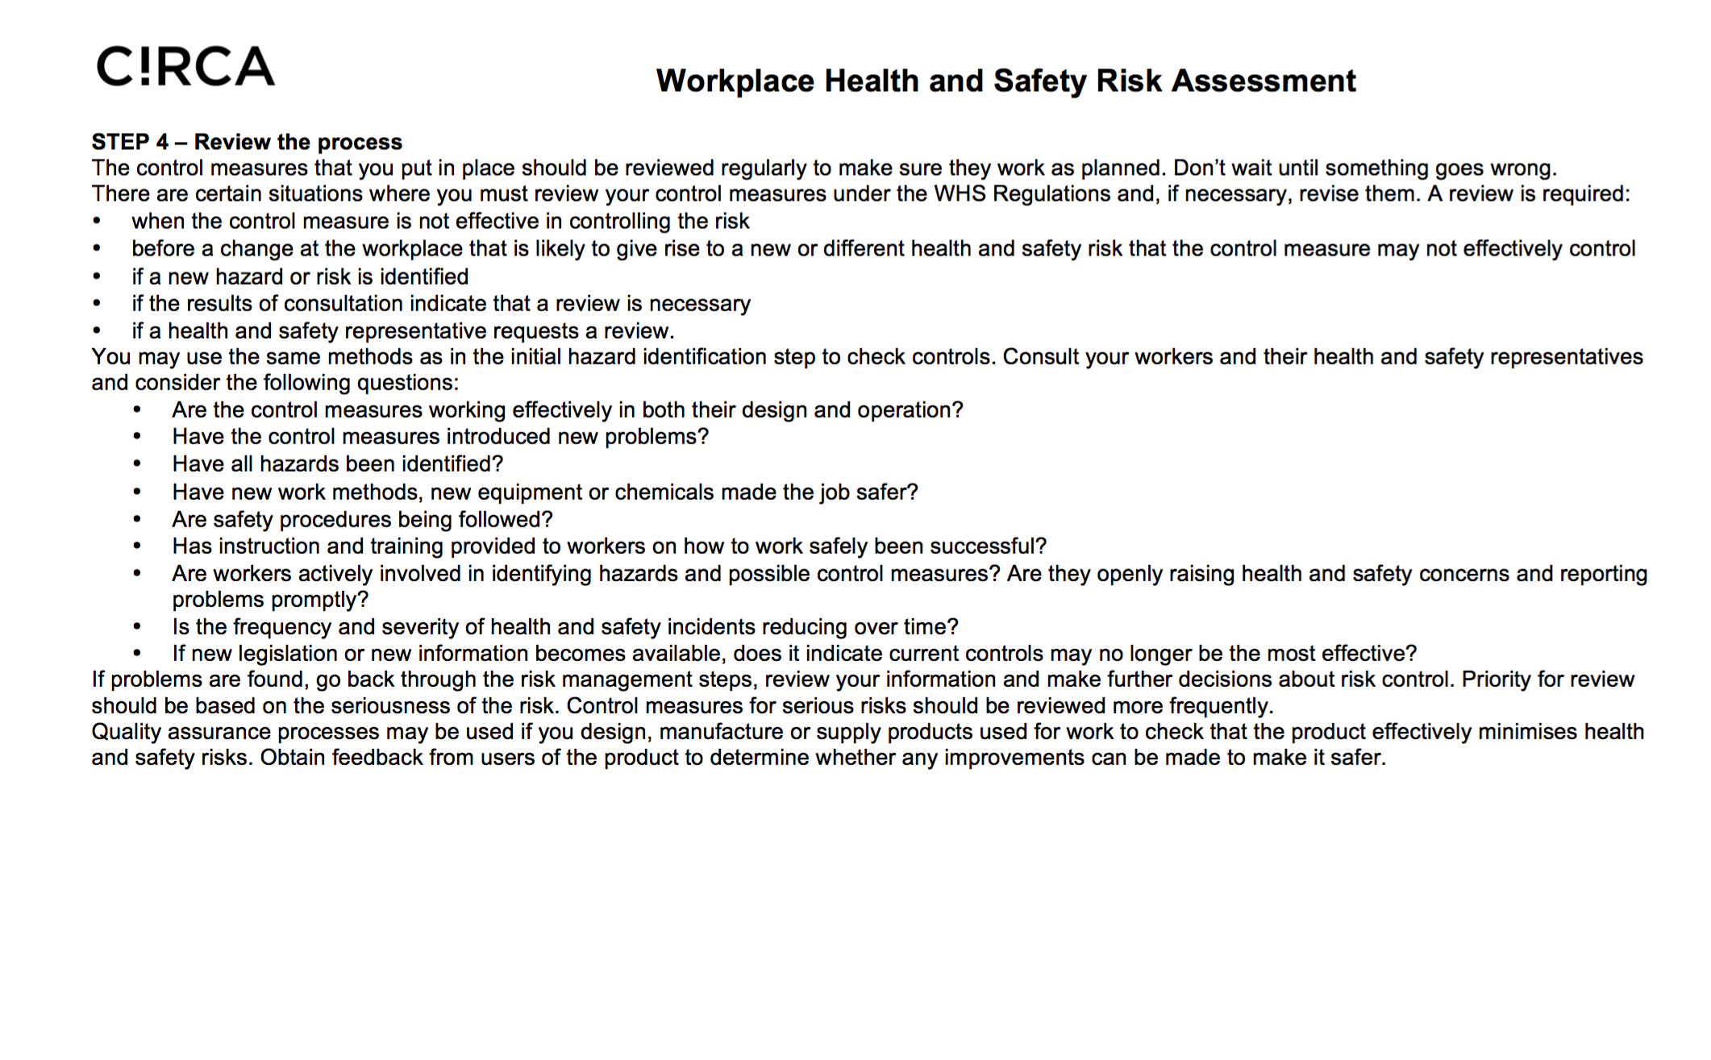
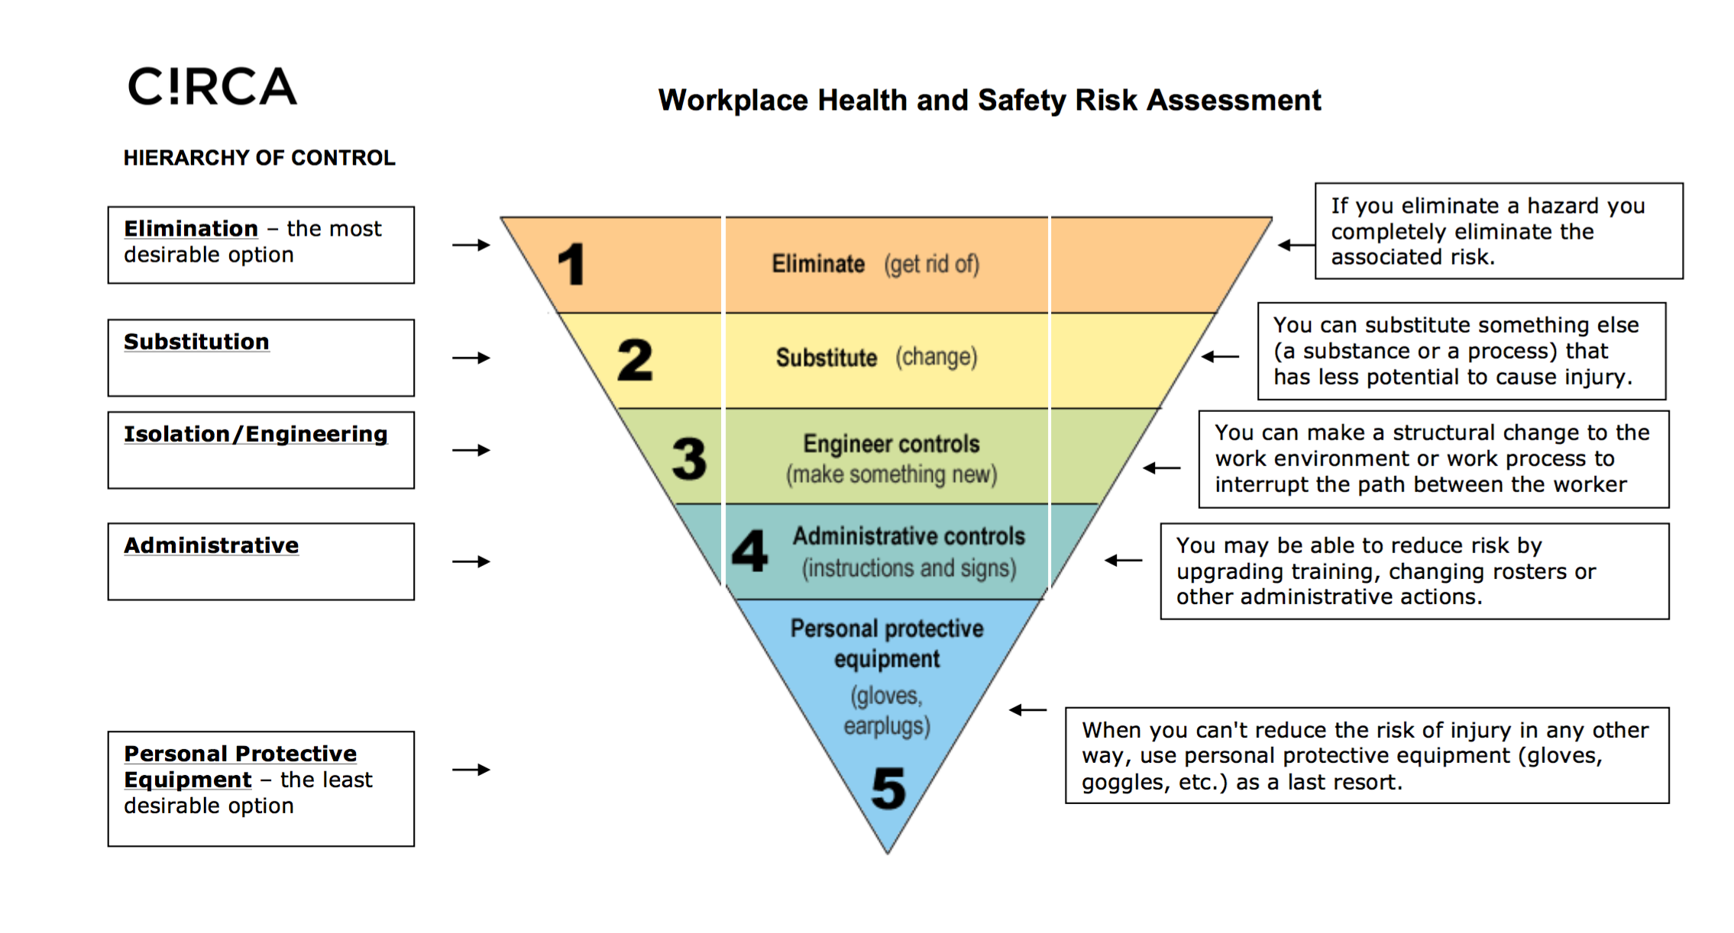
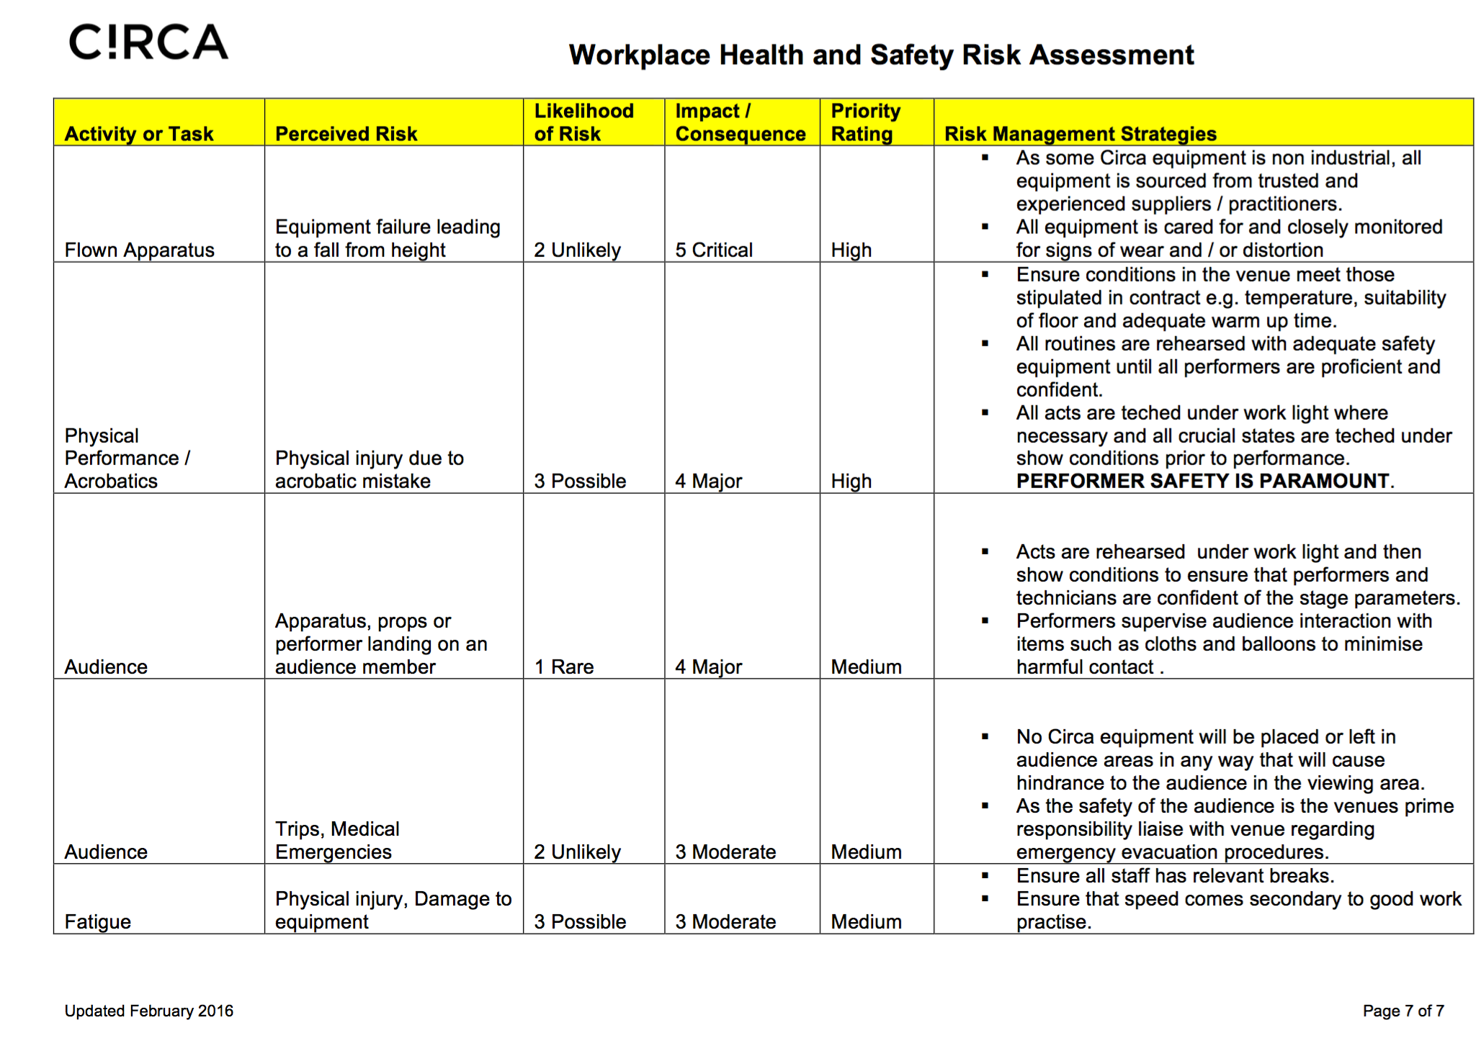

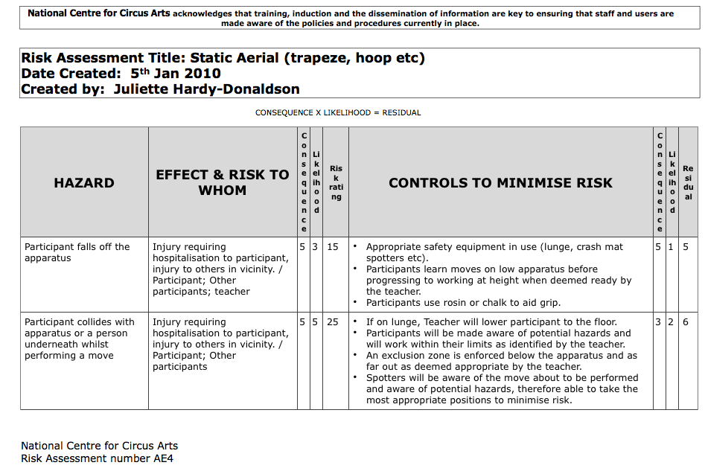
National Centre for Circus Arts RAMS
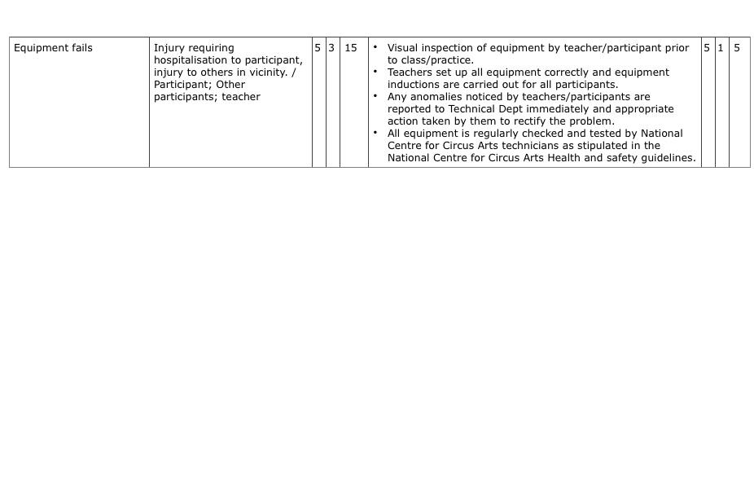
Fire Extinguishers, Disabled Area, Cleaning.

Fire Extinguisher Positions | AREA CO2 BLANKETS  SHOW control - 1 1  Generator 1 1  Generator 1 1  Bar 1 1  Various stations throughout site- TBC 3 3
Access | As performance is promenade, disabled attendees will be able to see most parts of the performance, as the surface is good for assisted wheelchairs.
Refuse & Site Cleaning | Litter pick immediately after all performances, carried out by stewards and stage management staff.  Any industrial waste removed by contractors.  Visual check carried out every morning by event staff of whole site.
First Aid position | Production Base, provided by TBC

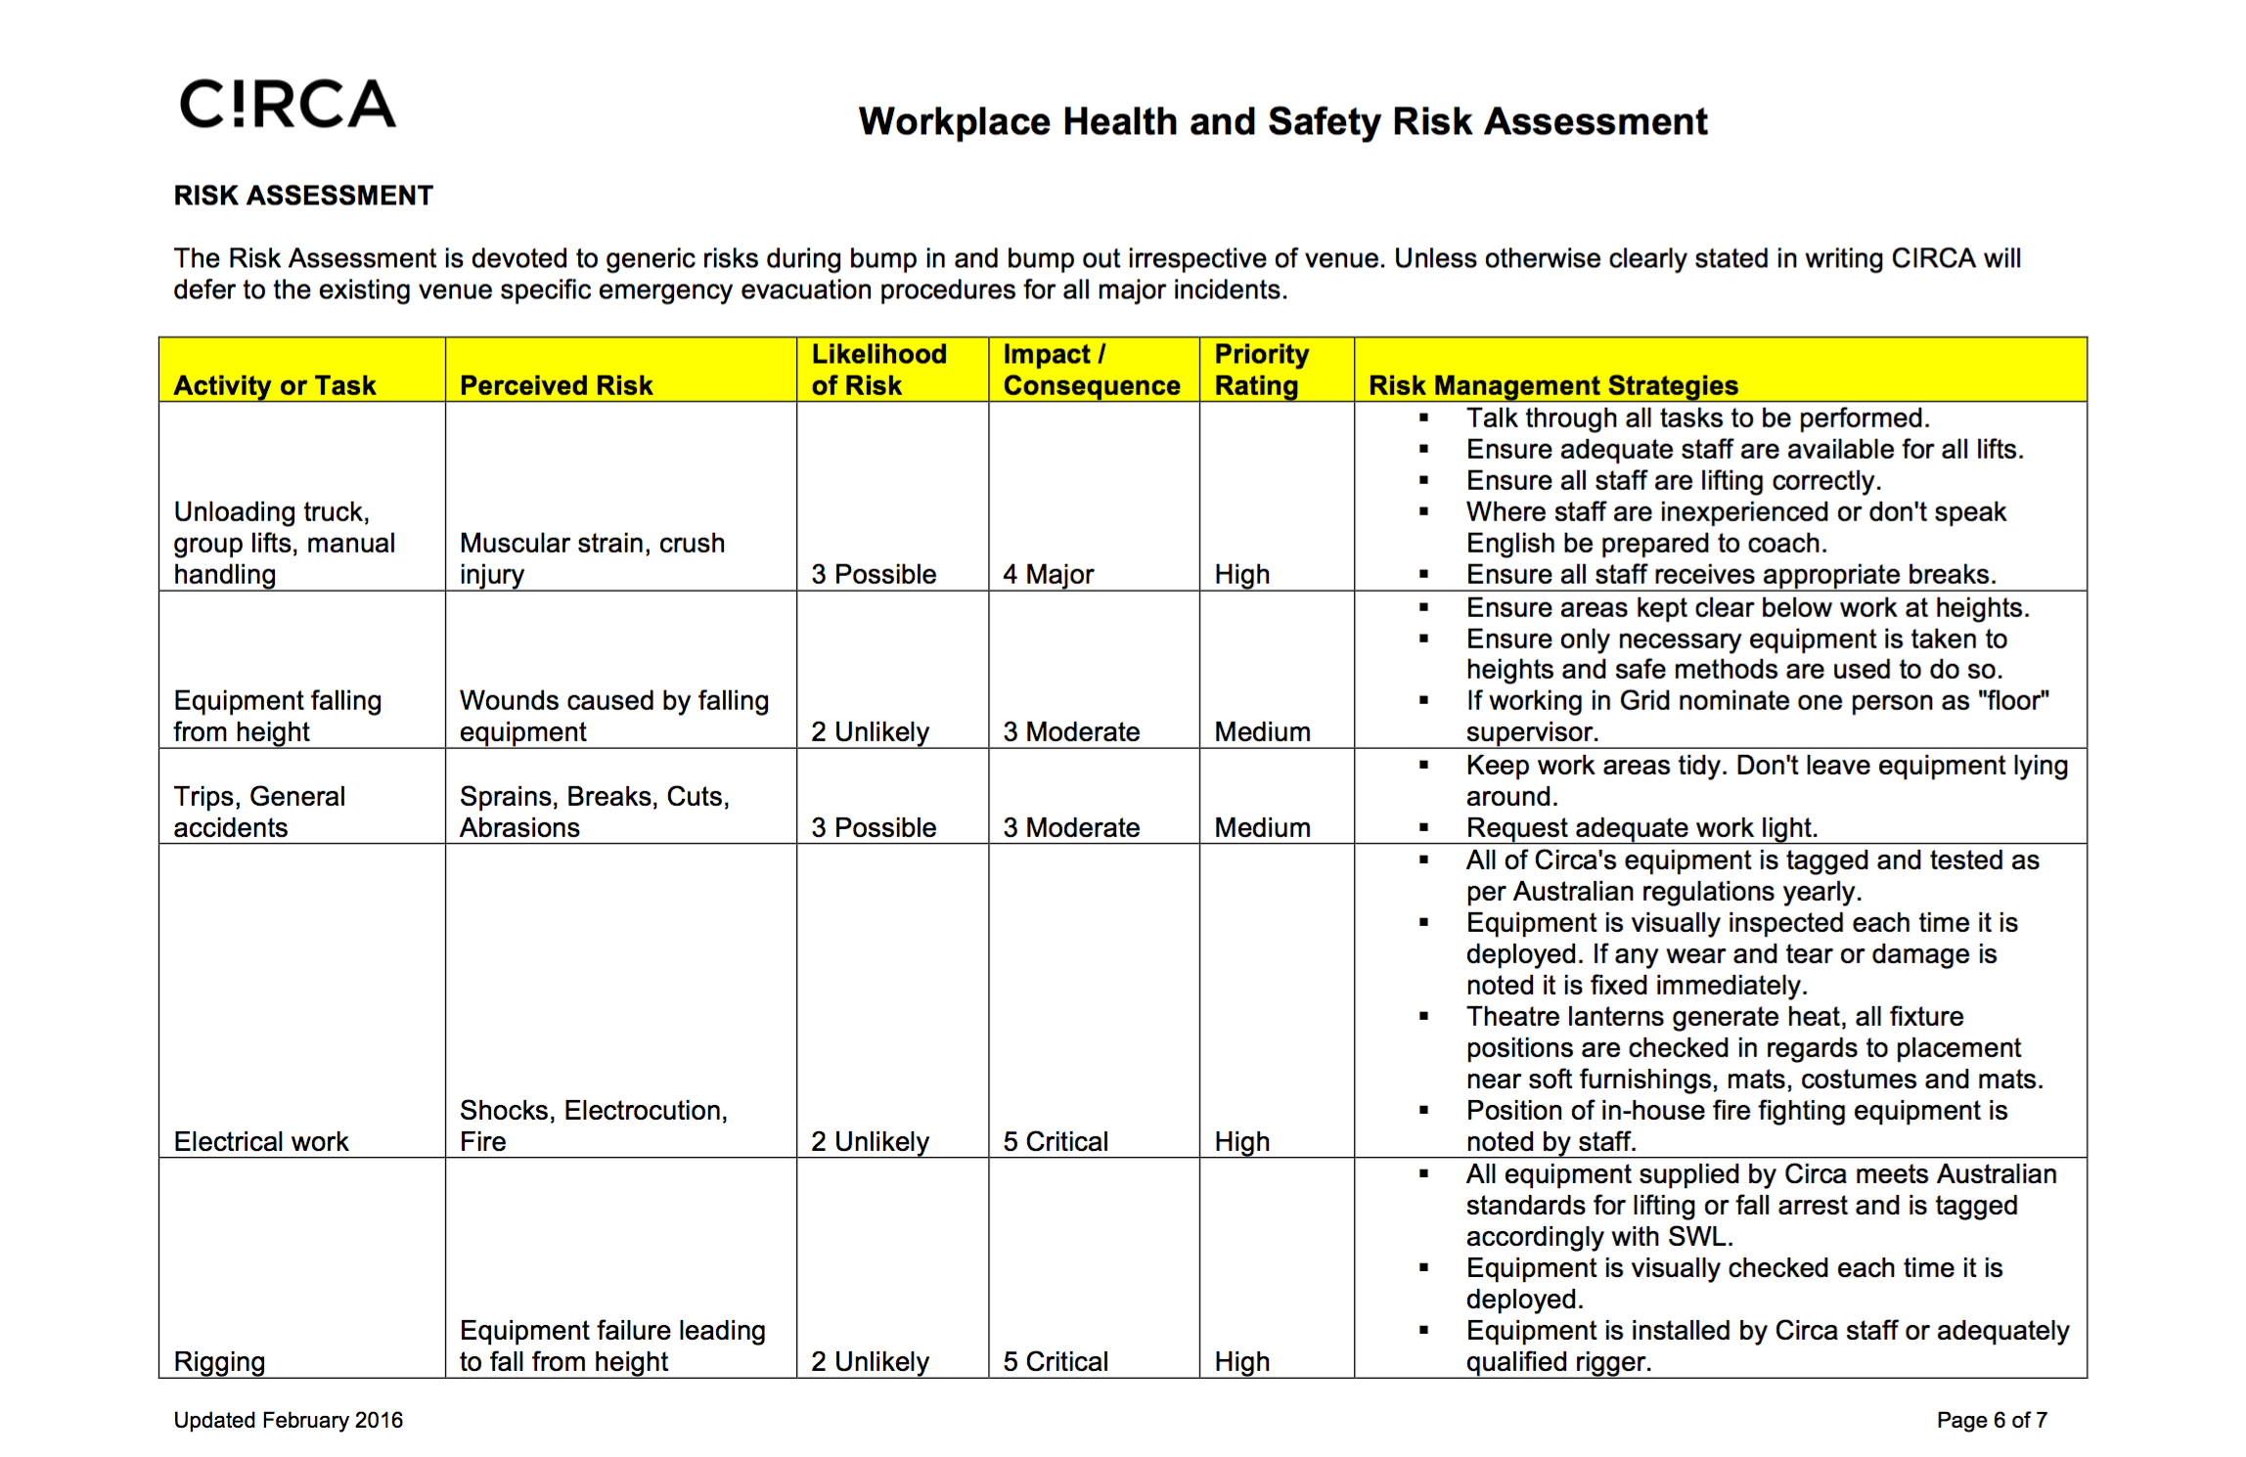

“Depart” Security and Stewarding Plan - V1
 | Mon 15th May | Get-in
1 | Security | Daytime/overnight | Production Base |  |  | 0900 - 0900
2 | Security | Daytime/overnight | Roaming |  |  | 0900 - 0900
 | Tue 16th May | Get-in/evening set-up
1 | Security | Daytime/overnight | Production Base |  |  | 24 hours
2 | Security | Daytime/overnight | Roaming |  |  | 24 hours
 | Wed 17th May | Get-in/evening set-up
1 | Security | Daytime/overnight | Production Base |  |  | 24 hours
2 | Security | Daytime/overnight | Roaming |  |  | 24 hours
3 | Security | Evening | Roaming |  |  | 1800 - 0000
 | Thu 18th May- Sun 21st May | Get-in/Dress Rehearsal
1 | Security | Daytime/overnight | Production Base/FOH |  |  | 24 hours
2 | Security | Daytime/overnight | Roaming |  |  | 24 hours
3 | Security | Evening /Dress Rehearsal | Roaming |  |  | 1800 - 0000
4 | Security | Evening /Dress Rehearsal | FOH/Roaming |  |  | 1800 - 0000
 | Mon May 22nd | Get-out
1 | Security | Daytime/overnight/until clear | Production Base/FOH |  |  | 24 hours
2 | Security | Daytime/overnight /until clear | Roaming |  |  | 24 hours
3 | Security | Evening /Dress Rehearsal | Roaming |  |  | 0900 - 1800

