Forthcoming Events
www.philiplarkin.com
AGM 2017
Saturday 3 June 2017: The Lawns Centre, Cottingham
AGM 12.00, followed by wine reception, 12.45, and buffet lunch at 1.15. Then at 2.30pm:
Philip Pullen
'On some Welsh beach my parents met' : How Sydney and Eva first 'became known'
James Booth
Kitty: Larkin's self-effacing sister
Graham Chesters
Larkin and Hull: from dump to proper ground, a rapid overview
Ticket only: Please return the enclosed booking form before Wednesday 24 May

Philip Larkin Society Distinguished Guest Lecturer 2017

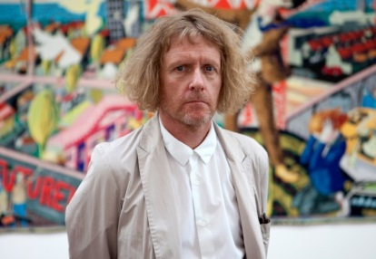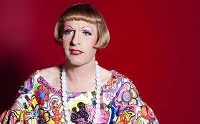
Grayson Perry CBE RA
'This frail travelling coincidence'
Wednesday 5 July 2017
The Middleton Hall, Cottingham Road, Hull, HU6 7RX

Wine reception 6.30pm. All to be seated for Grayson Perry by 7.15pm

Tickets – including a glass of wine on arrival – £20 (Students and Senior Citizens £15) available from Hull Box Office. Tel: 01482 221113

Grayson Perry is celebrated for his work in various media: from ceramic vases to tapestry and sculpture. He won the Turner Prize in 2003, famously taking the award dressed as his alter ego, Claire. He gave the BBC Reith Lecture in October 2013 and is currently Chancellor of the University of the Arts, London. He has appeared on Question Time, Desert Island Discs and Have I Got News For You, and has made a number of documentaries for Channel 4, most recently, 'All Man' in 2016, which explored what it is to be male in Britain today. He says he is looking forward in his lecture to 'exploring areas where my work bumps up against Larkin's'.

LARKIN'S HULL
A Morning Stroll around Hull City Centre
Don Lee and Gloria Gaffney
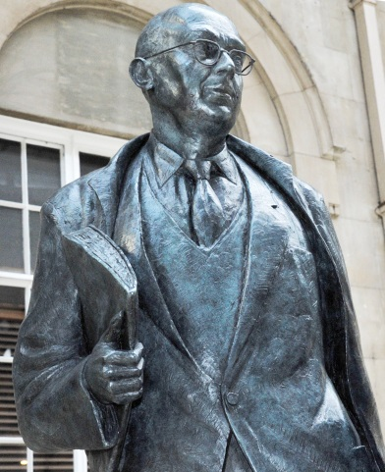 | Saturday 8 July 2017  Wednesday 9 August (Larkin's birthday)  Saturday 30 September  Meeting point: the Larkin statue at Paragon Station  Time: 10.45am  The walks will last until 12.45. Comfortable footwear is recommended.
The dates coincide with the beginning and end of the exhibition 'Larkin – New eyes each year' at the University of Hull, so members could combine a morning walk with an afternoon viewing. There will be some variation in route but some repetition, too. The emphasis will fall on locations not previously publicised in relation to Larkin. The Larkin Trail booklet is useful, and Jean Hartley's guide, Philip Larkin's Hull and East Yorkshire, gives much detail about Larkin's Hull.
Members and non-members are welcome. Those who intend to participate should contact Don Lee. Tel. 0161 273 4995. There will be no charge.

5 July – 1 October 2017
HULL UK CITY OF CULTURE 2017, PHILIP LARKIN SOCIETY AND UNIVERSITY OF HULL ARCHIVES

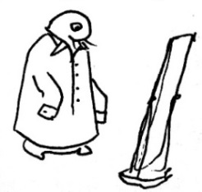  © Society of Authors | EXHIBITION  LARKIN  NEW EYES EACH YEAR
Brynmor Jones Library, University of Hull
Free admission
This biographic exhibition at the University of Hull, where Larkin spent three decades as Librarian, lifts the lid on the life of one of Hull’s most influential creatives.
Featuring his love of music, unseen letters, photography and personal possessions, 'Larkin – New eyes each year' explores connections between his life and work in Hull and the writing that led to Larkin being described as Britain’s best-loved poet.
The wider exhibition programme includes artists’ responses to Larkin’s life and work, and questions about how we choose to present ourselves now.
Curated by Anna Farthing

