COMMENTS from CARE HOMES that we are working with to respond to Turner Prize
FERNLEIGH GROUP
In response to Lubaina Himid's Five

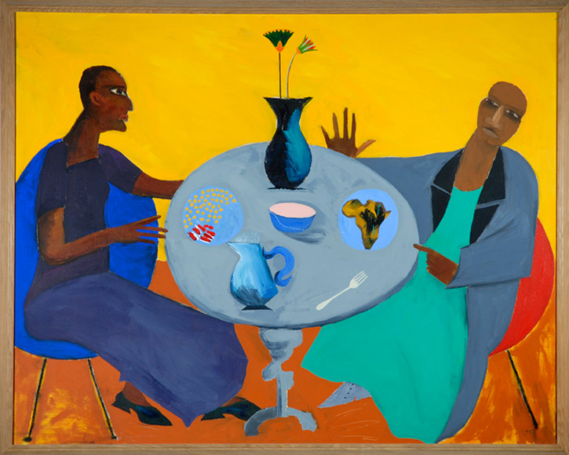

Jug.
What's that? That there?
Bacon. Beans.
I wouldn't eat it.
Banana! Looks brown. Yellow.
A jug with flowers.
There's bacon.
A fork
No knife
Bowl for sugar. Sugar bowl.
Friends. I think they're friends.
Happy.
Talking about holiday. Scotland.
Then Wales.
Home in time for pudding! 2:30!
Lovely.
Oh! The tea trolley! Time for a cuppa...

Rosalind Nashashibi's Two Tribes

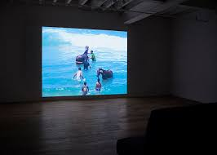

What's it supposed to be?
Green.
Green always reminds me of grass.
It's like a wall. A tree.
The trunk.
There's a bee.
The bee and the tree.

FERENS & PICKERING GROUP
Andrea Buttner’s Untitled (Three Kings)

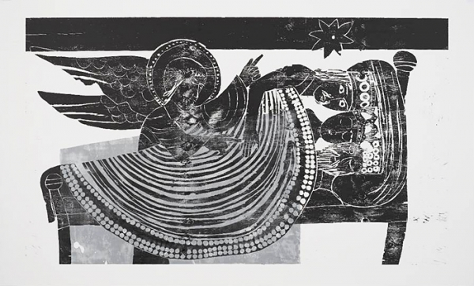

They’ve got that straight hair do, haven’t they?
A beard.
Dark blue
and it comes a bit higher.

A family together.
Could be sleeping on a child’s bed. Definitely a child’s bed.

The middle one isn’t happy. The one on the right isn’t.
The one on the left has a wickedness in him.
One is wickedness
Two is quieter
Three is wickedness
It draws me in on it.

And then there’s this one.
It has wings
And yet its not very robust.
Not and angel, let’s put it that way.

Lubaina Himid’s Five

Five fingers.
Five things on the table.
Some chocolate, I like chocolate.
A wafer.
Looks like a slaughtered animals’ head.
A bit queer.
Sugar and milk in the bowls.
Snowballs on the table.
A fork.
A yam.
A yam gone off.

Could be girlfriend and boyfriend.
Could be mother and son.

One is pushing the other away.
Having an argument, or
Making one up by the looks of his face.

Greedy
Summat funny
It’s about enjoying the interest.

