INNER COVER (front)

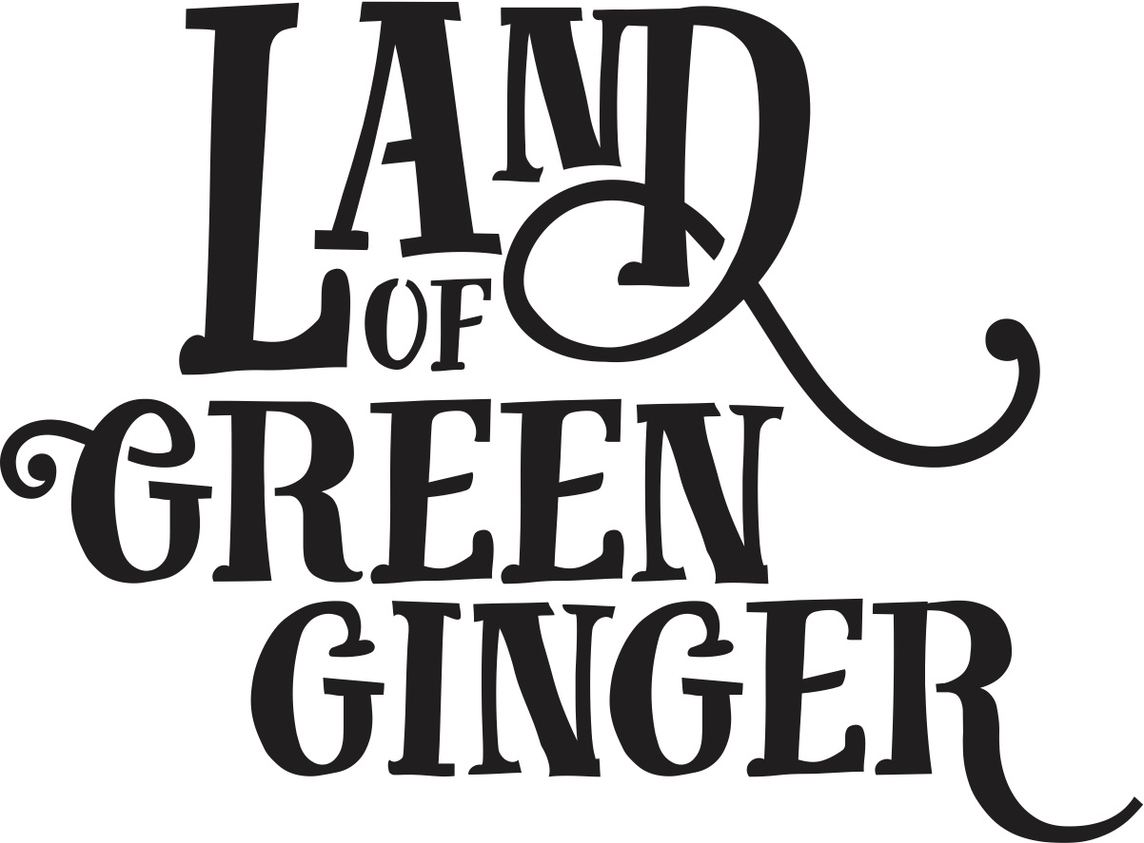

Illustrated by Katy Riddell
Written by Christina Lewis and Katy Fuller

© 2018 Hull UK City of Culture 2017 / Absolutely Cultured

All rights reserved. This book or any portion thereof may not be reproduced or used in any manner whatsoever without the express written permission of the publisher except for the use of brief quotations in a book review.

All characters and events in this publication, other than those clearly in the public domain, are fictitious and any resemblance to real persons, living or dead, is purely coincidental.

Limited Edition
First printing, 2018
Printed in the United Kingdom

ISBN No. 978-1-902039-32-9

Published by Absolutely Cultured
www.AbsolutelyCultured.co.uk

[Absolutely Cultured Logo] [Hull 2017 Logo]

Illustrated by Katy Riddell
Written by Katy Fuller and Christina Lewis
Edited by Maddie Maughan

Design by Process Black Printed and bound by Bluestorm Design & Marketing

Dedicated to

The people of Hull whose collective spirit provided constant inspiration for Land of Green Ginger.

WHOLE BOOK
Pgs 4-71

LAST PAGE
Pg 72

Background
Hull 2017’s ground-breaking community engagement project, Land of Green Ginger, invited Hull’s residents to immerse themselves in a magical citywide story, inspired by and celebrating the spirit of Hull.
Land of Green Ginger was presented as a series of events or Acts of Wanton Wonder united under an overarching narrative. The individual Acts were developed and delivered with artists who worked both independently and in collaboration to bring new kinds of art and culture into the neighbourhoods outside the city centre.
Six Acts of Wanton Wonder transformed communities across the city into places of wonder, delight, magic and possibility.
This book is the seventh and final Act of the Land of Green Ginger.
It has been delivered to residents and schools across the city as a record of the project that took place and as a keepsake for the people whose lives were touched by the magic of Land of Green Ginger.
Land of Green Ginger was delivered and produced by Hull 2017, the company which delivered the UK City of Culture programme and now continues as permanent organisation Absolutely Cultured.

Acknowledgements

To the artists who created the live Acts:
Act I: 7 Alleys by Periplum
Act II: The Gold Nose of Green Ginger by Joshua Sofaer
Act III: The Longhill Burn by And Now:
Act IV: Re-Rediffusion’s Voice Park by Aswarm
Act V: Micropolis by The McGuires
Act VI: Land of Green Ginger Unleashed by Macnas in collaboration with And Now:
To Simon Sharkey who helped to create the Land of Green Ginger and keep it alive when it threatened to evaporate.

In memory of Bill Mitchell, of Wildworks, who gifted the phrase “Acts of Wanton Wonder”

To the Green Ginger team who lived, breathed and dreamed this project.

INNER COVER (back)

