Larkin in 25 Objects
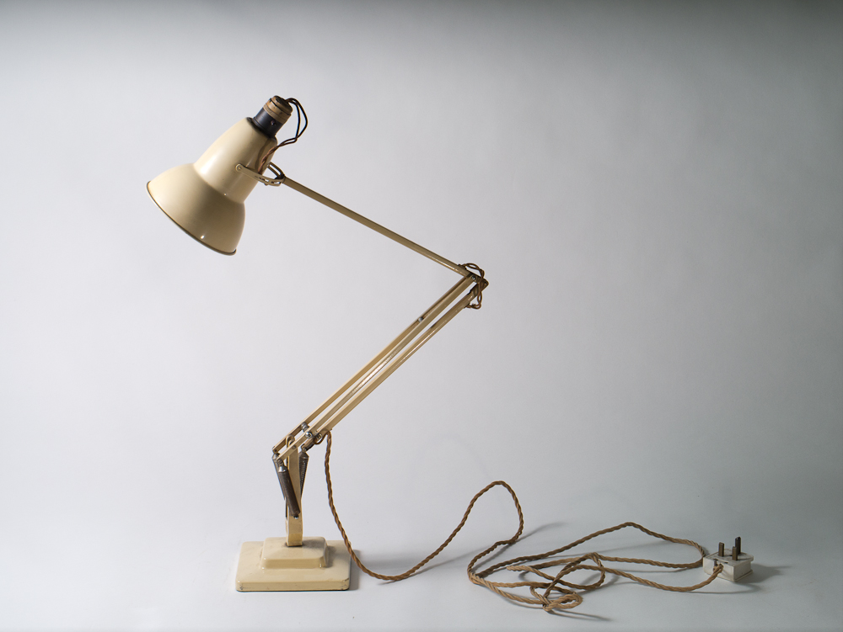
An exhibition of photographs of Larkinalia taken by Dennis Low. Text by James Booth. Organised by Graham Chesters.
Hull Central Library, 6th-19th September 2013
10.30 a.m. to 4.30 p.m., Monday to Saturday
