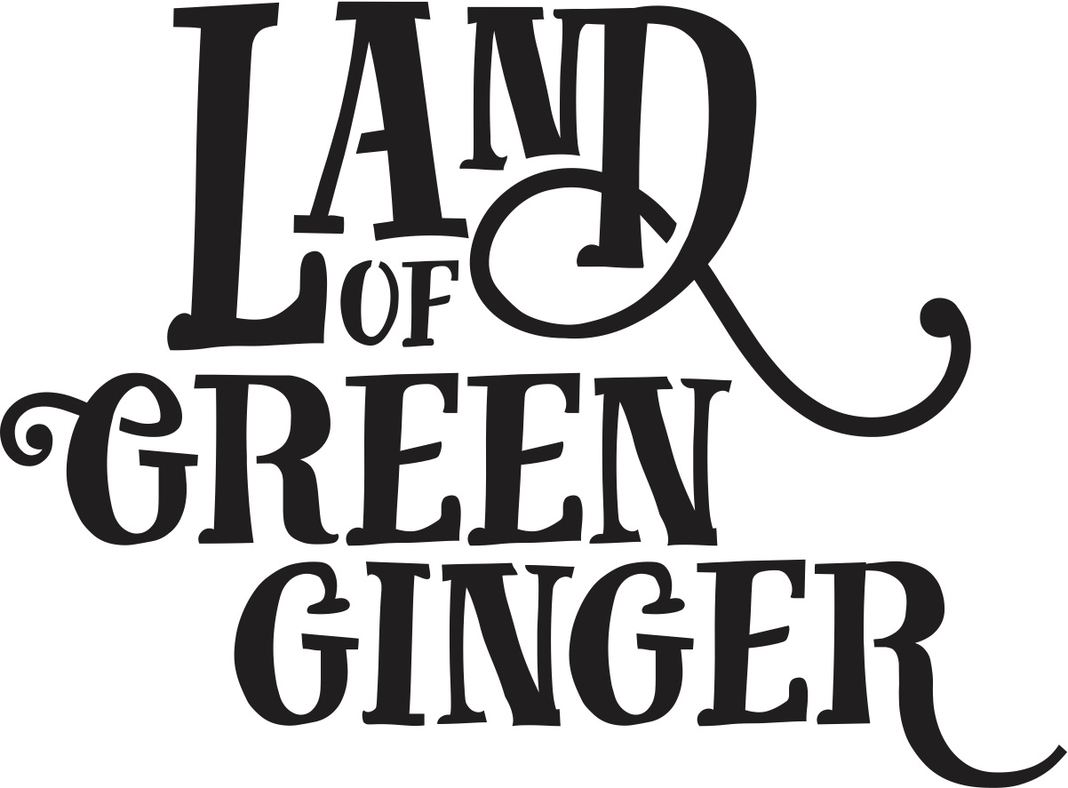

The Longhill Burn

Thank you for being part of The Longhill Burn. Please provide us with the following information.
First Name
Surname
Address
Email Address
Telephone
Date of Birth

Emergency Contact Details
Name
Relationship
Phone number

Would you be happy to be contacted to take part in research about your experience with The Longhill Burn?

Yes No

Do you agree to let us photograph/film you as part of the Guild of Commoners for documentation purposes?

Yes No
The following questions will enable us to see how well we are reaching a broad range of people with our opportunities, as well as how this compares to the general population locally and beyond. All data provided will remain anonymous and will be processed and stored in line with the Data Protection Act 1998.
Postcode: ___________________
Age
0-2 years 25-29 years 60-64 year
3-5 years 30-34 years 65-69 years
6-10 years 35-39 years 70-74 years
11-15 years 40-44 years 75+ years
16-17 years 45-49 years Prefer not to say
18-19 years 50-54 years
20-24 years 55-59 years
Gender
Male Female Transgender
Gender non-conforming Prefer not to say
Disability
Are your day-to-day activities limited because of a health problem or disability which has lasted, or is expected to last, at least 12 months?
Yes – limited a lot Yes – limited a little
No Prefer not to say
Ethnic Origin
What is your ethnic origin?
A. White
Welsh / English / Scottish / Northern Irish / British
Irish
Gypsy or Irish Traveller
Any other White background (Please specify):
B. Mixed / multiple ethnic groups
White and Black Caribbean
White and Black African
White and Asian
Any other Mixed / multiple ethnic background (Please specify):

C. Asian / Asian British
Indian
Pakistani
Bangladeshi
Chinese
Any other Asian background (Please specify):
D. Black / African / Caribbean / Black British
African
Caribbean
Any other Black / African / Caribbean background (Please specify):
E. Other ethnic group
Arab
Any other ethnic group (Please specify):

