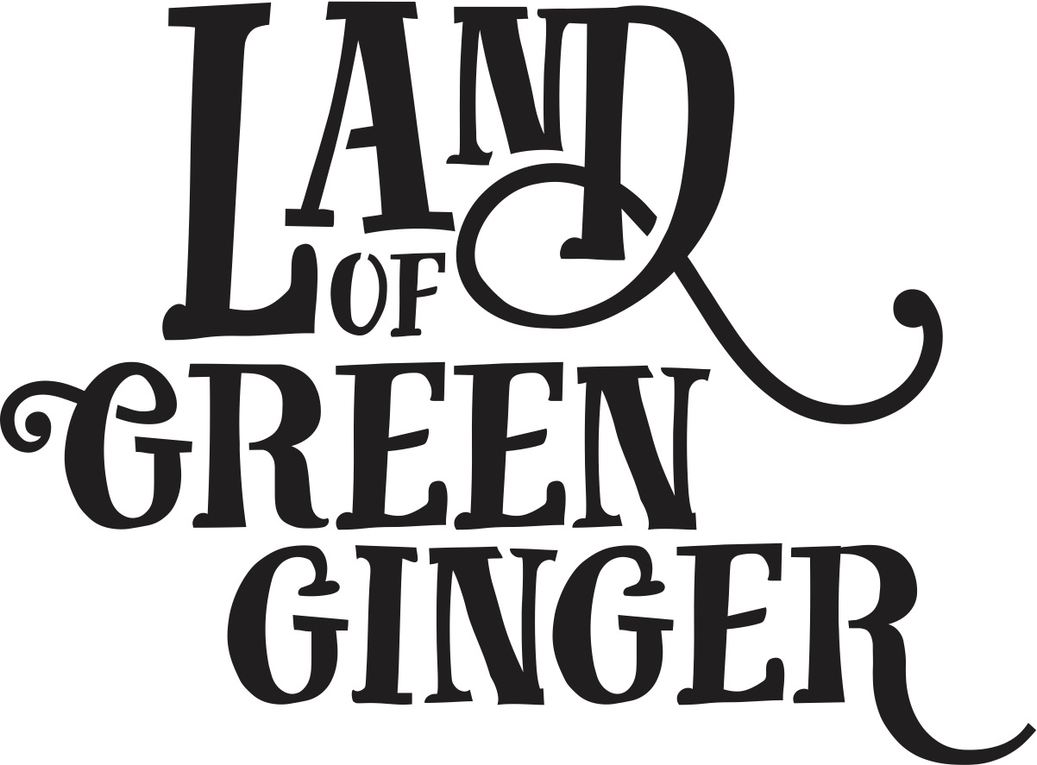

Book

Project Plan

Summary
Throughout the year Hull 2017’s ground-breaking community engagement project, Land of Green Ginger, invited Hull’s residents to immerse themselves in a magical citywide story, inspired by and celebrating the spirit of Hull.
In 2018, the Land of Green Ginger story will culminate in a seventh Act of Wanton Wonder – a beautiful book that will be delivered to every household in Hull.
The Land of Green Ginger book will tell the stories of the project, the narrative as it took place and the stories of the local people it touched. It will be the record of City of Culture as lived by the residents of the city and as informed by their imagination and creativity.
This project plan outlines the formats, timescales and budget for delivery of the Land of Green Ginger book.

Quantities
x118,500 for postage to reach every home in Hull.
x1,500 extra books printed for potential workshops.

OR

50,000 for all areas of LOGG Projects including city centre and enough for distribution at The Big Malarkey Festival
30,000 for schools

Total 80,000

Style
260x210mm (the same size as “hello hull” magazine)
60 pages
300gsm outer cover
120gsm inners
Full colour throughout.
Special finish on cover.
Special insert – TBC.
PUR bound.

Timescales*
The book will be distributed in the week of 18 June to tie in with a live moment/launch at The Big Malarkey Festival which takes place Thursday 20 – Sunday 24 June 2018.

To ensure delivery in the week of 18 June, the following deadlines will be in place:

Date | Action | Lead
W/C 29 January | Request for initial sketch submissions from contacted illustrators | Maddie, Illustrators
W/C 5 February | Initial sketches submitted by contacted illustrators | Maddie, Illustrators
W/C 5 February | Illustrator shortlisting | Maddie & Katy
W/C 12 February | Illustrator appointed | Maddie, Katy, Illustrator
W/C 12 March | First draft manuscript complete | Katy
W/C 12 March | Draft manuscript and full brief delivered for illustrator to start work | Maddie, illustrator
W/C 26 March | First draft sketches complete, feedback given | Illustrator
W/C 9 April | Final manuscript complete and submitted to illustrator | Katy
Monday 30 April | Quantity of books for print decided and addendum for print/delivery drawn up | Marketing lead
Monday 7 May | Final illustrations complete.  Illustrations, manuscript and design brief submitted to designer. | Illustrator  Marketing lead
Monday 7 May | Printing booked. | Marketing lead
Wednesday 16 May | Design work complete. Designer begin artworking. | Designer
Monday 21 May | Artworking complete | Designer
Monday 21 May | Book sent to print. | Marketing lead
Monday 21 May | Distribution company booked. | Marketing lead
w/c 18th June | Print complete and delivered to distribution agency for delivery to homes w/c 25th June | Printer/ Distribution agency
Wednesday 20 – Sunday 24 June | Moment at The Big Malarkey Festival
W/C 25th June | Distribution | Distribution agency

*Maddie – If you want to have the book ready and distributed BEFORE the Big Malarkey Festival, you’ll need to move all the deadlines forward by 2 weeks to ensure it makes this deadline.

Budget

To be fully scoped – quotes with us in early January 2018.

Writer/Illustrator | £15,000
Design | £10,000
Print | £60,000
Postage | £50,000
Total | £135,000

