VOICE RECORDER STEP-BY-STEP GUIDE
The below is a step-by-step guide for how to use the voice recorder, to feedback after your shift, if this is your preferred method.
- Pick one of the phones
- To turn on: click the top button (small button) on the right side of the phone
- The screen should light up
- Swipe up the screen from bottom to top and key pad should appear
- Enter 2017 and
- You should then be on the main screen
- If you can’t see an app called VoiceDrop swipe the screen to the right

- Click on this icon and you should see a time counter as below, but with 00:00:00
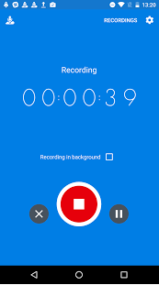
- To record your feedback hit the red button that will have the image of a microphone
- Deliver your feedback using the prompt cards provided to help you
- When you have finished hit the red stop button
- You will then see the following screen
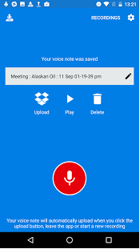
- Hit the Upload button that looks like an open box
- It’s the ready for the next person.

