PRSF NEW MUSIC BIENNIAL
HULL
29th JUNE to 2nd JULY 2017
ARTIST PACK
ARTIST: Sam Lee
ARTIST CONTACT (Mobile number): TBC – PROMOTER TO CONFIRM
VENUE: Hull Minster
Address: Market Pl, Hull HU1 1RR, UK
Phone: +44 1482 224460

LOADING IN FROM: North Church side, (Purple P)
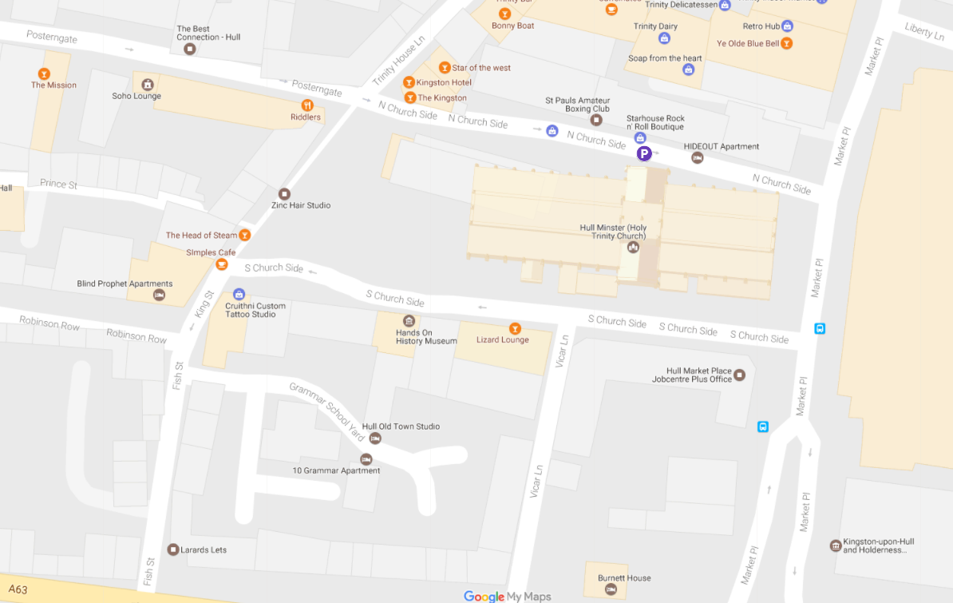
PARKING REQUIREMENT and LOCATION:
TBC – PROMOTER TO CONFIRM
PERSONNEL
STAGE MANAGER (Primary contact show weekend only): Ben Pugh - 07970 950552
PRODUCTION MANAGER: Gareth Hughes – 07733112272
PRODUCTION ASSISTANT: Joanna Morley – 07725 942808
VENUE CONTACT: Jane Owen

DATE AND TIME OF PERFORMANCE: Sunday 2nd July 20:00 (45mins)
PRODUCTION SCHEDULE:
FRIDAY 30 JUNE
08:00 - 00:00 (ACCESS) | 09:00 - 16:00 | Sound in | HPSS
 | 13:00 - 20:00 | Daniel Elms - rehearsal | Dan Elms
 | 21:00 | Box office on site | David Watson
 | 21:45 | Doors | SM
 | 22:15 | Daniel Elms - PERFORMANCE | Dan Elms
 | 23:00 | Finish | SM
 | 00:00 | Cleared - SL/SR screens derigged | HPSS
SATURDAY 1 JULY
20:30 | Piano delivered | From Fruit
SUNDAY 2 JULY
08:00 - 00:00 (ACCESS) | 09:00 - 12:00 | Risers configured for Peter Edwards brass | HPSS
 | AM | Piano tuned | ???
 | 12:15 - 13:00 | Artists arrive - Peter Edwards | Peter Edwards
 | 13:00 - 15:45 | Rehearsal - Peter Edwards | Peter Edwards
 | 15:45 | Doors | FOH
 | 16:15 | PERFORMANCE - Peter Edwards | Peter Edwards
 | ??? Sam Lee
 | ??? Sam Lee
 | 19:30 | Doors | FOH
 | 20:00 | PERFORMANCE - Sam Lee | Sam Lee
 | 21:30 | Cleared | FOH
 | 21:30 - 00:00 | LX and sound out | HPSS
MONDAY 3 JULY
08:00 - 12:00 (ACCESS) | 08:00 - 12:00 | Staging out | HPSS
 | AM | Piano out | ???

TECHNICAL
Sound
FOH Control
1 Yamaha LS9-32
Speaker System
6 L Acoustics - KARA
4 L Acoustics - KARA-ANGARMEX
2 L Acoustics - KARA M-Bump
2 L Acoustics - SB18
2 L Acoustics LA8
Monitor System
2 L Acoustic 108P
2 Rane 4 Channel Headphone Amplifier
8 Sennheiser HD201 Headphones
10 6.35mm Headphone Extension Cable
Microphones
4 Shure SM58
4 Microphone Stand - Tall
3 d:vote DPA 4099
2 DPA Clip for Piano (PC4099)
1 DPA Clip for Sax and Trumpet (STC4099)
3 DPA DAD 6001 XLR 48 volt adapter
1 Sennheiser e906
1 Microphone Stand - Short
Other Equipment
1 63A 3-Phase Mains Distro #3
1 63A 1-Phase Cable 10m
Staff
1 Engineer - FOH
1 Local Crew
1 Local Crew
AV
Projection
1 Truss Hammer
1 Christie Lens ILS 0.73SX+/0.67HD
1 Christie Roadster HD20K- J Series Projector
1 8m x 4.5m Contrast Grey Projection Surface (Widescreen)
4 Litec QX30 - Corner Dado Section
2 Litec QX30S - 0.5m Truss Section
2 Litec QX30S - 1m Truss Section
4 Litec QX30S - 2m Truss Section
6 Litec QX30S - 3m Truss section
32 Litec QX30S - Spigot
128 Litec QX30S - Split Pin
128 Litec QX30S - Truss Pin
2 Geni Super Lift
1 Custom Screen Surround
Sources
1 Apple iMac 21.5"
Processing
1 Black Magic ATEM 1 M/E Production Studio 4K
2 Black Magic Mini Converter - HDMI to SDI 4k
2 Black Magic - Switching PSU for Mini Convertor
Staff
1 Engineer – AV
Lighting
Control
1 Avolites Tiger Touch Pro Console
1 Avolites PowerCube
1 100m Lighting Multicore
Fixtures
4 Alu LED Par RGBW 18x 8W - 40deg
6 Robe Pointe
6 Robe Robin 600 LED Wash
6 ETC Source Four Junior Zoom 25 - 50 Degree
12 Prolights SmartBat+
Rigging
2 Litec QX30S - 3m Truss section
Misc
1 63A 3-Phase Cable 23m
Transportation
1 7.5T Box Van
1 Engineer - Lighting
1 Lighting Tech
RIDER:

BACKLINE:
ACCREDITATION
David & Alice Porter (Directors)
Steve & Sam Shaw (Directors)
Peter & Lorraine Boardman (Directors)
Wes Zepherin (Director)
Kirsty & Gary Halliday (Marketing)
Ben Pugh (Production)

