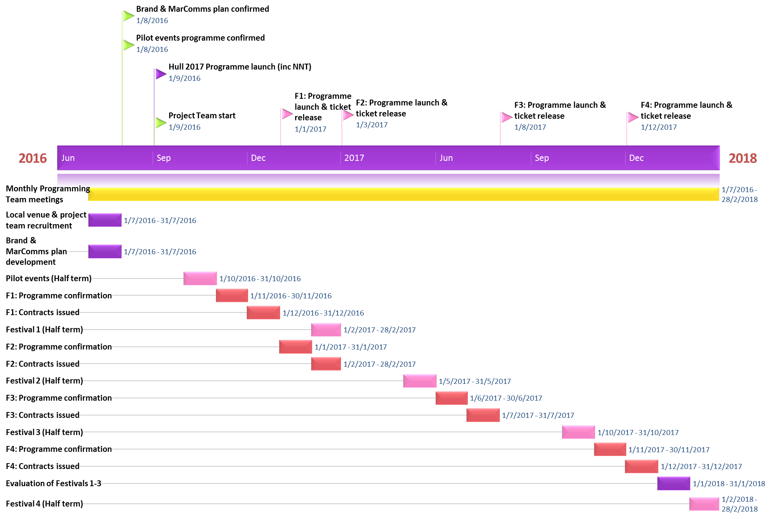
NETWORK NEIGHBOURHOOD TOURING

