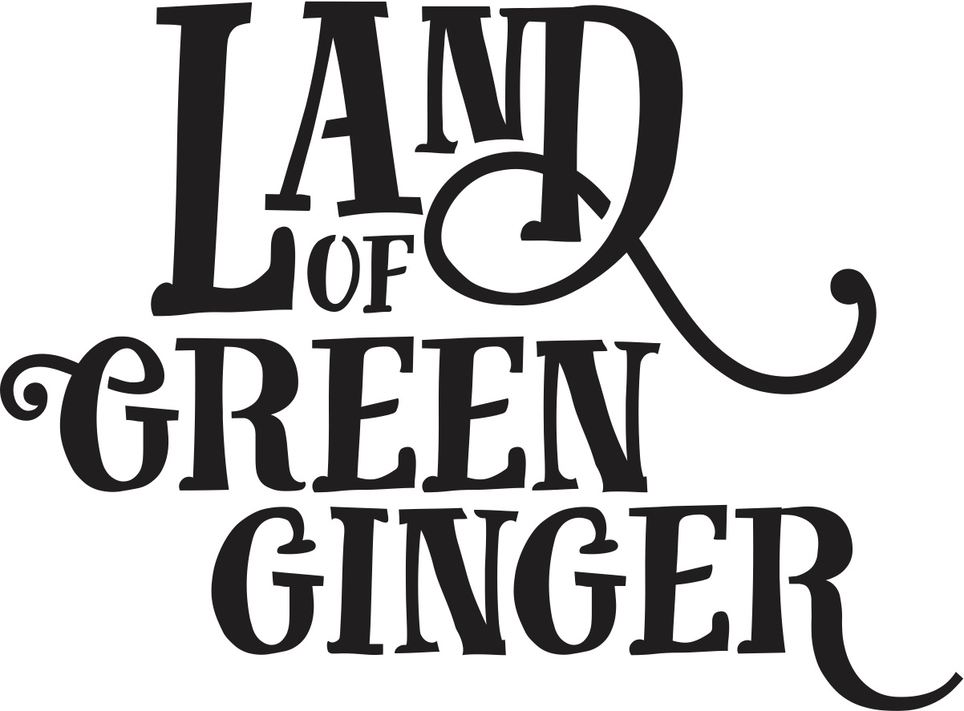

PRESS RELEASE
- The seventh act of wanton wonder, this book tells the stories of the mysterious Land of Green Ginger and the stories of the local people it touched. It is a record of Hull UK City of Culture 2017 as lived by the residents of the city and as informed by their imagination and creativity.
- Throughout the year Hull 2017’s ground-breaking community engagement project, Land of Green Ginger, invited Hull’s residents to immerse themselves in a magical citywide story, inspired by and celebrating the spirit of Hull.
- Limited edition print which will be sent out to schools and households in Hull. One per household
- Line about illustrator Katy Riddell and Big Malarkey festival?

- Include a line about not reselling the book?

- For more information please see website here:

WEBSITE FAQS
- When will I receive my copy of the LOGG book?
Books will be delivered to all households within the Hull boundary between the 15th and 22nd June 2018
- Where can I buy a Land of Green Ginger Book?
Books are limited edition. One per household in Hull. Books are not available to purchase separately.
Land of Green Ginger Merchandise will be available at The Big Malarkey Festival 23rd – 24th June at East Park ??
- Why did I receive the Land of Green Ginger Book?
For the seventh act of wanton wonder from the Land of Green Ginger, limited edition books are being delivered to every single household in Hull.
- Why wasn’t a Land of Green Ginger Book delivered to my house?
Households outside the Hull catchment area are not eligible for a copy of the book.
- How can I get another copy of the Land of Green Ginger Book?
Books are limited edition. One per household in Hull. Books are not available to purchase separately.
- I don’t want to keep my copy of the Land of Green Ginger Book, how can I return it?
- Why hasn’t my school received a crate from the Land of Green Ginger?

TEAM INBOX

If you are getting in touch with a query about the Land of Green Ginger’s latest act of Wanton Wonder, please refer to the FAQs found on our website here:

TIMELINE

15/06/2018 | Announcement of the books arriving at Hull household
15/06/2018 | Twitter announcement that Katy is the LOGG illustrator
15/06/2018 | Press release to reference live drawing by LOGG illustrator Katy Riddell at Big Malarkey Festival Saturday 23rd and Sunday 24th June  Q&A with Katy and Chris Riddell  10am, Sunday 24 June  Illustrator, Katy Riddell speaks about her work to date in this engaging conversation with her father - award winning illustrator, Chris Riddell. Since graduating from Manchester Metropolitan University with a BA Hons in Illustration and Animation, Katy has worked on a number of commissions including Pongwiffy by Kaye Umansky, Midnight Feasting by A.F. Harold and Ever After at the Oxford Story Museum. Katy has most recently been working on an exciting project for Hull, which will be announced just before the festival. Come along to find out more!  Illustrating Workshop with Katy Riddell  11am, Sunday 24 June  Ages 7-12  Join Katy Riddell in an interactive illustrating workshop, inspired by her most recent project. In this 45 minute drop-in session Katy will give participants the opportunity to learn how to work closely with a story to bring its characters and settings to life.

