PRSF NEW MUSIC BIENNIAL
HULL
29th JUNE to 2nd JULY 2017
ARTIST PACK
ARTIST: Anna Meredith
ARTIST CONTACT (Mobile number): TBC – PROMOTER TO CONFIRM
Management – ?
VENUE: Albermarle Music Centre
Address: Albermarle Music Centre, 60 Ferensway, Hull HU2 8LN
Phone: 01482 318800
LOADING IN FROM:
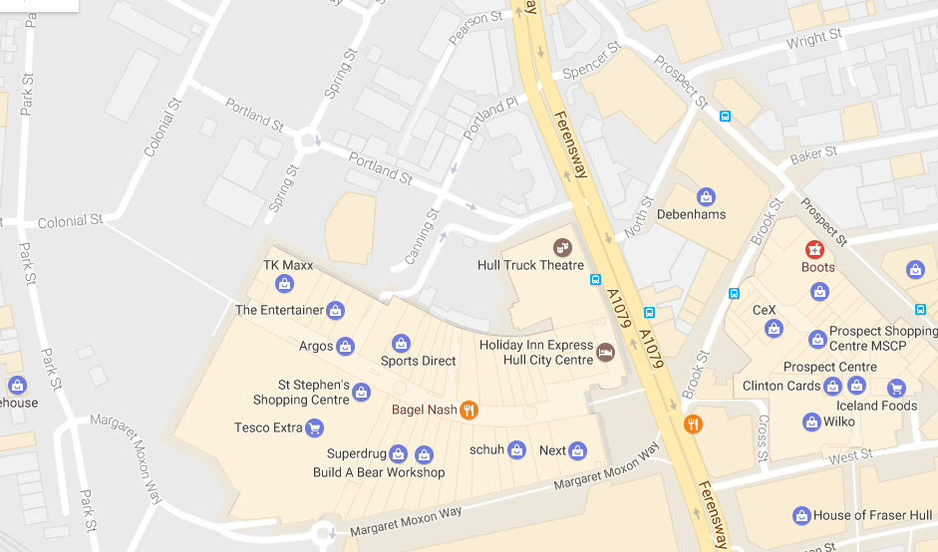

PARKING REQUIREMENT and LOCATION:
TBC – PROMOTER TO CONFIRM
PERSONNEL
STAGE MANAGER (Primary contact show weekend only): ??
PRODUCTION MANAGER: Gareth Hughes – 07733112272
PRODUCTION ASSISTANT: Joanna Morley – 07725 942808
VENUE CONTACT: ??

DATE AND TIME OF PERFORMANCE: Friday 30th June 17:30 (45mins)
PRODUCTION SCHEDULE:
THURSDAY 29 JUNE
09:00 - 18:00 (ACCESS) | 09:00 | Stage manager on site
 | DAY | Delivery of Harmonium (Gavin Bryars)
 | DAY | Set up dressing rooms
 | DAY | Dressing and branding
 | DAY | BBC to park up to the corner / rear
 | 12noon | Tech set up
 | 12noon | Set up Anna Meredith - percussion set up (see also Hannah Peel plot)
FRIDAY 30 JUNE
09:00 - 23:00 (ACCESS) | 09:00 | Stage manager on site - set for Anna Meredith
 | 09:00 | BBC OB in
 | 10:00 | Anna Meredith - Artists arrive
 | 11:00 - 12:00 | Anna Meredith - Set up
 | 13:00 - 16:00 | Anna Meredith - rehearsal
 | 16:30 | Box office on site
 | 17:00 | Doors
 | 17:30 | Anna Meredith PERFORMANCE
 | 18:15 | FINISH
 | 18:30 - 18:45 | Reset for Gavin Bryars
 | 18:45 | Rehearsal Gavin Bryars
 | 19:00 - 21:00 | Moulettes rehearsal - rehearsal - Rivers and Railways
 | 19:45 | Doors
 | 20:00 | Gavin Bryars - PERFORMANCE
 | 20:45 | FINISH
 | 21:00 - 23:00 | Reset for Hannah Peel and Laurence Crane
 | 21:00 - 23:00 | Reset Dressing rooms
SATURDAY 1 JULY
09:00 - 21:00 (ACCESS) | 09:00 | Stage manager on site
 | 10:00 | Artists arrive - Laurence Crane
 | 11:00 - 12:15 | Laurence Crane - rehearsal
 | 12:00 | Box office on site
 | 12:15 | Doors
 | 12:30 | Laurence Crane - PERFORMANCE
 | 13:15 | FINISH
 | 13:30 | Hannah Peel - Artists arrive - rehearsal synthesisers and percussion
 | 15:30 | Hannah Peel - Brass arrives - rehearsal
 | 16:15 | Doors
 | 16:30 | Hannah Peel - PERFORMANCE
 | 17:15 | FINISH
 | 17:30 | Set tech for Jocelyn Pook
 | 21:00 | Clear
SUNDAY 2 JULY
09:00 - 21:00 (ACCESS) | 09:00 | Stage Manager on site
 | 10:00 | Artists arrive - Jocelyn Pook
 | 10:00 - 14:00 | Jocelyn rehearsals
 | 14:00 | Box office on site
 | 14:45 | Doors
 | 15:00 | Jocelyn Pook - PERFORMANCE
 | 15:45 | FINISH
 | 16:00 - 20:00 | Clear and derig

TECHNICAL
Sound
FOH Control
1 Midas Pro 2C - Live Audio System

Speaker System
6 L Acoustics - ARCS
8 L Acoustic ARCS - ARCOUPL
2 Ratchet Strap (Black) - 7.5m 2T
4 L Acoustics - SB28
1 L Acoustics LA8 Rack (4 - Way)
2 NL4 Speakon Cable 4mm 20m
2 NL4 Speakon Cable 4mm 10m
2 NL4 Speakon Cable 4mm 5m
4 NL4 Speakon Cable 4mm 0.5m
3 NL4 Sub Split Cable

Monitor System (Up to 4x Mixes)
4 L Acoustic 115XT HiQ

Microphones
1 Shure ULXP Beta58 Handheld Radio System - CH38

Misc
1 63A 3-Phase Cable 20m
1 63A 3 Phase Mains Distro #5
1 Backline Power Prep - Standard

Staff
1 Engineer - FOH
1 Engineer – Systems
AV
Material
1 Blackmagic Design HDMI-SDI Converter
1 Blackmagic Design SDI-HDMI Converter
1 Black Magic ATEM 1 M/E Production Studio 4K
Staff
1 Engineer - AV

Lighting
Provided by House
Staff
1 Engineer – Lighting
Headphone Monitoring – Tubular Brass
Material
1 Art Head Amp 6
1 Closed Back Headphones
1 10m Balanced Jack Cable
1 5m Balanced Jack Cable
1 Jack to Jack Coupler
1 3.5mm to 6.35mm Jack Adapter
2 BSS AR133 DI
Microphones – Jocelyn Pook
RF
1 DPA 4088F - Headset Microphone
1 DPA DAD6034 - Microdot to 3.5mm Jack
1 Sennheiser EW512 G3 - Belt Pack System - Range GB
Microphones
3 Neumann KMS-105
3 AKG C451
3 AKG C414ULS
10 Microphone Stand – Tall
Microphones – Tubluar Brass
Material
6 BSS AR133 DI
2 AKG C451
1 Shure Beta 57
3 Microphone Stand – Tall
Microphone – Gavin Bryars
Material
1 Sennheiser e609
2 DPA DAD 4099-BC
1 DPA Clip for Violin and Mandolin (VC4099)
1 DPA Clip for Cello (CC4099)
2 DPA DAD 6001 XLR 48 volt adapter
1 Shure Beta 87
2 Shure SM57
2 BSS AR133 DI
1 Microphone Stand - Tall
2 Microphone Stand - Medium
1 Microphone Stand - Short

RIDER:
TBC
BACKLINE:
BACKLINE | 3 Full drumkits; | ALBEMARLE
 | Kit BD + pedal | ALBEMARLE
 | Floor Tom | ALBEMARLE
 | Snare Drum + stand | ALBEMARLE
 | 2 kit toms (high / medium) | ALBEMARLE
 | Hi-Hat | ALBEMARLE
 | Crash Cymbal | ALBEMARLE
 | Drum stool | ALBEMARLE
 | Drum mat (depending on the flooring! On wooden floors things can easily slip and this is very involved with pedals etc.) | ALBEMARLE

ACCREDITATION
David & Alice Porter (Directors)
Steve & Sam Shaw (Directors)
Peter & Lorraine Boardman (Directors)
Wes Zepherin (Director)
Kirsty & Gary Halliday (Marketing)
Ben Pugh (Production)

??Artists are Nick Blacka, Rob Turner, Chris Illingworth,
Sound Joe Reiser
Manager Kerstan Mackness

