Works for Hull:

Framed drawings for The Deep:

Tania Kovats
Evaporation (Black) 19, 2014
ink, salt, water on blotting paper, framed
42 x 30 cm, 16.5 x 11.8 in
H7014

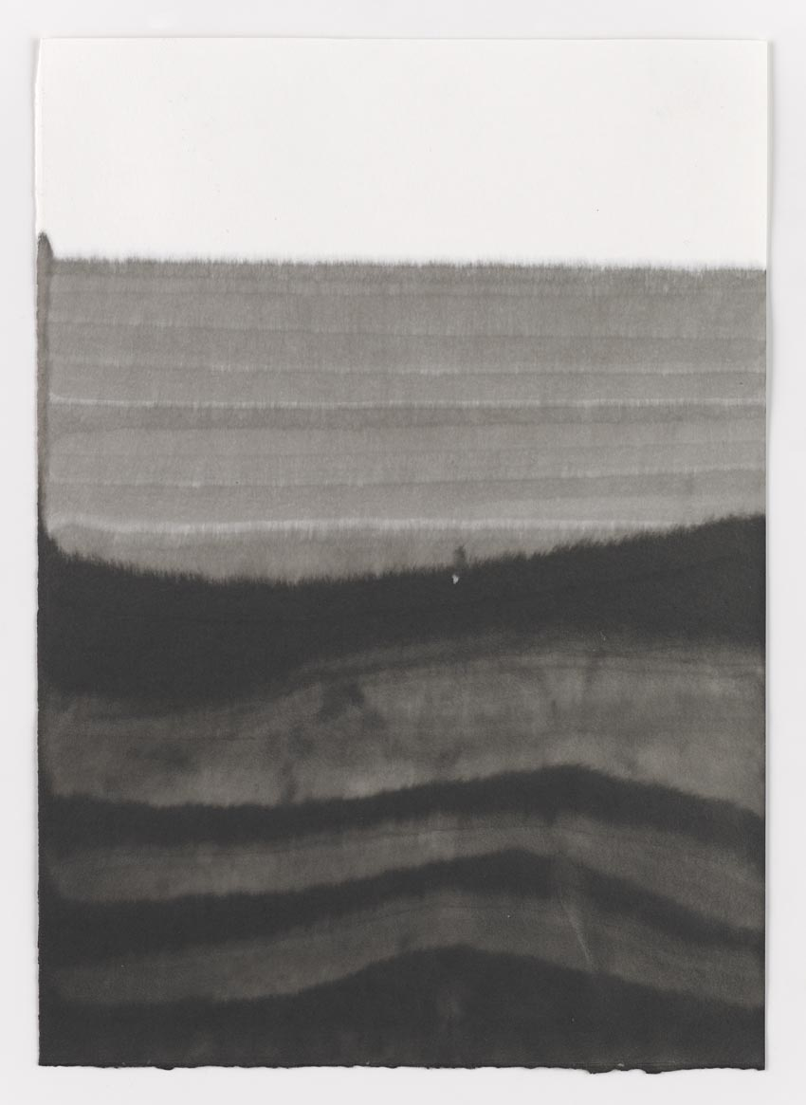

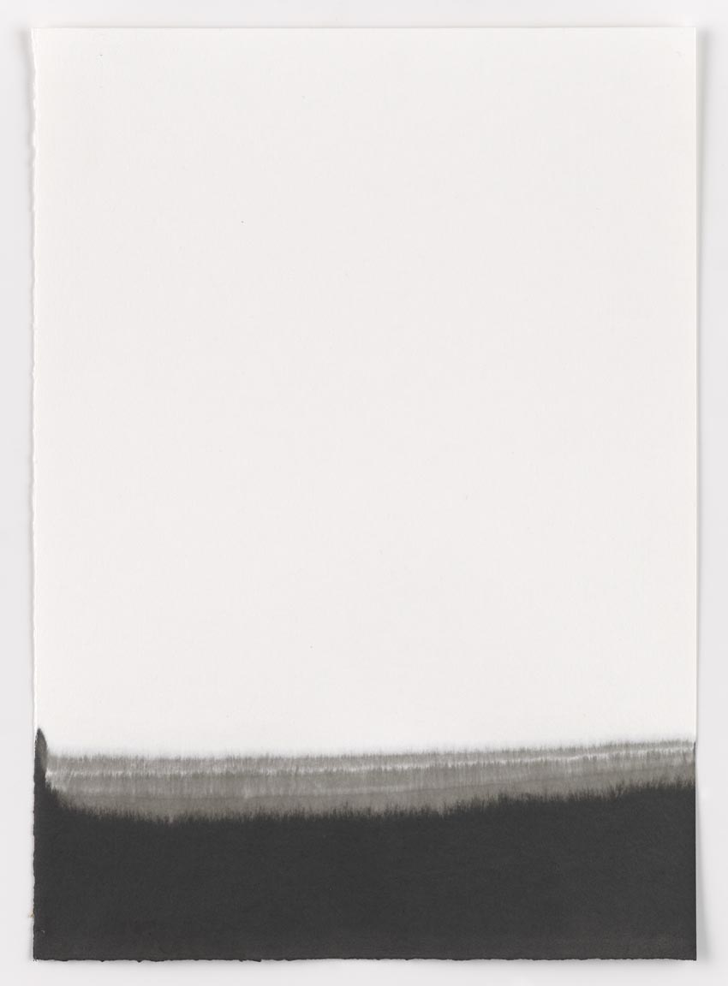

Tania Kovats
Evaporation (Black) 20, 2014
ink, salt, water on blotting paper, framed
42 x 30 cm, 16.5 x 11.8 in
H7015

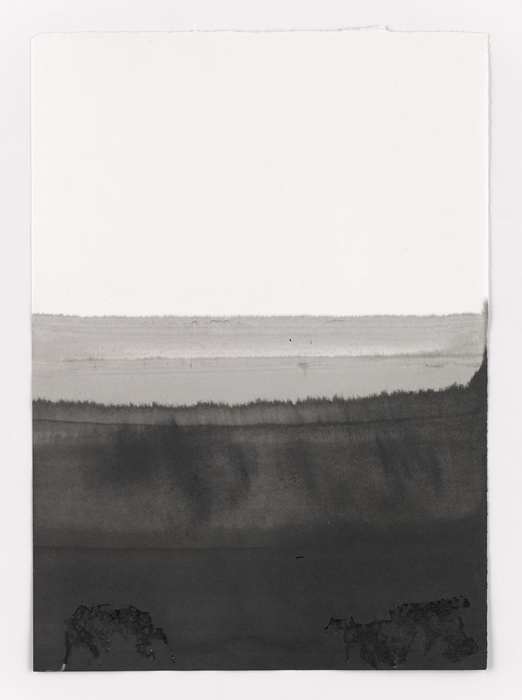

Tania Kovats
Evaporation (Black) 21, 2014
ink, salt, water on blotting paper, framed
42 x 30 cm, 16.5 x 11.8 in
H7015

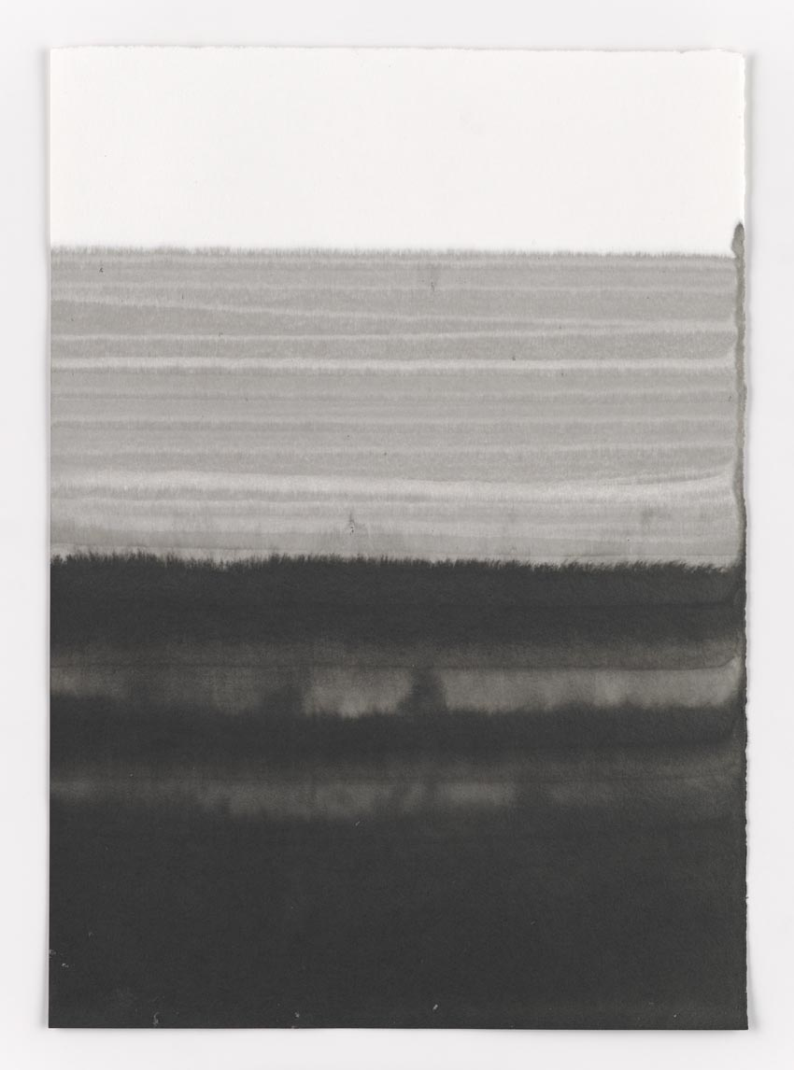

Tania Kovats
Evaporation (Black) 22, 2014
ink, salt, water on blotting paper, framed
42 x 30 cm, 16.5 x 11.8 in
H7017

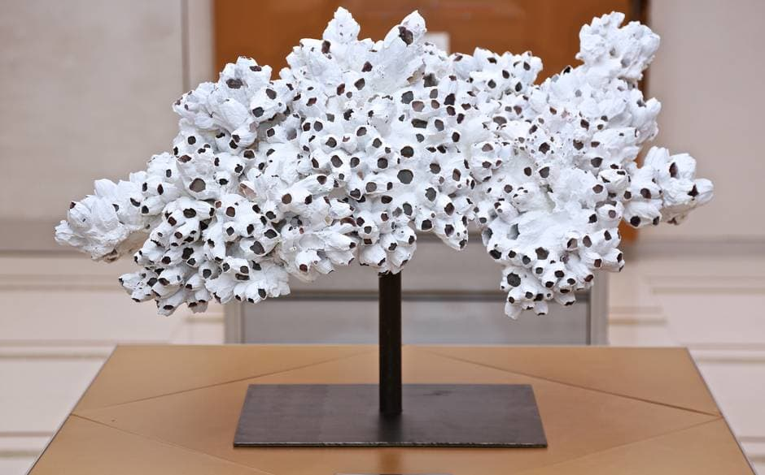

Colony
2012

barnacles, acrylic compound, steel

