

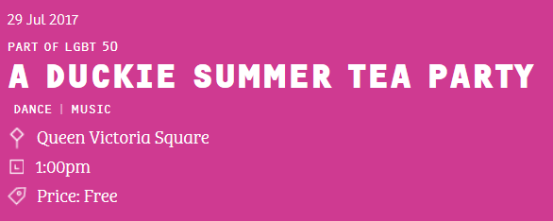
HULL2017 CITY OF CULTURE

A DUCKIE SUMMER TEA PARTY

AUDIENCE ESTIMATES

METHOD

Six counting points were utilised in Queen Victoria Square and counted between the hours of 12:00 noon and 6:00 pm.

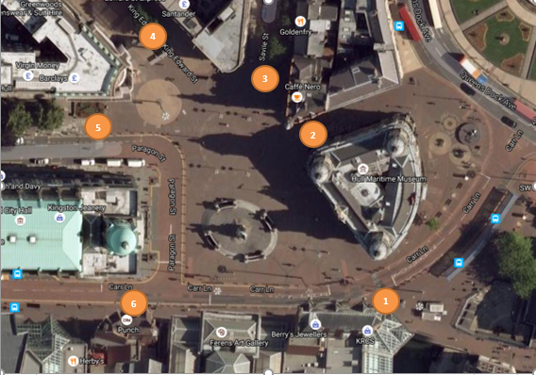

AUDIENCE ESTIMATES

The audience estimates for each hour are shown below.

The total audience estimate for the six hour period is 43,133

Information by Design
4 August 2017

