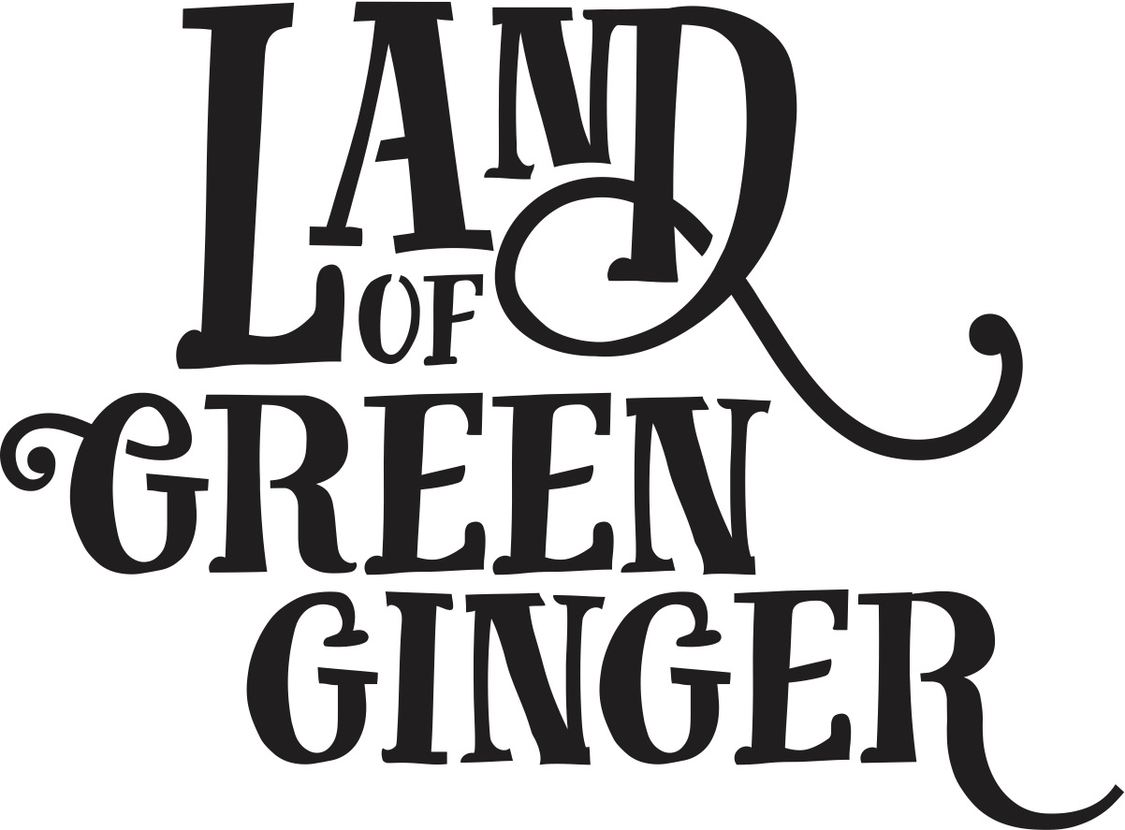

Book

Project Plan

Summary
Throughout the year Hull 2017’s ground-breaking community engagement project, Land of Green Ginger, invited Hull’s residents to immerse themselves in a magical citywide story, inspired by and celebrating the spirit of Hull.
In 2018, the Land of Green Ginger story will culminate in a seventh Act of Wanton Wonder – a beautiful book.
The Land of Green Ginger book will tell the stories of the project, the narrative as it took place and the stories of the local people it touched. It will be the record of City of Culture as lived by the residents of the city and as informed by their imagination and creativity.
This project plan outlines the formats, timescales and budget for delivery of the Land of Green Ginger book.

Style
260x210mm (the same size as “hello hull” magazine)
60 pages
300gsm outer cover
120gsm inners
Full colour throughout.
Special finish on cover.
PUR bound.

Distribution
On Thursday 14 June crates containing books will be delivered to schools across Hull and a mass storytelling moment will take place in every school.

In the week following (Friday 15 – Friday 22 June) books will be delivered to every house in Hull via Royal Mail.

Quantities
x118,500 for postage to reach every home in Hull.
X6,500 extra books printed for schools distribution and Big Malarkey.
Total 125,000

Print Timescales
The book will be distributed to schools in the week of 11 June and a mass storytelling moment will take place in all schools on Thursday 14 June.
The following week books will be distributed across the city and a a live launch-type activity will take place at The Big Malarkey Festival weekend on Saturday 23 and Sunday 24 June 2018.

To ensure the book is printed ready for delivery in the week of 11 June, the following deadlines will be in place:

Date | Action | Lead
W/C 29 January | Request for initial sketch submissions from contacted illustrators | Maddie, Illustrators
W/C 5 February | Initial sketches submitted by contacted illustrators | Maddie, Illustrators
W/C 12 February | Illustrator shortlisting | Maddie & Katy
W/C 12 February | Illustrator appointed | Maddie, Katy, Illustrator
W/C 12 March | First draft manuscript complete | Katy
W/C 12 March | Draft manuscript and full brief delivered for illustrator to start work | Maddie, illustrator
W/C 26 March | First draft sketches complete, feedback given | Illustrator
W/C 26 March | Final manuscript complete and submitted to illustrator | Katy
Friday 6 April | Confirm booking with Royal Mail | Marketing lead
Friday 13 April | Quantity of books for print decided and addendum for print and Royal Mail drawn up | Marketing lead
Friday 27 April | Printing booked. | Marketing lead
Thursday 3 May | Final illustrations complete.  Illustrations, manuscript and design brief submitted to designer. | Illustrator  Marketing lead
Friday 4 May | Design returned for proofing.  Feedback | Designer
Friday 4 May | Artworking complete | Designer
Friday 4 May | Book sent to print. | Marketing lead
Thursday 31 May | Print complete. Delivery of 118,500 books to Royal Mail. | Printers
Friday 1 June | 6,500 delivered to Hull 2017 (TBC) for schools distribution | Marketing lead
Thursday 14 June | Schools activity | Producing
Friday 15 June | Royal Mail delivery of books | Royal Mail
Saturday 23 – Sunday 24 June | Moment at The Big Malarkey Festival | Producing

Project Timescales
In order to create special moments around the release of the book, we plan to do the following:
- Delivery of a crate per primary school across Hull containing a number of books with an activity for schools to participate in e.g. time capsule, filling crate with memories to inspire Acts of Wanton Wonder for future generations
- A mass storytelling moment in schools across Hull on Thursday 14 June
- Schools activity using crate
- A door to door distribution to 40,000 households across the city
- Special door to door distribution in certain areas – costumed volunteers, interesting delivery vehicle, music
- Live drawing by LoGG illustrator at Big Malarkey Festival
- Performers at Big Malarkey with LoGG book giveaways and craft activities??

Actions

Book
- Book writing
- Illustration
- Design
- Print
- Distribution plan:
  - Door to door through Bluestorm
  - Volunteers??

Schools
- Get into schools to introduce the Land of Green Ginger storytelling moment
- Coordinate delivery of schools moment
- Coordinate making of crates
- Collection and storage of 70 crates
- Writing of schools crate activity
- Making of scrolls/information sheets to go with crates
- Delivery of crates to schools
- Writing of schools story
- Writing workshops in schools for National Writing Day 27 June
- Arrange special crate deliveries – horse and carriage, etc.

Big Malarkey
- Source performers
- Contract performers
- Brief performers and develop “script”
- Source costume
- Illustration for giveaways
- Design of giveaways
- Print of giveaways
- Arrange illustrator live drawing
- LoGG craft activities?? Tie in with parade?
- Crate installation at festival

Date | Action | Lead
W/C 29 January | Request for initial sketch submissions from contacted illustrators | Maddie, Illustrators
W/C 5 February | Initial sketches submitted by contacted illustrators | Maddie, Illustrators
W/C 12 February | Illustrator shortlisting | Maddie & Katy
W/C 12 February | Illustrator appointed | Maddie, Katy, Illustrator
W/C 26 February | First draft manuscript complete | Katy
W/C 26 February | Draft manuscript and full brief delivered for illustrator to start work | Maddie, illustrator
W/C 26 March | First draft sketches complete, feedback given | Illustrator
W/C 26 March | Final manuscript complete and submitted to illustrator | Katy
Monday 16 April | Quantity of books for print decided and addendum for print/delivery drawn up | Marketing lead
Monday 30 April | Final illustrations complete.  Illustrations, manuscript and design brief submitted to designer. | Illustrator  Marketing lead
Monday 30 April | Printing booked. | Marketing lead
Wednesday 2 May | Design work complete. Designer begin artworking. | Designer
Monday 7 May | Artworking complete | Designer
Monday 7 May | Book sent to print. | Marketing lead
Monday 7 May | Distribution company booked. | Marketing lead
w/c 11th June | Print complete and delivered to distribution agency for delivery to homes from Friday 15 June | Printer/ Distribution agency
Ws/C 11 and 18 June | Distribution | Distribution agency
Wednesday 20 – Sunday 24 June | Moment at The Big Malarkey Festival

