PRSF NEW MUSIC BIENNIAL
HULL
29th JUNE to 2nd JULY 2017
ARTIST PACK
ARTIST: Dark Star and James McVinnie
ARTIST CONTACT (Mobile number): TBC – PROMOTER TO CONFIRM
Management - Robin Pasrich - robin@giantmenmanagement.com - +44 7930 548922
Agent - Andy Duggan - andyduggan@primarytalent.com

VENUE: City Hall
Address: Hull City Hall, Queen Victoria Square, Carr Lane, Hull, Hu1 3RQ
Phone: direct no??
LOADING IN FROM: Paragon Street (Pink Dot)
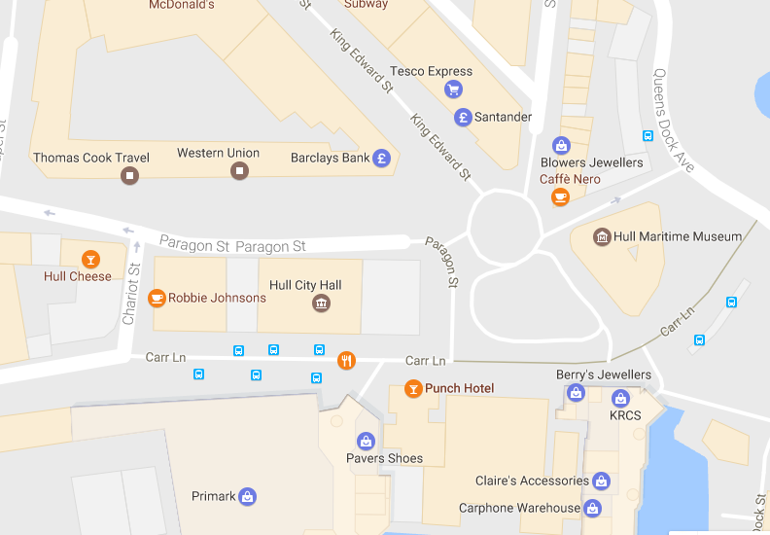

PARKING REQUIREMENT and LOCATION:
TBC – PROMOTER TO CONFIRM

PERSONNEL
STAGE MANAGER (Primary contact show weekend only): David Howard - 07774 729096
PRODUCTION MANAGER: Gareth Hughes – 07733112272
PRODUCTION ASSISTANT: Joanna Morley – 07725 942808
VENUE CONTACT: Tony Evans (Technical)/Lorna (FOH)

DATE AND TIME OF PERFORMANCE: Saturday 1st July 18:00 (45mins)
PRODUCTION SCHEDULE:
THURSDAY 29 JUNE
NO ACCESS TO MAIN HALL | AFTER PERFORMANCE 23:00 - 02:00 | Stage extension
STAGE EXT (23:00 - 02:00) | DAY | Set up dressing rooms
 | DAY | Dressing and branding
 | PM | OB truck into Paragon Street -
 | DAY | Volunteer briefing with Stage Manager
FRIDAY 30 JUNE
06:00 - 00:00 (ACCESS) | 06:00 - 11:00 | Tech in - ALL
 | 09:00 | Piano tuning - Main Hall
 | AM | 84 lit music stands
 | 10:30 | BBC radio 3 onsite - set up
 | 12:00 | BBC Phil load in
 | 12:00 | 2x crew 4 hour call - BBC load-in
 | 14:15 - 17:15 (16:45) | BBC Phil rehearsal
 | 18:00 | Box office on site
 | 18:15 | Doors
 | 18:45 | Simon Holt - BBC Phil - PERFORMANCE
 | 19:30 | FINISH
 | 20:30 | Doors
 | 21:00 | Mica Levi PERFORMANCE
 | 21:45 | FINISH
 | 22:00 - 23:00 | James McVinnie - access to organ - rehearsal
 | 22:00 - 23:00 | Reset for Errolyn Wallen
SATURDAY 1 JULY
08:00 - 00:00 (ACCESS) | 09:00 | Piano tuning - Mortimer and Main Hall
 | 10:00 - 13:00 | Errollyn Wallen - Artists arrive and rehearsal - Hall
 | 13:00 | Box office on site
 | 13:30 | DOORS - Main Hall
 | 14:00 - 14:45 | Errollyn Wallen - PERFORMANCE
 | 15:00 - 17:30 | Reset main hall - Dark Star in and rehearsal
 | 15:30 | Rehearsal Dark Star
 | 17:30 | DOORS
 | 18:00 - 18:45 | James McVinnie - Dark Star PERFORMANCE
SUNDAY 2 JULY
08:00 - 20:00 (ACCESS) | 09:00 - 16:00 | Main Hall - Residencies
 | 13:00 | Doors - Main hall - Super Group
 | 13:30 | PERFORMANCE - Super Group
 | 14:00 - 20:00 | Derig and clear
MONDAY 3 JULY
 | AM | Materials back to storage
 | AM | Piano off site

TECHNICAL
Sound
FOH Control
1 Yamaha M7CL-48
Speaker System
8 L Acoustics - ARCS
6 L Acoustic ARCS - ARCOUPL
2 Ratchet Strap (Black) - 5.5m 2T
2 L Acoustic SB218
1 Camco Amp Rack for L Acoustics
1 BSS 366 Omnidrive Compact Plus
Monitor System
6 Wedge Monitor 15" + 2"
1 Camco Amp Rack for L Acoustics
2 BSS Minidrive FDS-334
Microphones
1 Shure Beta 52
2 Audio Technica AT4050SM
1 Sennheiser e906
2 Shure SM58
4 DPA 4060-BM Miniature Microphone - Microdot
4 DPA DAD 6001 XLR 48 volt adapter
4 DPA MHS 6005 Mic Holder for Strings
4 Studiospares Active DI
1 Microphone Stand (Kick Style)
6 Microphone Stand - Tall
2 Shure ULXP Beta58 Handheld Radio System - CH38
Other Equipment
1 63A 3-Phase Mains Distro #2
1 Multicore System 1 - 48-way 70m
1 48-Way Stagebox & Line System
1 63A 3-Phase Cable 22m
1 48-Way 70m Multicore
Staff
1 Engineer - FOH
1 Engineer - Systems

Lighting
Material
1 Avolites Tiger Touch Pro Console
3 Martin Atomic 3000 Strobe
Staff
1 Engineer – Lighting

RIDER:
The promoter must provide a hot, quality, 3-course meal for 3 people. Or a buyout
of £15 / €15 / $20 per person (in the correct notes please!)

Backstage catering:
24 x Beer. Quality local beer preferred. Important – please ensure they are kept ICE cold.
1 x 1L Bottle of Jack Daniels OR Appleton’s Rum
6 x Cans / bottles of ginger beer
12 x Water. Small bottles at room temperature
6 x Soft drinks. Assortment of Diet Coke / Fanta / Sprite
Bread. Fresh pitta or baguette.
Dips. Houmous / Tzatziki / Alioli
1 x Jar of Honey
3 x Fresh Lemons
1 x Kettle - or access to boiling water
1 x Bucket of ICE
2 x Hot Pizza (IMPORTANT) Delivered to the dressing room directly after the performance.

BACKLINE:
BACKLINE | 4x tables for electronics - 50cm x100cm | CITY HALL
 | 4x Single tier keyboard stands | STS

ACCREDITATION
David & Alice Porter (Directors)
Steve & Sam Shaw (Directors)
Peter & Lorraine Boardman (Directors)
Wes Zepherin (Director)
Kirsty & Gary Halliday (Marketing)
Ben Pugh (Production)

Artistic Personnel: Band- Aiden Whalley, James Young. TM - Robin Pasricha

