PRSF NEW MUSIC BIENNIAL
HULL
29th JUNE to 2nd JULY 2017
ARTIST PACK
ARTIST: Brian Irvine
ARTIST CONTACT (Mobile number): 07841650383
Tour Co-Ordination: Brian Carson 078 8158 7620
Technical Contact: Chris McCorry 077 5203 0905
VENUE: Guildhall

Address: The Guildhall, Alfred Gelder Street, Hull HU9 9TA

Phone: 01482 613017

LOADING IN FROM:
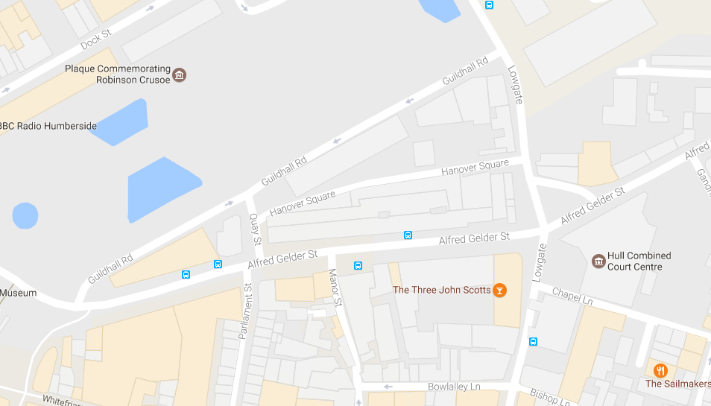

PARKING REQUIREMENT and LOCATION:
TBC – PROMOTER TO CONFIRM
PERSONNEL
STAGE MANAGER (Primary contact show weekend only): Hanna Lutkin - 07709 351209
PRODUCTION MANAGER: Gareth Hughes – 07733112272
PRODUCTION ASSISTANT: Joanna Morley – 07725 942808
VENUE CONTACT: ??

DATE AND TIME OF PERFORMANCE: Sunday 2nd July 18:45 (45mins)
PRODUCTION SCHEDULE:
SATURDAY 1 JULY
16:00 - 20:00 (ACCESS) | 16:00 |  | Access to Banqueting Hall
 | 16:00 - 19:00 |  | Stage and Power in
SUNDAY 2 JULY
09:00 - 00:00 (ACCESS) | 09:00 - 14:00 |  | LX and Sound in
 | 14:00 - 17:00 |  | Brian Irvine - Rehearsal
 | 17:30 |  | Box office on site
 | 18:15 |  | Doors
 | 18:45 |  | Brian Irvine - PERFORMANCE
 | 19:30 |  | Clear
 | 19:30 - 00:00 |  | Derig
TECHNICAL
Sound
FOH Control
1 Yamaha LS9-32
Speaker System
2 L Acoustic 115XT
4 Powerdrive 44BE Speaker Stand
2 L Acoustics - SB18
2 L Acoustics LA8
Delays
2 L Acoustic MTD108A
1 NL4 Speakon Cable 4mm 15m
2 NL4 Speakon Cable 4mm 25m
2 NL4 Speakon Coupler
Monitor System
6 Wedge Monitor 15" + 2"
1 Camco Amp Rack for L Acoustics
2 BSS Minidrive FDS-334
Microphones
1 Shure Beta 52
2 Audio Technica AT4050SM
1 Sennheiser e906
2 Shure SM58
4 DPA 4060-BM Miniature Microphone - Microdot
4 DPA DAD 6001 XLR 48 volt adapter
4 DPA MHS 6005 Mic Holder for Strings
4 Studiospares Active DI
1 Microphone Stand (Kick Style)
6 Microphone Stand - Tall
Other Equipment
1 63A 3-Phase Mains Distro #2
1 63A 1-Phase Cable 10m
2 Multicore System 2 - 48-way 50m
1 48-Way 50m Multicore
1 48-Way Stagebox & Line System
Staff
1 Engineer - FOH
Lighting
Material
1 6 Channel DMX Lighting Desk
4 Alu LED Par RGBW 18x 8W - 40deg
2 3m Lighting Stand
Staff
1 Engineer – Lighting
Power Cabling & Pipe and Drape
Pipe & Drape - Behind Stage
2 8m x 4m Black Drape
6 Pipe and Drape Base Plate - 450mm x 450mm
4 Pipe and Drape Crossbar - 2.1m - 3.6m
6 Pipe and Drape Spigot
6 Pipe and Drape Vertical - 1.8m - 4.2m
Power Cabling
1 63A 3-phase Split Box
2 63A 3-Phase Cable 20m
RIDER:
TBC
BACKLINE:
BACKLINE | 18" (or 20") Bass drum | ALBEMARLE KIT 2
 | 10" (or 12") top tom | ALBEMARLE KIT 2
 | 14" Floor tom | ALBEMARLE KIT 2
 | Snare drum and stand, hi-hat stand, 3 cymbal stands, bass drum pedal, Stool and carpet. | ALBEMARLE KIT 2
 | DOUBLE BASS: | STS
 | We require a good quality professional 3/4 size double bass with adjustable bridge and pick-up (Realist pickup or equivalent). | STS

ACCREDITATION
David & Alice Porter (Directors)
Steve & Sam Shaw (Directors)
Peter & Lorraine Boardman (Directors)
Wes Zepherin (Director)
Kirsty & Gary Halliday (Marketing)
Ben Pugh (Production)

Artistic personnel: Brian Irvine, Jennifer Walshe, Jacqueline Shave Smithies, Robert Irvine, Tom Hankey, Paul Dunmall, Paul Rogers, Mark Sanders and Chris McCorry

