Fountain 17 Links

Launch Day Video
https://youtu.be/ntt3p_pLhTg

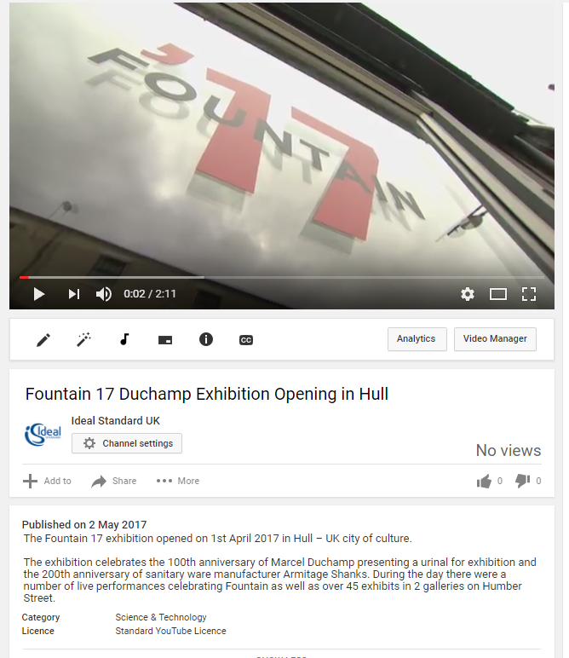

https://www.facebook.com/theculturezone/videos/1316832618413117/

Film made by local Film company

http://www.fountain17.com/

https://www.youtube.com/watch?v=hnh0Pfy3elI

Factory visit

