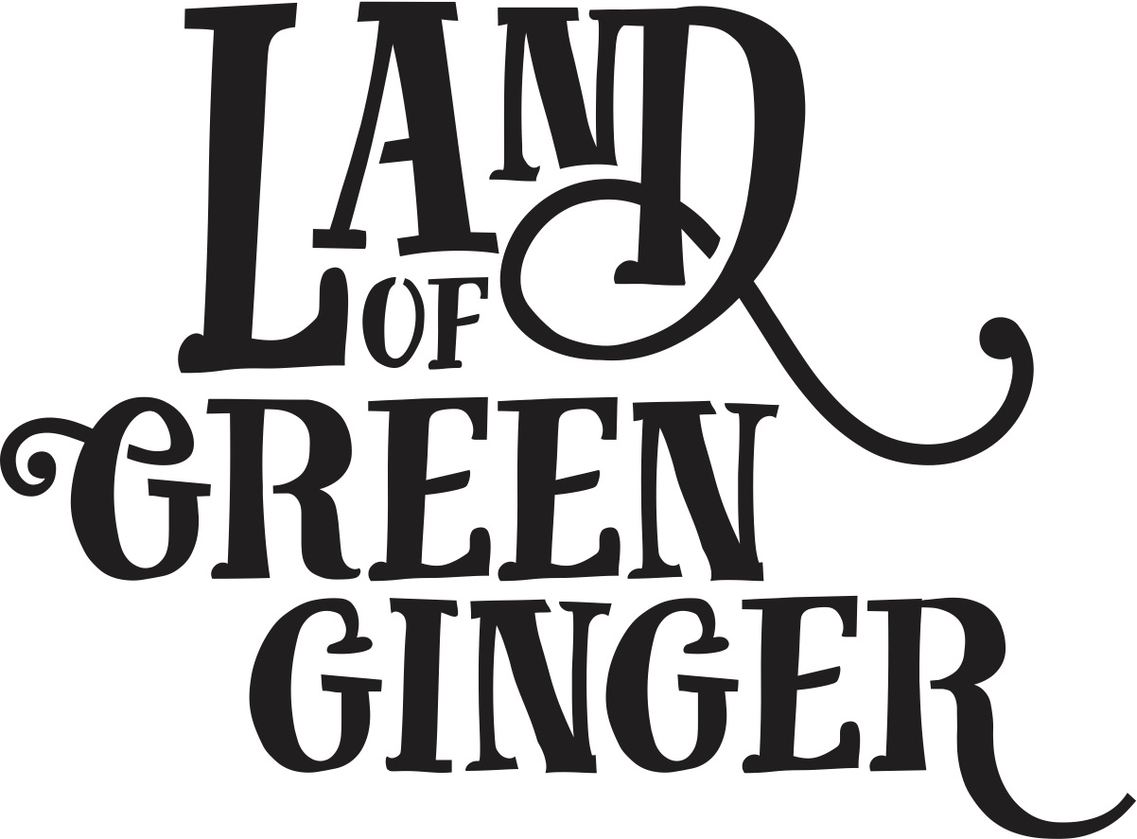

Book

Project Plan

Summary
Throughout the year Hull 2017’s ground-breaking community engagement project, Land of Green Ginger, invited Hull’s residents to immerse themselves in a magical citywide story, inspired by and celebrating the spirit of Hull.
In 2018, the Land of Green Ginger story will culminate in a seventh Act of Wanton Wonder – a beautiful book that will be delivered to every household in Hull.
The Land of Green Ginger book will tell the stories of the project, the narrative as it took place and the stories of the local people it touched. It will be the record of City of Culture as lived by the residents of the city and as informed by their imagination and creativity.
This project plan outlines the possible formats, timescales and budget for delivery of the Land of Green Ginger book.

Quantities
x118,500 for postage to reach every home in Hull
*Suggest an additional 5,000 for potential schools workshops

Style Options
260x210mm (the same size as “hello hull” magazine)
60 pages
300gsm outer cover
120gsm inners

Option 1
Full colour throughout. Special finish on cover. PUR bound - £55-60k.

Option 2
Black and white inside. Saddle stitched finish - £45-50k

Postage Costs

For either option, delivery to 118,500 households - £40-50k.

Timescales
For delivery in middle of March to tie in with the programme announcement on 15 March we’d be looking at the following booking and print timescales.

Option 1
Royal Mail booking required 18 January.
Printing booked by 31 January.
Sent to print 5 February.
To be with Royal Mail for distribution by 1 March absolute latest.
Delivered on Thursday 15 March.

Option 2
Royal Mail booking required 18 January.
Printing booked by 31 January.
Sent to print 12 February (difference of 4 working days).
To be with Royal Mail for distribution by 1 March absolute latest.
Delivered on Thursday 15 March.

For delivery nearer the end of March (29th March est) we’d be looking at the following booking and print timescales.

Option 1
Royal Mail booking required 1 February.
Printing booked by Monday 12 February.
Sent to print 19 February.
To be with Royal Mail for distribution by 15 March absolute latest.
Delivery in W/C 26 March*.

Option 2
Royal Mail booking required 1 February.
Printing booked by Monday 12 February.
Sent to print 26 February (difference of 4 working days).
To be with Royal Mail for distribution by 15 March absolute latest.
Delivery in W/C 26 March*.

*This is half term week. Schools workshops would potentially be possible in the week before or the week after.

Budget

Option 1
Writer/Illustrator | £15,000
Design | £10,000
Print | £60,000
Postage | £50,000
Total | £135,000

Option 2
Writer/Illustrator | £15,000
Design | £10,000
Print | £50,000
Postage | £50,000
Total | £125,000

