
Feedback

 | Proportion of people attending with a disability
21% | considered themselves to have a disability
11% | considered themselves to have a learning disability or difficulty
9% | considered themselves to have a physical disability
3% | considered themselves to have a sensory disability
 | Feedback about the event
100% | rated the event as good
100% | felt welcomed
74% | tried something new
61% | met new people
 | Previous or future Hull Red customers?
23% | had attended a Hull Red event previously
99% | would attend a Hull Red event in the future
 | Use of accessibility provisions
11% | accessed the BSL interpreter
20% | accessed the disabled toilets
14% | accessed the changing place
20% | said they would not have attended if the access provisions had not been available
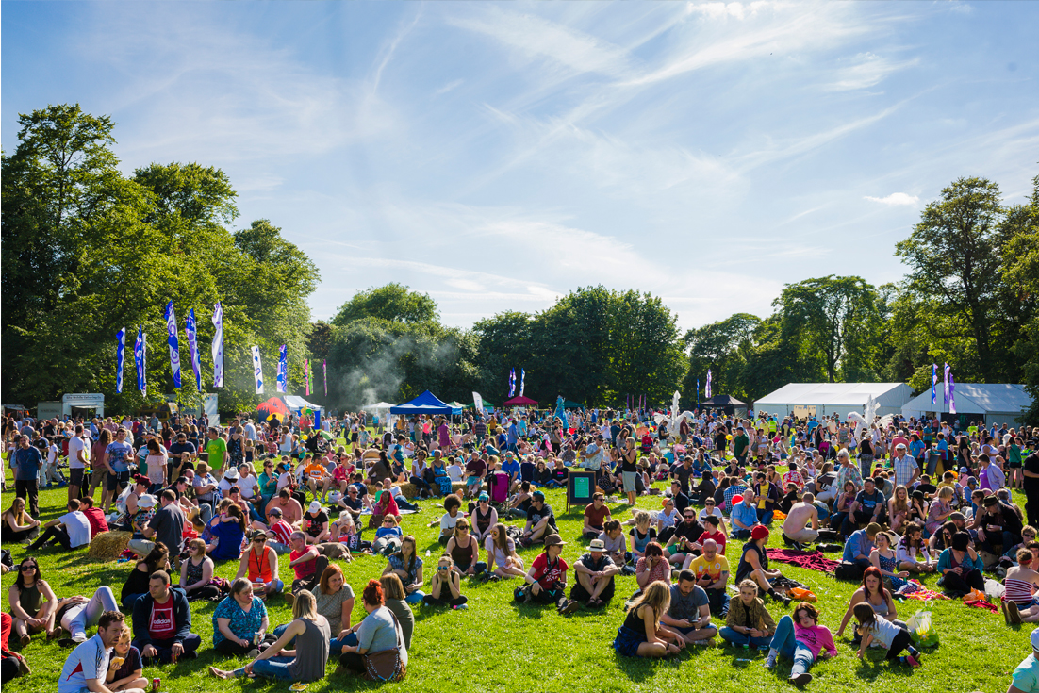
All statistics based on 109 feedback forms completed on the day.

