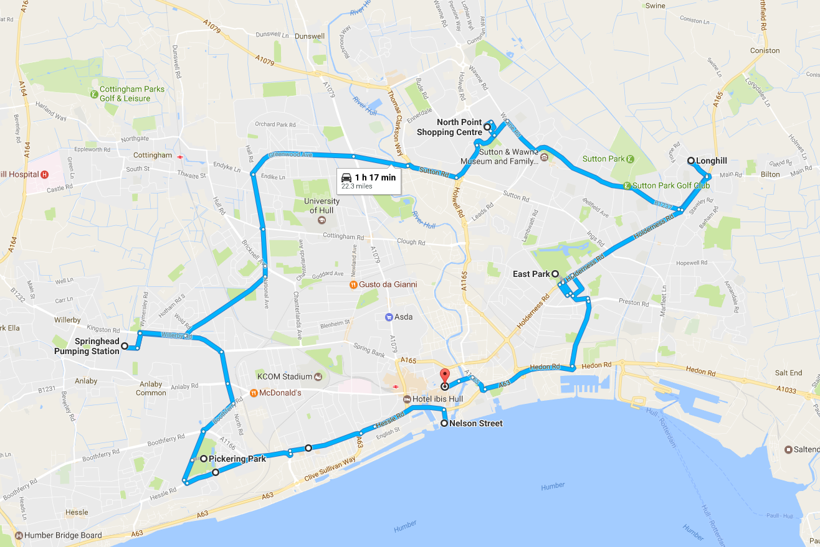

Land of Green Ginger Crate Movement Map
PRESS CALL AND TOURING
10th April
Schedule
PRE PRODUCTION | FAQ sheet to Pete from Maddie
Sunday 9th April
11am - 4pm | Load one crate large and a few smaller crates onto flatbed
 | Rig sound and smoke in the large crate
 | Put branding on flatbed
Monday 10th April
06:30 | Meet at Staples - Maddie and Pete
 | All to be in green overalls, green hardhats, gloves - you are now the Green Ginger Fellowship
07:00 - 08:00 | Flatbed to Land of Green Ginger (the Street)
 | Photo of loading (or looking like loading crates) -
 | Green smoke release
08:00 - 09:00 | To Nelson Street for potential Press Call
 | Green smoke release
09:00 - 12:30 | Tour of neighbourhoods - Chrissie with Pete with directions
10:00 - 10:30 | Nelson Street Car Park (HU1 1XE). Press op in front of the Deep
10:30 | Depart from Nelson Street, head for Pickering Park (HU4 7AB). 15-minute journey
10:45 | Chrissie photo op at Pickering Road. Trailer can loop round park via: Pickering Rd -> A1166 -> Council Ave -> Hessle Road -> Pickering Road, OR pull over on Pickering Road.
11:00 | Depart from Pickering Road to Springhead Pumping Station (HU5 5YJ). 10-minute journey
11:10 | Chrissie photo op on Springhead Lane facing station, either on street or in car park
11:20 | Depart from Springhead to North Point Shopping Centre (HU7 4EE). 22-minute journey
11:40 | Chrissie photo op on Holwell Road. Trailer can loop round NPSC car park, or simply park in car park for still shot.
12:00 | depart from NP and head to Longhill Estate (HU8 9PD). 11-minute journey
12:10 | Chrissie photo op facing parade of shops at St Margaret’s OR facing Eastmount Recreation Centre (HU8 9NB)
12:20 | depart Longhill and head down Holderness Road to East Park (HU8 8JU). 10-minute journey
12:30 | Chrissie photo op in the car park off Holderness Road right at entrance, maybe facing gate?
12:40 | depart East Park and head back to town, hitting Alfred Gelder Street (HU1 2AN). 12-minute journey
13:00 | Chrissie photo op facing Guildhall
 | Back to Staples - unload crates
13:00 - 13:30 | BREAK
13:30 - 16:30 | Elizabeth to meet Pete with keys at storage
 | Flatbed to Storage to load ALL materials
 | Flatbed to Low Gate to load printer from MCL
 | Flatbed back to Staples unload and leave

