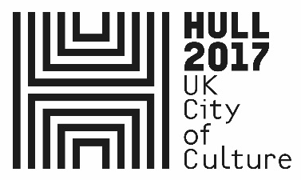

IN WITH A BANG FURTHER INFORMATION

27th December 2017

Dear Resident,

As you are hopefully aware we are kicking off the City of Culture year with some spectacular events in the city centre.

Made in Hull is a free unticketed event running from January 1st to 7th, which will see the city centre transformed by an eclectic mix of extraordinary artists. From river to roof top, Queen Victoria Square to The Deep, in shop windows and streets, this is the story of Hull and its people. Who we are. What we’ve lived through. Where we’re going next.

On January 1st In With a Bang will light up the skies above Hull. Set to the sounds of the city, this spectacular firework display will mark the start of our year in the spotlight.

Our priority when planning events is to promote public safety, which requires the implementation of a number of road closures, which we wrote to you about on November 21st.

Further to that letter, we would like to clarify the arrangements that will be in place in January 1st, specifically in regard to your area.

The following closures will be in place on January 1st from 16:00 to 21:30, however we will maintain resident access up to 17:00, please present this letter to stewards at the closure point to gain access.

- Manor House Street
- Kingston Street (between Manor House St. and Railway St.)
- Railway Street
- Wellington Street West

There will be no vehicle access during this period to the streets listed above, however pedestrian access will be maintained to the area, without the requirement for an access pass or wristband. Access will be via Kingston Street, Manor House Street and Wellington Street West.



In addition, and to ensure that ticket holders for the event can safely access the event area, the A63 / Castle Street will be closed between the Mytongate and Garrison Road roundabouts from 16:00 to 22:00 on January 1st. A fully signed diversion route along Ferensway, Freetown Way and Great Union Street will be in place. Access to Commercial Road will not be affected by this closure.

Carr Lane will be closed from 15:00 to 22:00 from January 1st to January 7th. Buses will be diverted during this period.

Other closures that you have previously been notified of will also be in place:

Nelson Street, Pier Street & Minerva Place.
Will be closed from 08:00 on December 31st to 10:00 on January 2nd.

Queen Street (at Blanket Row), Humber Dock Street (at Blanket Row), Blanket Row, Blackfriargate, Humber Place
Will be closed from 16:00 to 22:30 on January 1st.

High Street
Will be closed between Liberty Lane and Queen Street from 16:00 to 22:00 between January 1st and January 7th.

We hope that this letter explains the arrangements that will be in place and apologise for any inconvenience caused, additional information can be found online at www.hull2017.co.uk/madeinhull or you can contact us by email at: theteam@hull2017.co.uk

Yours sincerely

The Team

Hull 2017 UK City of Culture

