
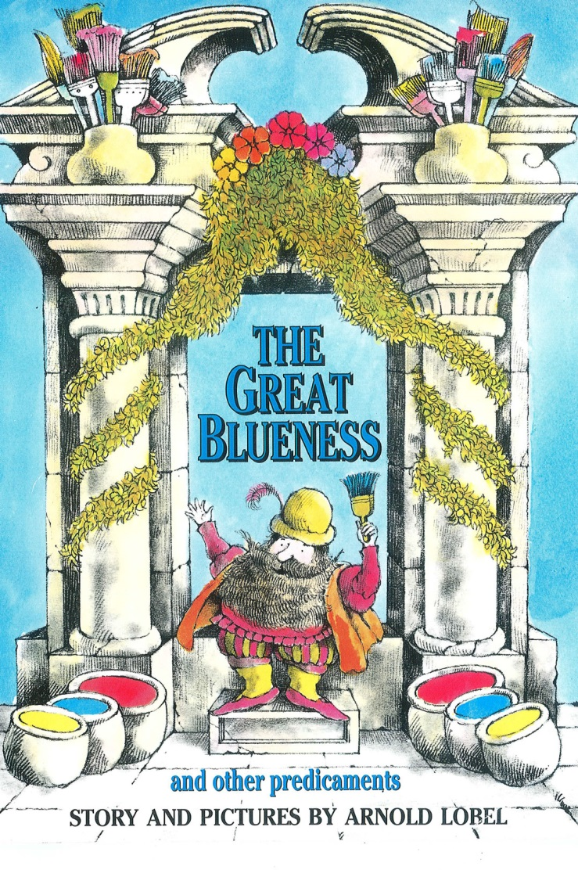


RESEARCH AND DEVELOPMENT FOR HULL2017
TUESDAY 28TH – THURSDAY 29TH 2016

HULL2017 – PRODUCTION BASE
PACIFIC EXCHANGE
40 HIGH STREET
HULL
HU1 1PS

HULL COLLEGE
QUEENS GARDENS
WILBERFORCE DRIVE
HULL
HU1 3DG

ENDIKE SCHOOL
ENDIKE LANE
HULL
HU6 8DX

NORTHERN ACADEMY OF PERFORMING ARTS
ANLABY ROAD
HULL
HU1 2PD

STAFF ON SITE

CBEEBIES PRODUCTION
ANGELA YOUNG Producer 07976 353 608 / angela.young@bbc.co.uk
DEE KALAKOTI Asst Producer 07703887787 / Dee.Kalakoti@bbc.co.uk
BRUCE TURNER Runner 07595 204408 / bruce.turner@bbc.co.uk

NORTHERN BALLET
MARK SKIPPER Chief Executive mark.skipper@northernballet.com
DANIEL DE ANDRADE Choreographer 07411 683163 / dan.deandrade@hotmail.co.uk
LEANNE KIRKHAM Workshop Leader 07825 545072 / Leanne.kirkham@northernballet.com
SOPHIE ALDER Early Years Specialist Sophie.alder@northernballet.com
MARK WILKINSON Pianist 07930 664451 / markwmusician@gmail.com

GARY YERSHON Composer gsyershon@gmail.com
MARK BAILEY Designer mark@mawb.co.uk

SCHOOL CONTACTS
Andrew Shimmin, Head Teacher Helen Dent Julie Lovewell
McMillan Nursery School Endike Primary Head of Dance, NAPA
07854769318 / (01482) 331370 01482 616461 07725213005
head@mcmillan.hull.sch.uk hdent@endike.hull.sch.uk julieLovewell@northernacademy.org.uk

HULL COLLEGE
Mark Pearce
079552251122

BBC CONTACTS
Head of CBeebies In-House Production | Alison Stewart  Alison.Stewart1@bbc.co.uk  Assistant: angela.burton@bbc.co.uk | 0161 836 0616  07712 876073
Production Executive Childrens | David Noble  David.Noble@bbc.co.uk  Sally Carroll  Sally.carroll@bbc.co.uk | 079735 05360  07912 583838
Legal & Business Affairs Manager | Mark Bennett  mark.bennett1@bbc.co.uk | 07714 957258
Business Affairs Executive | Hesham Sabry  hesham.sabry@bbc.co.uk | 07712 301171
Business Affairs Executive – Talent Rights | Amanda Barker | 07702 512 188
Bridge House Mail Room |  | 0161 836 0056
BBC 24 hour Ed Policy Advice |  | 020 8008 1819
BBC Safety Advisor | Katherine Fry | 07703 885814
Children’s IT Assistant | Jo Flitcroft | 07702444529
BBC Hotel bookings | Access Bookings | 0870 855 5777 / 0208 752 7555
BBC Trains | Train line | 020 8752 7676
BBC One Transport Taxis |  | 020 8225 8555 / 0345 155 0801
BBC Transport Hire Cars |  | 0844 579 8832
BBC Couriers |  | 07536 015200/ 020 8752 7555
Enterprise Car Hire |  | 0844 335 3825
TUESDAY 28TH JUNE

10:15 RV AT HULL2017, PACIFIC EXCHANGE
THE BOARD ROOM
COFFEE

10:30 OPENING DISCUSSION OF CREATIVE AND R&D PLAN
including Gary’s musical creative thoughts

13:00 LUNCH
MARK BAILEY ARRIVES OVER LUNCH

14:00 TRAVEL TO HULL COLLEGE

14:30 – 16:30 SESSION 1: HULL COLLEGE DANCE STUDENTS AND GRADUATES

16:45 TRAVEL BACK TO PACIFIC EXCHANGE

17:00 EVALUATION ON HOW SESSION WENT
FURTHER CREATIVE DISCUSSION TO END OF DAY
Including Mark’s design creative thoughts

WEDNESDAY 29TH JUNE

08:15 RV AT EXPRESS BY HOLIDAY INN
TRAVEL TO ENDIKE PRIMARY SCHOOL

09:15 – 10:15 SESSION 2: MACMILLAN NURSERY UNDER 4s

10:15 BREAK

10:45 – 11:45 SESSION 3: ENDIKE PRIMARY YEAR 1s

12:00 LUNCH

13:30 – 15:00 SESSION 4: ENDIKE PRIMARY YEAR 4s

15:30 TRAVEL TO NAPA

16:30 SET UP READY FOR DANCE SESSIONS

17:00 – 18:00 SESSION 5: BALLET STUDENTS AGED 7 to 10

18:00 – 19:00 SESSION 6: BALLET STUDENTS AGED 7 to 10

THURSDAY 30TH JUNE

09:30 RV AT HULL2017, PACIFIC EXCHANGE

EVALUATION SESSION

12:00 LUNCH

12:30 RECCES OF HULL VENUES – ADDRESSES TBC
Mark Skipper and Northern Ballet Technical Manager to join

15:13 GARY YERSHON AND MARK BAILEY BOOKED TRAIN

SESSION INFORMATION

SESSION 1 1 Group of Graduates and Students from Hull College
Session led by Daniel exploring movement motifs and characters

SESSION 2 1 Group of Under 4s – approx. 15 children
Session led by Sophie focussing on creative child led movement, focus on story through sensory movement play, play and painting with colours

SESSION 3 1 Group of Year 1s – approx. 30 children
Session led by Sophie with support from Leanne – movement and music focussed with children creating movements based on responses to primary colours; mixing colours and mixing movements

SESSION 4 1 Group of Year 4s - approx. 30 children
Session led by Leanne with support from Sophie – travelling movements inspired by the 3 primary colours; Dan will teach 3 actions and movements from the fairy / goblin repertoire; children create their own short dances

SESSIONS 5 & 6 2 Groups of Ballet Students aged 7 to 10 – 20 per group
Sessions led by Dan – experimenting with character / repertoire

ACCOMMODATION – BREAKFAST COST INCLUDED
EXPRESS BY HOLIDAY INN, HULL CITY CENTRE
80 FERENSWAY, HULL HU2 8LN

28th and 29th Angela Young / Bruce Turner / Daniel de Andrade / Gary Yershon /
Mark Bailey
28th only Dee Kalakoti / Mark Wilkinson

