
MADE IN HULL 2017

BUILD & BREAK
PHASED PLAN

CONTENTS

Page 3 | Overview
Page 4 | Core Operations Team
Page 5 - 12 | Schedule Breakdown - Build
Page 13 | Rehearsal Days - 29/12/16 - 30/12/16
Page 14 | Show Days 01/01/17 - 07/01/17
Page 15 - 18 | Schedule Breakdown - Break - 07/01/17
Page 19 | Appendices
Page 20 | Appendix 1 - Show Plans
Page 21 | Appendix 2.1 QVS Show Plan
Page 22 | Appendix 2.2 Underpass Show Plan
Page 23 | Appendix 2.3 The Deep Show Plan
Page 24 | Appendix 2.4 Zebedees Yard Show Plan
Page 25 | Appendix 2.5 Scale Lane Staith Show Plan
Page 26 | Appendix 3 - Structural Drawings
Page 27 | Appendix 3.1 QVS Projection Platforms
Page 28 | Appendix 3.2 QVS Front of House Tower
Page 29 | Appendix 3.3 QVS Projection Tower
Page 30 | Appendix 3.4 QVS Cable Pylon
Page 31 | Appendix 3.5 Zebedees Yard Lighting Tower
Page 32 | Appendix 3.6 C4DI (The Deep) Projection Platform
Page 33 | Appendix 3.7 Underpass Screen Support Small
Page 34 | Appendix 3.8 Underpass Screen Support Large
Page 35 | Appendix 4 - Hull Production Suppliers
Page 36 | Appendix 5 - Plant Schedule
Page 37 | Appendix 5 - Plant Schedule continued
OVERVIEW

The purpose of this document is to provide a brief for Hull city council and individual venues with a brief guide to the production schedule for the build and de-rig of Made In Hull; the launch event for Hull 2017.

Should there be any queries on the contents of this brief, please direct all correspondence through Chris Clay in the first instance to be directed to the person(s) responsible for the area with which the matter concerns.

To accompany the brief there are also appendices outlining:- plant movement, temporary structure drawings, site plans & plant working zones to be referenced at will. We have also drawn up technical production information packs for each venue, detailing specific technical specifications. These are available at request.

CORE OPERATIONS TEAM

SCHEDULE BREAKDOWN: – BUILD

19/12/2016

QVS
-Initial fencing off of working areas begins. There will also be a 7.5t truck unloading scaffolding ready for the first structures to be built.

Whitefriar Gate
No activity scheduled.

Zebedee's Yard
No activity scheduled.

Scale Lane Staith
-Building of projection tower in the yard of the Lion & Key pub, delivered by a 7.5t truck.

The Underpass
No activity scheduled.

The Deep
-Building of modular deck system on the 3rd floor balcony of C4Di, delivered by a 18t truck.

20/12/2016

QVS
-Building of projection platforms on the monument plinth in the centre of the square.
-Siting of twinset generators, 7m tele handler.
-Delivery of 10m PA towers, 7.5t truck.
-Tower light delivery.

Whitefriar Gate
-External cleaning of units 6a,6,8,9,16,17,20,23

Zebedee's Yard
No activity scheduled.

Scale Lane Staith
No activity scheduled.

The Underpass
No activity scheduled.

The Deep
No activity scheduled.

21/12/2016

QVS
-Erection of 10 PA towers, 7m tele handler.

Whitefriar Gate
No activity scheduled.

Zebedee's Yard
No activity scheduled.

Scale Lane Staith
No activity scheduled.

The Underpass
No activity scheduled.

The Deep
No activity scheduled.

22/12/2016

QVS
-Screen windows (externally) of Maritime, City Hall & Ferens with vinyl, truck mounted access platform.
-Audio cable install, cable runs across roof tops of all 3 buildings.

Whitefriar Gate
-Screen the window (internally) of unit 9 with contra-vision.

Zebedee's Yard
-Delivery and erection of 12m z towers for lighting, 7m tele handler
-Fencing install.
-Generator delivery.

Scale Lane Staith
No activity scheduled.

The Underpass
Delivery of all rigging, 7.5t truck.

The Deep
No activity scheduled.

23/12/2016

QVS
No activity scheduled.

Whitefriar Gate
-Test projection run in Unit 8.

Zebedee's Yard
No activity scheduled.

Scale Lane Staith
No activity scheduled.

The Underpass
No activity scheduled.

The Deep
No activity scheduled.

27/12/2016

QVS
-Lighting load in on square and rooftops, LWB vans.
-Projector load in, 40' artic truck.
-Audio load in, LWB van.

Whitefriar Gate
-Projector install.
-Lighting install.
-Audio install.

Zebedee's Yard
-Lighting install, 60ft cherry picker.

Scale Lane Staith
-Projector install, 7m tele handler.
-Generator drop, 17m tele handler.

The Underpass
-Install projectors, 17m tele and man basket.

The Deep
-Build PA risers, delivered in LWB van.
28/12/2016

QVS
-Technical system checks.
-Overnight projection line up.

Whitefriar Gate
-Install audio. Delivered in LWB van.
-Overnight projection line up.

Zebedee's Yard
-Install audio. Delivered in LWB van.
-Overnight projection line up.

Scale Lane Staith
-Install audio. Delivered in LWB van.
-Overnight projection line up.

The Underpass
-Install lighting. Delivered in LWB van.
-Install audio. Delivered in LWB van.
-Overnight projection line up.

The Deep
-Install lighting in the nose. Delivered in LWB van.
-Install audio. Delivered in LWB van.
-Generator drop. 17m tele handler.
-Overnight projection line up.

29/12/2016 – 30/12/2016

-Noise propagation at all site 10:00 – 12:00.
-Sound checks across all sites 12:00 – 16:00.
-Production rehearsals across all sites 16:00 – 21:00.

01/01/2017 – 07/01/2017

-Live activation across all sites 16:00 – 22:00.
SCHEDULE BREAKDOWN: – BREAK

07/01/2017

QVS
-Strike all video, 40ft artic.
-Strike all lighting, 40ft artic.
-Strike all audio, 40ft artic and 60ft cherry picker.
-Strike projection platforms on monument plinth, 7.5t truck.
-Strike PA and cable towers, 7m tele handler and 7.5t truck.

08/01/2017

Whitefriar Gate
-Strike all video, LWB van.
-Strike all lighting, LWB van.
-Strike all audio, LWB van.

Zebedee's Yard
-Strike all lighting, LWB van & 60ft cherry picker.
-Strike all audio, LWB van.
-Strike towers, 7.5t & 17m tele handler.

Scale Lane Staith
-Strike video, LWB van & 7m tele handler.
-Strike audio, LWB van.
-Strike projection tower, 7.5t truck and 7m tele handler.

The Underpass
-Strike lighting, 60ft cherry picker and LWB van.
-Strike audio, 60ft cherry picker and LWB van.
-Strike projection, 17m tele handler with man basket and LWB van.
-Strike structures and rigging, 7.5t truck and 60ft cherry picker.

The Deep
-Strike audio, 7m tele handler and 40ft artic.
-Strike lighting, 40ft artic.
-Strike projection, 40ft artic.
-Strike structures, 7.5t truck.

09/01/2017

QVS
-Strike PA towers, 17m tele and 7.5t truck.

Zebedee's Yard
-Strike lighting towers, 17m tele and 7.5t truck.

APPENDICES
APPENDIX 1 – SHOW PLANS

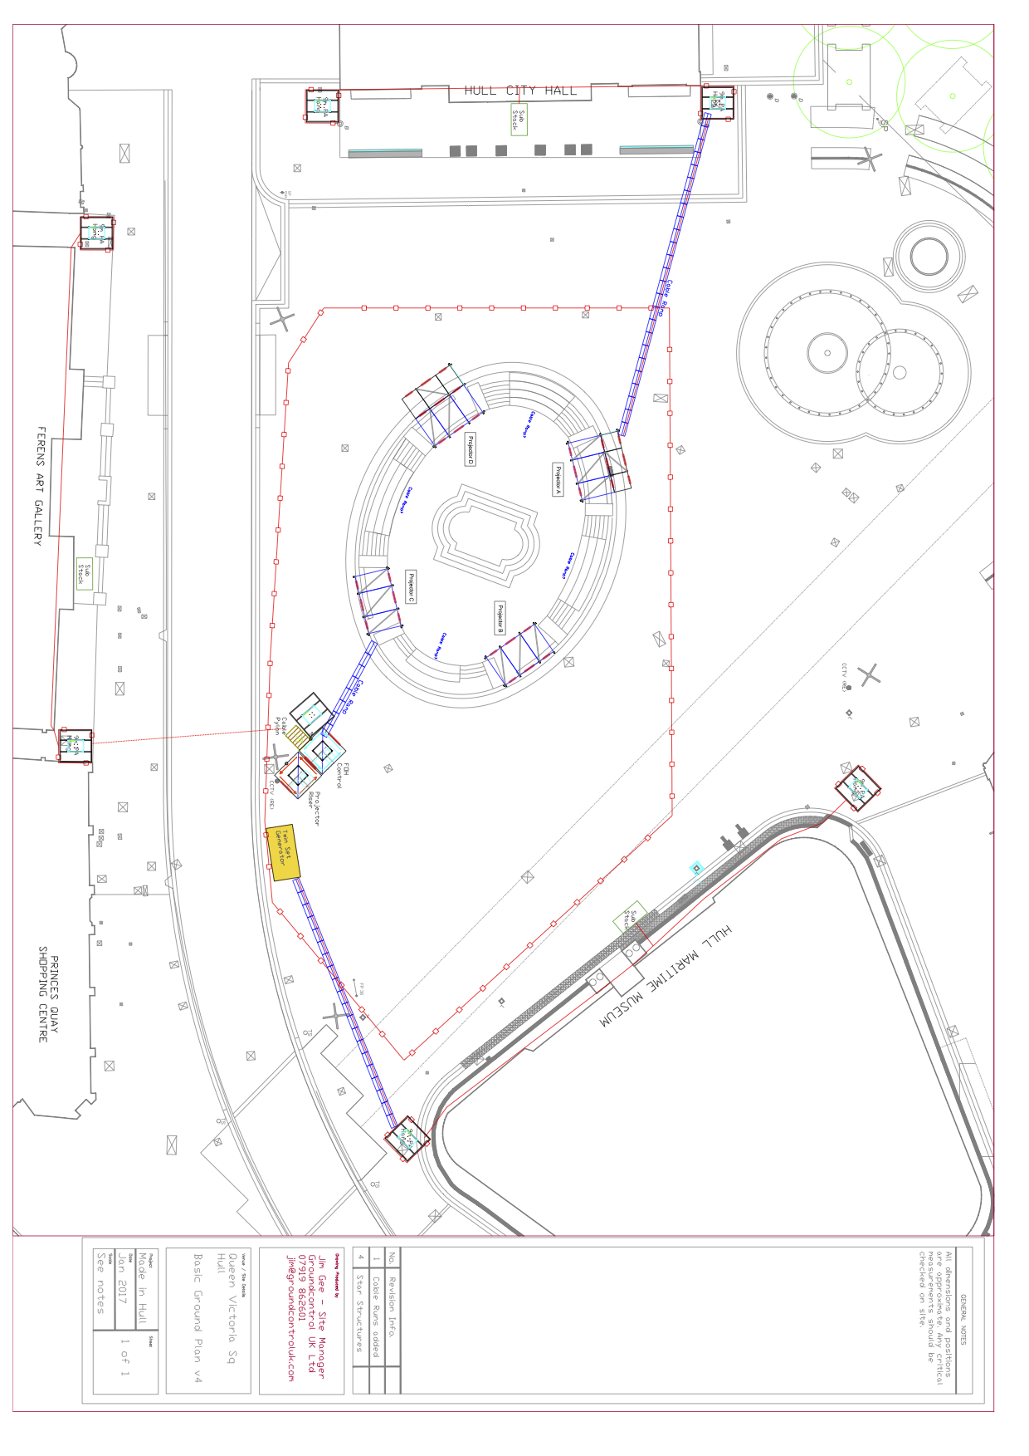
APPENDIX 2.1 QVS SHOW PLAN

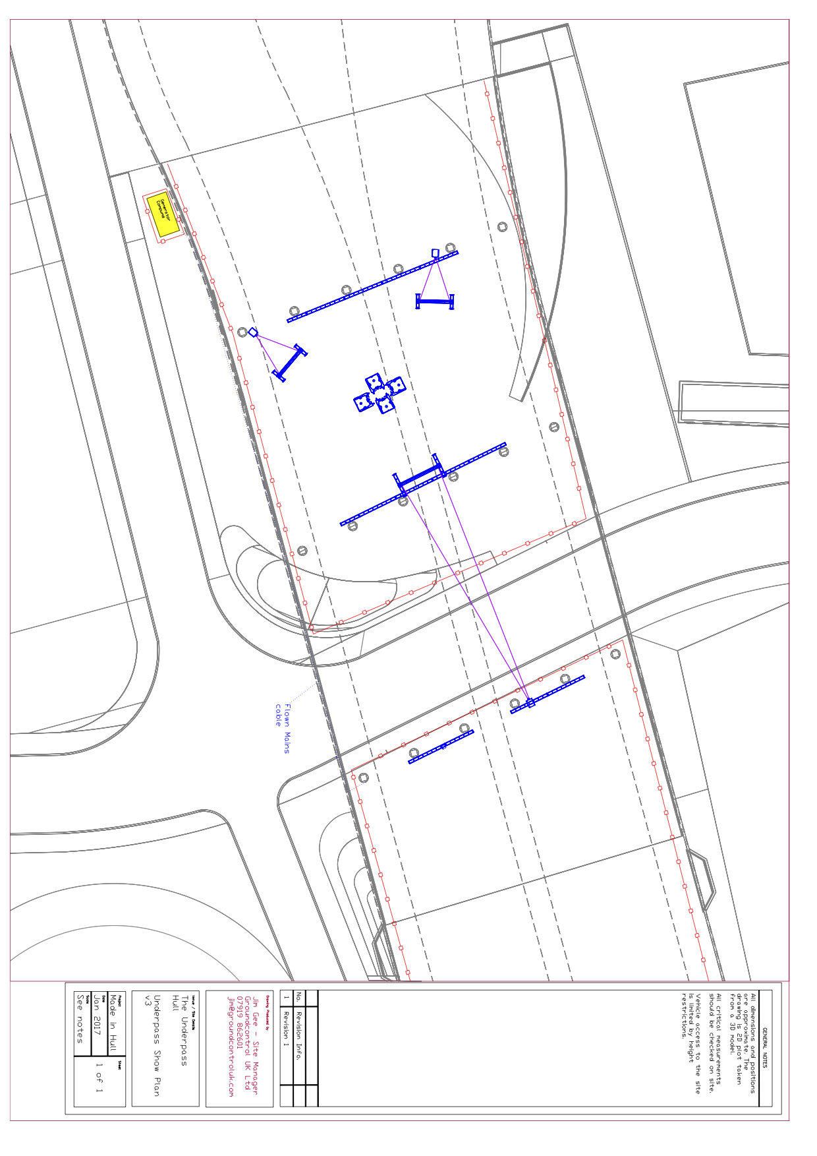
APPENDIX 2.2 UNDERPASS SHOW PLAN

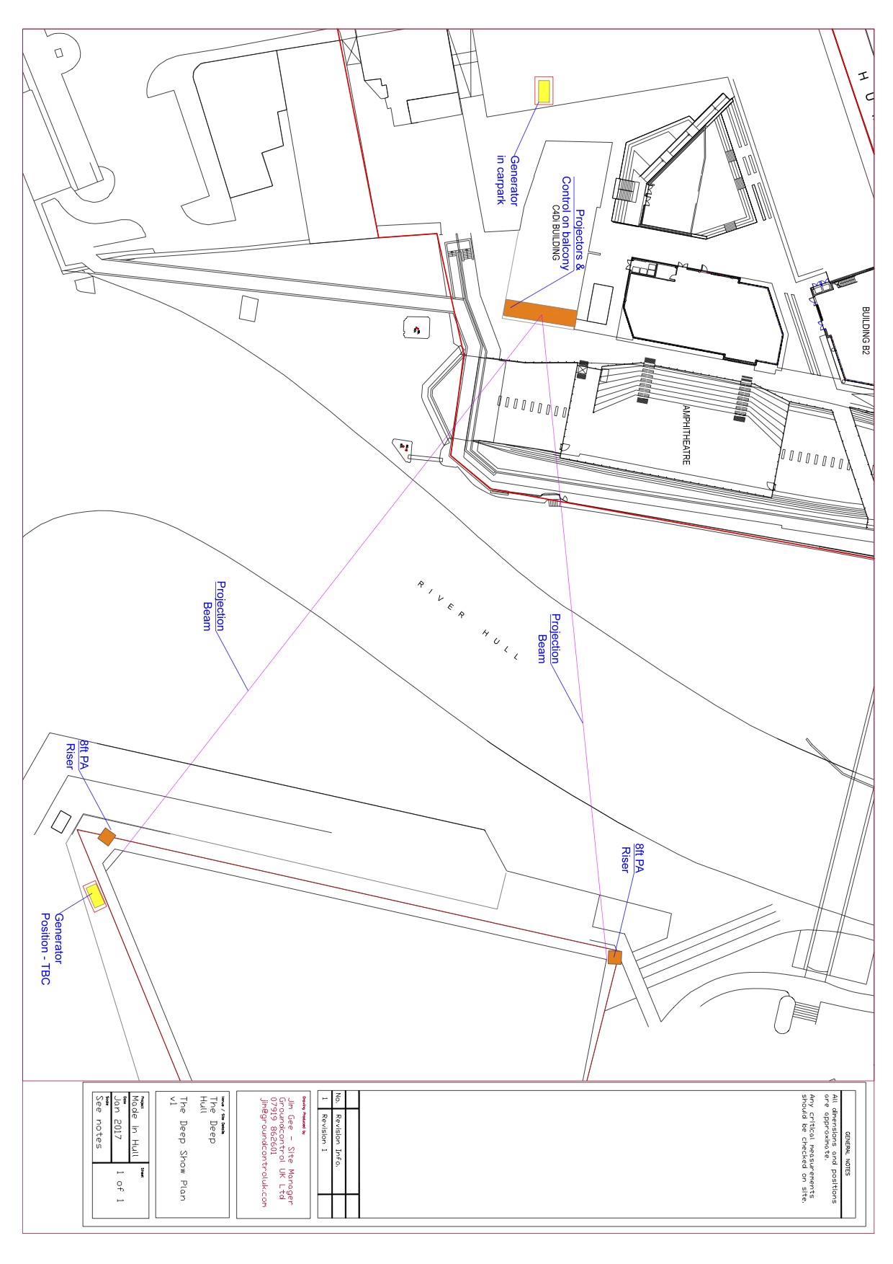
APPENDIX 2.3 THE DEEP SHOW PLAN
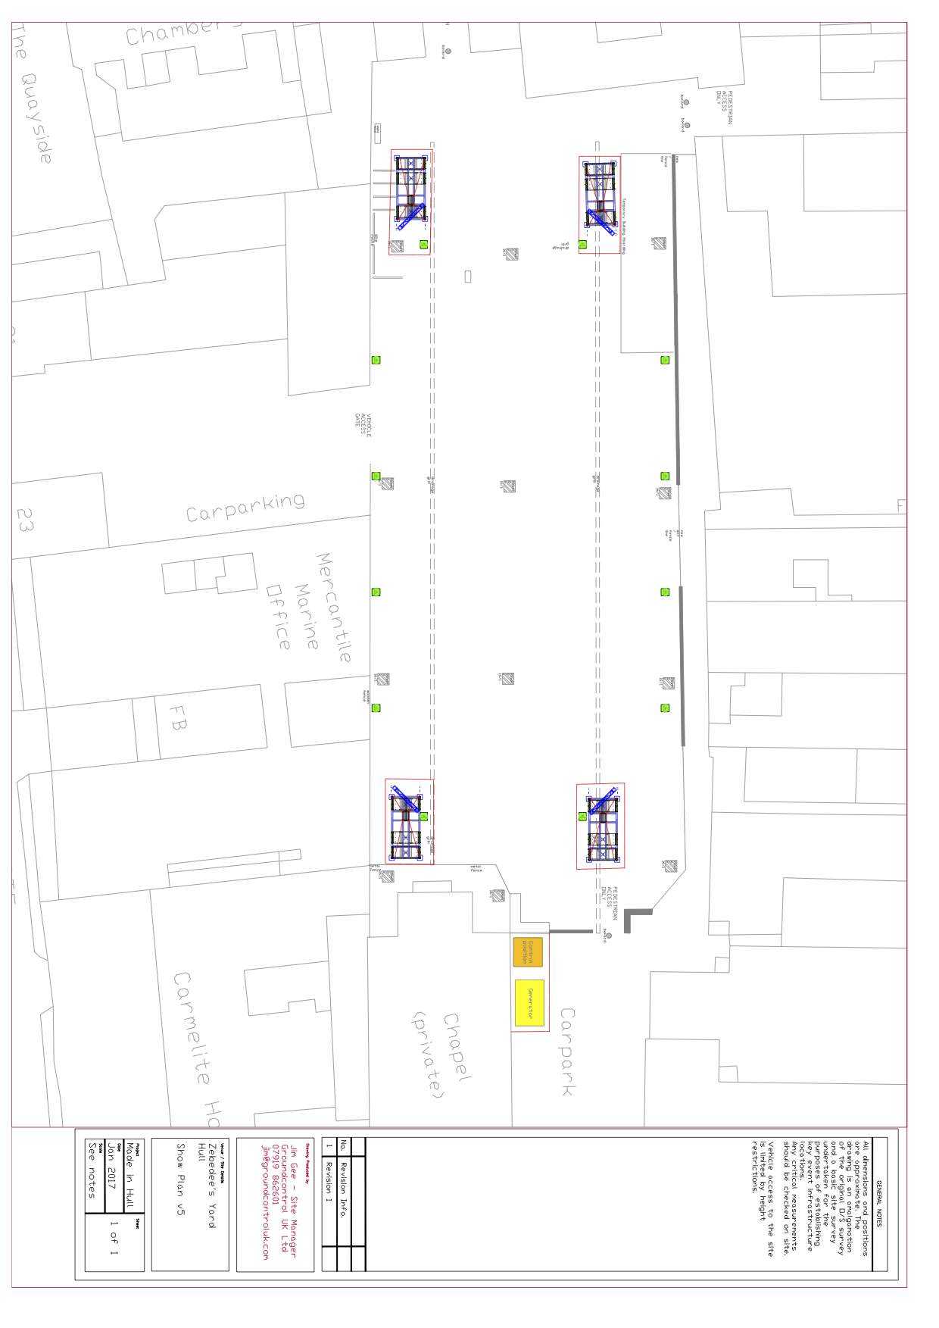
APPENDIX 2.4 ZEBEDEES YARD SHOW PLAN

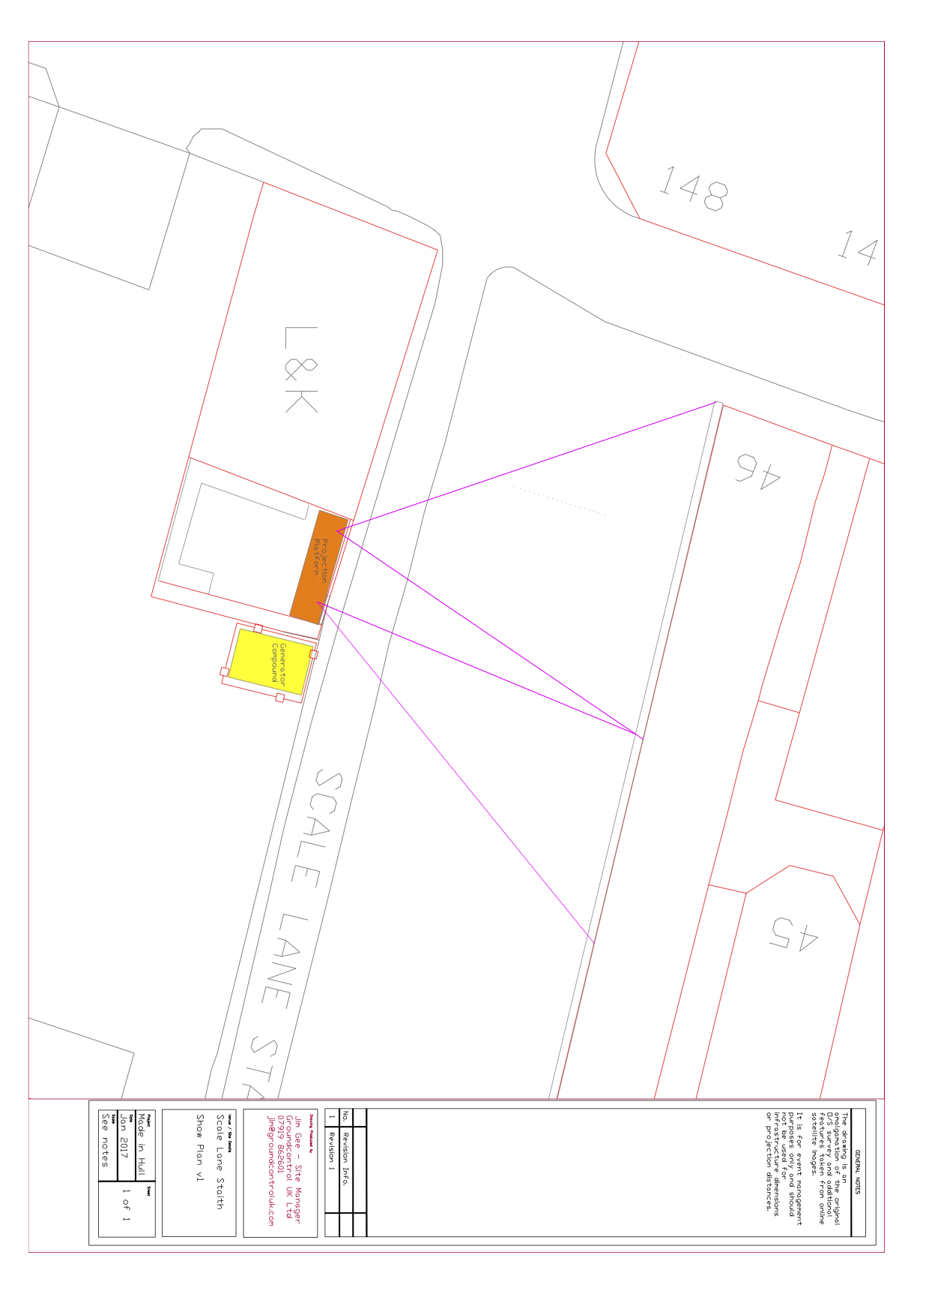
APPENDIX 2.5 SCALE LANE STAITH SHOW PLAN
APPENDIX 3 – STRUCTURAL DRAWINGS

APPENDIX 3.1 QVS PROJECTION PLATFORMS

APPENDIX 3.2 QVS FRONT OF HOUSE TOWER

APPENDIX 3.3 QVS PROJECTION TOWER

APPENDIX 3.4 QVS CABLE PYLON

APPENDIX 3.5 ZEBEDEES YARD LIGHTING TOWER

APPENDIX 3.6 C4DI (THE DEEP) PROJECTION PLATFORM

APPENDIX 3.7 UNDERPASS SCREEN SUPPORT SMALL

APPENDIX 3.8 UNDERPASS SCREEN SUPPORT LARGE

APPENDIX 4

HULL - PRODUCTION SUPPLIERS
ROLE | COMPANY | SITE CONTACT
AUDIO | Tube | Melv Coote
LIGHTING | DBN | Nick Walton
PROJECTION & VIDEO | Bluman Associates | Simon Hudson
STRUCTURES & RIGGING | Star Events | Pete Holdich
POWER | Midas | David Noble

APPENDIX 5 – PLANT SCHEDULE

DATE | DEPARTMENT | ACTIVITY | LOCATION | PLANT REQUIRED | REQUIRED FROM | REQUIRED UNTIL
19/12/2016 | SITE & PRODUCTION | TRUCK UNLOADING & CROSSLOADING | BONEYARD | 926 | ALL DAY | ALL DAY
19/12/2016 | STAR EVENTS | TRUCK CROSSLOADING | BONEYARD | 926 | 11:00 | 12:00
19/12/2016 | STAR EVENTS | TRUCK UNLOADING | SLS | 7M | 13:00 | 16:00
19/12/2016 | STAR EVENTS | TRUCK UNLOADING | QVS | 7M | 19:00 | 20:00
20/12/2016 | STAR EVENTS | TRUCK UNLOADING | QVS | 7M | ALL DAY | ALL DAY
20/12/2016 | SITE & PRODUCTION | TRUCK UNLOADING & CROSSLOADING | BONEYARD | 926 | ALL DAY | ALL DAY
21/12/2016 | PRODUCTION | WINDOW SCREENING | QVS | TRUCK MOUNT | ALL DAY | ALL DAY
21/12/2016 | STAR EVENTS | TRUCK UNLOADING | QVS | 7M | ALL DAY | ALL DAY
21/12/2016 | SITE & PRODUCTION | TRUCK UNLOADING & CROSSLOADING | BONEYARD | 926 | ALL DAY | ALL DAY
22/12/2016 | TUBE | CABLE INSTALL | QVS | 17MW/BASKET | 08:00 | 18:00
22/12/2016 | STAR EVENTS | TRUCK UNLOADING | ZEBEDEE'S YARD | 7M | 08:00 | 13:00
22/12/2016 | STAR EVENTS | TRUCK CROSSLOADING | BONEYARD | 926 | 18:00 | 18:30
22/12/2016 | SITE & PRODUCTION | TRUCK UNLOADING & CROSSLOADING | BONEYARD | 926 | ALL DAY | ALL DAY
23/12/2016 | STAR EVENTS | RIGGING INSTALL | UNDERPASS | 17MW/BASKET | 08:00 | 13:00
23/12/2016 | SITE & PRODUCTION | TRUCK UNLOADING & CROSSLOADING | BONEYARD | 926 | ALL DAY | ALL DAY
27/12/2016 | BLUMAN | PROJECTOR INSTALL | UNDERPASS | 17MW/BASKET | 12:00 | 16:00
27/12/2016 | BLUMAN | PROJECTOR INSTALL | SLS | 7M | 12:00 | 16:00
27/12/2016 | DBN | LX INSTALL | ZEBEDEE'S YARD | 60'PICKER | 13:00 | 19:00
27/12/2016 | SITE & PRODUCTION | TRUCK UNLOADING & CROSSLOADING | BONEYARD | 926 | ALL DAY | ALL DAY
28/12/2016 | TUBE | AUDIO INSTALL | THE DEEP | 7M | 08:00 | 10:00
28/12/2016 | DBN | LX INSTALL | UNDERPASS | 17MW/BASKET | 14:00 | 19:00
28/12/2016 | SITE & PRODUCTION | TRUCK UNLOADING & CROSSLOADING | BONEYARD | 926 | ALL DAY | ALL DAY
29/12/2016 | SITE & PRODUCTION | TRUCK UNLOADING & CROSSLOADING | BONEYARD | 926 | ALL DAY | ALL DAY
30/12/2016 | SITE & PRODUCTION | TRUCK UNLOADING & CROSSLOADING | BONEYARD | 926 | ALL DAY | ALL DAY
07/12/2016 | ALL | TRUCK LOADING | QVS | 7M&17M | 21:00 | 04:00
08/02/2017 | SITE & PRODUCTION | TRUCK UNLOADING & CROSSLOADING | BONEYARD | 926 | ALL DAY | ALL DAY
08/02/2017 | BLUMAN | PROJECTOR DERIG | UNDERPASS | 17MW/BASKET | 09:00 | 11:00
08/02/2017 | DBN | LX DERIG | UNDERPASS | 60'PICKER | 09:00 | 11:00
08/02/2017 | TUBE | AUDIO DERIG | THE DEEP | 7M | 09:00 | 11:00
08/02/2017 | BLUMAN | PROJECTOR DERIG | SLS | 7M | 11:00 | 13:00
08/02/2017 | STAR EVENTS | TRUCK LOADING | SLS | 7M | 11:00 | 13:00
08/02/2017 | DBN | LX DERIG | ZEBEDEE'S YARD | 60'PICKER | 11:00 | 13:00
09/02/2017 | STAR EVENTS | TRUCK LOADING | ZEBEDEE'S YARD | 7M | 08:00 | 14:00
09/02/2017 | STAR EVENTS | PA TOWER DERIG | QVS | 7M | 14:00 | 17:00
09/02/2017 | SITE & PRODUCTION | TRUCK UNLOADING & CROSSLOADING | BONEYARD | 926 | ALL DAY | ALL DAY
10/02/2017 | SITE & PRODUCTION | TRUCK UNLOADING & CROSSLOADING | BONEYARD | 926 | ALL DAY | ALL DAY

