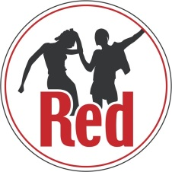
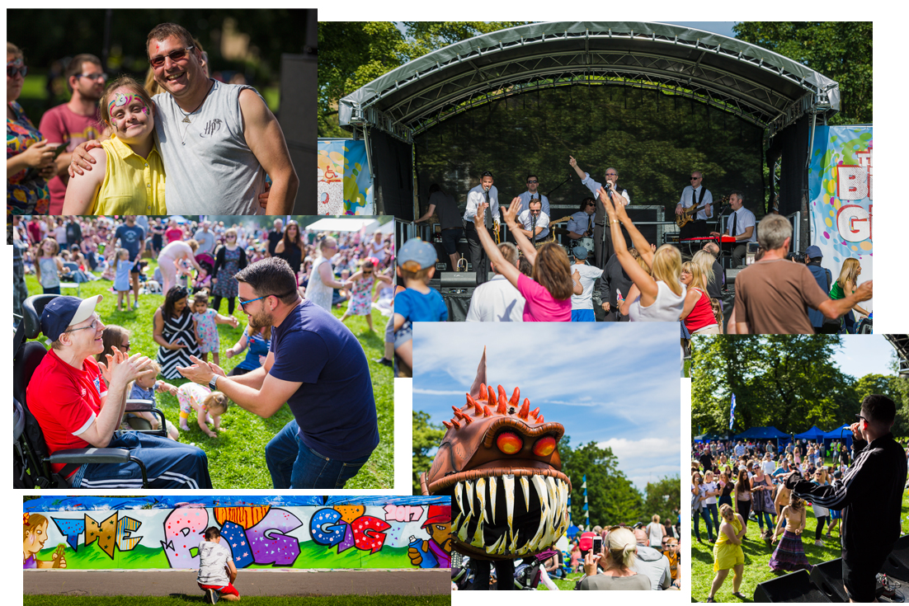
Feedback

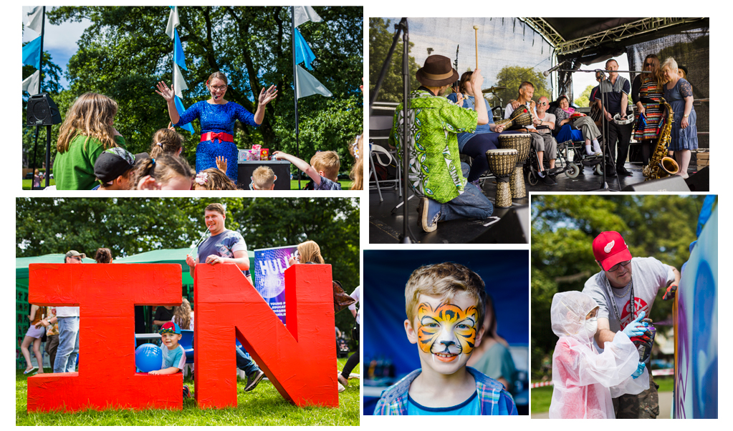
All comments taken from feedback forms completed on the day.
“Really positive for people with learning disabilities as we are all the same”
“A wonderful event, do it every year! xxx”
“The whole event is wonderful, really inclusive to everyone who attended”

“Lovely atmosphere, well organised”
“Thoroughly impressed with how the community have come out and enjoyed the afternoon for the music and activities”
“Great, welcoming, fun and accessible”
“It's red-hot! Wicked!”
“Very very sociable, easy access”
“Fab day, friendly staff, very “welcoming”
“Should be more like this!”
“I'm really happy!”

