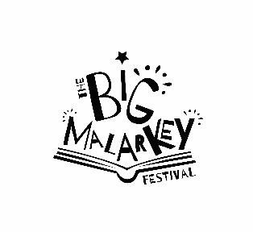

SATURDAY AUDIENCE FEEDBACK QUESTIONNAIRE

- What motivated you to attend this event? (Tick all that apply)
Because it’s part of Hull UK City of Culture 2017
Because I’m a regular attender of Hull Libraries events
It’s a unique experience not to be missed
General interest in this type of event
Wanted to see / do something creative
Specific interest in a group / performer involved (please specify which artists below)
Getting involved in what’s happening
Trying something new or different
Something to do while I’m in Hull on business
It’s affordable / good value
Something to do with friends / family
Something to do with the kids
Interested to find out more about Hull
No particular reason / someone else’s idea
Other (please specify below)

- Are you a member of Hull Libraries Yes/No
- Would you attend another event like this? Yes/ No
- Which events/activities did you attend today ? ………………………………………………………………

…………………………………………………………………………………………………………………………………………

……………………………………………………………………………………………………………………………………….
- How did you find out about the festival?
Friends/family/colleagues - told me in person
Friends/family colleagues – via social media / email
www.hull2017.co.uk
Other website (please specify)
Hull 2017 Social Media
Other organisation Social media (please specify)
Advertising and printed promotional material (e.g. brochure, leaflet, flyer, billboard)
Newspaper
TV
Radio
Don’t remember
Other (please specify)

- Please let us know your thoughts on today’s event by ticking the relevant boxes below:
Excellent Good Satisfactory Poor
Event organisation
Event promotion
Event location
Information available
Overall quality of the event
- Any other comments about today’s event?

Would you be willing to be contacted by Hull 2017 or the University of Hull to take part in further research? Yes/No

Your name:……………………………………………………………………………………………………………….

Email address:…………………………………………………………………………………………………Postcode……………….

Please tell us your age group? □ 16-17  □18-19 □ 20-24 □25-29 □30-34
□35-44 □45-49 □ 50-54 □ 55-59 □ 60-64 □ 65-69 □ 70-74 □ 75+
Thank you for taking the time to fill in this form. Your feedback will be very useful to us for planning for next year.

