
MADE IN HULL 2017

BUILD & BREAK
PHASED PLAN

CONTENTS

Page 3 | Overview
Page 4 | Core Operations Team
Page 5 - 12 | Schedule Breakdown - Build
Page 13 | Rehearsal Days - 29/12/16 - 30/12/16
Page 14 | Show Days 01/01/17 - 07/01/17
Page 15 - 18 | Schedule Breakdown - Break - 07/01/17
Page 19 | Appendices
Page 20 | Appendix 1 - Show Plans
Page 21 | Appendix 2.1 QVS Show Plan
Page 22 | Appendix 2.2 Underpass Show Plan
Page 23 | Appendix 2.3 The Deep Show Plan
Page 24 | Appendix 2.4 Zebedees Yard Show Plan
Page 25 | Appendix 2.5 Scale Lane Staith Show Plan
Page 26 | Appendix 3 - Structural Drawings
Page 27 | Appendix 3.1 QVS Projection Platforms
Page 28 | Appendix 3.2 QVS Front of House Tower
Page 29 | Appendix 3.3 QVS Projection Tower
Page 30 | Appendix 3.4 QVS Cable Pylon
Page 31 | Appendix 3.5 Zebedees Yard Lighting Tower
Page 32 | Appendix 3.6 C4DI (The Deep) Projection Platform
Page 33 | Appendix 3.7 Underpass Screen Support Small
Page 34 | Appendix 3.8 Underpass Screen Support Large
Page 35 | Appendix 4 - Hull Production Suppliers
Page 36 | Appendix 5 - Plant Schedule
Page 37 | Appendix 5 - Plant Schedule continued
OVERVIEW

The purpose of this document is to provide a brief for Hull city council and individual venues with a brief guide to the production schedule for the build and de-rig of Made In Hull; the launch event for Hull 2017.

Should there be any queries on the contents of this brief, please direct all correspondence through Chris Clay in the first instance to be directed to the person(s) responsible for the area with which the matter concerns.

To accompany the brief there are also appendices outlining:- plant movement, temporary structure drawings, site plans & plant working zones to be referenced at will. We have also drawn up technical production information packs for each venue, detailing specific technical specifications. These are available at request.

CORE OPERATIONS TEAM

SCHEDULE BREAKDOWN

APPENDICES
APPENDIX 1 – SHOW PLANS

APPENDIX 2.1 QVS PHASE PLANS

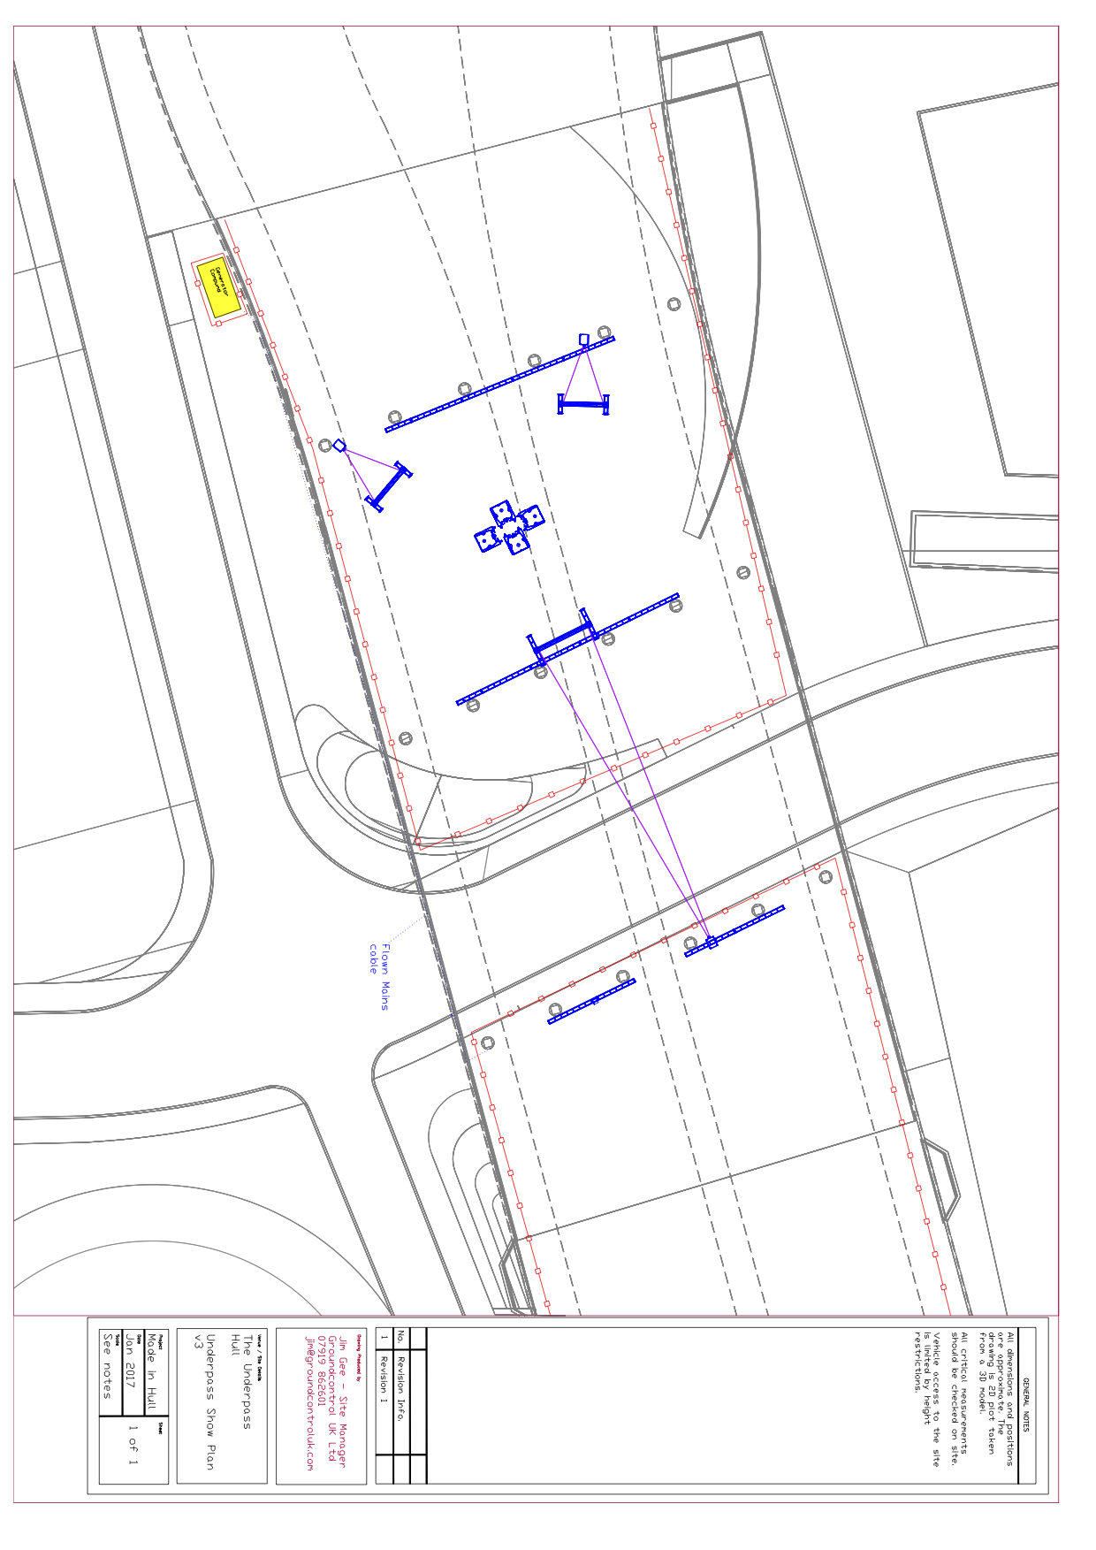
APPENDIX 2.2 UNDERPASS SHOW PLAN

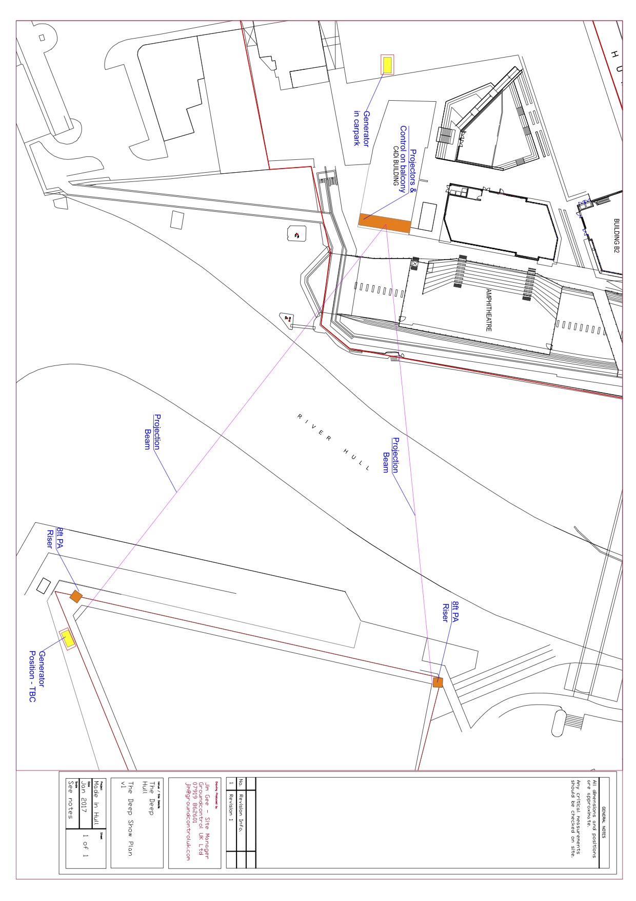
APPENDIX 2.3 THE DEEP SHOW PLAN
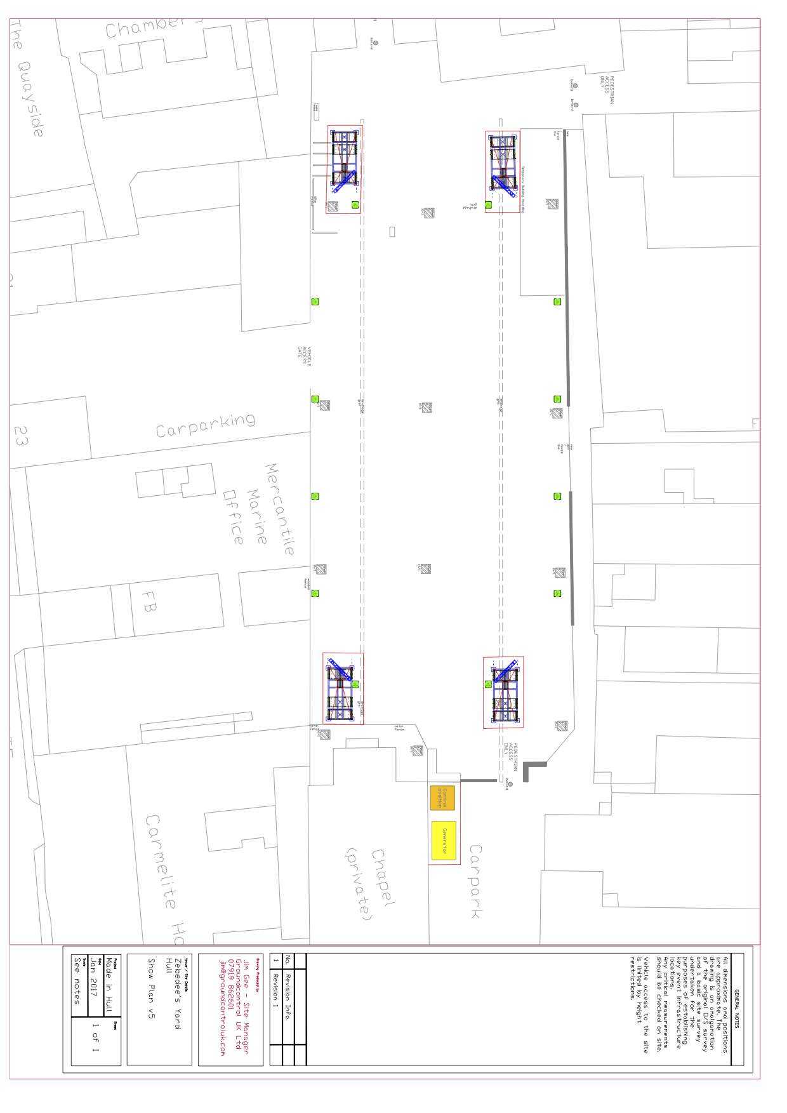
APPENDIX 2.4 ZEBEDEES YARD SHOW PLAN

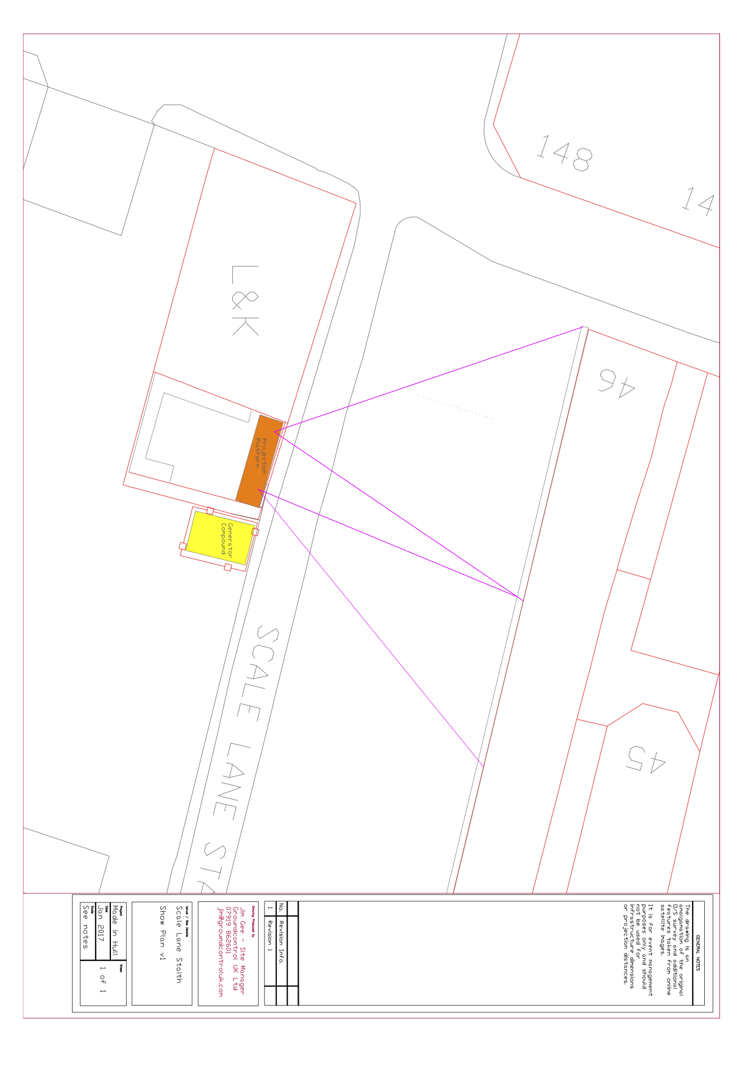
APPENDIX 2.5 SCALE LANE STAITH SHOW PLAN
APPENDIX 3 – STRUCTURAL DRAWINGS

APPENDIX 3.1 QVS PROJECTION PLATFORMS

APPENDIX 3.2 QVS FRONT OF HOUSE TOWER

APPENDIX 3.3 QVS PROJECTION TOWER

APPENDIX 3.4 QVS CABLE PYLON

APPENDIX 3.5 ZEBEDEES YARD LIGHTING TOWER

APPENDIX 3.6 C4DI (THE DEEP) PROJECTION PLATFORM

APPENDIX 3.7 UNDERPASS SCREEN SUPPORT SMALL

APPENDIX 3.8 UNDERPASS SCREEN SUPPORT LARGE

APPENDIX 4

HULL - PRODUCTION SUPPLIERS
ROLE | COMPANY | SITE CONTACT
AUDIO | Tube | Melv Coote
LIGHTING | DBN | Nick Walton
PROJECTION & VIDEO | Bluman Associates | Simon Hudson
STRUCTURES & RIGGING | Star Events | Pete Holdich
POWER | Midas | David Noble

APPENDIX 5 – PLANT SCHEDULE

DATE | DEPARTMENT | ACTIVITY | LOCATION | PLANT REQUIRED | REQUIRED FROM | REQUIRED UNTIL
19/12/2016 | SITE & PRODUCTION | TRUCK UNLOADING & CROSSLOADING | BONEYARD | 926 | ALL DAY | ALL DAY
19/12/2016 | STAR EVENTS | TRUCK CROSSLOADING | BONEYARD | 926 | 11:00 | 12:00
19/12/2016 | STAR EVENTS | TRUCK UNLOADING | SLS | 7M | 13:00 | 16:00
19/12/2016 | STAR EVENTS | TRUCK UNLOADING | QVS | 7M | 19:00 | 20:00
20/12/2016 | STAR EVENTS | TRUCK UNLOADING | QVS | 7M | ALL DAY | ALL DAY
20/12/2016 | SITE & PRODUCTION | TRUCK UNLOADING & CROSSLOADING | BONEYARD | 926 | ALL DAY | ALL DAY
21/12/2016 | PRODUCTION | WINDOW SCREENING | QVS | TRUCK MOUNT | ALL DAY | ALL DAY
21/12/2016 | STAR EVENTS | TRUCK UNLOADING | QVS | 7M | ALL DAY | ALL DAY
21/12/2016 | SITE & PRODUCTION | TRUCK UNLOADING & CROSSLOADING | BONEYARD | 926 | ALL DAY | ALL DAY
22/12/2016 | TUBE | CABLE INSTALL | QVS | 17MW/BASKET | 08:00 | 18:00
22/12/2016 | STAR EVENTS | TRUCK UNLOADING | ZEBEDEE'S YARD | 7M | 08:00 | 13:00
22/12/2016 | STAR EVENTS | TRUCK CROSSLOADING | BONEYARD | 926 | 18:00 | 18:30
22/12/2016 | SITE & PRODUCTION | TRUCK UNLOADING & CROSSLOADING | BONEYARD | 926 | ALL DAY | ALL DAY
23/12/2016 | STAR EVENTS | RIGGING INSTALL | UNDERPASS | 17MW/BASKET | 08:00 | 13:00
23/12/2016 | SITE & PRODUCTION | TRUCK UNLOADING & CROSSLOADING | BONEYARD | 926 | ALL DAY | ALL DAY
27/12/2016 | BLUMAN | PROJECTOR INSTALL | UNDERPASS | 17MW/BASKET | 12:00 | 16:00
27/12/2016 | BLUMAN | PROJECTOR INSTALL | SLS | 7M | 12:00 | 16:00
27/12/2016 | DBN | LX INSTALL | ZEBEDEE'S YARD | 60'PICKER | 13:00 | 19:00
27/12/2016 | SITE & PRODUCTION | TRUCK UNLOADING & CROSSLOADING | BONEYARD | 926 | ALL DAY | ALL DAY
28/12/2016 | TUBE | AUDIO INSTALL | THE DEEP | 7M | 08:00 | 10:00
28/12/2016 | DBN | LX INSTALL | UNDERPASS | 17MW/BASKET | 14:00 | 19:00
28/12/2016 | SITE & PRODUCTION | TRUCK UNLOADING & CROSSLOADING | BONEYARD | 926 | ALL DAY | ALL DAY
29/12/2016 | SITE & PRODUCTION | TRUCK UNLOADING & CROSSLOADING | BONEYARD | 926 | ALL DAY | ALL DAY
30/12/2016 | SITE & PRODUCTION | TRUCK UNLOADING & CROSSLOADING | BONEYARD | 926 | ALL DAY | ALL DAY
07/12/2016 | ALL | TRUCK LOADING | QVS | 7M&17M | 21:00 | 04:00
08/02/2017 | SITE & PRODUCTION | TRUCK UNLOADING & CROSSLOADING | BONEYARD | 926 | ALL DAY | ALL DAY
08/02/2017 | BLUMAN | PROJECTOR DERIG | UNDERPASS | 17MW/BASKET | 09:00 | 11:00
08/02/2017 | DBN | LX DERIG | UNDERPASS | 60'PICKER | 09:00 | 11:00
08/02/2017 | TUBE | AUDIO DERIG | THE DEEP | 7M | 09:00 | 11:00
08/02/2017 | BLUMAN | PROJECTOR DERIG | SLS | 7M | 11:00 | 13:00
08/02/2017 | STAR EVENTS | TRUCK LOADING | SLS | 7M | 11:00 | 13:00
08/02/2017 | DBN | LX DERIG | ZEBEDEE'S YARD | 60'PICKER | 11:00 | 13:00
09/02/2017 | STAR EVENTS | TRUCK LOADING | ZEBEDEE'S YARD | 7M | 08:00 | 14:00
09/02/2017 | STAR EVENTS | PA TOWER DERIG | QVS | 7M | 14:00 | 17:00
09/02/2017 | SITE & PRODUCTION | TRUCK UNLOADING & CROSSLOADING | BONEYARD | 926 | ALL DAY | ALL DAY
10/02/2017 | SITE & PRODUCTION | TRUCK UNLOADING & CROSSLOADING | BONEYARD | 926 | ALL DAY | ALL DAY

