PRSF NEW MUSIC BIENNIAL
HULL
29th JUNE to 2nd JULY 2017
ARTIST PACK
ARTIST: Hannah Peel
ARTIST CONTACT (Mobile number): TBC – PROMOTER TO CONFIRM
Band management - Jeremy Davies - 07775 892780
Technical - Jamie Saye - 07500 007490
VENUE: Albermarle Music Centre
Address: Albermarle Music Centre, 60 Ferensway, Hull HU2 8LN
Phone: 01482 318800
LOADING IN FROM:
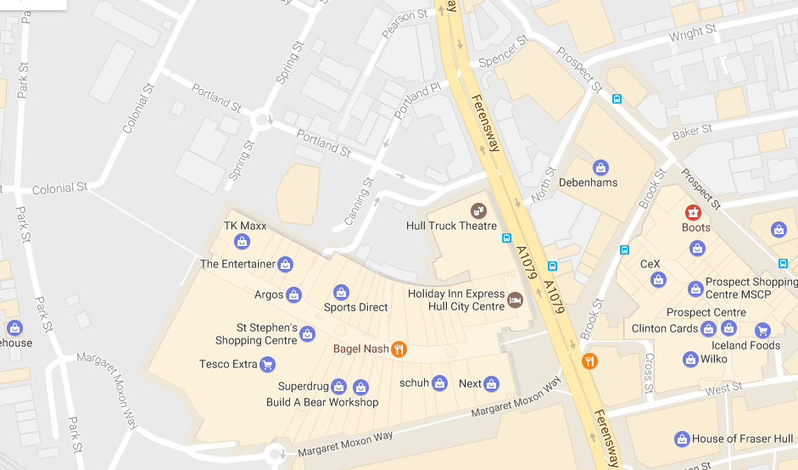

PARKING REQUIREMENT and LOCATION:
TBC – PROMOTER TO CONFIRM
PERSONNEL
STAGE MANAGER (Primary contact show weekend only): ??
PRODUCTION MANAGER: Gareth Hughes – 07733112272
PRODUCTION ASSISTANT: Joanna Morley – 07725 942808
VENUE CONTACT: ??

DATE AND TIME OF PERFORMANCE: Saturday 1st July 16:00 (45mins)
PRODUCTION SCHEDULE:
THURSDAY 29 JUNE
09:00 - 18:00 (ACCESS) | 09:00 | Stage manager on site
 | DAY | Delivery of Harmonium (Gavin Bryars)
 | DAY | Set up dressing rooms
 | DAY | Dressing and branding
 | DAY | BBC to park up to the corner / rear
 | 12noon | Tech set up
 | 12noon | Set up Anna Meredith - percussion set up (see also Hannah Peel plot)
FRIDAY 30 JUNE
09:00 - 23:00 (ACCESS) | 09:00 | Stage manager on site - set for Anna Meredith
 | 09:00 | BBC OB in
 | 10:00 | Anna Meredith - Artists arrive
 | 11:00 - 12:00 | Anna Meredith - Set up
 | 13:00 - 16:00 | Anna Meredith - rehearsal
 | 16:30 | Box office on site
 | 17:00 | Doors
 | 17:30 | Anna Meredith PERFORMANCE
 | 18:15 | FINISH
 | 18:30 - 18:45 | Reset for Gavin Bryars
 | 18:45 | Rehearsal Gavin Bryars
 | 19:00 - 21:00 | Moulettes rehearsal - rehearsal - Rivers and Railways
 | 19:45 | Doors
 | 20:00 | Gavin Bryars - PERFORMANCE
 | 20:45 | FINISH
 | 21:00 - 23:00 | Reset for Hannah Peel and Laurence Crane
 | 21:00 - 23:00 | Reset Dressing rooms
SATURDAY 1 JULY
09:00 - 21:00 (ACCESS) | 09:00 | Stage manager on site
 | 10:00 | Artists arrive - Laurence Crane
 | 11:00 - 12:15 | Laurence Crane - rehearsal
 | 12:00 | Box office on site
 | 12:15 | Doors
 | 12:30 | Laurence Crane - PERFORMANCE
 | 13:15 | FINISH
 | 13:30 | Hannah Peel - Artists arrive - rehearsal synthesisers and percussion
 | 15:30 | Hannah Peel - Brass arrives - rehearsal
 | 16:15 | Doors
 | 16:30 | Hannah Peel - PERFORMANCE
 | 17:15 | FINISH
 | 17:30 | Set tech for Jocelyn Pook
 | 21:00 | Clear
SUNDAY 2 JULY
09:00 - 21:00 (ACCESS) | 09:00 | Stage Manager on site
 | 10:00 | Artists arrive - Jocelyn Pook
 | 10:00 - 14:00 | Jocelyn rehearsals
 | 14:00 | Box office on site
 | 14:45 | Doors
 | 15:00 | Jocelyn Pook - PERFORMANCE
 | 15:45 | FINISH
 | 16:00 - 20:00 | Clear and derig

TECHNICAL
Sound
FOH Control
1 Midas Pro 2C - Live Audio System

Speaker System
6 L Acoustics - ARCS
8 L Acoustic ARCS - ARCOUPL
2 Ratchet Strap (Black) - 7.5m 2T
4 L Acoustics - SB28
1 L Acoustics LA8 Rack (4 - Way)
2 NL4 Speakon Cable 4mm 20m
2 NL4 Speakon Cable 4mm 10m
2 NL4 Speakon Cable 4mm 5m
4 NL4 Speakon Cable 4mm 0.5m
3 NL4 Sub Split Cable

Monitor System (Up to 4x Mixes)
4 L Acoustic 115XT HiQ

Microphones
1 Shure ULXP Beta58 Handheld Radio System - CH38

Misc
1 63A 3-Phase Cable 20m
1 63A 3 Phase Mains Distro #5
1 Backline Power Prep - Standard

Staff
1 Engineer - FOH
1 Engineer – Systems
AV
Material
1 Blackmagic Design HDMI-SDI Converter
1 Blackmagic Design SDI-HDMI Converter
1 Black Magic ATEM 1 M/E Production Studio 4K
Staff
1 Engineer - AV

Lighting
Provided by House
Staff
1 Engineer – Lighting
Headphone Monitoring – Tubular Brass
Material
1 Art Head Amp 6
1 Closed Back Headphones
1 10m Balanced Jack Cable
1 5m Balanced Jack Cable
1 Jack to Jack Coupler
1 3.5mm to 6.35mm Jack Adapter
2 BSS AR133 DI
Microphones – Jocelyn Pook
RF
1 DPA 4088F - Headset Microphone
1 DPA DAD6034 - Microdot to 3.5mm Jack
1 Sennheiser EW512 G3 - Belt Pack System - Range GB
Microphones
3 Neumann KMS-105
3 AKG C451
3 AKG C414ULS
10 Microphone Stand – Tall
Microphones – Tubluar Brass
Material
6 BSS AR133 DI
2 AKG C451
1 Shure Beta 57
3 Microphone Stand – Tall
Microphone – Gavin Bryars
Material
1 Sennheiser e609
2 DPA DAD 4099-BC
1 DPA Clip for Violin and Mandolin (VC4099)
1 DPA Clip for Cello (CC4099)
2 DPA DAD 6001 XLR 48 volt adapter
1 Shure Beta 87
2 Shure SM57
2 BSS AR133 DI
1 Microphone Stand - Tall
2 Microphone Stand - Medium
1 Microphone Stand - Short
RIDER:
TBC
BACKLINE:
BACKLINE | 3 timps /stool
 | Bass drum | ALBEMARLE KIT 1
 | Clash cymbals | ALBEMARLE KIT 1
 | Suspended cymbal | ALBEMARLE KIT 1
 | Mark tree
 | Glockenspiel
 | Xylophone
 | Tubular bells
 | Drum kit | ALBEMARLE KIT 1
 | Traps tray | ALBEMARLE KIT 1
 | 2 x extra snare drums + stands | ALBEMARLE KIT 1
 | Stand for woodblock

ACCREDITATION
David & Alice Porter (Directors)
Steve & Sam Shaw (Directors)
Peter & Lorraine Boardman (Directors)
Wes Zepherin (Director)
Kirsty & Gary Halliday (Marketing)
Ben Pugh (Production)

Artistic Personnel: Sandy Smith, Rob Westacott, Martin Britt, Chris Bradley, Norman Christie, Chic Cullen, Iain Culross, Andy Blackledge, Ronnie Wotherspoon, Colin Brooke, Jimmy Leggatt, Stuart Linguard, Owen Farr, Trevor McCormick, David Essex, Stevie Kane, Evelyn Bradley, Scott Kerr, Jonti Smith, Paul Kiernan, Johnathan Beatty, Mark Frost, Tony Whittingham, Jon Davies, Simon Gresswall, Andy Warriner, Rhianon Harding, josh Finzi and Pete Matthews.

