CREATIVE COMMUNITIES PROGRAMME
END OF PROJECT REPORT
GENERAL INFORMATION
PROJECT NAME: | Hear in Hull
PROJECT LEAD: | Jemma Brown
REPORT DATE: | 22/11/2017

INTRODUCTION
Everyone who receives a grant from the Creative Communities Programme must complete this End of Project Report. Please read it straight away – you will need to collect the information throughout the lifetime of your project.
Please refer to your Agreement, and any changes you agreed with us, when you complete this Report.
This End of Project Report tells us:
- What has happened during your project as a whole;
- Your final income and expenditure figures;
- What you have learned from the project, how you have adapted to these learnings, and what you plan to do with this learning in future.
We will send you a separate online survey about your experience of the Creative Communities Programme as a grant recipient. We will process the information you give us to understand:
- The outcomes and impacts of our grant and support on your organisation;
- The effectiveness of our services and grants administration; and
- What key things the city needs to be aware of in future, when supporting community level arts and culture projects.
We also use this information to report to our funders.
Please email this activity report to: creativecommunities@hull2017.co.uk

- PROJECT REPORT
Please provide a brief update (3 or 4) sentences on each of the following areas to let us know how your project went, what you’ve learnt and how well we supported you.
EVENT PLANNING AND PROJECT MANAGEMENT
(EXPAND BOX FOR ALL INFO)
Project planned and delivered in response to original timeline. All tasks on original brief completed within timeframe proposed.
Construction of animation took a little longer than first predicted – due to success of workshops and ideas created with the participants. However all completed within suitable time to circulate and prepare the main launch event at Hull Truck.
Effective support received from 2017 when looking for external venues to show finished work from project, also queries in terms of circulating information to contacts i.e education packs.

MARKETING AND COMMUNCIATIONS, PARTICIPATION AND LEARNING
(EXPAND BOX FOR ALL INFO)
Support from Hull 2017 team given with publicity – Hull Daily Mail and BBC Look North, Radio Humberside, Estuary TV. Animation was shared on Hull 2017 Social media.
Advice given on how to share with Digit-hull education portal – and education packs sent out to all schools.
Animation shared on Youtube channel (https://youtu.be/IGN0BB0HaCo), Artlink website & social media, My Pockets Website, vimeo. #mystammeringtap
Newspaper articles
http://www.hulldailymail.co.uk/news/hull-east-yorkshire-news/three-inspirational-youngsters-share-stories-660923
http://www.kcfm.co.uk/news/local-news/new-project-in-hull-raises-awareness-of-stammer/
Articles and Links to animation
http://www.hull2017.co.uk/whatson/events/ways-of-listening/
https://www.stammering.org/speaking-out/article/hear-hull-oct-dec-2017
National Clinical Excellence Network for dysfluency SIGNAL
Radio
KCFM 19/10/17
Radio Humberside breakfast show 26/10 8.50

RISK MANAGEMENT
(EXPAND BOX FOR ALL INFO)
Risk assessment completed for workshops and exhibition at launch event.

Artist used DBS checked. All participants signed media consent forms.

Inability to deliver project | Jemma | 3 | 5 | 15 | eg early discussions, backup plans | 2 | 5 | 10
Additional pressure on internal project team | Jemma | 3 | 3 | 9 | eg foreseeing required decisions and scheduling them in - regular meetings/ communication | 2 | 3 | 9
Additional pressure on internal project team; core components of project put at risk | Jemma | 4 | 4 | 16 | Scope of project signed off at SLT at greenlight. Detailed project brief attached to commissioning & production agreement. All aware that no additional budget is available for extra activity. | 2 | 4 | 8
Reputational damage with creative team, stakeholders and general public | Jemma | 3 | 5 | 15 | eg well managed creative process, management of expectations' - project brief sent out to artist - regular meetings to discuss/ communication | 2 | 5 | 10
Additional pressure on internal project team | Jemma | 3 | 5 | 15 | eg reliable documentation to allow others to pick up in someone's absence, advance planning for capacity & planned leave | 2 | 5 | 10

BUDGET
In this section we ask for a final summary of the income and expenditure of your activity to date.
Please complete the Budget Template provided. The template includes instructions on how to complete it.
Please use the space below for any comments and supporting information.
N/A

Specific Requirements - VAT
If you are registered for VAT, your expenditure figures should not include VAT that you can claim back. If you are not registered for VAT, your figures should include VAT. You may need to get advice from your own accountant or the relevant tax office. For information about VAT and other taxes, contact HM Revenue and Customs (HMRC) through their website at www.hmrc.gov.uk

B. MONITORING & EVALUATION REPORT

- Event Delivery
How did you do on reaching the targets laid out for project activity?
 | ORIGINAL TARGET* | REVISED TARGET* | TOTAL*
PROJECT VENUE/LOCATION
HU1 – HU9 | General public (stated in contract) | General public (stated in contract) | General public (stated in contract)
Not HU1 – HU9 | General public (stated in contract) | General public (stated in contract) | General public (stated in contract)
ACTIVITY
Number of performances (Launch Event) | 1 | 1 | 1
Number of exhibition days (Artlink, St Stephens & Station) | 23 | 26 | 26
Number of commissions* | 1 | 1 | 1
Number of sessions for education, training or taking part* | 8 | 10 | 10
Number of accessible activities | 0 | 0 | 0
*Original target: target(s) listed within your contract
*Revised target: new suggested targets now that your project planning and delivery is underway
*Total: final figures for the project as a whole
*Commissions: a commission is defined as the hiring or payment to an artist / artistic company to create an art work or performance. A commission can be wholly or partly funded by you / your organisation.
*Sessions for education, training or taking part: includes guided sessions, learning sessions, skills development workshops, formal training of volunteers, practical workshops, all other community/public facing workshops.
If your project incorporated heritage, please briefly say how you developed, presented and / or told people about heritage or historical content, e.g. using heritage buildings or sites, collecting oral history (stories and memories), displaying historical artworks or collections, working with museums or archives, sharing or presenting historical stories or events.
N/A

- Project Delivery Team
Who was involved in delivering your project? Please include yourself, employees and any freelancers that you contracted for this project.
 | TOTAL NO. INDIVIDUALS | TOTAL NO. OF DAYS WORKED | TOTAL NO. OF HU1-HU9 RESIDENTS | TOTAL NO. OF DAYS WORKED BY HU1-HU9 RESIDENTS
CATEGORY OR ROLE
Project Manager(s) | 1 | 15 | 1 | 15
Artists | 1 | 12 | 0 | 12
Production/exhibition staff | 0 | 0 | 0 | 0
Other staff | 2 | 15 | 2 | 30
Volunteers | 4 | 4 | 4 | 16
Using the equal opportunities form provided in the Toolkit, please complete the Total column within the tables below for all people involved in the Delivery Team for your project. We recommend that you ask all members of the project Delivery Team to complete this form at the start of the project, and include it as part of the contracting process for any new staff or freelancers going forward.
 | TOTAL |  |  | TOTAL
AGE GROUPS – DELIVERY TEAM |  |  | DISABILITY/LONG TERM ILLNESS – DELIVERY TEAM
16-17 years |  |  | Yes
18-19 years |  |  | No | 2
20-24 years |  |  | Prefer not to say | 6
25-29 years |  |  | CONDITIONS – DELIVERY TEAM
30-34 years | 1 |  | Learning disability
35-39 years |  |  | Long-term illness/condition
40-44 years | 1 |  | Sensory impairment
45-49 years |  |  | Mental Health condition
50-54 years |  |  | Physical impairment
55-59 years |  |  | Cognitive impairment
60-64 years |  |  | Other
65-69 years
70-74 years
75+ years
Prefer not to say | 6

 |  | TOTAL |  |  |  | TOTAL
GENDER - DELIVERY TEAM |  |  |  | ETHNICITY – DELIVERY TEAM
Male | 2 |  |  | Welsh/English/Scottish/Northern Irish/British | 2
Female | 6 |  |  | Irish
Transgender |  |  |  | Gypsy or Irish Traveller
Other |  |  |  | Any other White background
Prefer not to say |  |  |  | White and Black Caribbean
 |  |  |  | White and Black African
 |  |  |  | White and Asian
 |  |  |  | Any other Mixed/multiple ethnic background
 |  |  |  | Indian
 |  |  |  | Pakistani
 |  |  |  | Bangladeshi
 |  |  |  | Chinese
 |  |  |  | Any other Asian background
 |  |  |  | African
 |  |  |  | Caribbean
 |  |  |  | Any other Black/African/Caribbean background
 |  |  |  | Arab
 |  |  |  | Any other ethnic group
 |  |  |  | Prefer not to say | 6

Thinking about your project as a whole, what would you say have been the main successes and challenges for you and your project delivery team (approximately 500 words):
This can include formal and informal feedback given to you by staff and / or your own observations. You can use notes or minutes from project team meetings; informal conversations; emails; etc. to inform this.
Successes (EXPAND BOX FOR ALL INFO)
- Quality animation made by Artist Peter Snelling. Artwork created with participants will have ongoing legacy after the project.
- Artist’s relationship working with groups that stammer.
- Successful workshops run with participants of project resulting in an informed, relevant and quality animation that highlights stammering.
- Successful launch event at Hull Truck with 102 audience members (see feedback section).
- Animation – now live on the internet with the potential to educate a worldwide audience.
- Animation shared by Stammering Association.
- Successful external showings of animation with positive feedback (Wilberforce College Open Event 8th Nov – 582 audience) (HIC Short film nights 106 audience).
- Programme planned for exhibiting work after the project finishes for external showings (Hull University, St Stephens, Dr’s Surgeries, Paragon Station & Public venues around Hull).

Challenges (EXPAND BOX FOR ALL INFO)
- Gaining the confidence of the participants to take part in a public project.
- Creating a piece of work that represented the message.
- Meeting the deadlines.
- Working to within a budget.
- Challenges around expectations and ambitions within the project budget, in relation to original project outline from partners.

- Audiences & Participants
How many people, in total, attended or participated in the project as a whole?
TYPE OF ENGAGEMENT | TOTAL | % FROM HU1-HU9
Number of audience members* | 102 (launch)  218 (Artlink exhibition) | 89.87%  43.1%
Number of participants* | 93 | 100%
TOTAL BENEFICIARIES

*The % can be taken from the results of your audience and participant surveys or box office reports
*‘Audience members’ includes people going to an exhibition or performance, and people getting access to work that is printed, recorded, broadcast or on the internet.
*‘Participants’ means those doing the activity.
Please complete the Total column within the tables below. You should collect this information using the Audience Survey (which will be designed with support from the Hull 2017 team) and / or via the Participant Equal Opportunities Form provided in the Toolkit.
 | TOTAL |  |  | TOTAL
AGE GROUPS – AUD. & PART. |  |  | DISABILITY/LONG TERM ILLNESS – AUD. & PART.
0-2 years |  |  | Yes
3-5 years |  |  | No
6-10 years |  |  | Prefer not to say | 12
11-15 years |  |  | CONDITIONS – AUD. & PART.
16-17 years |  |  | Learning disability
18-19 years |  |  | Long-term illness/condition
20-24 years |  |  | Sensory impairment
25-29 years |  |  | Mental Health condition
30-34 years |  |  | Physical impairment
35-39 years |  |  | Cognitive impairment
40-44 years |  |  | Other
45-49 years
50-54 years
55-59 years
60-64 years
65-69 years
70-74 years
75+ years
Prefer not to say | 12

 |  | TOTAL |  |  |  | TOTAL
GENDER - AUDIENCES |  |  |  | ETHNICITY – AUDIENCES
Male | 7 |  |  | Welsh/English/Scottish/Northern Irish/British | 8
Female | 4 |  |  | Irish
Transgender | 0 |  |  | Gypsy or Irish Traveller
Other | 0 |  |  | Any other White background | 1
Prefer not to say | 1 |  |  | White and Black Caribbean
 |  |  |  | White and Black African
 |  |  |  | White and Asian | 1
 |  |  |  | Any other Mixed/multiple ethnic background | 1
 |  |  |  | Indian
 |  |  |  | Pakistani
 |  |  |  | Bangladeshi
 |  |  |  | Chinese
 |  |  |  | Any other Asian background
 |  |  |  | African
 |  |  |  | Caribbean
 |  |  |  | Any other Black/African/Caribbean background
 |  |  |  | Arab
 |  |  |  | Any other ethnic group
 |  |  |  | Prefer not to say | 1

Thinking about your project as a whole, what would you say have been the main successes and challenges for your audience members / participants:
This can include formal and informal feedback given to you by staff and / or your own observations. You can use comments books; informal conversations; emails; etc. to inform this. It must also include any findings from your Audience/Participant Survey (A Question Bank is provided for the Audience/Participant Survey, from which you will build your own project questionnaire with support from Hull 2017 staff).
Successes of participants/ audience members (EXPAND BOX FOR ALL INFO)
Gaining the confidence to take part in the project and promote the animation on local news.
Raising awareness of stammering and receiving positive feedback from an audience of potential non-stammerers.
Challenging perceptions of an audience. Learning and appreciating the thoughts and feelings of people who stammer.
Feedback from Audience survey
Thoroughly enjoyed
I am a person who stammers; loved my day in Hull
Needs to be an ongoing thing for the future
The video was excellent
Great. I have been involved in many stammering related awareness events - I loved today.
An inspirational and positive event, look forward to the sequel.

Feedback from Postcards at launch event
To Liz and the children in the video you are all inspirational. I hope one day stammering becomes normal so we will not need events like this.
Thank you for commissioning and funding this wonderful such a wonderful and life changing and enhancing film you should be very proud.
Fantastic animation. These children have a voice a message it was great to hear it, their therapists are wonderful tour de force.
I will listen I hope Brilliant afternoon.
You are all inspirational.
Great message to hear hope everyone was listening!
Well done on a great event/project/ Proud my children were part of spreading the word, Ill spread the word (Video) on Facebook Congratulations.
Listen to what they say not how they are saying it
A Great project very positive and inspiring. Great that it is accessible to the general public. Loved it .Thank you
Absolutely fantastic you are all stars.
To hear the message and not the stammer.
Well done
Fantastic event it is a really amazing animation. At Action for Stammering Children we would like to link the animation on our new website. Many thanks
Be yourself. Amazing young people
Today has taught me to be more aware of people who stammer and listen more! What an amazing animation
I will make sure I smile while I wait for you to finish .Inspirational group of young people. What you are saying!!
I thought I knew a huge amount about communication – I m going home to do some “homework” THANK YOU.
Excellent. Worth all the hard work everyone put in.
To the young people you are inspirational, Brave, positive role models. To Liz a great speech, moving and worth listening to.
I’m inspired! And proud of you for making all this happen. I’ve learned loads about stammering and about you! The things you still don’t know!!
It’s quite a hidden condition because someone who stammers may keep quiet a lot of the time. There seem to be fewer PWS, maybe it’s easier to keep quiet in a noisy world than it used to be?
SLT team. Keep up the good work you are amazing!
Listening is so important along with patience. LET THEM SHINE. Animation was excellent and well thought out congratulations. Everyone. As a parent of one of the children I am very proud and so happy to have been part of this project.
Fantastic very proud of the boys and all the children. Can’t thank everyone enough for the effort and time you’ve put in. I’m sure the message will be spread Many Thanks.
Hear in Hull. Fantastic event to raise awareness around stammering. Loved it!
What a fantastic afternoon. To the young people just know that you can do what you want to and be who you are. AMAZING
Inspiring the start of a new era.
Great event loved the film very well made. Well run event THANKS
The 3 children. You are very brave talking in front of people. Well done.
A brilliant collaboration and informative and entertaining animation.
What a wonderful video! Well done to everyone involved. Particularly the children and adults who stammer. I will share it on facebook immediately.
A brilliant project raising awareness of stammering I loved the thought of stammering being like a tap.
To the young people who stammer Take heart, Be Brave, Let your Voice be heard.
++ Proud mum
Great idea to show stammering like a blocked tap. I’ll use that image in the future. I’m going to direct parents children and teachers to the YouTube animation.
Wonderful accessible animation.
An inspirational and very moving project promoting a greater understanding of these people who stammer.
WE all have something valuable to say. Listen to what I’m saying don’t judge me.
Fantastic afternoon feel more confident now.
Great film, Great speakers, Great afternoon, Hope the film gets spread around.

Challenges of participants/audience members
Agreeing to take part in the project.
Talking about personal issues relating to stammering with the Artist Peter Snelling.
Talking about the project in public (at the launch and local news).
Creating a piece of work that an audience will engage, that also gets the message across.

- Online Engagement
How did your project impact upon your online presence?
 | TOTAL PAGE VIEWS | UNIQUE PAGE VEIWS
Website views relating to project | 2152 | N/A

 | LIKES/FOLLOWERS AT START | LIKES/FOLLOWERS AT END | IMPRESSIONS ON POSTS RELATING TO THE PROJECT | ENGAGEMENTS WITH POSTS RELATING TO THE PROJECT
Facebook | 2380 | 2428 | 1484247 | 1027
Twitter | 1204 | 1262 | 28.4k | 1291
Instagram | 1596 | 1644 | 534 | 10
Other – Youtube channel set up  (views from 20/10/2017 – 03/11/2017) | 0 | 8 subscribers | 793 | n/a
DEFINITIONS
- Followers include: Facebook Page Likes / Profile Friends; Twitter Followers; YouTube Subscribers; etc.
- Impressions: impressions (“views”) of Facebook posts linked to CCP project; impressions (“views”) of Twitter tweets linked to CCP project; views of YouTube videos linked to CCP project; etc.
- Engagements: Facebook posts, likes, shares, comments; Twitter tweets, retweets, likes; YouTube shares, comments; etc.
In the boxes below, please share a selection of audience comments or quotes from social media made about your project. Please provide different examples to those in your Project Update Report:
Youtube (please extend box)

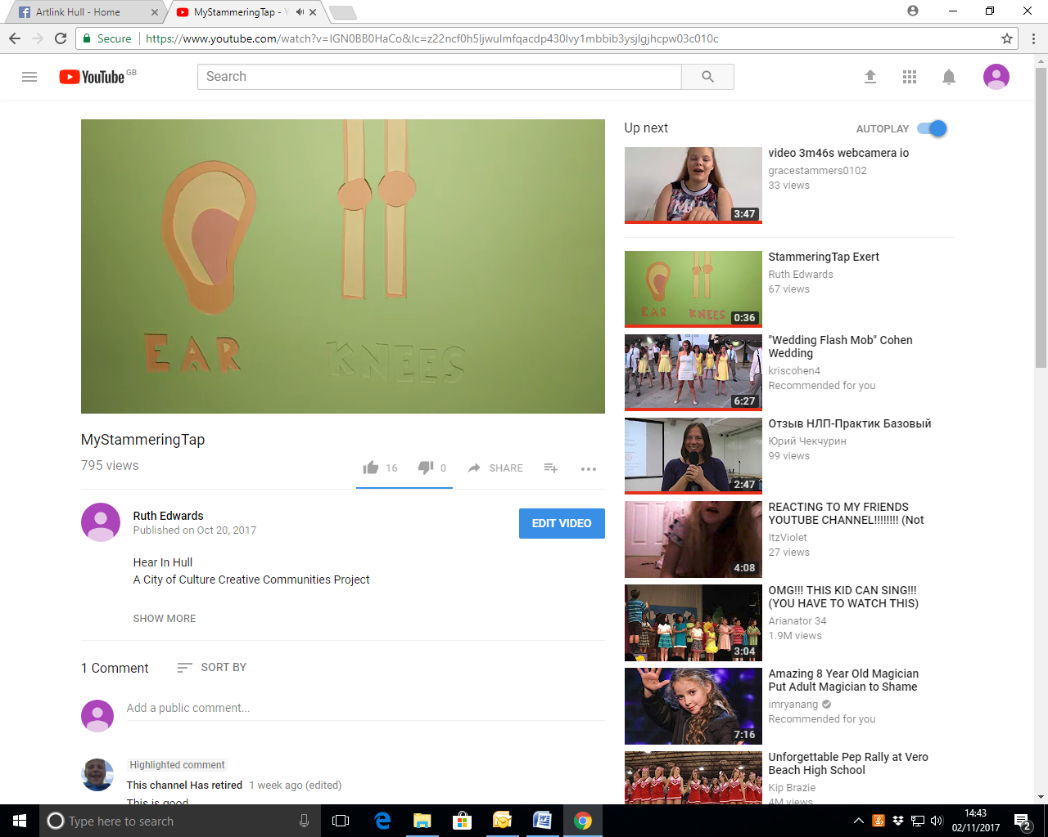
Facebook (please extend box)

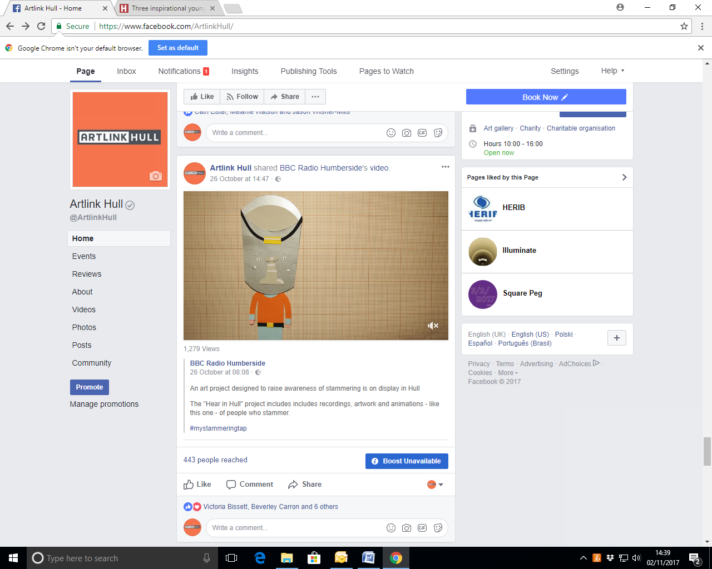
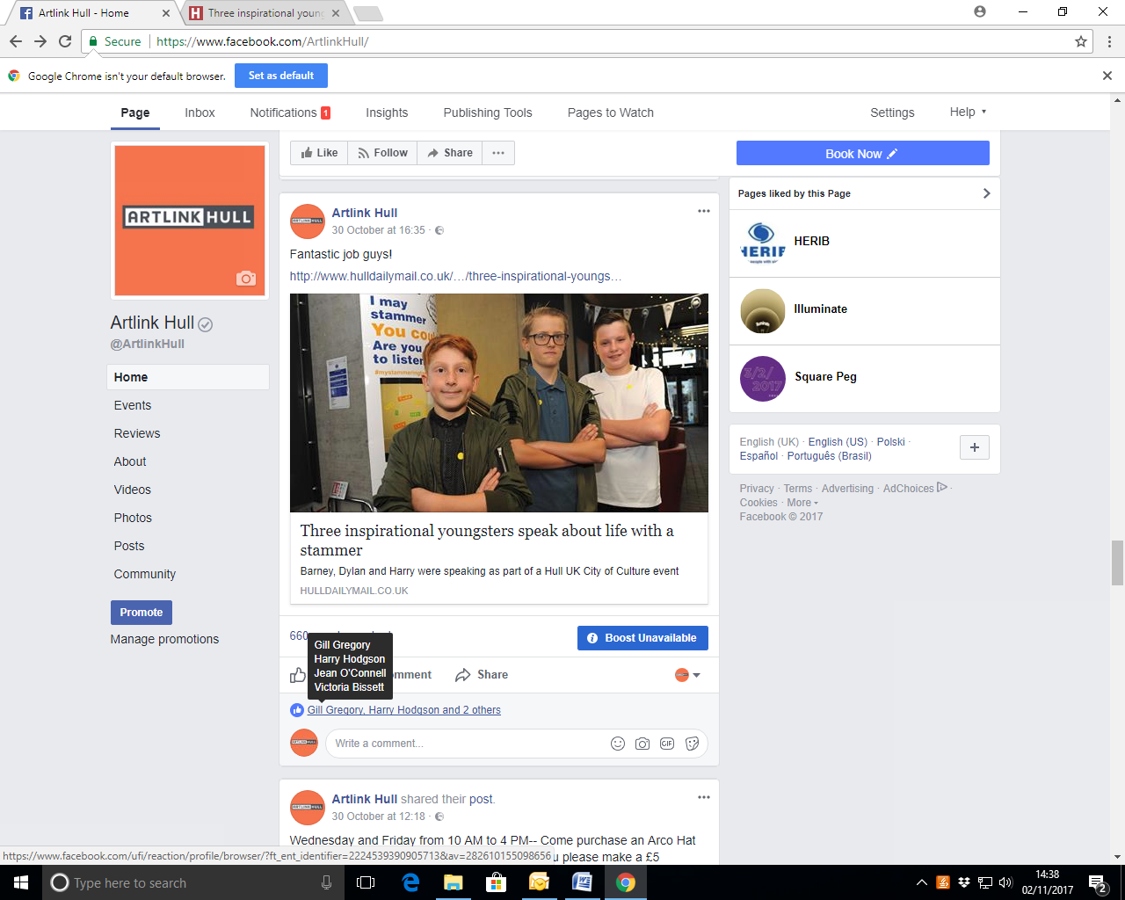
Twitter (please extend box)
Rosie Millard‏ @Rosiemillard Oct 21
More
Proud @2017Hull helped to get this wonderful project made with the inspired Peter & Sally Snelling & a fab cast

HellomynameisJulia‏ @JuliaMizon Oct 20
More
HellomynameisJulia Retweeted Jason Addison
What a privilege 2 see and Hear in Hull today #mystammeringtap premiere. Inspired by children, adults, @HumberNHSFT staff and #partnerships

HellomynameisJulia‏ @JuliaMizon Oct 20
More
HellomynameisJulia Retweeted Artlink Hull
@ArtlinkHull #ThankYou for your contribution to Hear in Hull #mystammeringtap #inspirational #emotional #partnerships

according to GARP‏ @grahamarpark Oct 20
More
Great animation - watch and please RT. Hear the message not the stammer. #mystammeringtap #HearInHull #Hull2017

Rachel E Wilson‏ @rachele500 Oct 24
More
Rachel E Wilson Retweeted UCL Giving Voice
Wonderful video. And my nephew involved! #mystammeringtap #isad2017

Bulletin Editor‏ @rcslt_bulletin Oct 24
More
Bulletin Editor Retweeted ASC
Just watched this brilliant animation about what it's like to have a stammer. http://bit.ly/2yCv56f Very enlightening. #mystammeringtap

Stammer@BSA‏ @stammer Oct 20
More
Asking the three youngsters on stage involved in #mystammeringtap how they feel now: nervous, but happy and excited!

Hull Daily Mail
http://www.hulldailymail.co.uk/news/hull-east-yorkshire-news/three-inspirational-youngsters-share-stories-660923

Audience Survey Feedback

- Thoroughly enjoyed
- I am a person who stammers; loved my day in Hull
- Needs to be an ongoing thing for the future
- The video was excellent
- Great. I have been involved in many stammering related awareness events - I loved today.
- An inspirational and positive event, look forward to the sequel.

1.2k views of animation on radio humberside fb page.
660 views – My Pockets Vimeo.

- Partners
How many partners were involved with the project?
 | TOTAL BASED IN  HU1 – HU9 | TOTAL BASED OUTSIDE  HU1 – HU9
PARTNER TYPE
Artistic partner (e.g. theatre, art gallery, music venue) | 0 | 1
Heritage partner (e.g. museum, archive) | 0 | 0
Funder (e.g. Arts Council England, business, private trust) | 0 | 0
Public Sector partner (e.g. libraries, GPs) | 1 | 0
Voluntary sector partner (e.g. community group, charity) | 0 | 0
Education (e.g. school, college, university) | 0 | 0
Other | 0 | 0
PARTNERSHIP STAGE
Number of new partnerships established via this project | 1 | 1
Number of existing partners involved in this project | 0 | 0

Thinking about your project as a whole, what would you say have been the main successes and challenges for your partners:
This can include formal and informal feedback given to you by staff and / or your own observations. You can use notes or minutes from partner meetings; informal conversations; emails; etc. to inform this.
Successes (EXPAND BOX FOR ALL INFO)
- Regular meetings to make sure project deadlines on target
- SMART targets
- Delegation of tasks to complete
- Successful workshops – partners, participants and artists.
- Huge traction of views on social media.
- Artlink & My Pockets collaborating on future arts projects.
- Artwork created with participants that will have ongoing legacy after the project.

Challenges
- Challenges around expectations and ambitions within the project budget, in relation to original project outline from partners.

