Invitation to artists/creative industries

Save the date - Thursday 7 December, Hull

Culture and creativity – how the North can lead the future

Substance Future Forum is a new one-day symposia exploring how arts and culture is redefining the image of the north, and how the north is leading the way in showing how culture and creativity can provide answers to everything from public health to Brexit.
Substance,Hull 2017 and an array of partners, including The Guardian, Arts Council England, BBC Academy, British Council, The Quietus, Northern Fiction Alliance, University of Hull, Hack and Host, CANVAS and The Spaceinvite artists, creative industries, businesses, organisations, digital pioneers, social commentators, policy makers and change makers of the future to a day of provocations on culture, creativity and future of the north.
Through discussions, keynotes, installations and debate and the release of a landmark research project; Substance will show how the rich creativity and culture of the north is laying foundations for future generations, using regenerated areas of Hull UK City of Culture as a backdrop.
Sessions and topics will include:
- How arts and culture can provide the answer to the identity crisis caused by Brexit

- London calling, no longer. Why musicians are better off away from the capital.

- How arts and culture are driving political, social and economical change

- Why culture should be part of the welfare system

- How do artists reach a global audience, and how does that benefit their hometown?

- What makes a successful city of culture?

- How arts and business can find a working relationship with benefits beyond the obvious.

- The next generation of creatives and the future of arts and culture in the North.

With more to be announced soon, as well as keynote speakers and installations.

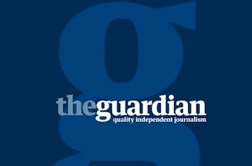  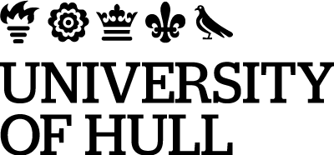 | 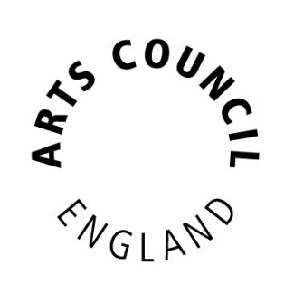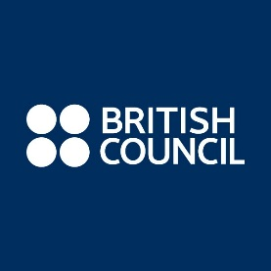 | 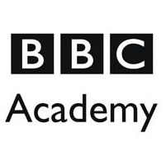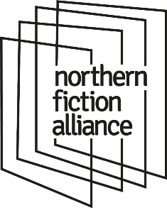
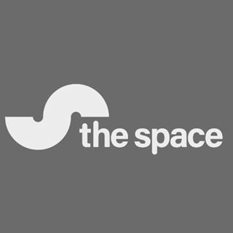 | 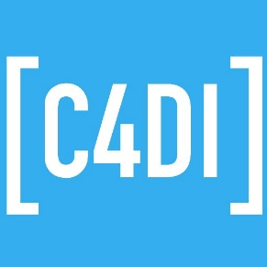 | 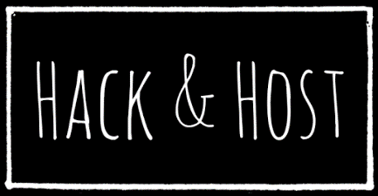
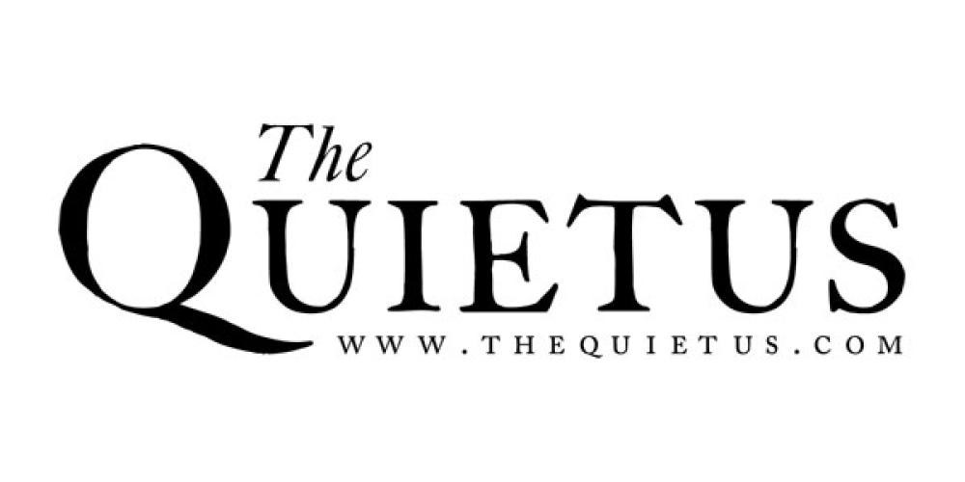 | 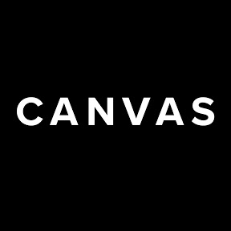 | 